Supplementary Material for “Steroidal ferrocenes as potential enzyme inhibitors of the estrogen biosynthesis”
Bianka Edina Hermanª, János Gardiª, János Juleszª, Csaba Tömböly^{b}, Eszter Szánti-Pintér^{c}, Klaudia Fehér^{c}, Rita Skoda-Földes^{c,*}, Mihály Szécsi^{a,*}
ª 1st Department of Medicine, University of Szeged, Korányi fasor 8–10 (P. O. Box 427), H-6720 Szeged, Hungary
^{b} Laboratory of Chemical Biology, Institute of Biochemistry, Biological Research Centre of the Hungarian Academy of Sciences, Temesvári körút 62 (P. O. Box 521), H-6726 Szeged, Hungary
^{c} Department of Organic Chemistry, Institute of Chemistry, University of Pannonia, Egyetem utca 10 (P. O. Box 158), H-8200 Veszprém, Hungary
*Authors for correspondence:
Rita Skoda-Földes (skodane@almos.uni-pannon.hu),
Mihály Szécsi (szecsi.mihaly@med.u-szeged.hu)

Synthesis and characterization of 17α-(1-ferrocenylmethyl-1H-1,2,3-triazol-4-yl)-17β-hydroxy-18a-homo-19-nor-androst-4-ene-3-one (12)

General methods
¹H and ¹³C NMR spectra were recorded in CDCl₃ on a Bruker Avance 400 spectrometer at 400.13 MHz and 100.62 MHz. Chemical shifts (δ) are reported in ppm relative to CHCl₃ (7.26 and 77.00 ppm for ¹H and ¹³C, respectively). HRMS spectrum was recorded using a Q-TOF Premier mass spectrometer (Waters Corporation, Milford, MA, USA), which was operated in positive electrospray ionization mode. Elemental analysis was measured on a 1108 Carlo Erba apparatus. Azidomethylferrocene was synthesized from ferrocenecarboxaldehyde via reduction to ferrocenylmethanol (Broadhead et al. 1958) followed by substitution of the OH group with NaN₃. (Casas-Solvas et al. 2004) The spectra of azidomethylferrocene corresponded well to literature data (Casas-Solvas et al. 2004).

Synthetic procedure
Levonorgestrel (0.1 mmol, 31.2 mg), azidomethylferrocene (0.1 mmol, 24.1 mg), CuSO₄.5H₂O (0.015 mmol, 3.8 mg), sodium ascorbate (0.038 mmol, 7.5 mg), CH₂Cl₂ (1 ml) and water (1 ml) was stirred at room temperature for 48 hours. The product was extracted with CH₂Cl₂ (3 x 2 ml). The combined organic phase was dried over Na₂SO₄ and concentrated under reduced pressure. The product was purified by column chromatography (silica, eluent: toluene/EtOAc (1:1, v/v)) to obtain 12 as an oily substance in 98% yield after evaporation of the eluent from the fractions containing the product.
¹H-NMR (δ, CDCl₃, 400.13 MHz): 7.17 (s, 1H, CH(triazole)), 5.76-5.80 (m, 1H, 4-H), 5.21-5.30 (m, 2H, Fc-CH₂), 4.23-4.27 (m, 2H, substituted Cp), 4.18-4.22 (m, 2H, substituted Cp), 4.16 (s, 5H, unsubstituted Cp), 0.91-2.53 (m, 21H, steroidal ring protons, OH), 1.08 (t, J = 7.4 Hz, 3H, 18a-H₃), 0.52-0.65 (m, 1H), 0.18-0.26 (m, 1H). (Fig. S1)
¹³C-NMR (δ, CDCl₃, 100.62 MHz): 199.9; 166.7; 153.8; 124.5; 120.3; 83.8; 80.9; 69.0 ; 68.9; 68.9; 68.8; 68.7; 50.0; 49.8; 48.7; 48.1; 42.3; 40.9; 38.3; 36.4; 35.5; 30.8; 28.9; 26.4; 26.1; 22.9; 20.2; 9.8. (Fig. S2)
HRMS: calculated for C₃₂H₃₉N₃O₂Fe: M⁺ 553.2392, found 553.2393.
Analysis calculated for C₃₂H₃₉N₃O₂Fe (553.53): C, 69.44; H, 7.10; N, 7.59; Found: C, 69.51; H, 7.22; N, 7.44.
R_{f}: 0.48 (silica, toluene/EtOAc 1:1)

Materials for enzyme experiments
Radiolabelled steroids [1,2,6,7-³H]testosterone (S.A. = 54 Ci/mmol), [6,7-³H(N)]estrone (S. A. = 52 Ci/mmol), [6,7-³H(N)]estrone-3-sulfate, (S.A. = 50 Ci/mmol) were obtained from American Radiolabeled Chemicals (St. Louis, MO, USA) or prepared in the Laboratory of Chemical Biology, Biological Research Centre of the Hungarian Academy of Sciences (Szeged, Hungary). Non-radioactive testosterone, estrone, estrone-3-sulfate and estrone-3-sulfamate (EMATE) standards and other chemicals and solvents of analytical grade purity were purchased from Sigma (St. Louis, MO, USA), from Fluka (Buchs, Switzerland) or from Merck (Darmstadt, Germany).
Human placenta microsomal fraction and cytosol were produced and applied with the permission of the Human Investigation Review Board of the University of Szeged.

Preparation of placental cytosol and microsomes
Human term placenta were collected immediately after delivery and stored frozen at -80 °C. Tissue specimens were washed with an isotonic solution of NaCl. 5 g pieces of the five placenta specimens were mixed and the tissue sample was homogenized with an Ultra-Turrax in 50 ml 0.1 M HEPES buffer (pH=7.3) containing 1 mM EDTA and 1 mM dithiothreitol. Homogenization was performed for 4×1 min with continuous cooling. Supernatant of subsequent cooled centrifugations of the homogenate at 1200 g for 7 min and 12000 g for 30 min was subjected to ultracentrifugation at 100000 g for 60 min at 4 °C. Obtained cytosol was drained and the microsomes sediment was resuspended in 12 ml HEPES buffer with ultrasonic homogenization. Cytosol and microsomes fraction was divided into portions for storage at -70 °C. Application of the human tissue was approved by the institutional Human Investigation Review Board.

Supplement reference
- Broadhead, G. D.; Osgerby, J. M.; Pauson, P. L. (1958) 127. Ferrocene derivatives. Part V. Ferrocenealdehyde. J. Chem. Sci. 650-656
- Casas-Solvas, J. M,, Vargas-Berenguel, A., Capitán-Vallvey, L. F., Santoyo-González, F. (2004) Convenient methods for the synthesis of ferrocene-carbohydrate conjugates. Org Lett. 6, 3687-3690.

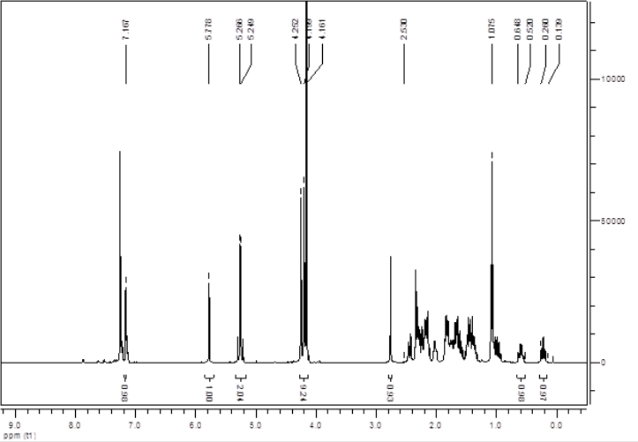
Figure S1. ¹H NMR of compound 12.

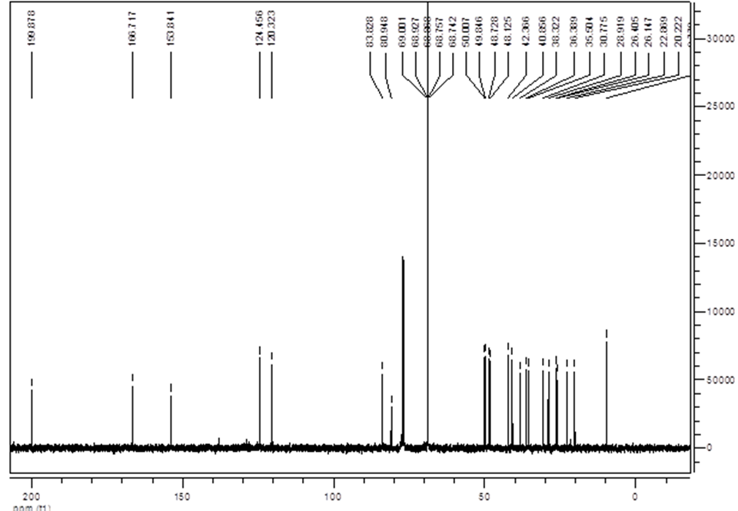
Figure S2. ¹³C NMR of compound 12.

