Depression and Anxiety Symptoms Associated with Internet Gaming Disorder Before and During the COVID-19 Pandemic: A Longitudinal Study

Online Supplementary Materials

Table S1. Model Fit Indices for Measurement Invariance and the Cross-Lagged Panel Models Between Internet Gaming Disorder (IGD) and Depressive and Anxiety Symptoms.
Table S2. Demographic Factors and T1 Variables as The Predictors of T2 Variables Among Perceived COVID-19 Impacts, Depressive Symptoms, Internet Gaming Disorder, and Videogame Use (Figure 3).
Table S3. Demographic Factors and T1 Variables as the Predictors of T2 Variables Among Perceived COVID-19 Impacts, Anxiety Symptoms, Internet Gaming Disorder, and Videogame Use (Figure 4).
Table S4. Cross-Lagged Panel Models for Multiple-Group Analyses Across Age (children vs. adolescents) And Gender (boys vs. girls).
Table S5. Developmental Difference in The Model of Anxiety Symptoms, Videogame Use, and Internet Gaming Disorder.
Table S6. Gender Differences in The Model of Depression Symptoms, Videogame Use, and Internet Gaming Disorder.
Table S7. Gender Differences in The Model of Anxiety Symptoms, Videogame Use, and Internet Gaming Disorder.
Figure S1 Depression and Anxiety Symptoms Associated with Internet Gaming Disorder and Video game Use.
Figure S2 The Mediation Model of Perceived COVID-19 in the Relationship Between Depression and Anxiety Symptoms Associated with Internet Gaming Disorder and Video game Use.

Table S1
Model Fit Indices for Measurement Invariance and the Cross-Lagged Panel Models Between Internet Gaming Disorder (IGD) and Depressive and Anxiety Symptoms.
 | Fit Indices |  |  |  |  |  |  |  | Model Comparison
 | χ² | df | SCF | AIC | CFI | TLI | RMSEA | SRMR | ΔCFI | ΔTLI
Model A
Configural invariance model | 611.60 | 145 | 1.37 | 99752.14 | .97 | .96 | .04 | .04 | – | –
Weak factorial invariance model | 625.47 | 152 | 1.67 | 99783.23 | .97 | .96 | .04 | .05 | .00 | .00
Strong factorial invariance model | 765.25 | 162 | 1.67 | 99880.41 | .96 | .96 | .05 | .05 | .01 | .00
Cross-lagged panel model | 1231.41 | 249 | 1.49 | 99802.82 | .94 | .93 | .05 | .06 | – | –
Mediation model | 1525.73 | 368 | 1.45 | 139234.46 | .94 | .93 | .04 | .06 | .00 | .00
Model B
Configural invariance model | 309.53 | 81 |  | 90753.20 | .98 | .97 | .04 | .03 | – | –
Weak factorial invariance model | 310.89 | 86 | 1.35 | 90753.86 | .98 | .97 | .04 | .03 | .00 | .00
Strong factorial invariance model | 376.52 | 94 | 1.34 | 90822.54 | .97 | .96 | .04 | .04 | .01 | .01
Cross-lagged panel model | 800.25 | 161 | 1.25 | 90685.01 | .94 | .93 | .04 | .07 | – | –
Mediation model | 1051.02 | 260 | 1.24 | 130110.85 | .94 | .93 | .04 | .06 | .00 | .00
Note. Model A = Depressive symptoms, Videogame use, and IGD, Model B = Anxiety symptoms, Videogame use, and IGD; SCF = Scaling correction factor; AIC = Akaike information criterion, CFI = Comparative fit index, TLI = Tucker-Lewis index, RMSEA = Root mean square error of approximation, SRMR = Standardized root mean square residual.

Table S2
Demographic Factors and T1 Variables as The Predictors of T2 Variables Among Perceived COVID-19 Impacts, Depressive Symptoms, Internet Gaming Disorder, and Videogame Use (Figure 3).
 | COVID-19 impacts T2 |  |  |  | Depressive symptoms T2 |  |  |  | Gaming disorder T2 |  |  |  | Videogame use T2
 | β | SE | p |  | β | SE | p |  | β | SE | p |  | β | SE | p
Age | .17 | 0.04 | .000 |  | –.01 | 0.01 | .886 |  | .01 | 0.01 | .254 |  | .01 | 0.01 | .729
Gender (1=male, 0=female) | .05 | 0.03 | .049 |  | –.08 | 0.02 | .000 |  | .17 | 0.02 | .000 |  | .15 | 0.02 | .000
Family month income | .01 | 0.03 | .994 |  | –.01 | 0.02 | .411 |  | –.06 | 0.02 | .006 |  | .04 | 0.03 | .160
Parental education level | –.07 | 0.03 | .015 |  | –.01 | 0.02 | .973 |  | –.01 | 0.02 | .885 |  | –.06 | 0.02 | .007
Time spent at home | –.04 | 0.02 | .135 |  | –.04 | 0.02 | .056 |  | –.06 | 0.03 | .019 |  | .01 | 0.02 | .646
Depressive symptoms (T1) | .19 | 0.04 | .000 |  | .63 | 0.03 | .000 |  | .12 | 0.03 | .000 |  | .09 | 0.03 | .005
Internet gaming disorder (T1) | .10 | 0.04 | .018 |  | .02 | 0.03 | .593 |  | .40 | 0.05 | .000
Videogame use (T1) | –.03 | 0.05 | .553 |  | –.01 | 0.03 | .960 |  |  |  |  |  | .60 | 0.03 | .000
COVID-19 impacts (T2) |  |  |  |  | .20 | 0.03 | .000 |  | .12 | 0.03 | .000 |  | –.01 | 0.03 | .928
R² |  | .10 |  |  |  | .51 |  |  |  | .29 |  |  |  | .40
Note. COVID-19 impacts = perceived COVID-19 impacts; Gaming disorder = Internet gaming disorder; T1/T2 = first/second measurement time point; statistically significant coefficients at p < .05 are in bold. T1 = before COVID-19 pandemic, T2 = during COVID-19 pandemic.

Table S3
Demographic Factors and T1 Variables as the Predictors of T2 Variables Among Perceived COVID-19 Impacts, Anxiety Symptoms, Internet Gaming Disorder, and Videogame Use (Figure 4).
 | COVID-19 impacts T2 |  |  |  | Anxiety symptoms T2 |  |  |  | Gaming disorder T2 |  |  |  | Videogame use T2
 | β | SE | p |  | β | SE | p |  | β | SE | p |  | β | SE | p
Age | .15 | 0.04 | .000 |  | .03 | 0.01 | .029 |  | .01 | 0.01 | .236 |  | .01 | 0.01 | .716
Gender (1=male, 0=female) | .06 | 0.03 | .019 |  | –.08 | 0.03 | .003 |  | .17 | 0.02 | .000 |  | .14 | 0.02 | .000
Family month income | .01 | 0.03 | .910 |  | –.01 | 0.02 | .826 |  | –.05 | 0.02 | .011 |  | .04 | 0.03 | .129
Parental education level | –.08 | 0.03 | .012 |  | –.01 | 0.02 | .805 |  | –.01 | 0.02 | .623 |  | –.06 | 0.02 | .006
Time spent at home | –.03 | 0.02 | .191 |  | –.06 | 0.02 | .008 |  | –.05 | 0.02 | .028 |  | .01 | 0.02 | .589
Anxiety symptoms (T1) | .29 | 0.04 | .000 |  | .84 | 0.04 | .000 |  | .12 | 0.04 | .000 |  | .09 | 0.04 | .012
Internet gaming disorder (T1) | .03 | 0.05 | .593 |  | .02 | 0.04 | .598 |  | .39 | 0.05 | .000
Videogame use (T1) | –.01 | 0.04 | .801 |  | –.02 | 0.05 | .678 |  |  |  |  |  | .60 | 0.03 | .000
COVID-19 impacts (T2) |  |  |  |  | .18 | 0.04 | .000 |  | .12 | 0.03 | .000 |  | –.01 | 0.03 | .774
R² |  | .13 |  |  |  | .85 |  |  |  | .28 |  |  |  | .40
Note. COVID-19 impacts = perceived COVID-19 impacts; Gaming disorder = Internet gaming disorder; T1/T2 = first/second measurement time point; statistically significant coefficients at p < .05 are in bold. T1 = before COVID-19 pandemic, T2 = during COVID-19 pandemic.

Table S4
Cross-Lagged Panel Models for Multiple-Group Analyses Across Age (children vs. adolescents) And Gender (boys vs. girls).
 | Fit Indices |  |  |  |  |  |  |  | Model Comparison
 | χ² | df | SCF | AIC | CFI | TLI | RMSEA | SRMR | Δχ² | Δdf | p | ΔCFI
Model A
invariant | 2101.45 | 768 | 1.36 | 138981.95 | .94 | .93 | .04 | .06 | 7.03 | 13 | .901 | .00
unconstrained | 2094.42 | 755 | 1.36 | 138986.41 | .94 | .93 | .05 | .06
Model B
invariant | 1809.59 | 726 | 1.17 | 138380.41 | .94 | .94 | .04 | .06 | 30.59 | 13 | .004 | .01
unconstrained | 1779.00 | 713 | 1.17 | 138367.61 | .95 | .94 | .04 | .06
Model C
invariant | 1459.98 | 548 | 1.18 | 129832.44 | .94 | .93 | .04 | .06 | 30.51 | 13 | .004 | .00
unconstrained | 1429.47 | 535 | 1.18 | 129822.56 | .94 | .93 | .04 | .06
Model D
invariant | 1219.34 | 514 | 1.19 | 129274.29 | .95 | .94 | .04 | .05 | 27.09 | 13 | .012 | .00
unconstrained | 1192.25 | 501 | 1.19 | 129266.43 | .95 | .94 | .04 | .05
Note. Model A = Depressive symptoms, Videogame use, and IGD across age, Model B = Depressive symptoms, Videogame use, and IGD across gender, Model C = Anxiety symptoms, Videogame use, and IGD across age, Model D = Anxiety symptoms, Videogame use, and IGD across gender; SCF = Scaling correction factor; AIC = Akaike information criterion, CFI = Comparative fit index, TLI = Tucker-Lewis index, RMSEA = Root mean square error of approximation, SRMR = Standardized root mean square residual.

Table S5
Developmental Difference in The Model of Anxiety Symptoms, Videogame Use, and Internet Gaming Disorder.
Paths | Children |  |  |  | Adolescents
 | β | SE | p |  | β | SE | p |  | Wald χ² | p
Stability
T1 Anxiety symptoms → T2 Anxiety symptoms | .76 | 0.08 | .000 |  | .90 | 0.05 | .000 |  | 4.59 | .032
T1 IGD → T2 IGD | .37 | 0.05 | .000 |  | .41 | 0.07 | .000 |  | 0.11 | .735
T1 Video game use → T2 Video game use | .54 | 0.03 | .000 |  | .65 | 0.05 | .000 |  | 5.04 | .025
Cross-lagged effects
T1 IGD → T2 Anxiety symptoms | .04 | 0.05 | .456 |  | –.01 | 0.02 | .956 |  | 0.49 | .484
T1 Video game use → T2 Anxiety symptoms | –.13 | 0.08 | .137 |  | .08 | 0.08 | .263 |  | 3.77 | .052
T1 Anxiety symptoms → T2 Video game use | .11 | 0.06 | .047 |  | .13 | 0.04 | .001 |  | 0.31 | .579
T1 Anxiety symptoms → T2 IGD | .09 | 0.05 | .069 |  | .15 | 0.04 | .000 |  | 1.78 | .183
The role of Perceived COVID-19 impacts
T1 Anxiety symptoms → T2 COVID-19 impacts | .37 | 0.07 | .000 |  | .24 | 0.06 | .000 |  | 1.29 | .257
T1 IGD → T2 COVID-19 impacts | –.05 | 0.07 | .435 |  | .07 | 0.07 | .284 |  | 1.79 | .181
T1 Video game use → T2 COVID-19 impacts | .02 | 0.07 | .757 |  | –.01 | 0.06 | .826 |  | 0.15 | .702
T2 COVID-19 impacts → T2 Anxiety symptoms | .30 | 0.05 | .000 |  | .09 | 0.04 | .035 |  | 12.07 | .001
T2 COVID-19 impacts → T2 IGD | .16 | 0.03 | .000 |  | .08 | 0.04 | .059 |  | 2.08 | .150
T2 COVID-19 impacts → T2 Video game use | .01 | 0.05 | .919 |  | –.04 | 0.04 | .417 |  | 0.40 | .528
Note: IGD=internet gaming disorder; statistically significant coefficients at p < .05 are in bold. T1 = before COVID-19 pandemic, T2 = during COVID-19 pandemic.

Table S6
Gender Differences in The Model of Depression Symptoms, Videogame Use, and Internet Gaming Disorder.
 | Boys |  |  |  | Girls
Paths | β | SE | p |  | β | SE | p |  | Wald χ² | p
Stability
T1 Depressive symptoms → T2 Depressive symptoms | .65 | 0.04 | .000 |  | .61 | 0.04 | .000 |  | 0.45 | .503
T1 IGD → T2 IGD | .34 | 0.06 | .000 |  | .47 | 0.06 | .000 |  | 5.31 | .021
T1 Video game use → T2 Video game use | .64 | 0.03 | .000 |  | .49 | 0.06 | .000 |  | 4.89 | .027
Cross-lagged effects
T1 IGD → T2 Depressive symptoms | –.01 | 0.05 | .784 |  | .03 | 0.05 | .499 |  | 0.56 | .454
T1 Video game use → T2 Depressive symptoms | –.02 | 0.04 | .705 |  | .01 | 0.05 | .903 |  | 0.10 | .757
T1 Depressive symptoms → T2 Video game use | .12 | 0.04 | .001 |  | .08 | 0.05 | .120 |  | 2.60 | .107
T1 Depressive symptoms → T2 IGD | .17 | 0.03 | .000 |  | .06 | 0.04 | .095 |  | 7.90 | .005
The role of perceived COVID-19 impacts
T1 Depressive symptoms → T2 COVID-19 impacts | .12 | 0.05 | .017 |  | .27 | 0.05 | .000 |  | 2.30 | .129
T1 IGD → T2 COVID-19 impacts | .09 | 0.06 | .150 |  | .13 | 0.06 | .017 |  | 0.45 | .500
T1 Video game use → T2 COVID-19 impacts | –.01 | 0.05 | .991 |  | –.08 | 0.06 | .157 |  | 1.33 | .248
T2 COVID-19 impacts → T2 Depressive symptoms | .22 | 0.04 | .000 |  | .14 | 0.04 | .000 |  | 0.12 | .725
T2 COVID-19 impacts → T2 IGD | .16 | 0.04 | .000 |  | .08 | 0.04 | .070 |  | 2.72 | .099
T2 COVID-19 impacts → T2 Video game use | .01 | 0.04 | .943 |  | –.01 | 0.06 | .945 |  | 0.01 | .922
Note: IGD=internet gaming disorder; statistically significant coefficients at p < .05 are in bold. T1 = before COVID-19 pandemic, T2 = during COVID-19 pandemic.

Table S7
Gender Differences in The Model of Anxiety Symptoms, Videogame Use, and Internet Gaming Disorder.
Paths | boys |  |  |  | Girls
 | β | SE | p |  | β | SE | p |  | Wald χ² | p
Stability
T1 Anxiety symptoms T2 Anxiety symptoms | .88 | 0.06 | .000 |  | .83 | 0.05 | .000 |  | 0.87 | .352
T1 IGD T2 IGD | .32 | 0.07 | .000 |  | .47 | 0.05 | .000 |  | 5.99 | .014
T1 Video game use T2 Video game use | .63 | 0.03 | .000 |  | .48 | 0.05 | .000 |  | 4.73 | .030
Cross-lagged effects
T1 IGD T2 Anxiety symptoms | –.01 | 0.05 | .886 |  | .03 | 0.05 | .582 |  | 0.32 | .572
T1 Video game use T2 Anxiety symptoms | –.06 | 0.07 | .429 |  | –.03 | 0.10 | .707 |  | 0.01 | .952
T1 Anxiety symptoms T2 Video game use | .12 | 0.04 | .002 |  | .09 | 0.06 | .123 |  | 1.37 | .242
T1 Anxiety symptoms T2 IGD | .18 | 0.06 | .002 |  | .04 | 0.05 | .444 |  | 5.16 | .023
The role of Perceived COVID-19 impacts
T1 Anxiety symptoms T2 COVID-19 impacts | .24 | 0.06 | .000 |  | .36 | 0.07 | .000 |  | 0.25 | .615
T1 IGD T2 COVID-19 impacts | –.01 | 0.08 | .956 |  | .06 | 0.07 | .406 |  | 0.35 | .556
T1 Video game use T2 COVID-19 impacts | .02 | 0.06 | .707 |  | –.06 | 0.06 | .330 |  | 1.14 | .287
T2 COVID-19 impacts T2 Anxiety symptoms | .25 | 0.07 | .000 |  | .11 | 0.05 | .031 |  | 0.91 | .340
T2 COVID-19 impacts T2 IGD | .14 | 0.04 | .000 |  | .08 | 0.04 | .068 |  | 1.91 | .167
T2 COVID-19 impacts T2 Video game use | –.01 | 0.04 | .819 |  | –.02 | 0.06 | .782 |  | 0.01 | .933
Note: IGD=internet gaming disorder; statistically significant coefficients at p < .05 are in bold. T1 = before COVID-19 pandemic, T2 = during COVID-19 pandemic.

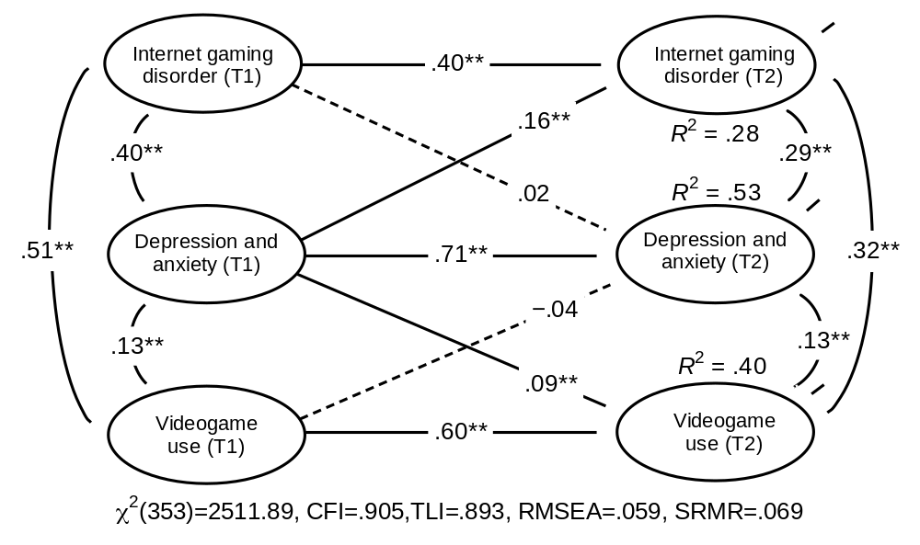
Figure S1 Depression and Anxiety Symptoms Associated with Internet Gaming Disorder and Video game Use.

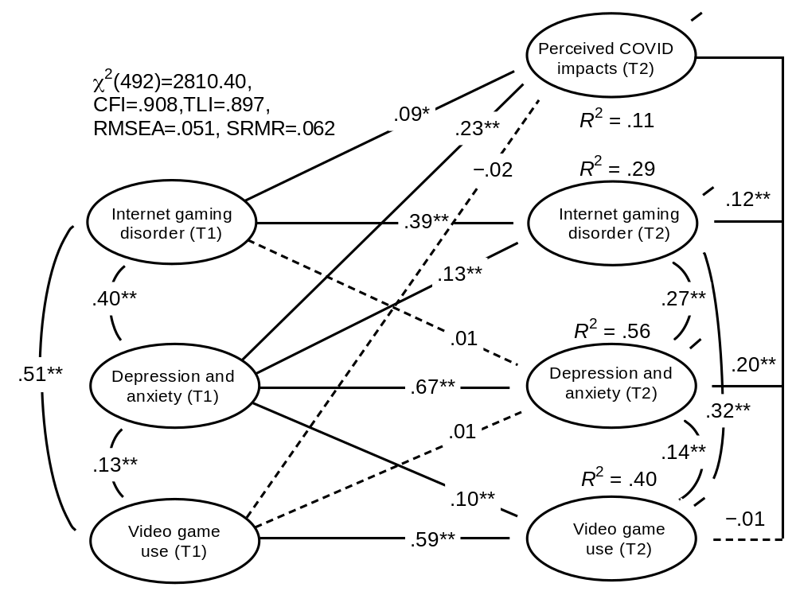
Figure S2 The Mediation Model of Perceived COVID-19 in the Relationship Between Depression and Anxiety Symptoms Associated with Internet Gaming Disorder and Video game Use.

