Supplementary Materials
METHOD
MTT assay for cell proliferation
Cell proliferation was assessed by the MTT assay. Cells in the logarithmic growth phase were harvested, seeded in a 96-well plate at 5×10³ cells/well, and cultured in a 5% CO₂ incubator at 37 °C for 24 h. When the cells were 80% confluent, the supernatant was discarded, and the cells were washed once with PBS. Subsequently, the cells were treated with different concentrations of samples for 24, 48, and 72 h. The supernatant was discarded and the cells were washed with PBS. Following the addition of 100 μL MTT buffer (0.5 mg mL^{–1}), the plates were cultured at 37 ℃ in the dark for 4 h. The MTT buffer was removed and 150 μL DMSO was added to each well. After shaking the plates for 10 min, absorbance (OD) was measured on a microplate reader at 570 nm. Cell proliferation was calculated using the following formula:
Cell proliferation (%) = (OD sample/OD control) ×100

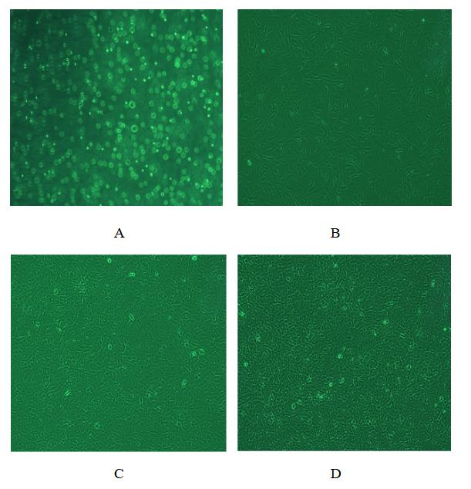
Fig. S1. Morphological Observation of MC3T3-E1 cells. MC3T3-E1 cells were cultured in an incubator with 5% CO₂ and 95% wet air and observed by inverted microscope after passage (A) and after 24 h (B), 48 h (C), and 72 h (D) culturing.

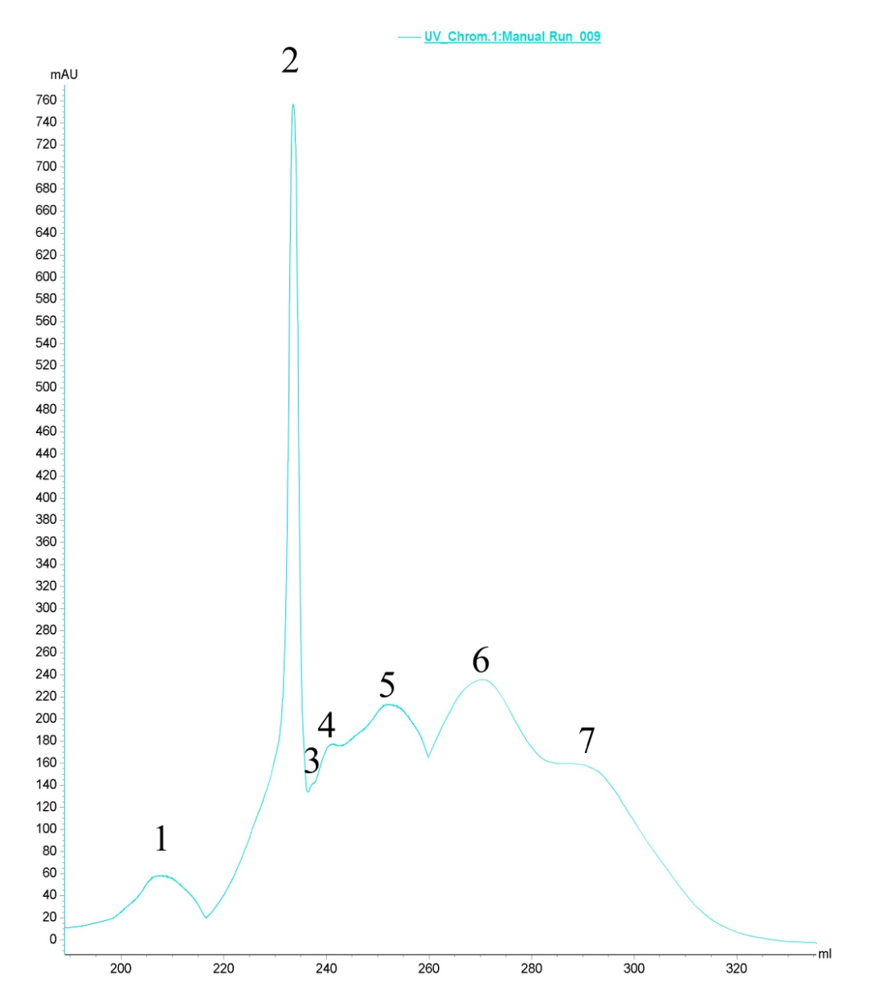
Fig. S2. Elution diagram of the Sephadex G-25 column of the complete shellfish. Elution was monitored at wavelengths of 280 nm. The peaks are numbered WP1–WP7 in order of elution.

Fig. S3. Total ion chromatogram of WP2 component in positive ion scan mode.

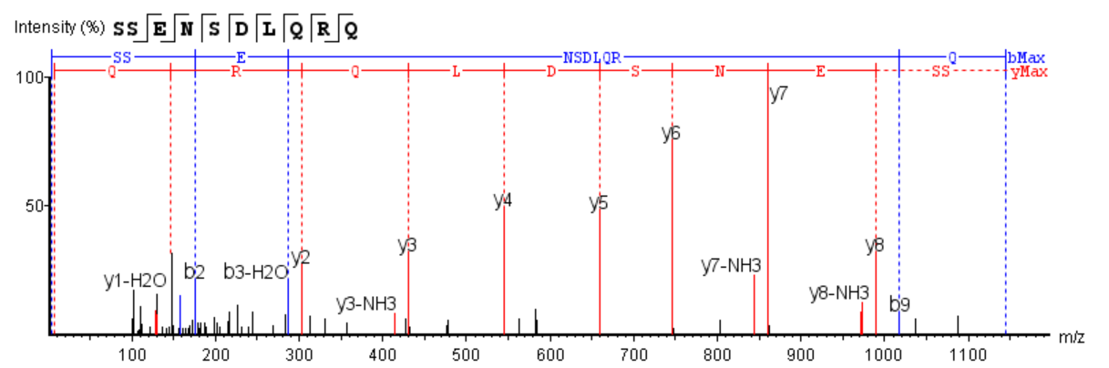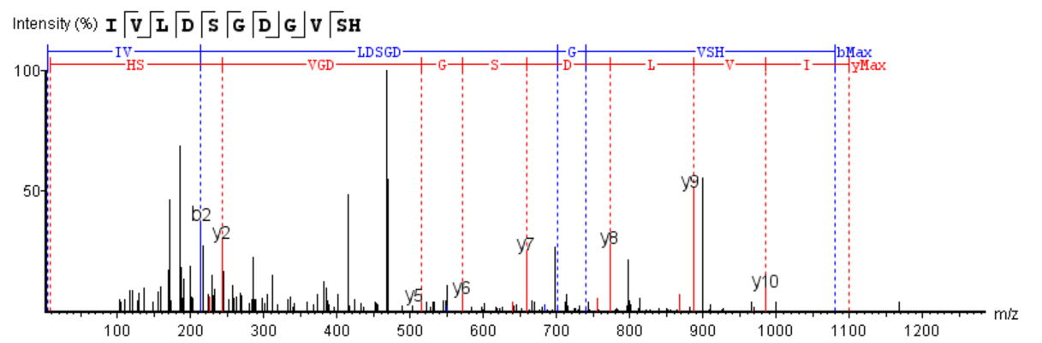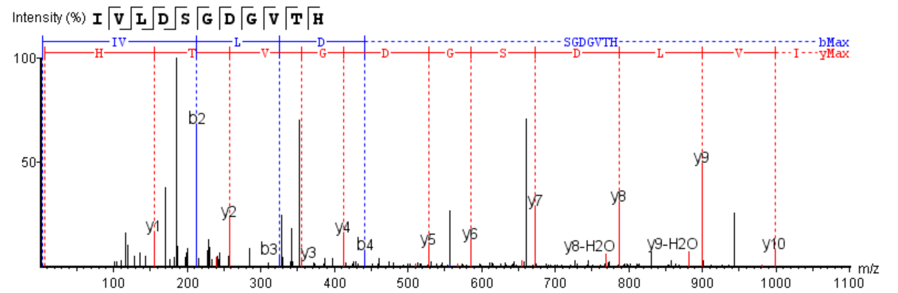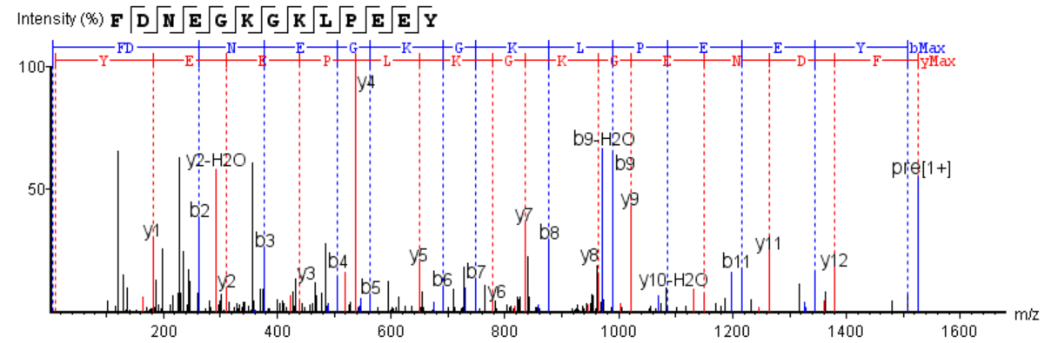Fig. S4. MS/MS spectrum of the peptides FDNEGKGKLPEEY, IVLDSGDGVTH, IVLDSGDGVSH, and SSENSDLQRQ.

