Table 1: LA-ICP-MS analyses of some mineral phases of Sample 784
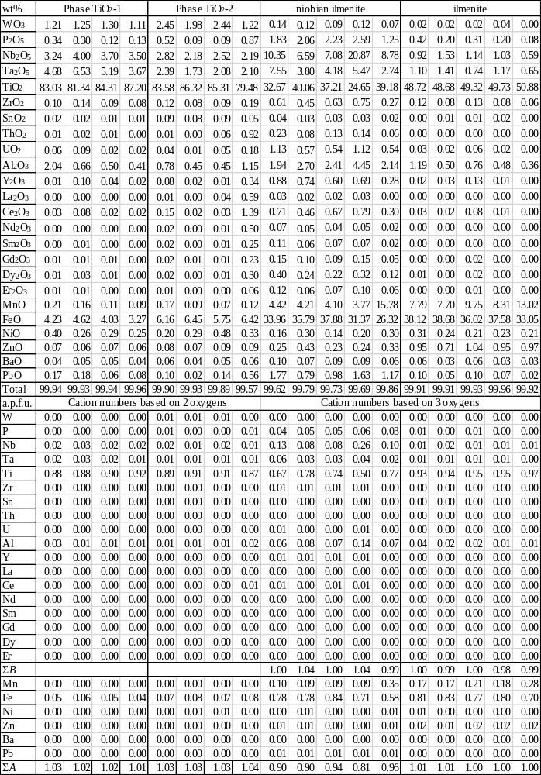

Table 2a: EDX composition of ilmenite in wt%. Phase labels: Figure No./the phase marked with a number in the BSE images. *Low cation numbers come from significant Nb-Ta-content causing high vacancy in position A; however, this very high Nb-Ta content is very atypical in ilmenite, probably submicroscopic Nb-Ta oxides were measured with ilmenite. **Cation numbers are too high in the B and too low in the A position, possibly indicating the transition of ilmenite into rutile
Phase | 4/5* | 4/9* | 8/1**
P₂O₅ |  | 6.21
Nb₂O₅ | 24.43 | 17.54
Ta₂O₅ | 18.34 | 14.01
TiO₂ | 24.29 | 22.19 | 63.21
UO₂ |  | 1.63
Al₂O₃ | 2.43 | 4.19
MnO | 2.35 | 3.96 | 2.82
FeO | 27.45 | 28.97 | 33.97
CaO | 0.71 | 1.30
Total | 100.00 | 100.00 | 100.00
Cation numbers based on 3 oxygens
P |  | 0.14
Nb | 0.31 | 0.21
Ta | 0.14 | 0.10
Ti | 0.51 | 0.44 | 1.13
U |  | 0.01
Al | 0.08 | 0.13
ΣB | 1.04 | 1.03 | 1.13
Mn | 0.06 | 0.09 | 0.06
Fe | 0.65 | 0.64 | 0.68
Ca | 0.02 | 0.04
ΣA | 0.73 | 0.77 | 0.74

Table 2b: EDX composition of rutile in wt%. Phase labels: Figure No./the phase marked with a number in the BSE images
Phase | 4/4 | 4/5 | 4/13 | 4/14 | 4/15 | 5/1 | 5/2
WO₃ | 7.84 |  |  |  | 2.05 | 5.48 | 5.49
Nb₂O₅ | 10.78 | 7.00 | 6.06 | 2.25 | 12.23 | 5.77 | 5.74
Ta₂O₅ | 6.07 | 20.95 | 3.45 |  | 3.02
SiO₂ |  |  | 2.54 | 0.70 |  | 1.02 | 1.15
TiO₂ | 67.89 | 64.03 | 84.51 | 95.50 | 76.92 | 80.56 | 80.57
ZrO₂ |  |  |  |  |  | 0.37 | 0.49
SnO₂ | 1.01 |  |  |  |  | 1.37 | 1.25
UO₂ |  |  |  |  |  | 0.34 | 0.33
Al₂O₃ |  |  |  |  |  | 0.59 | 0.60
Y₂O₃ |  |  |  |  |  | 0.18
CaO |  |  |  |  |  |  | 0.13
FeO | 6.41 | 8.02 | 3.44 | 1.55 | 5.77 | 3.70 | 3.70
PbO |  |  |  |  |  | 0.61 | 0.55
Total | 100.00 | 100.00 | 100.00 | 100.00 | 99.99 | 99.99 | 100.00
Cation numbers based on 2 oxygens
W | 0.03 |  |  |  | 0.01 | 0.02 | 0.02
Nb | 0.07 | 0.05 | 0.04 | 0.01 | 0.08 | 0.04 | 0.04
Ta | 0.03 | 0.09 | 0.01 |  | 0.01
Si |  |  | 0.04 | 0.01 |  | 0.01 | 0.02
Ti | 0.78 | 0.77 | 0.88 | 0.96 | 0.84 | 0.87 | 0.86
Zr |  |  |  |  |  | 0.00 | 0.00
Sn | 0.01 |  |  |  |  | 0.01 | 0.01
U |  |  |  |  |  | 0.00 | 0.00
Al |  |  |  |  |  | 0.01 | 0.01
Y |  |  |  |  |  | 0.00
Ca |  |  |  |  |  |  | 0.00
Fe | 0.08 | 0.11 | 0.04 | 0.02 | 0.07 | 0.04 | 0.04
Pb |  |  |  |  |  | 0.00 | 0.00
Total | 1.00 | 1.02 | 1.01 | 1.00 | 1.01 | 1.00 | 1.00
Table 2b continued: *too high total cation number possibly means a mixture with submicroscopic grains of a Mn-Fe-Zn rich phase, maybe pyrophanite
Phase | 5/5 | 5/6 | 5/8* | 7/1 | 7/2 | 7/3 | 9/2
SO₃ |  |  |  | 0.20
WO₃ |  | 1.62 |  | 0.58
P₂O₅ |  |  |  | 3.50 | 4.27
Nb₂O₅ | 2.31 | 4.15 | 3.23 | 24.93 | 18.99 | 24.75 | 1.68
Ta₂O₅ |  | 1.76 | 2.46 | 2.31 | 3.73 | 2.81
SiO₂ |  |  | 3.19 | 4.16 | 9.43 | 5.59
TiO₂ | 96.66 | 88.87 | 64.75 | 53.09 | 46.70 | 53.36 | 98.32
SnO₂ |  | 1.04
ThO₂ |  |  |  | 0.13 | 0.62 | 1.13
UO₂ |  |  |  | 0.33 |  | 0.98
Al₂O₃ |  | 0.35 |  | 2.48 | 3.20 | 2.62
Y₂O₃ |  |  |  |  | 1.47
Nd₂O₃ |  |  |  |  | 0.28
Sm₂O₃ |  |  |  |  | 0.30
Gd₂O₃ |  |  |  |  | 0.44
Er₂O₃ |  |  |  |  | 0.38
Yb₂O₃ |  |  |  |  | 0.26
MgO |  |  |  |  |  | 0.41
CaO |  |  |  | 0.32 | 0.46 | 0.10
MnO |  |  | 13.93 |  |  | 0.04
FeO | 1.03 | 2.21 | 5.23 | 5.27 | 6.06 | 7.21
ZnO |  |  | 7.21
PbO |  |  |  | 1.72 | 1.52
Na₂O |  |  |  | 0.57 | 0.60 | 0.64
K₂O |  |  |  | 0.41 | 1.30 | 0.35
Total | 100.00 | 100.00 | 100.00 | 100.00 | 100.01 | 99.99 | 100.00
Cation numbers based on 2 oxygens
S |  |  |  | 0.00
W |  | 0.01 |  | 0.00
P |  |  |  | 0.04 | 0.05
Nb | 0.01 | 0.03 | 0.02 | 0.16 | 0.12 | 0.17 | 0.01
Ta |  | 0.01 | 0.01 | 0.01 | 0.01 | 0.01
Si |  |  | 0.05 | 0.06 | 0.14 | 0.08
Ti | 0.98 | 0.93 | 0.75 | 0.58 | 0.51 | 0.60 | 0.99
Sn |  | 0.01
Th |  |  |  | 0.00 | 0.00 | 0.00
U |  |  |  | 0.00 |  | 0.00
Al |  | 0.01 |  | 0.04 | 0.05 | 0.05
Y |  |  |  |  | 0.01
Nd |  |  |  |  | 0.00
Sm |  |  |  |  | 0.00
Gd |  |  |  |  | 0.00
Er |  |  |  |  | 0.00
Yb |  |  |  |  | 0.00
Mg |  |  |  |  |  | 0.01
Ca |  |  |  | 0.01 | 0.01 | 0.00
Mn |  |  | 0.18 |  |  | 0.00
Fe | 0.01 | 0.03 | 0.07 | 0.06 | 0.07 | 0.09
Zn |  |  | 0.08
Pb |  |  |  | 0.01 | 0.01
Na |  |  |  | 0.02 | 0.02 | 0.02
K |  |  |  | 0.01 | 0.02 | 0.01
Total | 1.00 | 1.03 | 1.16 | 1.00 | 1.02 | 1.04 | 1.00
Table 2c: EDX composition of columbite-tantalite in wt%. Phase labels: Figure No./the phase marked with a number in the BSE images
Phase | 4/1 | 4/2 | 4/3 | 4/7 | 5/7
Nb₂O₅ | 42.11 | 55.92 | 46.63 | 17.30 | 59.34
Ta₂O₅ | 24.74 | 10.49 | 21.52 | 51.78 | 4.58
TiO₂ | 9.78 | 7.45 | 7.48 | 11.91 | 10.89
SnO₂ |  | 0.15 |  |  | 1.02
Sc₂O₃ | 0.25 | 0.25 | 0.37 | 0.38 | 0.57
Y₂O₃ | 1.24 | 1.14 | 1.58 | 1.15 | 1.44
Sm₂O₃ |  |  | 0.20
Gd₂O₃ |  |  | 0.41 | 0.15
Ho₂O₃ |  |  |  |  | 0.23
Er₂O₃ | 0.23 | 0.31 | 0.47 | 0.61 | 0.41
Yb₂O₃ | 0.46 | 1.20 | 1.02 | 0.59 | 0.89
Lu₂O₃ | 0.45 | 0.47 | 0.68 | 0.18 | 0.17
MgO | 0.56 | 0.31
CaO | 0.22 | 0.28 | 0.38 |  | 0.77
MnO | 9.11 | 9.04 | 5.88 | 5.66 | 7.72
FeO | 10.77 | 12.89 | 13.30 | 10.07 | 11.83
Total | 99.92 | 99.90 | 99.92 | 99.78 | 99.86
Cation numbers based on 6 oxygens
Nb | 1.16 | 1.47 | 1.29 | 0.53 | 1.50
Ta | 0.41 | 0.17 | 0.36 | 0.96 | 0.07
Ti | 0.45 | 0.33 | 0.34 | 0.61 | 0.46
Sn |  | 0.00 |  |  | 0.02
Sc | 0.01 | 0.01 | 0.02 | 0.02 | 0.03
Y | 0.04 | 0.04 | 0.05 | 0.04 | 0.04
Sm |  |  | 0.00
Gd |  |  | 0.01 | 0.00
Ho |  |  |  |  | 0.00
Er | 0.00 | 0.01 | 0.01 | 0.01 | 0.01
Yb | 0.01 | 0.02 | 0.02 | 0.01 | 0.02
Lu | 0.01 | 0.01 | 0.01 | 0.00 | 0.00
ΣB | 2.09 | 2.06 | 2.11 | 2.18 | 2.15
Mg | 0.05 | 0.03
Ca | 0.01 | 0.02 | 0.02 |  | 0.05
Mn | 0.47 | 0.45 | 0.30 | 0.33 | 0.37
Fe | 0.55 | 0.63 | 0.68 | 0.57 | 0.55
ΣA | 1.08 | 1.13 | 1.00 | 0.90 | 0.97
Table 2d: EDX composition of other accessory minerals in wt%. Phase labels: Figure No./the phase marked with a number in the BSE images. n.d. = non detected.
Formulae:
4/8: (Ca_{0.89}Na_{0.70}Al_{0.36}Fe_{0.14}Pb_{0.05}Mn_{0.02})_{Σ=2.16} (Ta_{1.46}Nb_{0.25}Ti_{0.21}Sn_{0.03}U_{0.01})_{Σ=1.96} O₆ (F_{0.51}O_{0.49})_{Σ=1.00}.
4/12: (Zr_{0.68}Hf_{0.14}Si_{0.11}Al_{0.05}Fe_{0.03}Ti_{0.01})_{Σ=1.02} Si_{1.00} O₄.
5/3: (Sn_{0.84}Ti_{0.13}Nb_{0.02}Fe_{0.02})_{Σ=1.01} O₂.
9/1 Ca_{1.00} (Ca_{0.27}Ce_{0.24}La_{0.14}Nd_{0.10})_{Σ=0.75} Al_{2.00} (Fe_{0.64}Al_{0.38})_{Σ=1.02} Si_{3.15} O₁₂ (OH).
Phase | 4/8 | 4/12 | 5/3 | 9/1
Mineral | fluorcalcio-microlite | zircon | cassiterite | allanite-(Ce)
Nb₂O₅ | 6.57 |  | 1.52
Ta₂O₅ | 64.58 |  | 0.62
SiO₂ |  | 35.84 |  | 37.27
TiO₂ | 3.29 | 0.60 | 7.24
ZrO₂ |  | 45.40
SnO₂ | 0.83 |  | 89.84
HfO₂ |  | 15.62
UO₂ | 0.45
Al₂O₃ | 3.69 | 1.48 |  | 23.96
La₂O₃ |  |  |  | 4.35
Ce₂O₃ |  |  |  | 7.84
Nd₂O₃ |  |  |  | 3.48
CaO | 9.97 |  |  | 14.01
MnO | 0.25
FeO | 2.02 | 1.06 | 0.78 | 9.09
PbO | 2.06
Na₂O | 4.36
H₂O | n.d. |  |  | n.d.
F | 1.92
–O = F | –0.81
Total | 99.18 | 100.00 | 100.00 | 100.00
Table 2e: EDX composition of some undefined Ti-Nb-Y-(Fe)-oxide minerals in wt%. Phase: Figure No./the phase marked with a number in the BSE images.
Phase | 4/10 | 4/11 | 5/4 | 5/9
P₂O₅ | 3.99 | 3.41
Nb₂O₅ | 22.11 | 26.77 | 34.59 | 21.21
Ta₂O₅ | 10.66 | 9.08 | 2.32 | 1.47
SiO₂ |  |  |  | 2.53
TiO₂ | 27.81 | 25.57 | 23.54 | 33.49
ThO₂ |  |  |  | 0.79
UO₂ | 1.28 | 0.59 | 0.19 | 1.34
Al₂O₃ | 3.64 | 2.78 |  | 1.21
Y₂O₃ | 8.67 | 11.83 | 17.35 | 11.24
Ce₂O₃ |  |  | 0.86 | 11.07
Nd₂O₃ | 1.58 | 1.97 | 2.45 | 4.60
Sm₂O₃ | 1.84 | 2.45 | 3.27
Gd₂O₃ |  | 2.47 | 3.45 | 2.21
Dy₂O₃ |  |  | 6.60 | 2.24
Er₂O₃ |  |  | 1.95
Yb₂O₃ |  |  | 1.11 | 1.24
CaO | 1.64 | 1.80 | 2.33 | 2.56
MnO | 2.21 | 1.31
FeO | 14.56 | 9.98 |  | 1.52
Na₂O |  |  |  | 1.17
K₂O |  |  |  | 0.12
Total | 99.99 | 100.01 | 100.01 | 100.01
Table 3: Formulae of the Nb-Ta-bearing mineral phases with the measured replacements. *Possibly mixture of ilmenite and small inclusions of oxides and phosphates of these elements)
Mineral phase | Formulae with common replacements | Analyzed other replacements  (enriched occasionally) | Analytical method
rutile | (Ti,Fe,Nb,Ta)O₂ | W, Sn, Al, P, Zn, Y, Mn, Zr | EDX
niobian ilmenite* | (Fe,Mn,Pb)(Ti,Nb,Ta,P,Al,U,Zr,Y,Ce)O₃ | Zn, W, Th, Dy, Sm, Gd, Er, Ca, Ni | LA-ICP-MS, EDX
ilmenite | (Fe,Mn,Zn)(Ti,Ta,Nb)O₃ | Al, Ni, Pb, Zr, Y | LA-ICP-MS
columbite-(Fe) | (Fe,Mn)(Nb,Ti,Ta)₂O₆ | Ca, Mg, W, Sn, Y | EDX
tantalite-(Fe) | (Fe,Mn)(Ta,Ti,Nb)₂O₆ | Y | EDX
fluorcalciomicrolite | (Ca,Na,Fe)₂(Ta,Nb,Ti,Al)₂O₆F | Sn, Mn | EDX
cassiterite | (Sn,Ti,Fe,Nb,Ta)O₂ |  | EDX

Table 4: Major and trace element contents of samples of the BMR and the SMV (from SiO₂ to TOTAL: wt%, from Sr to Lu: ppm, n. a. means non analyzed, EOV means Uniform National Projection System in Hungary)
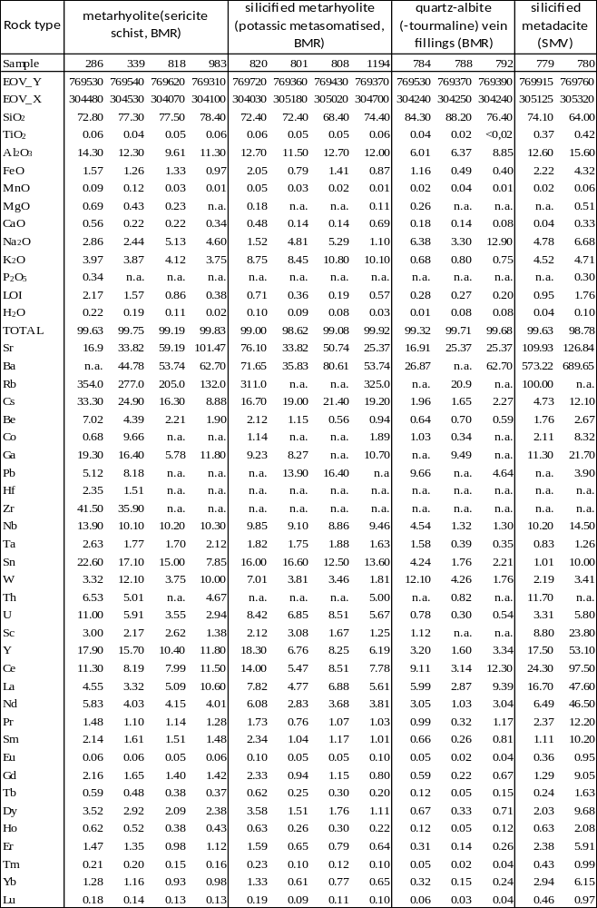
Table 5: Detailed results of the laser ablation U-Pb geochronology
