Taylor’s law (Taylor 1961, Brown et al. 2017) for the relation between variance and mean abundance.

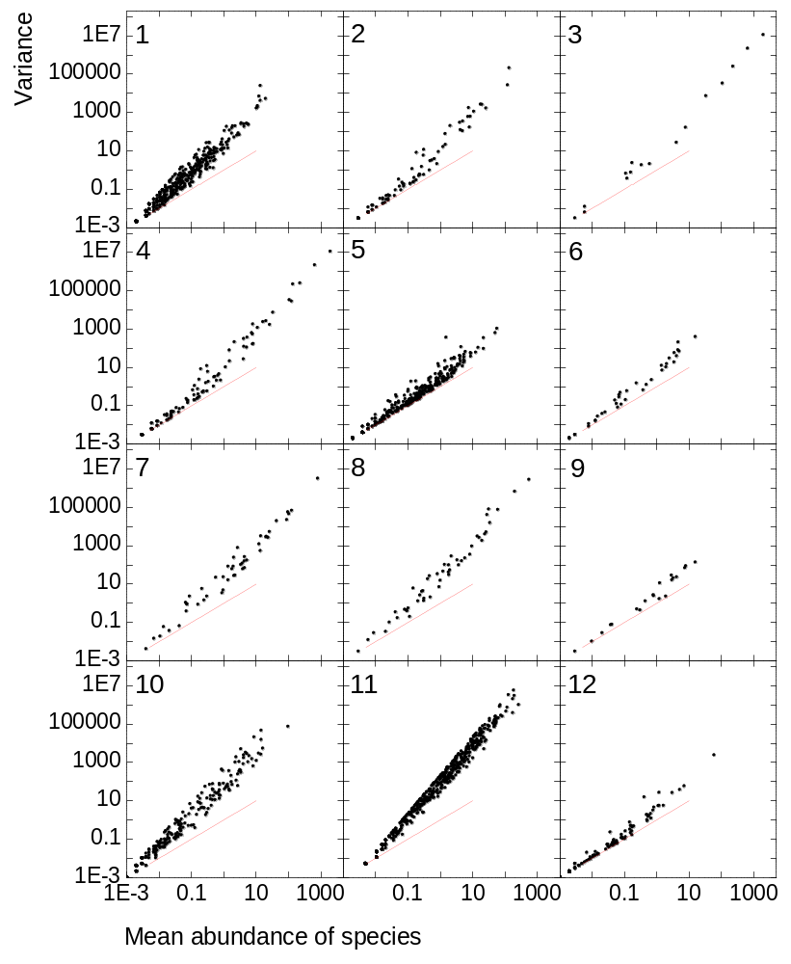

Figure 1. Abundances of species (zeros included), each species a dot. The red line represents equality of variance and mean. Above this line, data points represent overdispersed abundance values of species.
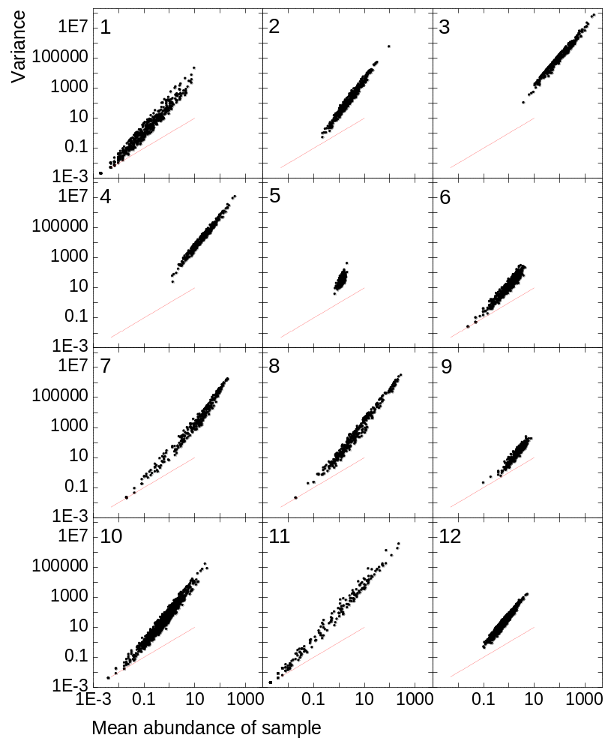

Figure 2. Abundances of samples (zeros included), each sample a dot. The red line represents equality of variance and mean. Above this line, data points represent overdispersed abundance values of samples.

