Supplementary Material

Code
Available at https://github.com/juliana-p/Pollination_network_reconstruction.

Table 1.
Environmental covariates used in Maxent Species Distribution Modeling of plant and pollinator species.
Category | Layers | Data type | Resolution / Scale | CRS (EPSG) | Source | Date of access
Topography | - Elevation  - Eastness | Raster | 1 km | 4326 | EarthEnv | 20 Sep 2019
Soil | - Soil 37 classes  - Derived soil 5 classes | Vector  Raster | 1:5.000.000  1 km | 4618  4326 | IBGE-EMBRAPA 2001  Reclassification of soil classes layer. | 20 Sep 2019
Climatic | - BIO5: temperature seasonality (SD)  - BIO14: precipitation of driest month | Raster | 0.5 degrees (~ 1km) | 4326 | WorldClim with the raster R package | 20 Sep 2019
Land cover | - Land cover 19 classes  - Derived density for selected classes: natural forest, planted forest, pasture, annual and perennial crop, semi-perennial crop, mosaic of agriculture and pasture, urban infrastructure  - Derived land cover heterogeneity | Raster  Raster  Raster | 30 m  1 km  1 km | 4326  4326  4326 | Mapbiomas 2018 with user-toolkit  Percentage cover  Shannon entropy index of land cover classes | 5 Dec 2019

Table 2.
Studied species, maxent SDM model performance and correlation of species distribution with natural forest (Spearman’s rho). Species with AUC < 0.7 were discarded. Out of 389 successful SDM species, 223 are positively correlated with forest (forest species) and were included in the forest-spp networks.
species | mode | AUC | rho | forest species
Adenostemma brasilianum | plant | 0.85732 | 0.69248 | yes
Aechmea ornata | plant | 0.80139 | 0.31504 | yes
Albizia polycephala | plant | 0.77779 | -0.26892 | no
Alchornea sidifolia | plant | 0.77385 | 0.52316 | yes
Anadenanthera colubrina | plant | 0.76709 | -0.44734 | no
Anemopaegma scabriusculum | plant | 0.94016 | -0.30940 | no
Annona monticola | plant | 0.84137 | -0.16885 | no
Anthurium affine | plant | 0.76552 | -0.29507 | no
Aristolochia gigantea | plant | 0.80977 | -0.27364 | no
Aspilia foliosa | plant | 0.93320 | -0.19680 | no
Aspidosperma olivaceum | plant | 0.72090 | 0.25951 | yes
Aspidosperma pyrifolium | plant | 0.84907 | -0.34950 | no
Austroeupatorium inulaefolium | plant | 0.71106 | 0.47481 | yes
Baccharis anomala | plant | 0.83243 | 0.46249 | yes
Baccharis articulata | plant | 0.87959 | 0.38370 | yes
Baccharis concinna | plant | 0.93323 | -0.10886 | no
Baccharis conyzoides | plant | 0.82988 | 0.26209 | yes
Baccharis crispa | plant | 0.80471 | 0.39800 | yes
Baccharis leucopappa | plant | 0.85564 | 0.38666 | yes
Baccharis megapotamica | plant | 0.93611 | 0.30159 | yes
Baccharis microdonta | plant | 0.84560 | 0.46777 | yes
Baccharis patens | plant | 0.82339 | 0.26512 | yes
Baccharis pentodonta | plant | 0.90453 | 0.28197 | yes
Baccharis retusa | plant | 0.80000 | 0.24422 | yes
Baccharis sagittalis | plant | 0.73929 | 0.53432 | yes
Bactris setosa | plant | 0.73994 | 0.37671 | yes
Baccharis singularis | plant | 0.74313 | 0.26816 | yes
Baccharis spicata | plant | 0.80299 | 0.27699 | yes
Banara guianensis | plant | 0.80629 | -0.09056 | no
Bathysa australis | plant | 0.75929 | 0.70472 | yes
Bixa orellana | plant | 0.71035 | -0.41092 | no
Blutaparon portulacoides | plant | 0.86194 | -0.08376 | no
Buchnera longifolia | plant | 0.84228 | n.s. | no
Byrsonima correifolia | plant | 0.92977 | -0.21843 | no
Byrsonima dealbata | plant | 0.81982 | -0.23386 | no
Byrsonima gardneriana | plant | 0.80323 | -0.37239 | no
Caesalpinia echinata | plant | 0.71704 | -0.15511 | no
Caladium bicolor | plant | 0.78934 | -0.12485 | no
Calliandra brevipes | plant | 0.70165 | 0.44358 | yes
Calea harleyi | plant | 0.87851 | -0.05176 | no
Calea pinnatifida | plant | 0.72837 | 0.43053 | yes
Calliandra tweedii | plant | 0.71713 | 0.15189 | yes
Campylocentrum aromaticum | plant | 0.76093 | 0.40335 | yes
Campomanesia aurea | plant | 0.82524 | 0.15059 | yes
Camptosema coriaceum | plant | 0.91277 | -0.15384 | no
Campomanesia dichotoma | plant | 0.84135 | -0.28104 | no
Campuloclinium macrocephalum | plant | 0.78259 | 0.29776 | yes
Campomanesia phaea | plant | 0.80224 | 0.27046 | yes
Camellia sinensis | plant | 0.77557 | 0.61598 | yes
Cambessedesia wurdackii | plant | 0.90879 | -0.00276 | no
Canavalia rosea | plant | 0.88121 | -0.12914 | no
Cardiospermum corindum | plant | 0.87497 | -0.33855 | no
Cassia fistula | plant | 0.78818 | -0.09777 | no
Cattleya elongata | plant | 0.92756 | -0.07616 | no
Centrolobium tomentosum | plant | 0.77003 | -0.15676 | no
Cestrum strigillatum | plant | 0.75293 | 0.01736 | yes, but isolated in forest-spp only networks
Chamaecrista calycioides | plant | 0.74854 | 0.18861 | yes
Chamaecrista desvauxii | plant | 0.73894 | -0.25211 | no
Chamaecrista rotundifolia | plant | 0.70151 | -0.39879 | no
Chamaecrista zygophylloides | plant | 0.83682 | -0.13347 | no
Chromolaena ascendens | plant | 0.78264 | 0.50982 | yes
Chromolaena congesta | plant | 0.87109 | 0.17675 | yes
Chrysolaena flexuosa | plant | 0.89860 | 0.28989 | yes
Chromolaena hirsuta | plant | 0.88251 | 0.41729 | yes
Cirrhaea dependens | plant | 0.82905 | 0.18572 | yes
Coccoloba brasiliensis | plant | 0.88564 | -0.08002 | no
Coccocypselum erythrocephalum | plant | 0.92599 | 0.00266 | yes
Cocos nucifera | plant | 0.77516 | -0.24149 | no
Cochlospermum vitifolium | plant | 0.80773 | -0.35856 | no
Coffea arabica | plant | 0.73119 | -0.03327 | no
Collaea cipoensis | plant | 0.97374 | -0.1549 | no
Collaea stenophylla | plant | 0.80686 | 0.27012 | yes
Condea fastigiata | plant | 0.72908 | 0.34177 | yes
Croton blanchetianus | plant | 0.93988 | -0.39192 | no
Croton campestris | plant | 0.89408 | -0.26980 | no
Crocosmia crocosmiiflora | plant | 0.77648 | 0.39145 | yes
Croton glutinosus | plant | 0.91573 | -0.08715 | no
Croton gnaphalii | plant | 0.97771 | 0.06815 | yes
Cucurbita pepo | plant | 0.72252 | -0.06588 | no
Cuphea ericoides | plant | 0.87612 | -0.19785 | no
Cuphea flava | plant | 0.81667 | -0.31329 | no
Cuphea glutinosa | plant | 0.91507 | 0.25684 | yes
Cyclopogon apricus | plant | 0.87219 | 0.25203 | yes
Cypella amplimaculata | plant | 0.88352 | 0.04982 | yes
Daphnopsis schwackeana | plant | 0.87212 | 0.30708 | yes
Declieuxia deltoidea | plant | 0.98015 | -0.37617 | no
Delonix regia | plant | 0.79031 | 0.03354 | yes
Desmodium uncinatum | plant | 0.77533 | 0.69778 | yes
Diplusodon orbicularis | plant | 0.98319 | -0.1435 | no
Diplusodon parvifolius | plant | 0.96570 | -0.37648 | no
Diplusodon ulei | plant | 0.94503 | -0.23702 | no
Disynaphia ligulifolia | plant | 0.87007 | 0.28347 | yes
Duranta erecta | plant | 0.75165 | 0.15810 | yes
Eichhornia crassipes | plant | 0.77802 | -0.59863 | no
Epistephium sclerophyllum | plant | 0.78046 | -0.17661 | no
Eremanthus capitatus | plant | 0.83456 | -0.03478 | no
Eriope salviifolia | plant | 0.89543 | -0.10896 | no
Erythrina crista-galli | plant | 0.72838 | 0.10149 | yes
Eryngium elegans | plant | 0.81384 | 0.23303 | yes
Eryngium eriophorum | plant | 0.94075 | 0.00383 | yes
Eryngium horridum | plant | 0.72755 | 0.33207 | yes
Eryngium sanguisorba | plant | 0.74961 | 0.22670 | yes
Euphorbia milii | plant | 0.85601 | -0.65750 | no
Evolvulus glomeratus | plant | 0.80006 | -0.27981 | no
Faramea montevidensis | plant | 0.77199 | 0.37995 | yes
Ficus cestrifolia | plant | 0.75916 | 0.54994 | yes, but isolated in forest-spp only networks
Ficus crocata | plant | 0.72044 | -0.35764 | no
Ficus obtusiuscula | plant | 0.73198 | -0.47245 | no
Forsteronia glabrescens | plant | 0.77180 | -0.05663 | no
Fridericia dispar | plant | 0.86894 | -0.40768 | no
Galianthe fastigiata | plant | 0.96901 | 0.41316 | yes
Galianthe valerianoides | plant | 0.75494 | 0.55848 | yes
Genipa americana | plant | 0.75449 | -0.49638 | no
Glechon ciliata | plant | 0.74493 | -0.09383 | no
Glechon marifolia | plant | 0.95904 | 0.29288 | yes
Gliricidia sepium | plant | 0.80613 | -0.22467 | no
Gomphrena demissa | plant | 0.70322 | -0.25232 | no
Grazielia intermedia | plant | 0.81772 | 0.48800 | yes
Guatteria australis | plant | 0.70397 | 0.59693 | yes
Guazuma ulmifolia | plant | 0.76086 | -0.51866 | no
Habenaria macronectar | plant | 0.91135 | 0.38111 | yes
Habenaria montevidensis | plant | 0.98486 | 0.37532 | yes
Handroanthus albus | plant | 0.77123 | 0.21691 | yes
Heimia salicifolia | plant | 0.84850 | 0.28494 | yes
Heliconia psittacorum | plant | 0.73252 | -0.15593 | no
Hennecartia omphalandra | plant | 0.83989 | 0.35946 | yes
Hillia parasitica | plant | 0.80760 | 0.27568 | yes
Hippeastrum morelianum | plant | 0.94559 | -0.13049 | no
Hippeastrum psittacinum | plant | 0.75704 | 0.44892 | yes
Hippeastrum stylosum | plant | 0.80191 | -0.22747 | no
Hippocratea volubilis | plant | 0.78725 | -0.25804 | no
Houlletia brocklehurstiana | plant | 0.84885 | 0.42667 | yes
Hovenia dulcis | plant | 0.74754 | 0.35383 | yes
Hymenaea courbaril | plant | 0.78544 | -0.33815 | no
Hypericum brasiliense | plant | 0.81112 | 0.34090 | yes
Hyptis lacustris | plant | 0.92386 | 0.12390 | yes
Hyptis lappulacea | plant | 0.72358 | 0.61226 | yes
Hypolytrum schraderianum | plant | 0.83937 | 0.36921 | yes
Ilex pseudobuxus | plant | 0.70022 | 0.37880 | yes
Impatiens walleriana | plant | 0.75261 | 0.42947 | yes
Inga marginata | plant | 0.77074 | 0.16748 | yes
Inga sessilis | plant | 0.72047 | 0.72066 | yes
Ipomoea asarifolia | plant | 0.87329 | -0.45407 | no
Ipomoea bahiensis | plant | 0.77495 | -0.33173 | no
Ipomoea carnea | plant | 0.77973 | -0.44497 | no
Ipomoea grandifolia | plant | 0.82414 | 0.01005 | yes
Ipomoea pes-caprae | plant | 0.84233 | 0.11131 | yes
Ipomoea purpurea | plant | 0.76642 | 0.34259 | yes
Jacquemontia nodiflora | plant | 0.85979 | -0.23576 | no
Jacaranda puberula | plant | 0.72185 | 0.50530 | yes
Kielmeyera albopunctata | plant | 0.73103 | 0.14206 | yes
Lagerstroemia indica | plant | 0.82810 | 0.04253 | yes
Laportea aestuans | plant | 0.74748 | -0.21370 | no
Leandra australis | plant | 0.76018 | 0.58383 | yes
Leandra hirtella | plant | 0.86923 | 0.62599 | yes
Leandra lacunosa | plant | 0.79771 | 0.21617 | yes
Leandra reversa | plant | 0.87191 | 0.13254 | yes
Leonurus japonicus | plant | 0.70205 | 0.26975 | yes
Lessingianthus hypochaeris | plant | 0.84301 | 0.01745 | yes
Licania dealbata | plant | 0.96144 | -0.15493 | no
Ludwigia multinervia | plant | 0.89030 | 0.18090 | yes
Ludwigia peruviana | plant | 0.75096 | 0.54101 | yes
Luxemburgia schwackeana | plant | 0.98156 | -0.18641 | no
Lychnophora salicifolia | plant | 0.92624 | -0.36479 | no
Macroptilium prostratum | plant | 0.83799 | 0.07366 | yes
Mandevilla funiformis | plant | 0.77495 | 0.23302 | yes
Mandevilla hirsuta | plant | 0.72147 | -0.19249 | no
Mangifera indica | plant | 0.73861 | -0.50472 | no
Marcgravia polyantha | plant | 0.83100 | 0.56063 | yes
Miconia cabucu | plant | 0.85727 | 0.55135 | yes
Miconia cinerascens | plant | 0.78378 | 0.56925 | yes
Miconia cinnamomifolia | plant | 0.70851 | 0.40973 | yes
Mikania involucrata | plant | 0.87482 | 0.44926 | yes
Mikania lundiana | plant | 0.70288 | 0.27612 | yes
Mikania neurocaula | plant | 0.98665 | -0.15085 | no
Mikania trinervis | plant | 0.71022 | 0.53326 | yes
Mimosa arenosa | plant | 0.82171 | -0.22327 | no
Mimosa aurivillus | plant | 0.93179 | -0.10575 | no
Mimosa caesalpiniifolia | plant | 0.82933 | -0.29385 | no
Mimosa pudica | plant | 0.71381 | -0.28007 | no
Mimosa tenuiflora | plant | 0.79328 | -0.34454 | no
Mollinedia elegans | plant | 0.78459 | 0.46246 | yes
Momordica charantia | plant | 0.74928 | -0.61809 | no
Moquiniastrum cordatum | plant | 0.97206 | 0.06916 | yes
Muntingia calabura | plant | 0.79260 | 0.01213 | yes
Myracrodruon urundeuva | plant | 0.87251 | -0.39878 | no
Neea schwackeana | plant | 0.80929 | 0.41677 | yes
Neomitranthes cordifolia | plant | 0.87922 | 0.02599 | yes
Norantea guianensis | plant | 0.76857 | -0.25275 | no
Nymphoides indica | plant | 0.75813 | -0.53326 | no
Ocimum gratissimum | plant | 0.73219 | -0.07099 | no
Ocotea lancifolia | plant | 0.72373 | -0.03595 | no
Opuntia monacantha | plant | 0.73537 | -0.13840 | no
Oreopanax capitatus | plant | 0.80214 | 0.36432 | yes
Ossaea amygdaloides | plant | 0.73113 | 0.59596 | yes
Ouratea cuspidata | plant | 0.71377 | -0.19220 | no
Ouratea hexasperma | plant | 0.75940 | -0.04072 | no
Ouratea parviflora | plant | 0.81108 | 0.64960 | yes
Palicourea guianensis | plant | 0.74073 | 0.28554 | yes
Palicourea marcgravii | plant | 0.71352 | -0.03081 | no
Palicourea rigida | plant | 0.85067 | -0.04868 | no
Paliavana tenuiflora | plant | 0.74526 | 0.01688 | yes
Parthenium hysterophorus | plant | 0.84824 | -0.47339 | no
Passiflora cincinnata | plant | 0.80348 | -0.40305 | no
Passiflora morifolia | plant | 0.70672 | 0.20886 | yes
Paullinia elegans | plant | 0.72318 | -0.50173 | no
Pavonia cancellata | plant | 0.74984 | -0.37083 | no
Pavonia friesii | plant | 0.81306 | 0.25820 | yes
Pavonia sepium | plant | 0.74938 | 0.35720 | yes
Paypayrola blanchetiana | plant | 0.84494 | 0.03483 | yes
Pelexia oestrifera | plant | 0.77876 | -0.18851 | no
Pfaffia tuberosa | plant | 0.86464 | 0.19305 | yes
Piper arboreum | plant | 0.72459 | 0.09433 | yes
Piptocarpha quadrangularis | plant | 0.80375 | 0.13237 | yes
Piptadenia stipulacea | plant | 0.81656 | -0.19697 | no
Piptadenia viridiflora | plant | 0.90678 | -0.30809 | no
Pleroma mutabile | plant | 0.79475 | 0.25808 | yes
Pleroma trichopodum | plant | 0.78101 | 0.38013 | yes
Pogonophora schomburgkiana | plant | 0.72255 | -0.07458 | no
Portulaca oleracea | plant | 0.78110 | -0.77252 | no
Protium aracouchini | plant | 0.70675 | 0.09430 | yes
Prosopis juliflora | plant | 0.93220 | -0.31601 | no
Pseudobrickellia brasiliensis | plant | 0.92492 | -0.27840 | no
Pseudostifftia kingii | plant | 0.95027 | -0.58521 | no
Psychotria brachyceras | plant | 0.90508 | 0.19776 | yes
Psychotria schlechtendaliana | plant | 0.93178 | 0.22325 | yes
Psychotria suterella | plant | 0.75166 | 0.64064 | yes
Randia armata | plant | 0.69996 | -0.54301 | no
Raphanus sativus | plant | 0.77512 | -0.06934 | no
Rauvolfia grandiflora | plant | 0.70837 | 0.14063 | yes
Remijia ferruginea | plant | 0.92444 | -0.07809 | no
Rhododendron simsii | plant | 0.78595 | 0.09579 | yes
Rhynchosia corylifolia | plant | 0.90333 | 0.29269 | yes
Ricinus communis | plant | 0.72093 | -0.01688 | no
Richardia grandiflora | plant | 0.72305 | -0.38636 | no
Rubus rosifolius | plant | 0.76686 | 0.72749 | yes
Rudgea jasminoides | plant | 0.75384 | 0.49408 | yes
Ruellia affinis | plant | 0.80660 | 0.18314 | yes
Sabicea villosa | plant | 0.77405 | 0.40697 | yes
Sagittaria montevidensis | plant | 0.74940 | 0.26864 | yes
Sarcoglottis fasciculata | plant | 0.71931 | 0.13636 | yes
Schlechtendalia luzulifolia | plant | 0.75530 | 0.28521 | yes
Schlumbergera truncata | plant | 0.83379 | 0.34806 | yes
Sclerolobium aureum | plant | 0.95294 | -0.25673 | no
Senecio brasiliensis | plant | 0.76658 | 0.45565 | yes
Senna cana | plant | 0.90949 | -0.1794 | no
Senna corymbosa | plant | 0.84953 | 0.02899 | yes
Senecio crassiflorus | plant | 0.92120 | -0.13625 | no
Senna georgica | plant | 0.75926 | -0.10466 | no
Senna uniflora | plant | 0.89750 | -0.20557 | no
Serjania lethalis | plant | 0.77465 | -0.14978 | no
Sisyrinchium palmifolium | plant | 0.80491 | 0.36149 | yes
Sisyrinchium vaginatum | plant | 0.77949 | 0.21760 | yes
Solidago chilensis | plant | 0.75309 | 0.39524 | yes
Solanum concinnum | plant | 0.71720 | 0.09079 | yes
Solanum guaraniticum | plant | 0.76449 | 0.45007 | yes
Solanum mauritianum | plant | 0.70509 | 0.30610 | yes
Solanum paludosum | plant | 0.85042 | -0.30721 | no
Solanum piluliferum | plant | 0.74911 | 0.64464 | yes
Solanum rufescens | plant | 0.70306 | 0.36412 | yes
Spondias mombin | plant | 0.87604 | -0.13966 | no
Stachytarpheta maximiliani | plant | 0.77314 | 0.03743 | yes
Stenocephalum megapotamicum | plant | 0.81929 | 0.16836 | yes
Stigmaphyllon paralias | plant | 0.75844 | -0.16850 | no
Stryphnodendron pulcherrimum | plant | 0.81941 | -0.15305 | no
Styrax camporum | plant | 0.74435 | -0.19626 | no
Stylosanthes montevidensis | plant | 0.75929 | -0.21141 | no
Syagrus coronata | plant | 0.77873 | -0.39047 | no
Symphyopappus reticulatus | plant | 0.87367 | -0.13030 | no
Syzygium cumini | plant | 0.76619 | -0.44050 | no
Tecoma ype | plant | 0.93806 | -0.12721 | no
Temnadenia odorifera | plant | 0.78171 | -0.21800 | no
Tetrapterys microphylla | plant | 0.96450 | -0.10326 | no
Tibouchina barnebyana | plant | 0.93381 | -0.01248 | no
Tibouchina cerastifolia | plant | 0.85200 | 0.62601 | yes
Tibouchina clavata | plant | 0.72896 | 0.30705 | yes
Tibouchina regnellii | plant | 0.87477 | 0.27917 | yes
Tibouchina urvilleana | plant | 0.90430 | 0.55090 | yes
Tipuana tipu | plant | 0.86403 | 0.38534 | yes
Tocoyena bullata | plant | 0.80314 | -0.28002 | no
Tripodanthus acutifolius | plant | 0.71268 | 0.14757 | yes
Trixis praestans | plant | 0.79125 | 0.37117 | yes
Tropaeolum majus | plant | 0.83172 | 0.20185 | yes
Turnera subulata | plant | 0.83957 | -0.42338 | no
Vernonanthura beyrichii | plant | 0.74099 | 0.25294 | yes
Verbena bonariensis | plant | 0.77399 | 0.39670 | yes
Vernonanthura discolor | plant | 0.76797 | 0.72433 | yes
Verbena litoralis | plant | 0.71221 | 0.41464 | yes
Vernonanthura nudiflora | plant | 0.83294 | 0.13043 | yes
Vernonanthura puberula | plant | 0.84033 | 0.64454 | yes
Vernonanthura tweediana | plant | 0.73834 | 0.34263 | yes
Vitex triflora | plant | 0.90901 | -0.12143 | no
Vriesea gigantea | plant | 0.80960 | 0.47646 | yes
Vriesea hoehneana | plant | 0.88188 | 0.18567 | yes
Vriesea philippocoburgii | plant | 0.79765 | 0.41983 | yes
Vriesea vagans | plant | 0.83194 | 0.61815 | yes
Waltheria indica | plant | 0.71933 | -0.41773 | no
Agraulis vanillae | insect pollinator | 0.72259 | -0.27653 | no
Anidarnes dissidens | insect pollinator | 0.81163 | -0.32422 | no
Ascia monuste | insect pollinator | 0.80314 | -0.30828 | no
Atta sexdens | insect pollinator | 0.84054 | -0.08607 | no
Augochloropsis brachycephala | insect pollinator | 0.99271 | 0.07943 | yes
Augochlora cephalica | insect pollinator | 0.99220 | 0.06553 | yes
Augochlorella ephyra | insect pollinator | 0.97667 | 0.46926 | yes
Augochloropsis patens | insect pollinator | 0.99271 | 0.07932 | yes
Battus polydamas | insect pollinator | 0.93187 | 0.19068 | yes
Bombus brasiliensis | insect pollinator | 0.84491 | 0.47514 | yes
Bombus brevivillus | insect pollinator | 0.78455 | -0.08989 | no
Bombus pauloensis | insect pollinator | 0.91603 | 0.30396 | yes
Brachygastra lecheguana | insect pollinator | 0.71290 | 0.34950 | yes
Callimormus corades | insect pollinator | 0.99297 | 0.08428 | yes
Camponotus crassus | insect pollinator | 0.93112 | 0.05447 | yes
Camponotus rufipes | insect pollinator | 0.78610 | 0.47056 | yes
Centris analis | insect pollinator | 0.75910 | -0.15344 | no
Centris flavifrons | insect pollinator | 0.71805 | -0.29831 | no
Centris fuscata | insect pollinator | 0.85188 | -0.45745 | no
Centris varia | insect pollinator | 0.77988 | -0.66903 | no
Cephalotes atratus | insect pollinator | 0.77644 | -0.17055 | no
Cephalotes pusillus | insect pollinator | 0.87280 | -0.17041 | no
Cycloneda sanguinea | insect pollinator | 0.90838 | 0.26059 | yes
Diabrotica speciosa | insect pollinator | 0.82469 | -0.06836 | no
Drosophila bromelioides | insect pollinator | 0.81516 | 0.44855 | yes
Epicharis analis | insect pollinator | 0.70576 | 0.02852 | yes
Euglossa annectans | insect pollinator | 0.85906 | 0.14865 | yes
Euglossa cordata | insect pollinator | 0.85543 | 0.27680 | yes
Euglossa fimbriata | insect pollinator | 0.71153 | -0.18494 | no
Euglossa pleosticta | insect pollinator | 0.75032 | 0.08047 | yes
Eulaema nigrita | insect pollinator | 0.76774 | -0.2979 | no
Exaerete smaragdina | insect pollinator | 0.82447 | 0.09985 | yes
Exomalopsis analis | insect pollinator | 0.99566 | 0.00349 | yes
Exomalopsis auropilosa | insect pollinator | 0.96760 | -0.27562 | no
Geotrigona subterranea | insect pollinator | 0.92428 | -0.06214 | no
Gnamptogenys striatula | insect pollinator | 0.79941 | 0.23239 | yes
Heliopetes arsalte | insect pollinator | 0.79685 | 0.00809 | yes
Heteroponera dolo | insect pollinator | 0.72794 | 0.12526 | yes
Hylomyrma balzani | insect pollinator | 0.92184 | -0.09449 | no
Hypoponera foreli | insect pollinator | 0.91310 | -0.05346 | no
Idarnes brevicollis | insect pollinator | 0.71433 | -0.21510 | no
Idarnes carme | insect pollinator | 0.74934 | -0.34640 | no
Idarnes dimorphicus | insect pollinator | 0.87475 | -0.26865 | no
Idarnes maximus | insect pollinator | 0.73941 | -0.25065 | no
Idarnes punctatus | insect pollinator | 0.84106 | -0.25438 | no
Lachnomyrmex plaumanni | insect pollinator | 0.94409 | 0.78858 | yes
Lachnomyrmex victori | insect pollinator | 0.86412 | 0.56433 | yes
Linepithema iniquum | insect pollinator | 0.98928 | -0.01735 | no
Linepithema neotropicum | insect pollinator | 0.81834 | -0.12455 | no
Mechanitis lysimnia | insect pollinator | 0.72276 | 0.14657 | yes
Megachile susurrans | insect pollinator | 0.81808 | 0.11803 | yes
Melipona mondury | insect pollinator | 0.81798 | 0.09714 | yes
Melipona quadrifasciata | insect pollinator | 0.71797 | 0.22771 | yes
Melipona rufiventris | insect pollinator | 0.86867 | 0.30997 | yes
Melitoma segmentaria | insect pollinator | 0.92058 | -0.18392 | no
Mischocyttarus drewseni | insect pollinator | 0.99559 | 0.21734 | yes
Mischocyttarus rotundicollis | insect pollinator | 0.92058 | 0.12047 | yes
Myrmelachista catharinae | insect pollinator | 0.78538 | -0.05236 | no
Oxaea flavescens | insect pollinator | 0.90538 | -0.37693 | no
Palpada conica | insect pollinator | 0.98849 | -0.08938 | no
Paratetrapedia fervida | insect pollinator | 0.82119 | 0.08017 | yes
Partamona helleri | insect pollinator | 0.73772 | 0.12518 | yes
Paratrigona subnuda | insect pollinator | 0.77169 | 0.42119 | yes
Pegoscapus aerumnosus | insect pollinator | 0.91761 | -0.19060 | no
Phoebis argante | insect pollinator | 0.78953 | 0.36623 | yes
Plebeia emerina | insect pollinator | 0.95423 | 0.21821 | yes
Plebeia remota | insect pollinator | 0.74103 | 0.52236 | yes
Polybia ignobilis | insect pollinator | 0.73384 | 0.26479 | yes
Polybia sericea | insect pollinator | 0.82129 | -0.09453 | no
Protambulyx strigilis | insect pollinator | 0.70645 | 0.36470 | yes
Pseudodorus clavatus | insect pollinator | 0.82096 | 0.32442 | yes
Ptilothrix tricolor | insect pollinator | 0.99471 | -0.00701 | no
Salpingogaster nigra | insect pollinator | 0.99128 | 0.05880 | yes
Scaptotrigona xanthotricha | insect pollinator | 0.99127 | 0.05424 | yes
Schwarziana quadripunctata | insect pollinator | 0.71250 | 0.42710 | yes
Tegosa claudina | insect pollinator | 0.71911 | 0.16479 | yes
Thygater analis | insect pollinator | 0.77471 | 0.16495 | yes
Toxomerus basalis | insect pollinator | 0.99433 | 0.06937 | yes
Toxomerus norma | insect pollinator | 0.99201 | 0.08326 | yes
Toxomerus pictus | insect pollinator | 0.99271 | 0.07883 | yes
Toxomerus productus | insect pollinator | 0.99307 | 0.08139 | yes
Toxomerus steatogaster | insect pollinator | 0.99307 | 0.08191 | yes
Toxomerus virgulatus | insect pollinator | 0.98892 | 0.01093 | yes
Trigona braueri | insect pollinator | 0.94909 | 0.37908 | yes
Trina geometrina | insect pollinator | 0.78558 | 0.43088 | yes
Urbanus simplicius | insect pollinator | 0.79949 | -0.06998 | no
Urbanus teleus | insect pollinator | 0.82502 | 0.35825 | yes
Vanessa braziliensis | insect pollinator | 0.78495 | 0.47514 | yes
Vanessa myrinna | insect pollinator | 0.72604 | -0.00269 | no
Xylocopa brasilianorum | insect pollinator | 0.95362 | 0.10404 | yes
Xylocopa ciliata | insect pollinator | 0.99663 | 0.17876 | yes
Xylocopa suspecta | insect pollinator | 0.74791 | 0.27223 | yes

Table 3.
Minimum and maximum values of the studied network properties for all-spp and forest-spp networks, with sites of 25km N-S length.
 | all-spp |  | forest-spp
network properties | min | max | min | max
N_{pl} | 273 | 297 | 159 | 163
N_{po} | 66 | 92 | 42 | 58
L | 3995 | 5648 | 1803 | 2587
S | 1.33211 | 42.17379 | 0.22008 | 38.57559
HS_{pl} | 2.40993 | 4.1966 | 1.55808 | 3.74466
HS_{po} | 1.47311 | 3.69256 | 1.06112 | 3.40528
C | 0.00712 | 0.02115 | 0.00814 | 0.03464
Centr | 0.75128 | 0.79556 | 0.66419 | 0.73824
A | -0.11582 | 0.03233 | -0.08182 | 0.01404
M | 0.31453 | 0.80177 | 0.31584 | 0.7904
Nb_{mod} | 6 | 29 | 5 | 22
Nest | 0.09774 | 2.90643 | 0.02969 | 2.77831

Table 4.
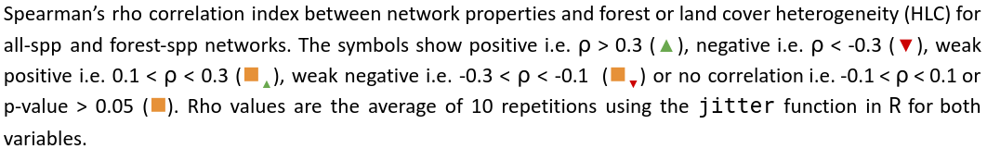
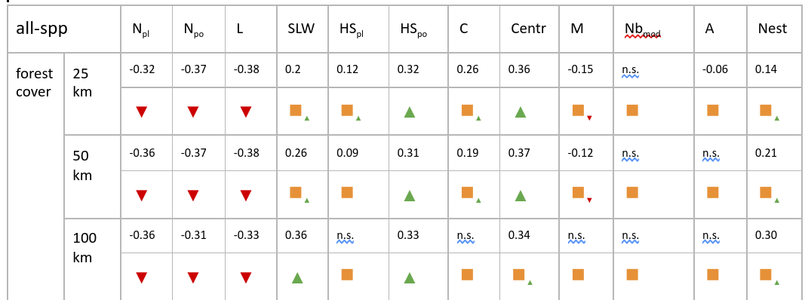
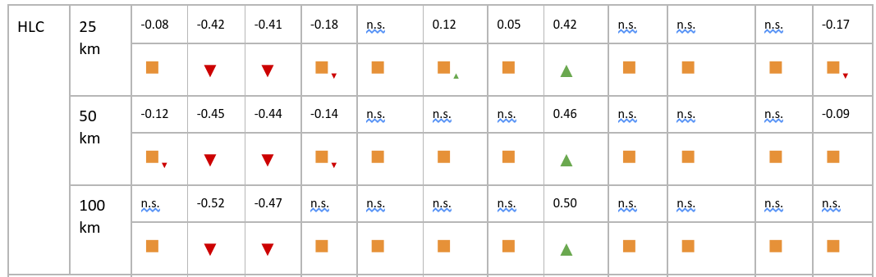
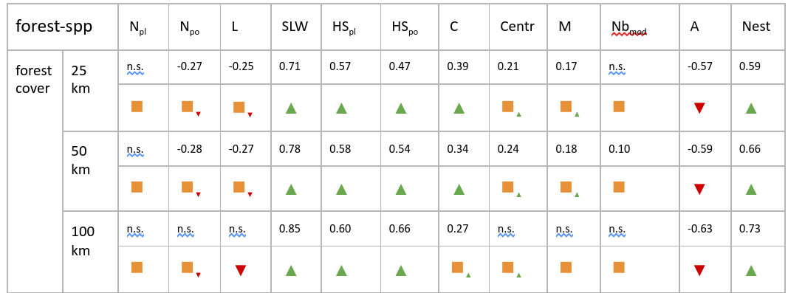
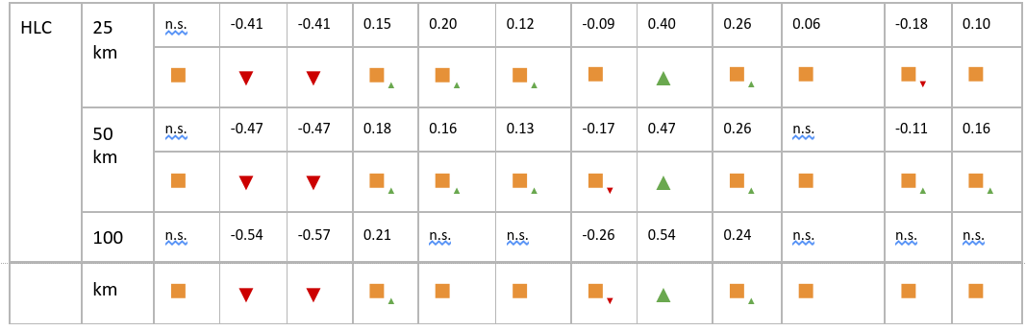

Figure 1.
Blockmodels of networks. Example of blockmodel for a hypothetical network where white flowers usually are visited by moths, and never by butterflies, pink flowers are visited by both butterflies and bees, and yellow and blue flowers are visited only by bees. The species are partitioned into six groups, and we visualize the block model as a block matrix, where each entry b_{ij} corresponds to the probability of a link between a node of group i and a node of group j. Darker colors indicate higher probability.

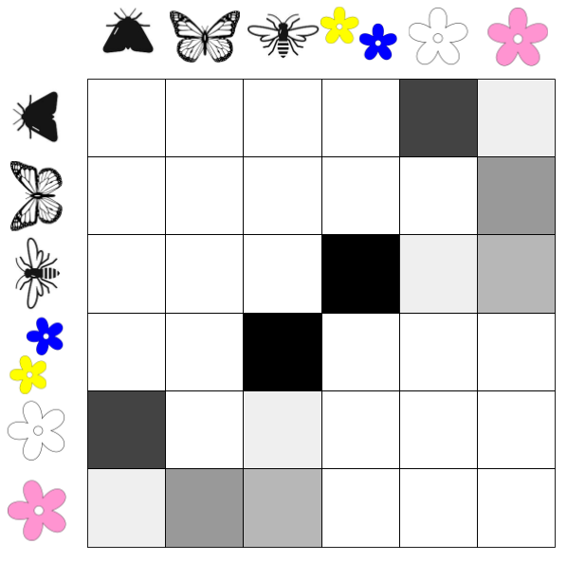

Figure 2.
Network properties and habitat variables. Each plot shows the corresponding Spearman’s rank correlation (SLW stands for sum of link weights, S).

All-spp networks: Network properties ~ forest cover (25 km scale)

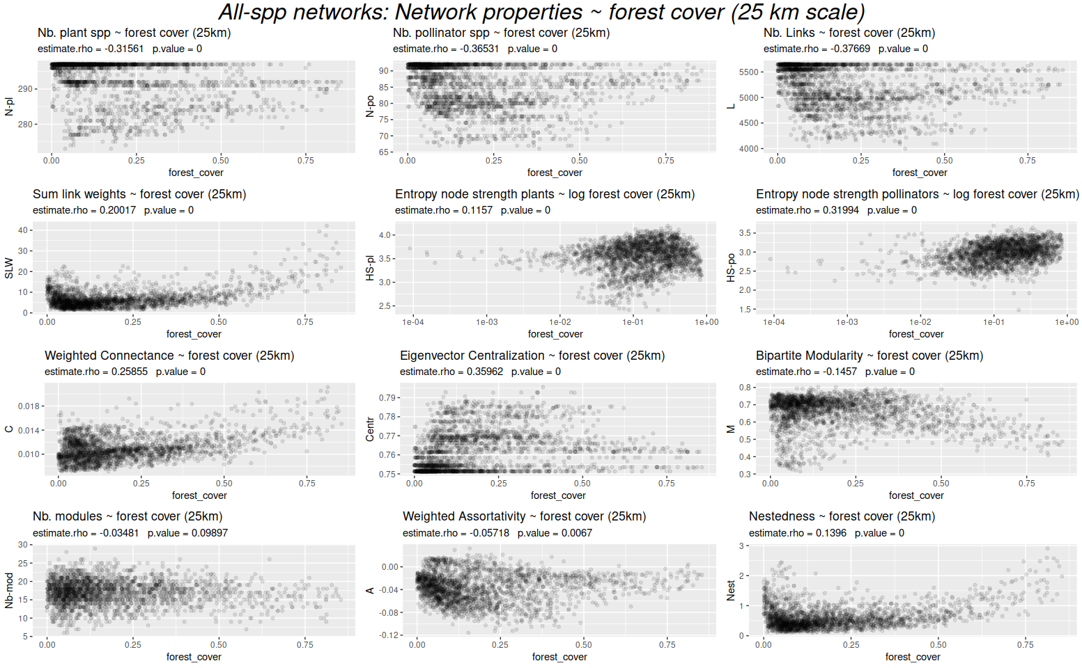

All-spp networks: Network properties ~ land cover heterogeneity (25 km scale)

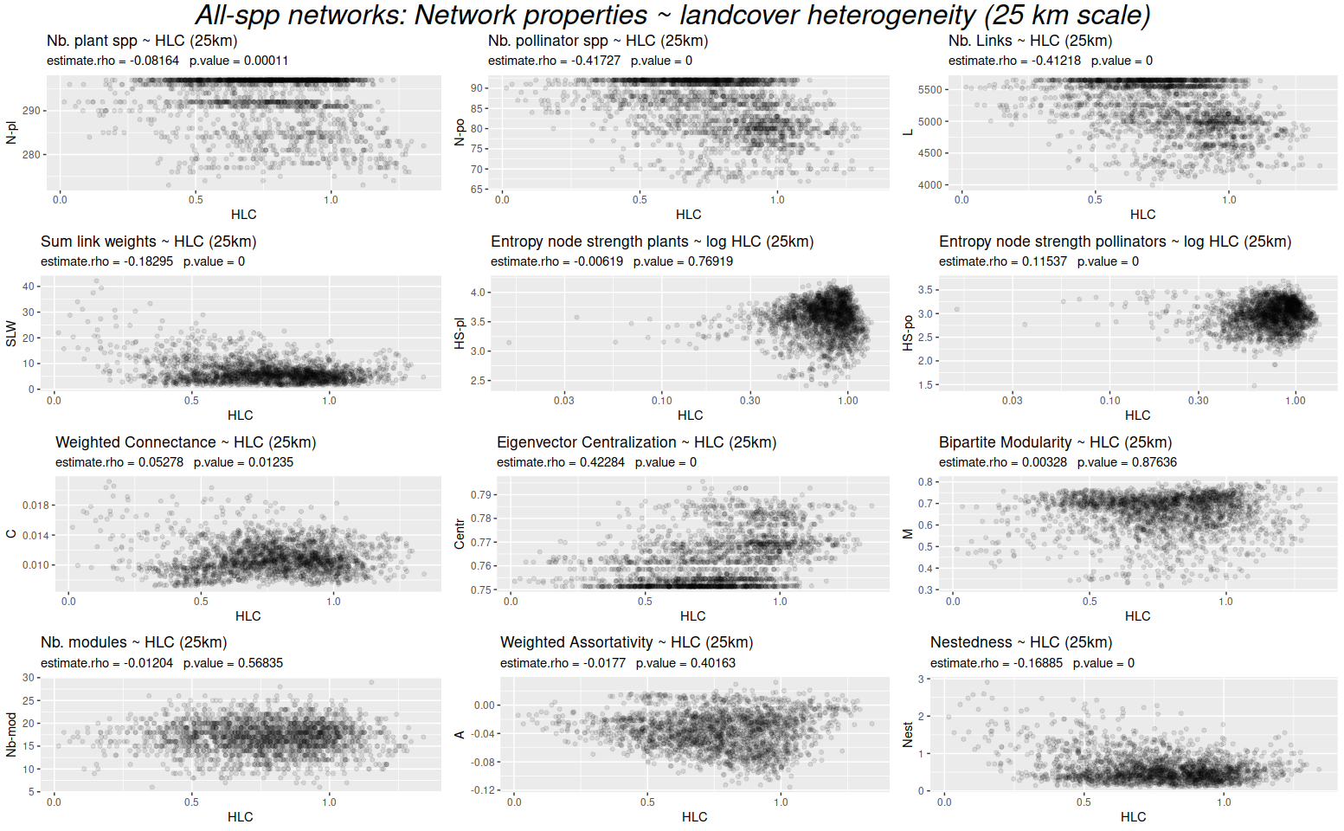

All-spp networks: Network properties ~ forest cover (50 km scale)

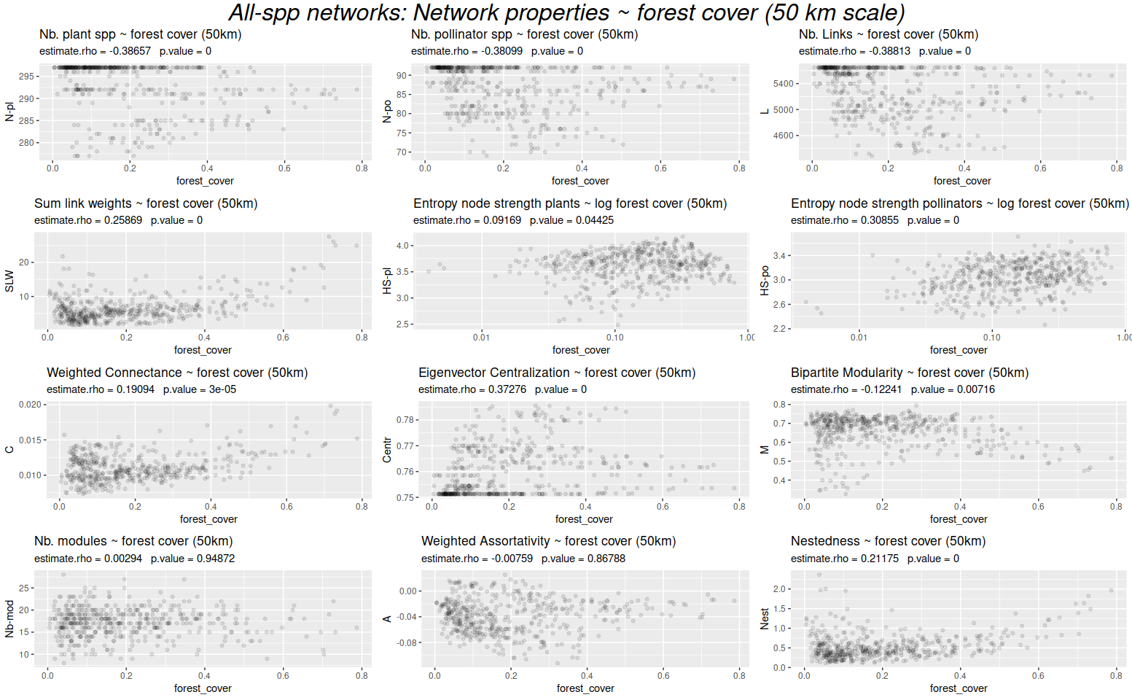

All-spp networks: Network properties ~ land cover heterogeneity (50 km scale)

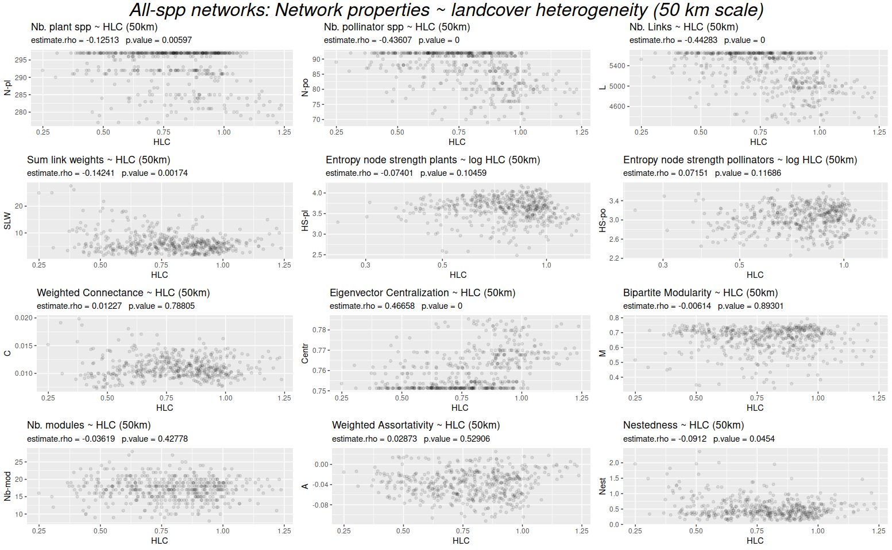

All-spp networks: Network properties ~ forest cover (100 km scale)

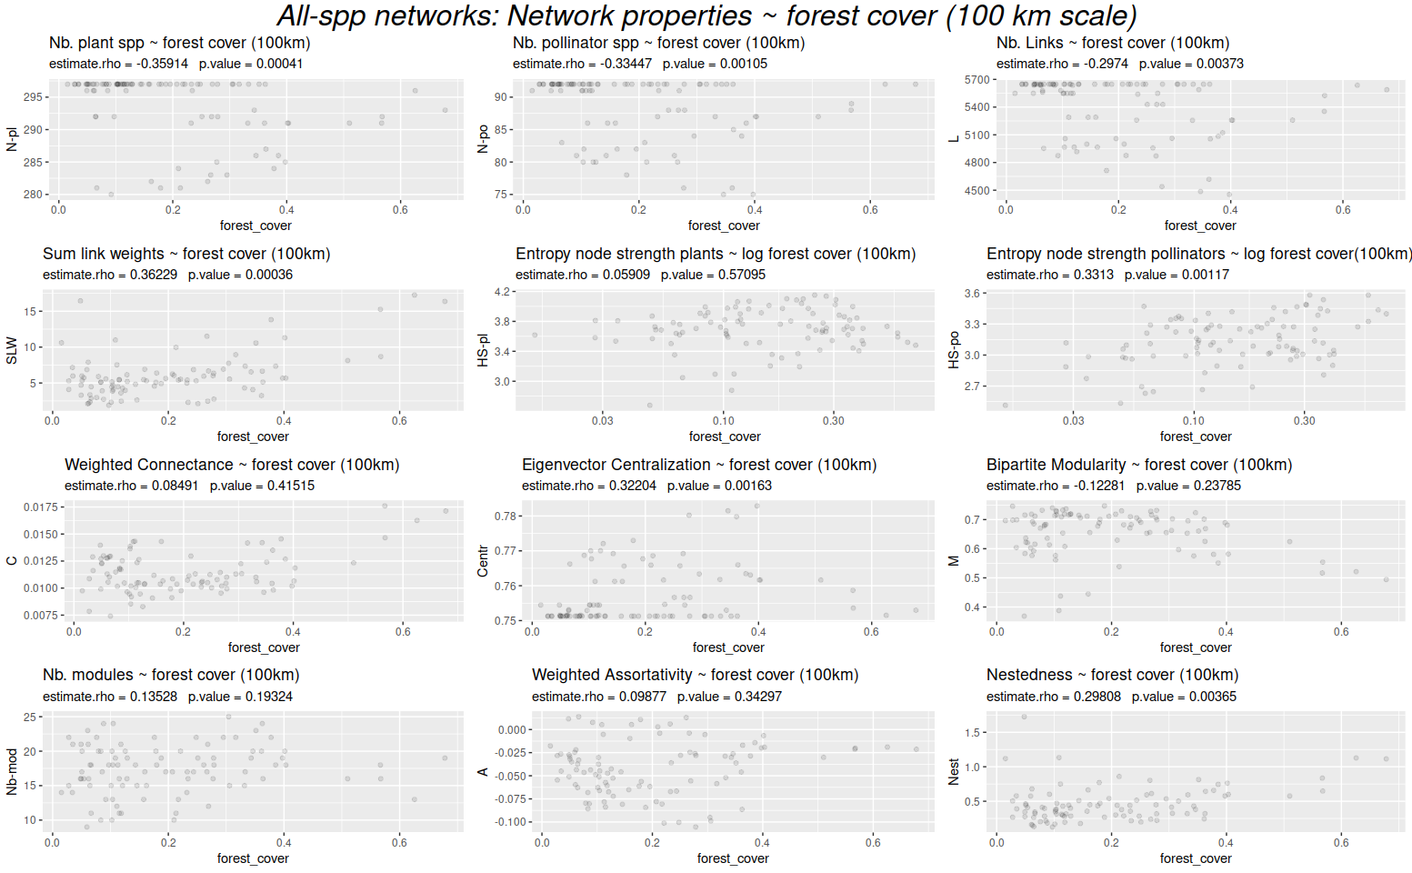

All-spp networks: Network properties ~ land cover heterogeneity (100 km scale)

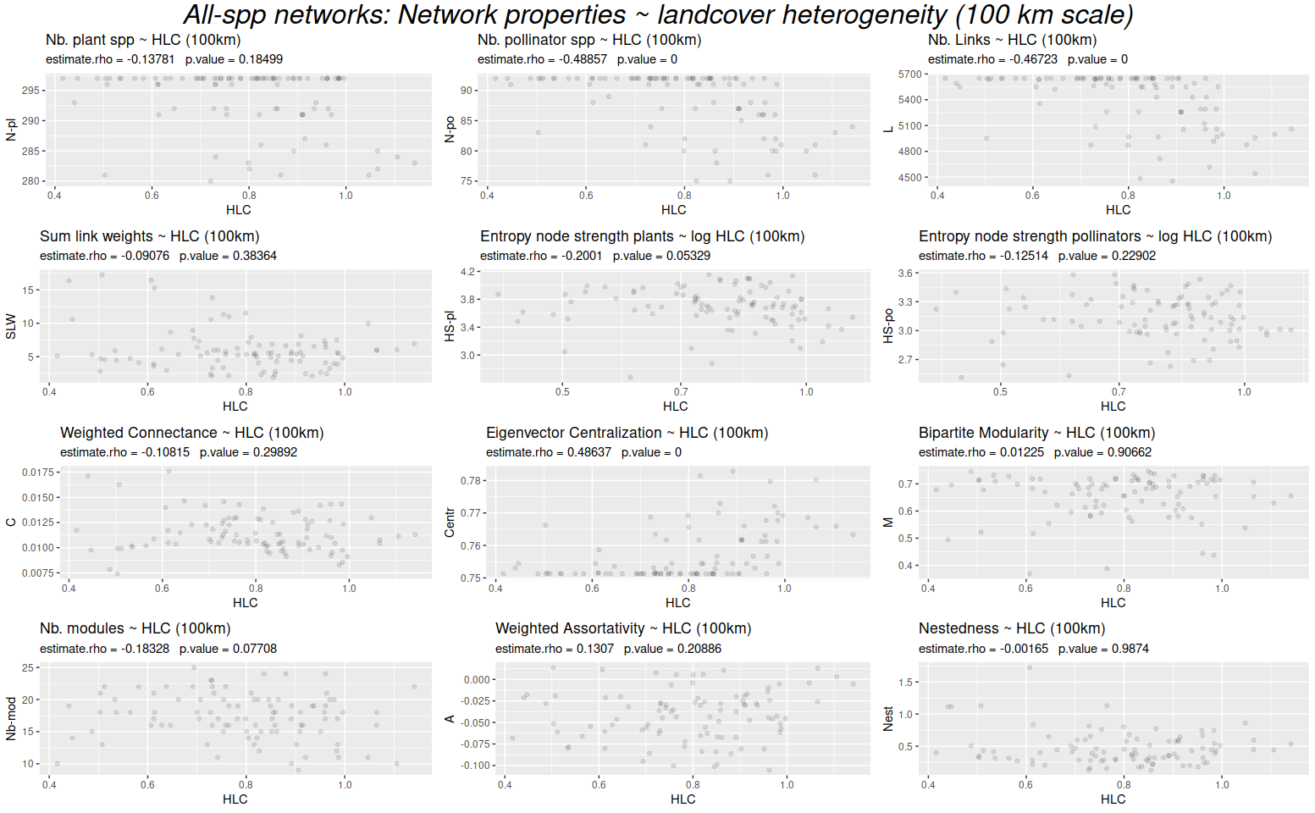

Forest-spp networks: Network properties ~ forest cover (25 km scale)

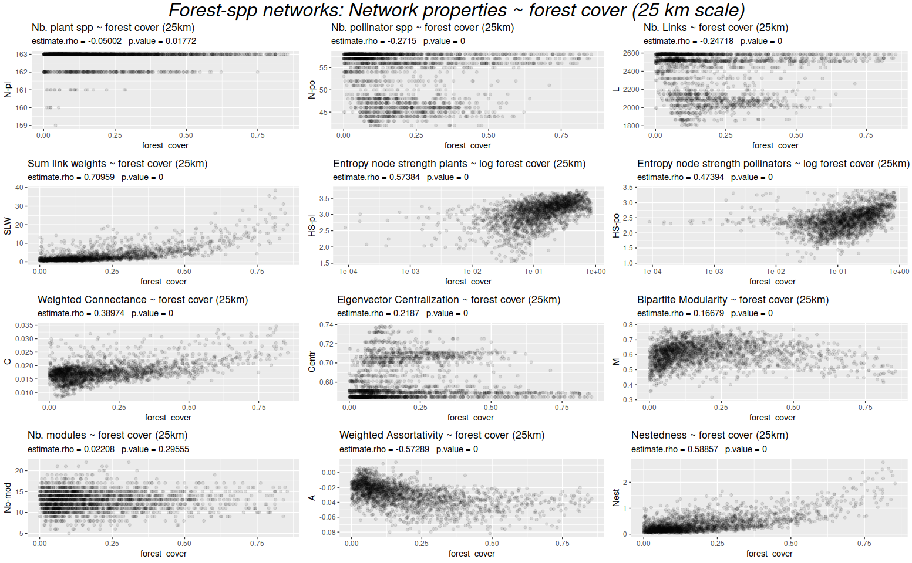

Forest-spp networks: Network properties ~ land cover heterogeneity (25 km scale)

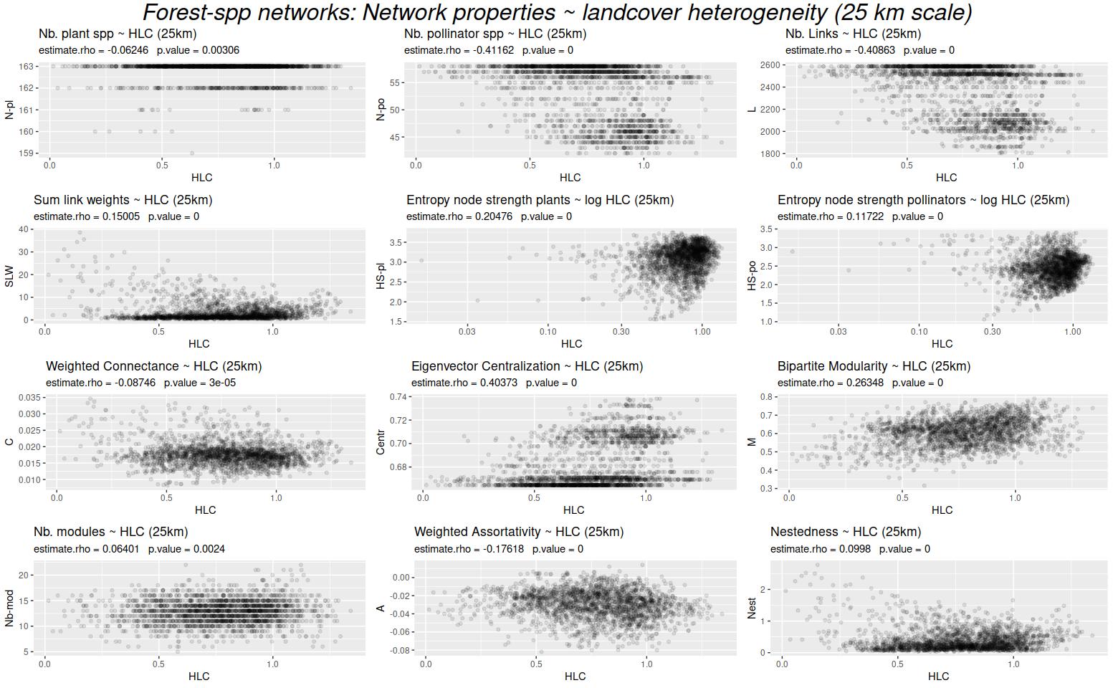

Forest-spp networks: Network properties ~ forest cover (50 km scale)

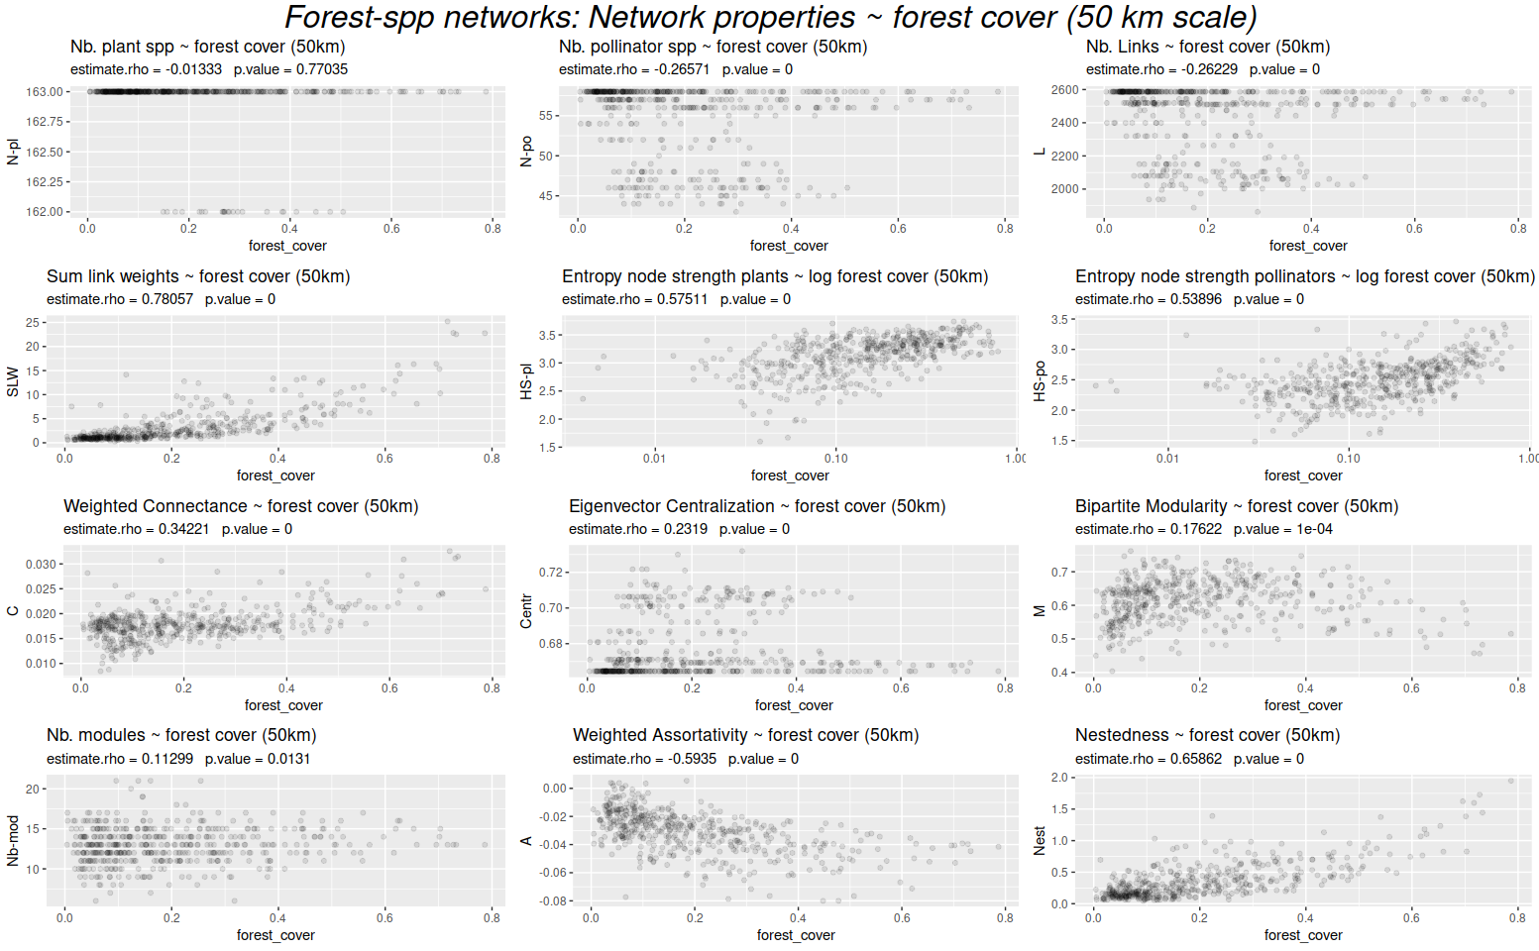

Forest-spp networks: Network properties ~ land cover heterogeneity (50 km scale)

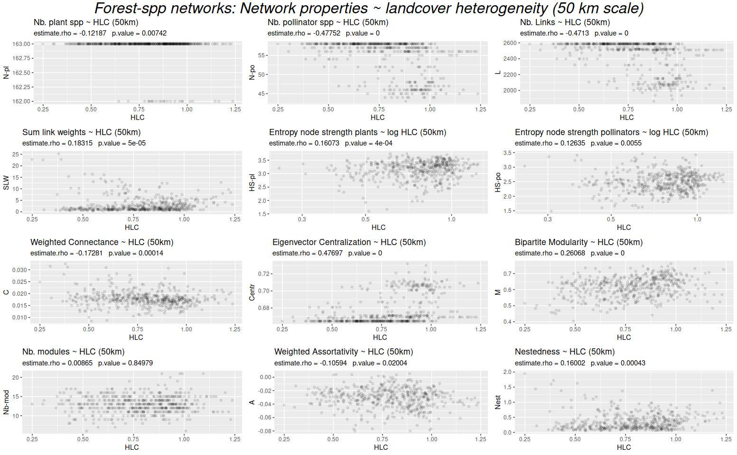

Forest-spp networks: Network properties ~ forest cover (100 km scale)

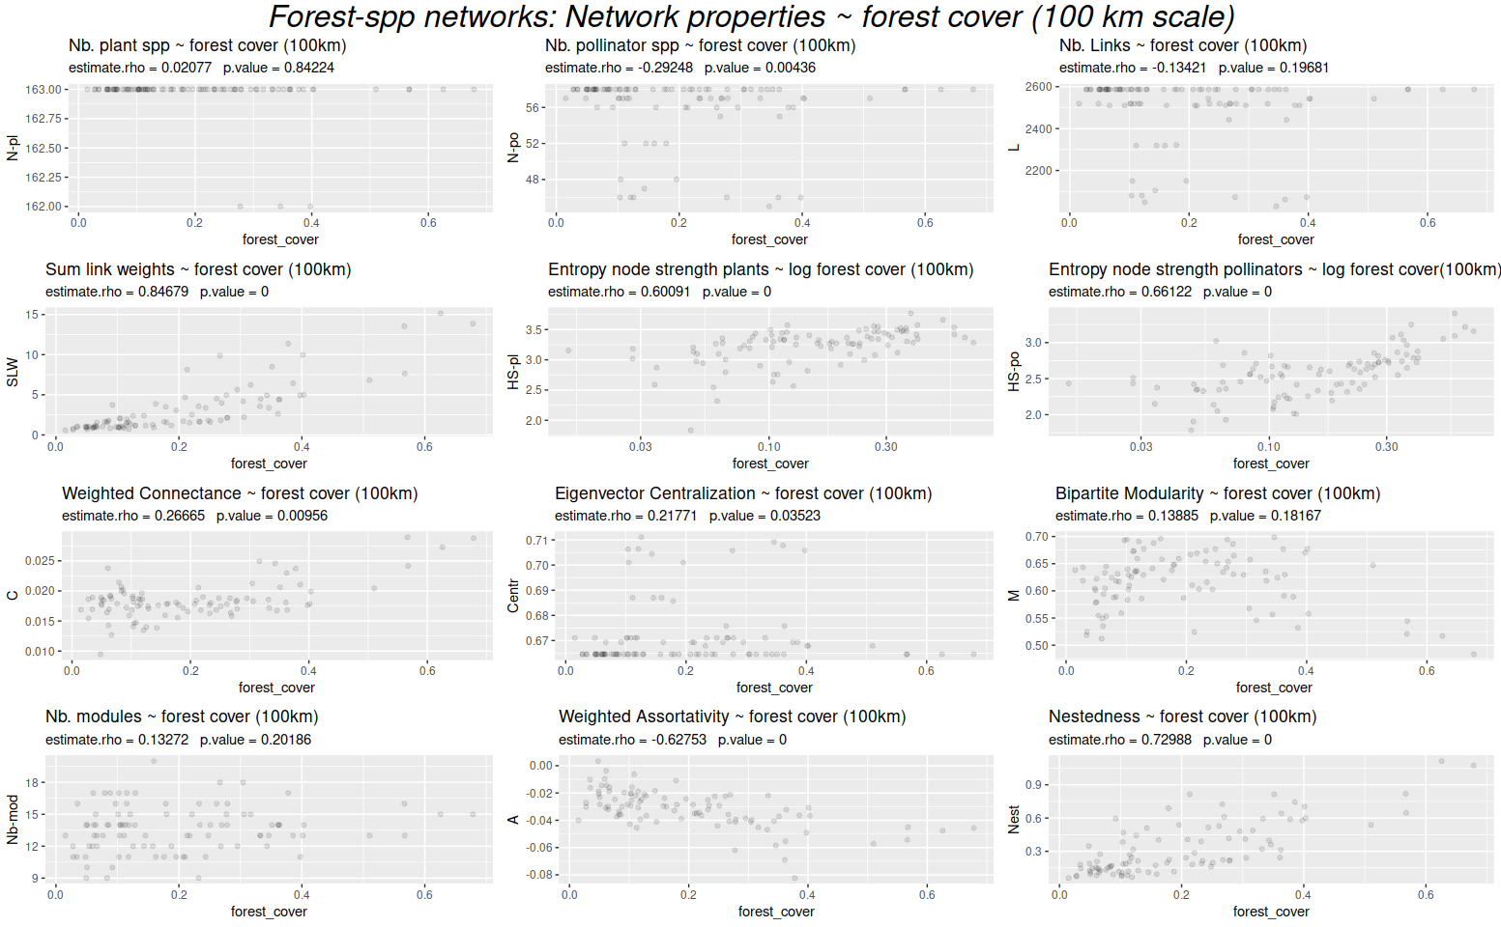

Forest-spp networks: Network properties ~ land cover heterogeneity (100 km scale)

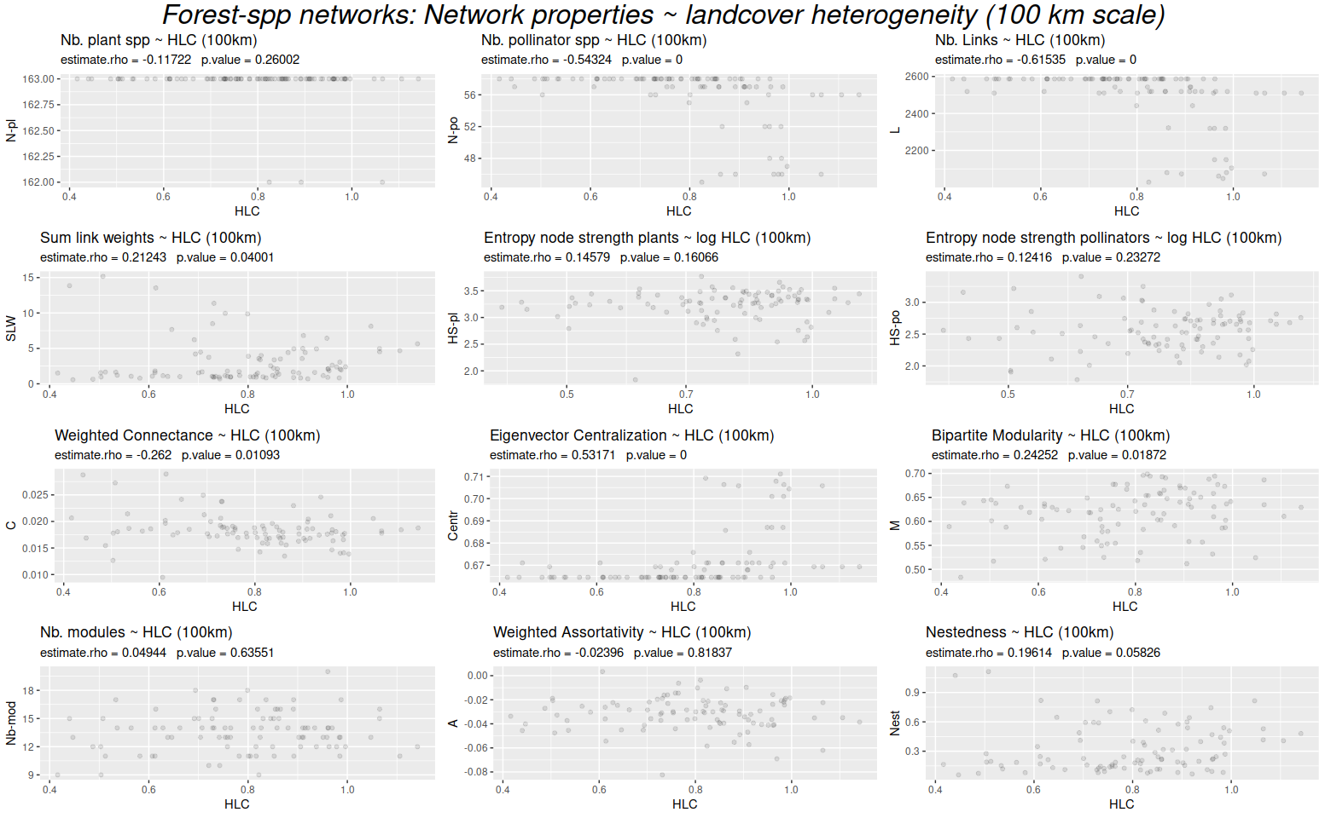

Figure 3.
Three dimensional plot showing forest cover, number of links (L) and sum of link weights (S) for the forest-spp networks in the 25 km scale. Networks of high forest cover sites are always relatively large, both in L and N (not shown) and have higher S, while those sites with little forest show a wide range of network sizes (L), but their total strength S is always low. We see that only high forest sites have networks with higher S, while L is independent of forest cover.

