Supplementary materials
Examining the reliability of the scores of self-report instruments assessing problematic exercise: A systematic review and meta-analysis

- Supplementary material A: PRISMA 2009 Checklist
- Supplementary material B: Search Strategy
- Supplementary material C: Google scholar citations for PE measures
- Supplementary material D: Meta-Analysis Coding Sheet
- Supplementary material E: Sensitivity analysis by PE
- Supplementary material F: Publication bias analyses by PE
- Supplementary material G: Forest plots by PE
- Supplementary material H: Studies included in meta-analysis and systematic review

Supplementary material A: PRISMA 2009 Checklist
Section/topic | # | Checklist item | Reported on page #
TITLE
Title | 1 | Identify the report as a systematic review, meta-analysis, or both. | 1
ABSTRACT
Structured summary | 2 | Provide a structured summary including, as applicable: background; objectives; data sources; study eligibility criteria, participants, and interventions; study appraisal and synthesis methods; results; limitations; conclusions and implications of key findings; systematic review registration number. | 1
INTRODUCTION
Rationale | 3 | Describe the rationale for the review in the context of what is already known. | 1-4
Objectives | 4 | Provide an explicit statement of questions being addressed with reference to participants, interventions, comparisons, outcomes, and study design (PICOS). | 4-5
METHODS
Protocol and registration | 5 | Indicate if a review protocol exists, if and where it can be accessed (e.g., Web address), and, if available, provide registration information including registration number. | 5
Eligibility criteria | 6 | Specify study characteristics (e.g., PICOS, length of follow-up) and report characteristics (e.g., years considered, language, publication status) used as criteria for eligibility, giving rationale. | 6
Information sources | 7 | Describe all information sources (e.g., databases with dates of coverage, contact with study authors to identify additional studies) in the search and date last searched. | 5
Search | 8 | Present full electronic search strategy for at least one database, including any limits used, such that it could be repeated. | 5
Study selection | 9 | State the process for selecting studies (i.e., screening, eligibility, included in systematic review, and, if applicable, included in the meta-analysis). | 5-6; Figure1

Data collection process | 10 | Describe method of data extraction from reports (e.g., piloted forms, independently, in duplicate) and any processes for obtaining and confirming data from investigators. | 5-6
Data items | 11 | List and define all variables for which data were sought (e.g., PICOS, funding sources) and any assumptions and simplifications made. | 8
Risk of bias in individual studies | 12 | Describe methods used for assessing risk of bias of individual studies (including specification of whether this was done at the study or outcome level), and how this information is to be used in any data synthesis. | NA
Summary measures | 13 | State the principal summary measures (e.g., risk ratio, difference in means). | 6-8
Synthesis of results | 14 | Describe the methods of handling data and combining results of studies, if done, including measures of consistency (e.g., I²) for each meta-analysis. | 6-8
Risk of bias across studies | 15 | Specify any assessment of risk of bias that may affect the cumulative evidence (e.g., publication bias, selective reporting within studies). | 6-8
Additional analyses | 16 | Describe methods of additional analyses (e.g., sensitivity or subgroup analyses, meta-regression), if done, indicating which were pre-specified. | 6-8 (Supplementary material C;  Supplementary material D)
RESULTS
Study selection | 17 | Give numbers of studies screened, assessed for eligibility, and included in the review, with reasons for exclusions at each stage, ideally with a flow diagram. | 8; Figure 1
Study characteristics | 18 | For each study, present characteristics for which data were extracted (e.g., study size, PICOS, follow-up period) and provide the citations. | 8; Tables 2-11
Risk of bias within studies | 19 | Present data on risk of bias of each study and, if available, any outcome level assessment (see item 12). | NA
Results of individual studies | 20 | For all outcomes considered (benefits or harms), present, for each study: (a) simple summary data for each intervention group (b) effect estimates and confidence intervals, ideally with a forest plot. | Supplementary material E
Synthesis of results | 21 | Present results of each meta-analysis done, including confidence intervals and measures of consistency. | 8-15; Table 1
Risk of bias across studies | 22 | Present results of any assessment of risk of bias across studies (see Item 15). | Supplementary material D
Additional analysis | 23 | Give results of additional analyses, if done (e.g., sensitivity or subgroup analyses, meta-regression [see Item 16]). | 8-15; Tables 2-11;  Supplementary material C
DISCUSSION

Summary of evidence | 24 | Summarize the main findings including the strength of evidence for each main outcome; consider their relevance to key groups (e.g., healthcare providers, users, and policy makers). | 15-24
Limitations | 25 | Discuss limitations at study and outcome level (e.g., risk of bias), and at review-level (e.g., incomplete retrieval of identified research, reporting bias). | 24-25
Conclusions | 26 | Provide a general interpretation of the results in the context of other evidence, and implications for future research. | 25-27
FUNDING
Funding | 27 | Describe sources of funding for the systematic review and other support (e.g., supply of data); role of funders for the systematic review. | Title page

Supplementary material B. Search Strategy
 | WOS Core Collection  (n = 1197) |  | ScieLO  (n = 46) |  | Medline  (n = 862) |  | Current Contents Connect  (n = 675) |  | PsycINFO  (n = 802) |  | Dissertations & Theses Global  (n = 267)
1.  2.  3.  4.  5.  6.  7.  8.  9.  10.  11.  12.  13.  14.  15.  16. | Problematic exercise /  Morbid exercise /  Exercise addiction /  Exercise Addiction Inventory /  Exercise dependence /  Exercise Dependence Scale /  Compulsive exercise /  Compulsive Exercise Test /  Compulsive physical activity /  Obligatory exercise /  Obligatory Exercise Questionnaire /  Commitment to exercise /  Commitment to Exercise Scale /  Excessive exercise /  1 OR 2 OR 3 OR 4 OR 5 OR 6 OR  7 OR 8 OR 9 OR 10 OR 11 OR 12  OR 13 OR 14  Limit 14 to English language | 1.  2.  3.  4.  5.  6.  7.  8.  9.  10.  11.  12.  13.  14.  1.  1. | Problematic exercise /  Morbid exercise /  Exercise addiction /  Exercise Addiction Inventory /  Exercise dependence /  Exercise Dependence Scale /  Compulsive exercise /  Compulsive Exercise Test /  Compulsive physical activity /  Obligatory exercise /  Obligatory Exercise Questionnaire /  Commitment to exercise /  Commitment to Exercise Scale /  Excessive exercise /  1 OR 2 OR 3 OR 4 OR 5 OR 6 OR  7 OR 8 OR 9 OR 10 OR 11 OR 12  OR 13 OR 14  Limit 14 to English language | 1.  2.  3.  4.  5.  6.  7.  8.  9.  10.  11.  12.  13.  14.  15.  16. | Problematic exercise /  Morbid exercise /  Exercise addiction /  Exercise Addiction Inventory /  Exercise dependence /  Exercise Dependence Scale /  Compulsive exercise /  Compulsive Exercise Test /  Compulsive physical activity /  Obligatory exercise /  Obligatory Exercise Questionnaire /  Commitment to exercise /  Commitment to Exercise Scale /  Excessive exercise /  1 OR 2 OR 3 OR 4 OR 5 OR 6 OR  7 OR 8 OR 9 OR 10 OR 11 OR 12  OR 13 OR 14  Limit 14 to English language | 1.  2.  3.  4.  5.  6.  7.  8.  9.  10.  11.  12.  13.  14.  15.  16. | Problematic exercise /  Morbid exercise /  Exercise addiction /  Exercise Addiction Inventory /  Exercise dependence /  Exercise Dependence Scale /  Compulsive exercise /  Compulsive Exercise Test /  Compulsive physical activity /  Obligatory exercise /  Obligatory Exercise Questionnaire /  Commitment to exercise /  Commitment to Exercise Scale /  Excessive exercise /  1 OR 2 OR 3 OR 4 OR 5 OR 6 OR  7 OR 8 OR 9 OR 10 OR 11 OR 12  OR 13 OR 14  Limit 14 to English language | 1.  2.  3.  4.  5.  6.  7.  8.  9.  10.  11.  12.  13.  14.  15.  16. | Problematic exercise /  Morbid exercise /  Exercise addiction /  Exercise Addiction Inventory /  Exercise dependence /  Exercise Dependence Scale /  Compulsive exercise /  Compulsive Exercise Test /  Compulsive physical activity /  Obligatory exercise /  Obligatory Exercise Questionnaire /  Commitment to exercise /  Commitment to Exercise Scale /  Excessive exercise /  1 OR 2 OR 3 OR 4 OR 5 OR 6 OR  7 OR 8 OR 9 OR 10 OR 11 OR 12  OR 13 OR 14  Limit 14 to English language and  Spanish language | 1.  2.  3.  4.  5.  6.  7.  8.  9.  10.  11.  12.  13.  14.  15.  16. | Problematic exercise /  Morbid exercise /  Exercise addiction /  Exercise Addiction Inventory /  Exercise dependence /  Exercise Dependence Scale /  Compulsive exercise /  Compulsive Exercise Test /  Compulsive physical activity /  Obligatory exercise /  Obligatory Exercise Questionnaire /  Commitment to exercise /  Commitment to Exercise Scale /  Excessive exercise /  1 OR 2 OR 3 OR 4 OR 5 OR 6 OR  7 OR 8 OR 9 OR 10 OR 11 OR 12  OR 13 OR 14  Limit 14 to English language and  Spanish language, Title, Abstract,  Keywords

Supplementary material C. Google scholar citations for PE measures
Measure | Abbreviation | Google Scholar citations (2021)
Commitment to Exercise Scale | CES | 279
Commitment to Physical Activity questionnaire | CPA | 8
Commitment to Physical Activity Scale -Revised | CPA-R | 1
Compulsive Exercise Test | CET | 370
Excessive Exercise Scale | EES | 28
Exercise Addiction Inventory | EAI | 894
Exercise Addiction Inventory-Revised | EAI-R | 3
Exercise Beliefs Questionnaire | EBQ | 134
Exercise Dependence Questionnaire | EDQ | 381
Exercise Dependence Scale | EDS | 1050
Exercise Dependence Scale-Revised | EDS-R | 435
Exercise Salience Scale | ESS | 25
Obligatory Exercise Questionnaire | OEQ | 442
Obligatory Exercise Questionnaire-Revised | OEQ-R | 3
Problematic Practice of Physical Exercise Scale | PPPE | 5
Note. Instruments included in the review are bold-highlighted.

Supplementary material D: Meta-Analysis Coding Sheet

Citation and year of publication
Insert citation and year of study

Sample size
N used to compute α

Exercise modality
- Unknown (e.g., undergraduate)
- Unclear (e.g., gym users)
- Power disciplines
- Non-endurance
- Multiple sports
- Fitness & health
- Endurance

Eating disorders
- Unknown
- At-risk
- Not at-risk
- Mixed
- Clinical

Report of Leisure Time Exercise (Report of LTE)
- Yes
- No

Regular exercisers
- Unknown
- Yes (i.e., exercise at least once a week)

Region
- Unknown
- South America
- Oceania
- North America
- Mixed
- Europe
- Asia

Test version
- Original
- Linguistically adapted

Study design
- Psychometric
- Applied

Type of survey
- Unknown
- Paper-pencil
- On-line
- Both

Publication status
- Published
- Unpublished

Problematic Exercise measure
- Commitment Exercise Scale (CES-Likert)
- Commitment Exercise Scale (CES- VAS)
- Compulsive Exercise Test (CET)
  - Avoidance subscale of Compulsive Exercise Test
  - Weight control subscale of Compulsive Exercise Test
  - Mood improvement subscale of Compulsive Exercise Test
  - Lack of enjoyment subscale of Compulsive Exercise Test
  - Rigidity subscale of Compulsive Exercise Test
- Exercise Addiction Inventory (EAI)
- Exercise Dependence Questionnaire (EDQ)
  - Interference subscale of Exercise Dependence Questionnaire
  - Positive reward subscale of Exercise Dependence Questionnaire
  - Withdrawal subscale of Exercise Dependence Questionnaire
  - Weight control subscale of Exercise Dependence Questionnaire
  - Insight into problem subscale of Exercise Dependence Questionnaire
  - Social reasons subscale of Exercise Dependence Questionnaire
  - Health reasons subscale of Exercise Dependence Questionnaire
  - Stereotyped behaviour subscale of Exercise Dependence Questionnaire
- Exercise Dependence Scale-21 (EDS-21)
  - Tolerance subscale of Exercise Dependence Scale-21
  - Withdrawal of Exercise Dependence Scale-21
  - Intention effects of Exercise Dependence Scale-21
  - Lack of control of Exercise Dependence Scale-21
  - Time of Exercise Dependence Scale-21
  - Reduction in other activities of Exercise Dependence Scale-21
  - Continuance of Exercise Dependence Scale-21
- Obligatory Exercise Questionnaire (OEQ)

Mean PE
Insert mean total scores of Problematic Exercise measure

Standard deviation PE
Insert mean SD of Problematic Exercise measure

Mean age
Insert mean age

Standard deviation age
Insert SD age

Percentage of whites
Insert % of whites

Percentage of females
Insert % of females

Supplementary material E: Sensitivity analysis by PE
Results from the sensitivity analyses (i.e., by conducting systematic reanalysis while removing studies one at a time) showed that the pooled estimates resulting from the 27 meta-analyses conducted were not significantly modified when specific data were removed one at a time therefore suggesting the robustness of the results.
CES-Likert
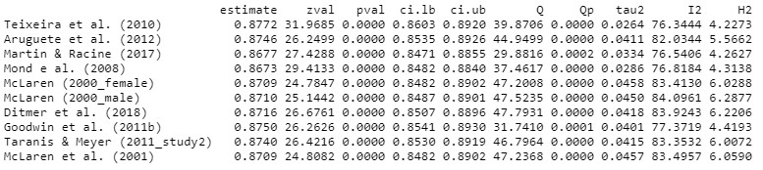
CES-VAS
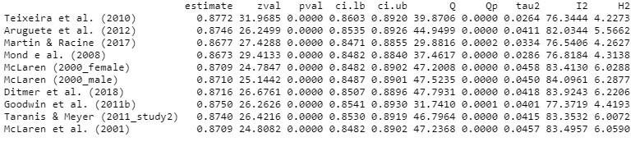
CET global score
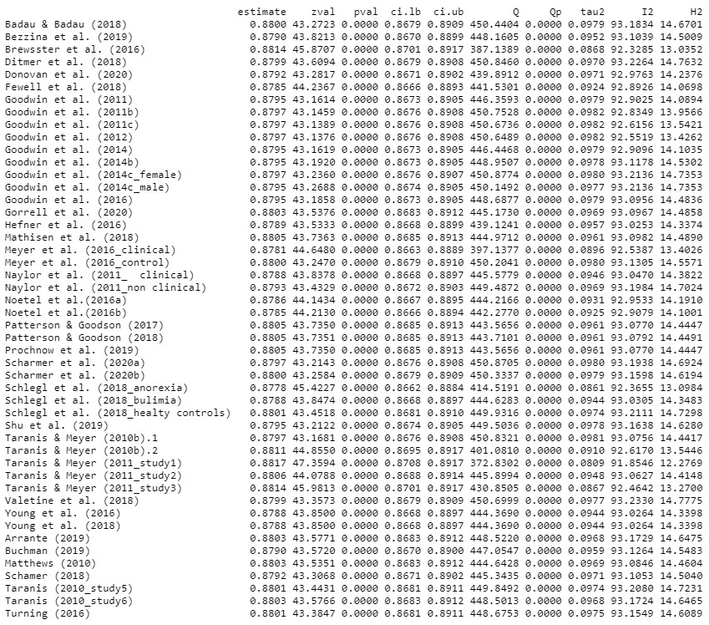
CET-Avoidance
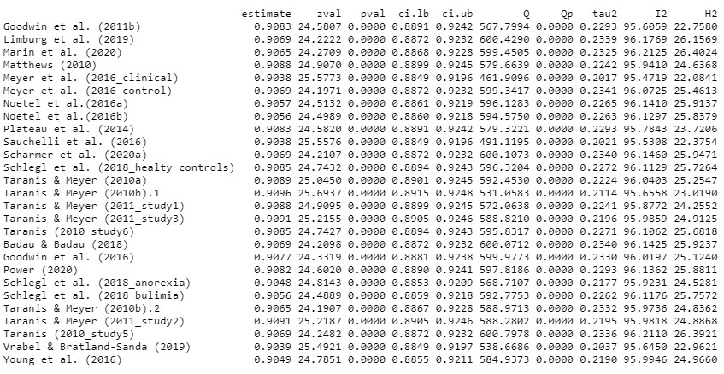
CET-Weight control
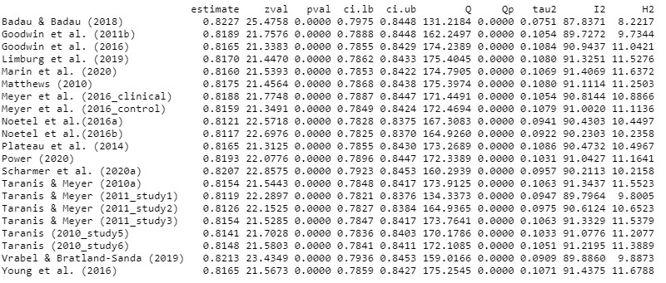
CET-Mood improvement
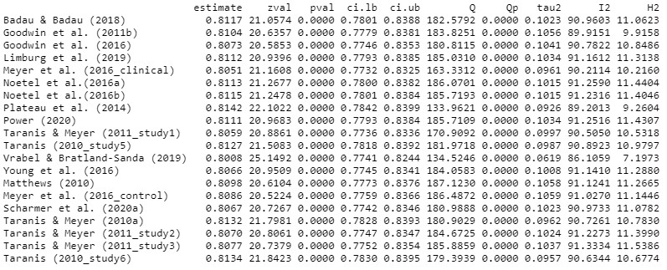

CET-Lack of enjoyment
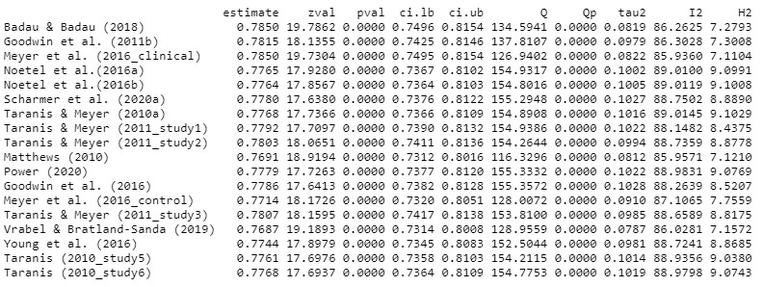

CET-Rigidity
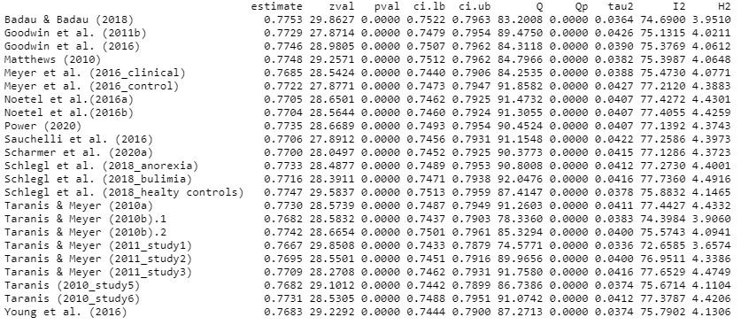
EAI global score
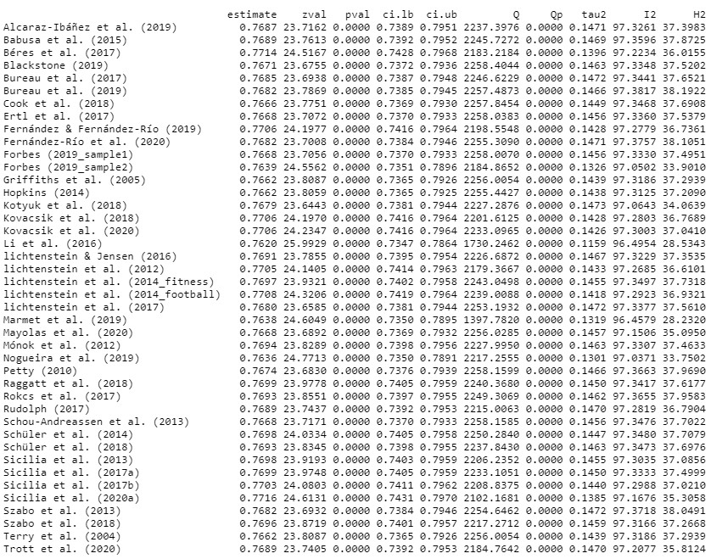

EDQ global score
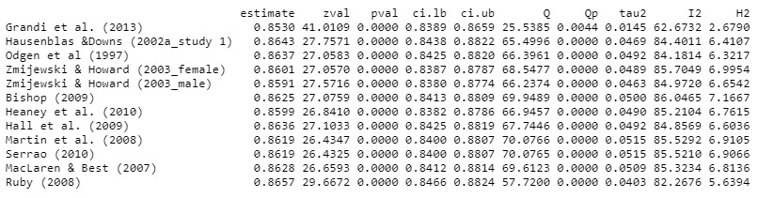
EDQ-Interference
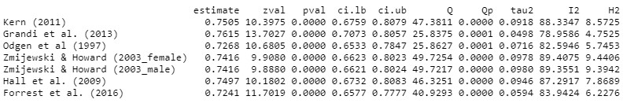
EDQ-Positive reward
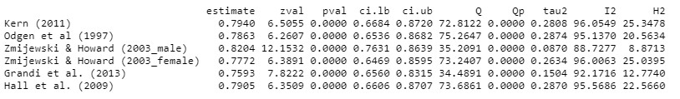
EDQ-Withdrawal
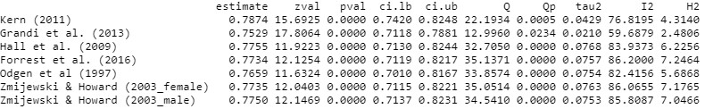
EDQ-Weight control
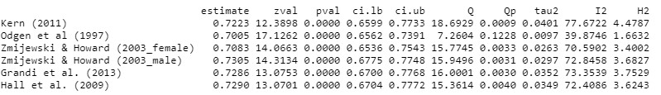
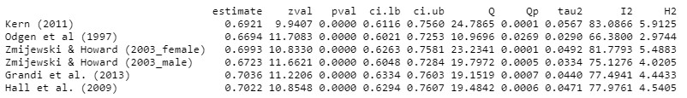
EDQ-Insight in to problem

EDQ-Social reason
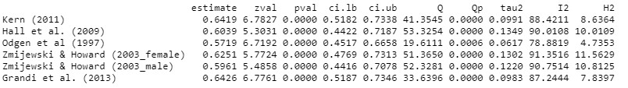
EDQ-Health reason
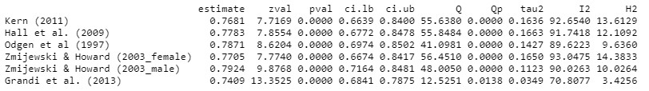
EDQ-Stereotyped behaviour
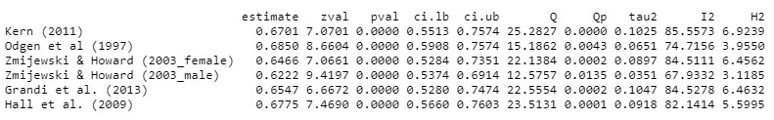
EDS-21 global score
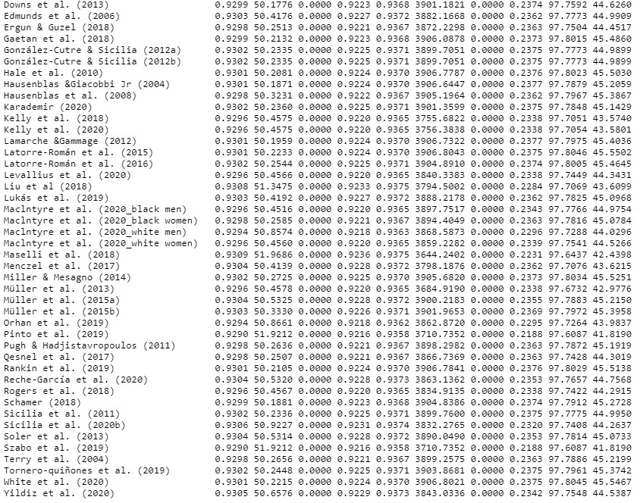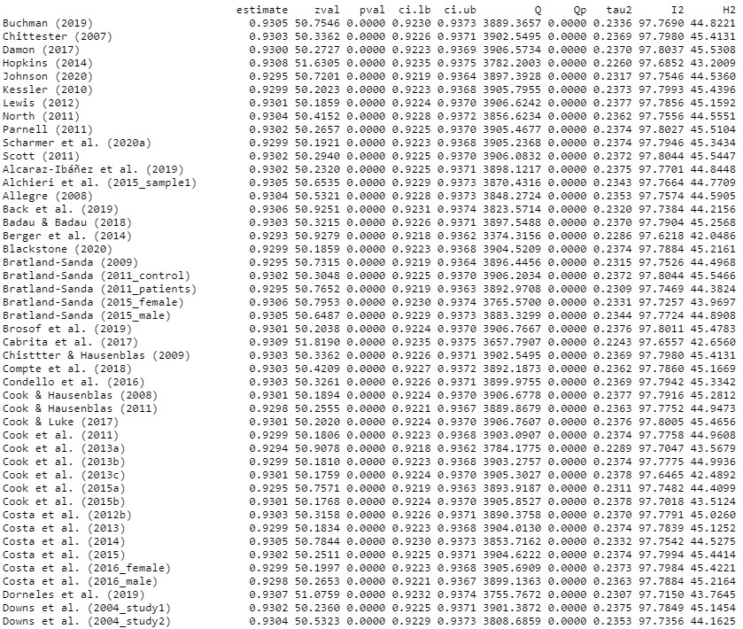

EDS-21 Tolerance
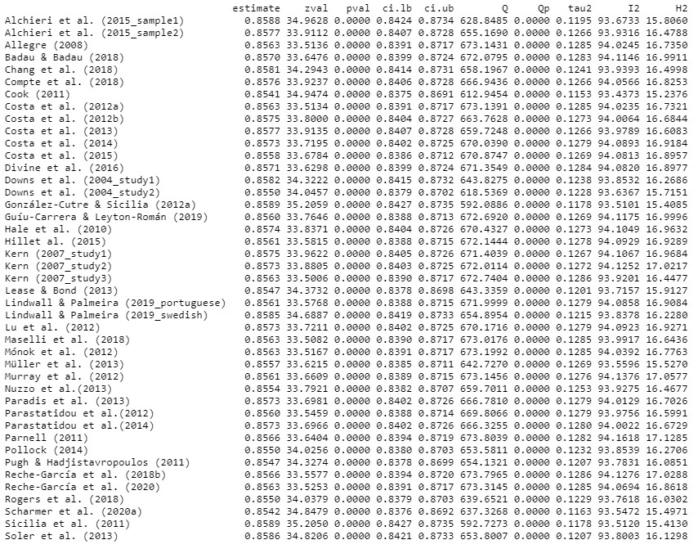
EDS-21 Withdrawal
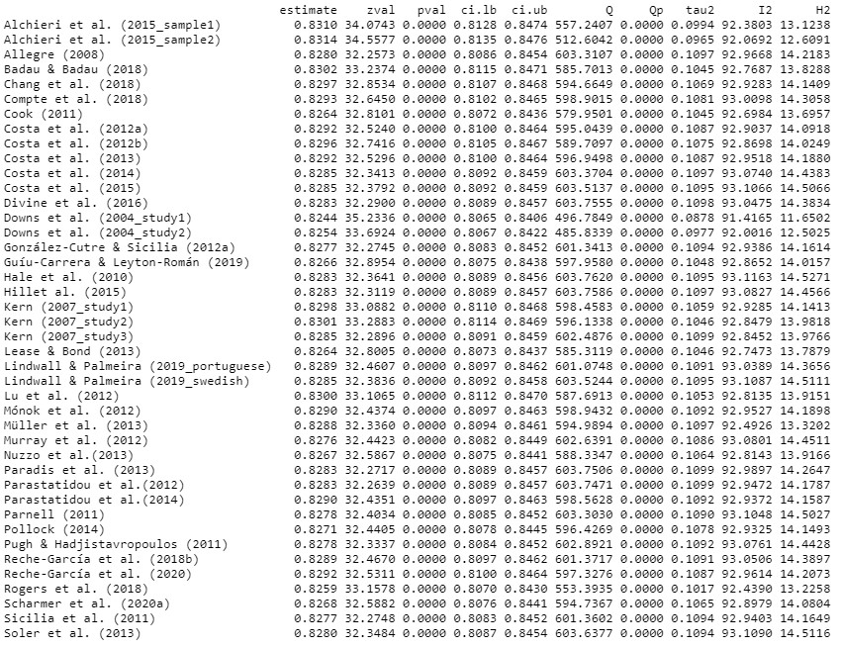

EDS-21 Intention effects
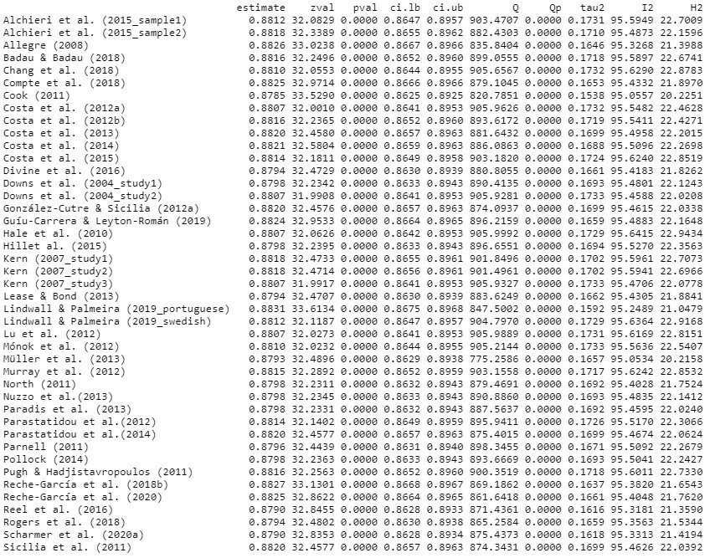
EDS-21 Lack of control
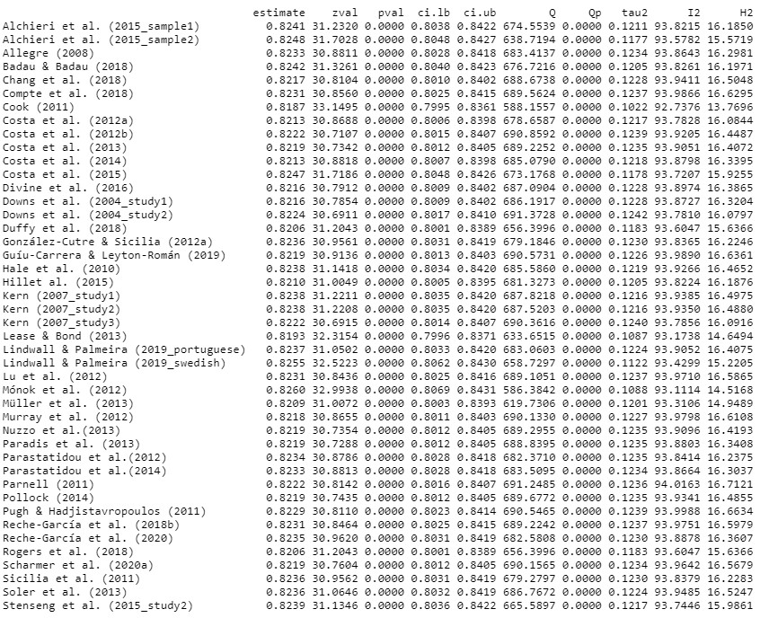

EDS-21 Time
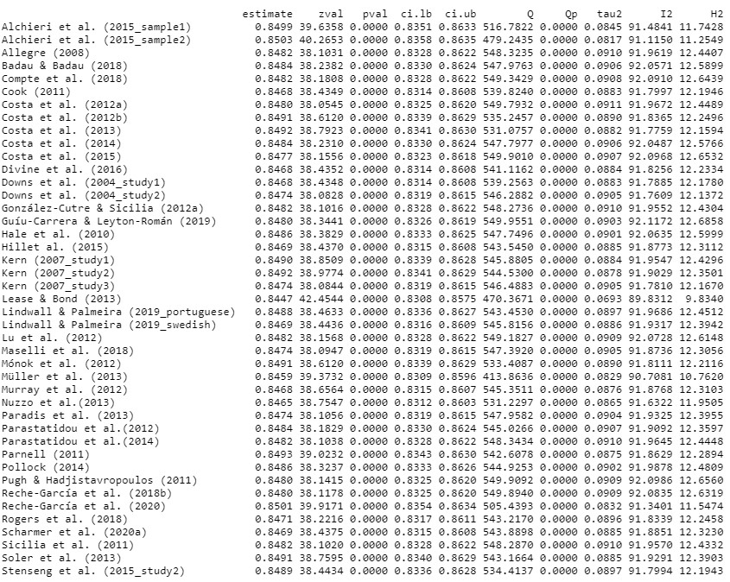
EDS-21 Reduction in other activities
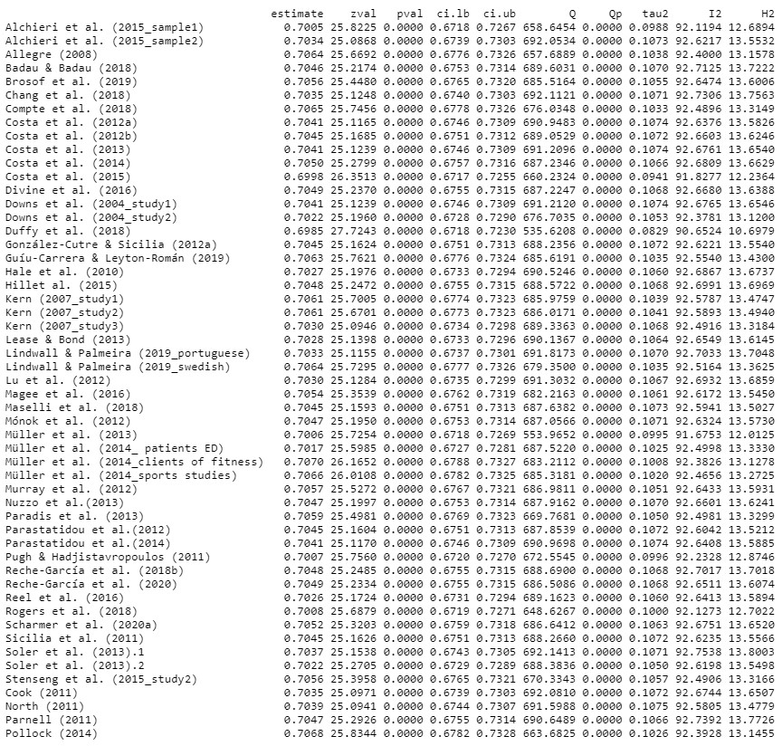
EDS-21 Continuance
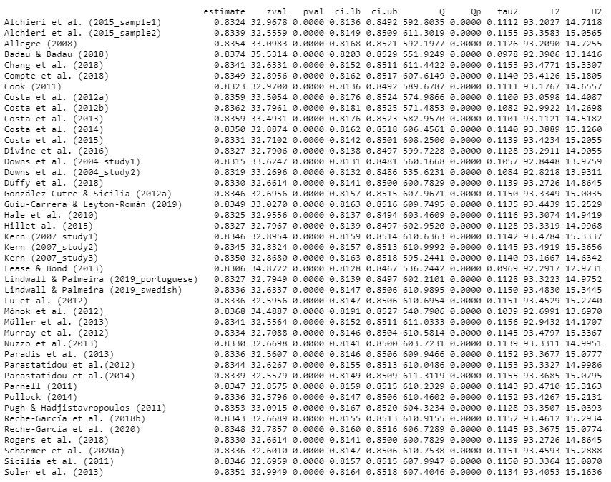
OEQ global score
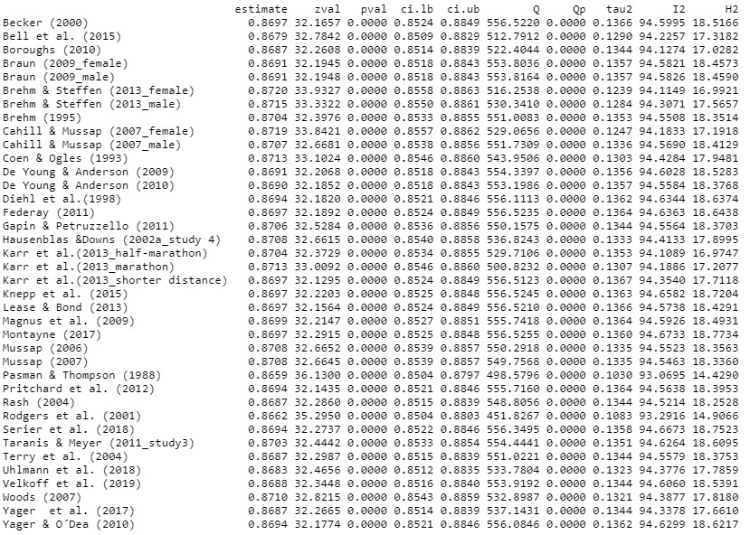

Supplementary material F: Publication bias analyses by PE
Due to unavailability of data (K< 10) publication bias analyses were not conducted in the case of EDQ subscales. Evidence of publication bias was suggested by funnel plot asymmetry and the results of Egger test both for the CET (global score, p = .084; and weight control subscale, p = .026) and the EDS-21 (global score, p = .096; and reduction in other activities subscale, p = .027) (see Supplementary material G). Additionally, the ‘trim and fill’ procedure showed differences between the pooled and the adjusted pooled estimates in the following cases: (a) the global score on the CET (ᾱ = .880, p < .001; 95% CI = 868. to .891, I² = 92.99 vs. adjusted ᾱ = .876, p < .001; 95% CI = .863 to .887, I² = 93.67; missing studies K = 3); (b) the weight control subscale of the CET (ᾱ = .817, p < .001; 95% CI = 787. to .842, I² = 90.72 vs. adjusted ᾱ = .792, p < .001; 95% CI = .755 to .823, I² = 93.31; missing studies K = 5); and (c) the reduction in other activities subscale of the EDS-21 (ᾱ = .704, p < .001; 95% CI = 675. to .730, I² = 92.53 vs. adjusted ᾱ = .730, p < .001; 95% CI = .702 to .755, I² = 93.59; missing studies K = 10). Conversely, no significant differences between the pooled estimate (ᾱ = .930, p < .001; 95% CI = 923. to .937, I² = 97.76) and adjusted pooled estimate (ᾱ = .930, p < .001; 95% CI = .923 to .937, I² = 97.76; missing studies K = 0) were found in the case of the global score on the EDS-21.

Supplementary material G: Forest plots by PE

Supplementary material H: Studies included in meta-analysis and systematic review
Adkins, E. C., & Keel, P. K. (2005). Does “excessive” or “compulsive” best describe exercise as a symptom of bulimia nervosa? International Journal of Eating Disorders, 38(1), 24–29. https://doi.org/10.1002/eat.20140
Aguirre, S. (2014). Exercise dependence, disordered eating behaviors, and general nutrition knowledge in female group fitness instructors employed at college and university recreation centers [Master’s thesis, Northern Illinois University]. ProQuest Dissertations & Theses Global.
Alcaraz-Ibáñez, M., Aguilar-Parra, J. M., & Álvarez-Hernández, J. F. (2018). Exercise addiction: Preliminary evidence on the role of psychological inflexibility. International Journal of Mental Health and Addiction, 16(1), 199–206. https://doi.org/10.1007/s11469-018-9875-y
Alcaraz-ibáñez, M., Sicilia, Á., Dumitru, D. C., & Paterna, A. (2019). Examining the relationship between fitness-related self-conscious emotions, disordered eating symptoms, and morbid exercise behavior: An exploratory study. Journal of Behavioral Addictions. 8(3), 603-612. https://doi.org/10.1556/2006.8.2019.43
Alchieri, J. C., Gouveia, V. V., de oliveira, I. C. V., de medeiros, E. D., Grangeiro, A. S. de M., & da Silva, C. F. de L. S. (2015). Exercise Dependence Scale: Adaptação e evidências de validade e precisão. Jornal Brasileiro de Psiquiatria, 64(4), 279–287. https://doi.org/10.1590/0047-2085000000090
Allegre, B., & Therme, P. (2008). Étude confirmative de l’échelle de dépendance à l’activité physique Exercise Dependence Scale-Revised pour une population francophone. Encephale, 34(5), 490–495. https://doi.org/10.1016/j.encep.2007.08.004
Allegre, B., Therme, P., & Griffiths, M. D. (2007). Individual factors and the context of physical activity in exercise dependence: A prospective study of “ultramarathoners.” International Journal of Mental Health and Addiction, 5(3), 233–243. https://doi.org/10.1007/s11469-007-9081-9
Andreassen, C. S., Griffiths, M. D., Gjertsen, S. R., Krossbakken, E., Kvam, S., & Pallesen, S. (2013). The relationships between behavioral addictions and the fivefactor model of personality. Journal of Behavioral Addictions, 2(2), 90–99. https://doi.org/10.1556/JBA.2.2013.003
Arrante, J. (2019). Impact of attachment on the relationship between emotion regulation, body satisfaction, and compulsive exercise in female college athletes [Master’s thesis, East Carolina University]. ProQuest Dissertations & Theses Global.
Aruguete, M., Edman, J. L., & Yates, A. (2012). The relationship between anger and other correlates of eating disorders in women. North American Journal of Psychology, 14(1), 139–148.
Babusa, B., Czeglédi, E., Túry, F., Mayville, S. B., & Urbán, R. (2015). Differentiating the levels of risk for muscle dysmorphia among Hungarian male weightlifters: A factor mixture modeling approach. Body Image, 12(1), 14–21. https://doi.org/10.1016/j.bodyim.2014.09.001
Back, J., Josefsson, T., Ivarsson, A., & Gustafsson, H. (2021). Psychological risk factors for exercise dependence. International Journal of Sport and Exercise Psychology, 19(4), 461-472. https://doi.org/10.1080/1612197X.2019.1674902
Badau, D., & Badau, A. (2018). Identifying the incidence of exercise dependence attitudes, levels of body perception, and preferences for use of fitness technology monitoring. International Journal of Environmental Research and Public Health, 15(12), 1–20. https://doi.org/10.3390/ijerph15112614
Bamber, D., Cockerill, I. M., & Carroll, D. (2000). The pathological status of exercise dependence. British Journal of Sports Medicine, 34(2), 125–132. https://doi.org/10.1136/bjsm.34.2.125
Becker, D. (2000). An examination of exercise dependence and its relation to eating pathology [Master’s thesis, University of Windsor]. ProQuest Dissertations & Theses Global.
Bell, H. S., Donovan, C. L., & Ramme, R. (2016). Is athletic really ideal? An examination of the mediating role of body dissatisfaction in predicting disordered eating and compulsive exercise. Eating Behaviors, 21, 24–29. https://doi.org/10.1016/j.eatbeh.2015.12.012
Béres, A., Czeglédi, E., & Babusa, B. (2017). Effects of a single aerobic exercise session on body image. Mentalhigiene Es Pszichoszomatika, 18(1), 84–104. https://doi.org/10.1556/0406.18.2017.1.4
Berger, N. A. A., Müller, A., Brähler, E., Philipsen, A., & de Zwaan, M. (2014). Association of symptoms of attention-deficit/hyperactivity disorder with symptoms of excessive exercising in an adult general population sample. BMC Psychiatry, 14(1), 1–9. https://doi.org/10.1186/s12888-014-0250-7
Bezner, J. R. (1995). The exploration of physical health as a component of wellness [Doctoral dissertation, University of Texas at Austin]. ProQuest Dissertations & Theses Global.
Bezzina, L., Touyz, S., Young, S., Foroughi, N., Clemes, S., Meyer, C., Arcelus, J., Madden, S., Attia, E., Pike, K. M., & Hay, P. (2019). Accuracy of self-reported physical activity in patients with anorexia nervosa: Links with clinical features. Journal of Eating Disorders, 7(1), 1–12. https://doi.org/10.1186/s40337-019-0258y
Bishop, I. J. (2009). Health or harm? Exercise dependence and its effects on body satisfaction and self-esteem [Master’s thesis, University of Windsor]. ProQuest Dissertations & Theses Global.
Blackmore, E. (2002). Parental influences on the physical activity of adolescent females with anorexia nervosa [Master’s thesis, York University]. ProQuest Dissertations & Theses Global.
Blackstone, S. R., & Herrmann, L. K. (2020). Fitness wearables and exercise Dependence in college women: considerations for University health education specialists. American Journal of Health Education, 51(4), 225–233. https://doi.org/10.1080/19325037.2020.1767004
Blackstone, S. R., Johnson, A. K., & Sutton, D. (2019). Perceptions of weight-conscious drinking and the role of mental health: A mixed-methods approach. American Journal of Health Education, 50(4), 225–235. https://doi.org/10.1080/19325037.2019.1616013
Blaydon, M. J., Linder, K. J., & Kerr, J. H. (2004). Metamotivational characteristics of exercise dependence and eating disorders in highly active amateur sport participants. Personality and Individual Differences, 36(6), 1419–1432. https://doi.org/10.1016/S0191-8869(03)00238-1
Blaydon, M. J., & Lindner, K. J. (2002). Eating disorders and exercise dependence in triathletes. Eating Disorders, 10(1), 49–60. https://doi.org/10.1080/106402602753573559
Boroughs, M. S., Krawczyk, R., & Thompson, J. K. (2010). Body dysmorphic disorder among diverse racial/ethnic and sexual orientation groups: Prevalence estimates and associated factors. Sex Roles, 63(9–10), 725–737. https://doi.org/10.1007/s11199-010-9831-1
Bratland-Sanda, S., Martinsen, E. W., Rosenvinge, J. H., Rã, Ã., Hoffart, A., & Sundgot-Borgen, J. (2011). Exercise dependence score in patients with longstanding eating disorders and controls: The importance of affect regulation and physical activity intensity. European Eating Disorders Review, 19(3), 249–255. https://doi.org/10.1002/erv.971
Bratland-Sanda, S., Nilsson, M. P., & Sundgot-Borgen, J. (2015). Disordered eating behavior among group fitness instructors: A health-threatening secret? Journal of Eating Disorders, 3(1), 1–8. https://doi.org/10.1186/s40337-015-0059-x
Bratland-Sanda, S., Sundgot-Borgen, J., Rø, Ø., Rosenvinge, J. H., Hoffart, A., & Martinsen, E. W. (2010). Physical activity and exercise dependence during inpatient treatment of longstanding eating disorders: An exploratory study of excessive and non-excessive exercisers. International Journal of Eating Disorders, 43(3), 266–273. https://doi.org/10.1002/eat.20769
Braun, S. J. (2009). Exercise can be bad for your health? Models of obligatory exercise in males and females [Doctoral dissertation, Southern Illinois University]. ProQuest Dissertations & Theses Global.
Brehm, B. J., & Steffen, J. J. (2013). Links among eating disorder characteristics, exercise patterns, and psychological attributes in college students. SAGE Open, 3(3), 215824401350298. https://doi.org/10.1177/2158244013502985
Brewster, M. E., Sandil, R., Deblaere, C., Breslow, A., Eklund, A., Brewster, M. E., Sandil, R., Breslow, A., & Eklund, A. (2017). “Do you even lift, bro?” Objectification, minority stress, and body image concerns for sexual minority men. Psychology of Men and Masculinity, 18(2), 87–98.
Brosof, L. C., Williams, B. M., & Levinson, C. A. (2020). Exploring the contribution of exercise dependence to eating disorder symptoms. International Journal of Eating Disorders, 53(1), 123–127. https://doi.org/10.1002/eat.23156
Brown, K. L. (2009). Attachment anxiety and avoidance: Relationship to body image and exercise behavior [Doctoral dissertation, University of Southern Mississippi]. ProQuest Dissertations & Theses Global.
Bruno, A., Quattrone, D., Scimeca, G., Cicciarelli, C., Romeo, V. M., Pandolfo, G., Zoccali, R. A., & Muscatello, M. R. A. (2014). Unraveling exercise addiction: The role of narcissism and self-esteem. Journal of Addiction, 2014, 1–6. https://doi.org/10.1155/2014/987841
Buchman-Schmitt, J. M. (2019). Excessive exercise, eating pathology and suicidality: Investigating the role of capability for suicide [Doctoral dissertation, Florida State University]. ProQuest Dissertations & Theses Global.
Buck, K., Spittler, J., Reed, A., & Khodaee, M. (2018). Psychological attributes of ultramarathoners. Wilderness and Environmental Medicine, 29(1), 66–71. https://doi.org/10.1016/j.wem.2017.09.003
Bueno-Antequera, J., Mayolas-Pi, C., Reverter-Masià, J., López-Laval, I., Oviedo-Caro, M. Á., Munguía-Izquierdo, D., Ruidíaz-Peña, M., & Legaz-Arrese, A. (2020). Exercise addiction and its relationship with health outcomes in indoor cycling practitioners in fitness centers. International Journal of Environmental Research and Public Health, 17, 4159. https://doi.org/10.3390/ijerph17114159
Bureau, A T, Razon, S., Saville, B. K., Tokac, U., & Judge, L. W. (2017). Passion for academics and problematic health behaviors. International Journal of Exercise Science, 10(3), 417–433.
Bureau, Alexander T, Blom, L. C., Bolin, J., & Nagelkirk, P. (2019). Passion for exercise: passion’s relationship to general fitness indicators and exercise addiction. International Journal of Exercise Science, 12(5), 122–135.
Cabrita, T., Rosado, A., De La Vega, R., & Serpa, S. (2017). Athletic identity and athlete characteristics as predictor of exercise dependence. Revista de Psicologia Del Deporte, 27(2), 99–106.
Cahill, S., & Mussap, A. J. (2007). Emotional reactions following exposure to idealized bodies predict unhealthy body change attitudes and behaviors in women and men. Journal of Psychosomatic Research, 62(6), 631–639. https://doi.org/10.1016/j.jpsychores.2006.11.001
Calogero, R. M., & Pedrotty, K. N. (2004). The practice and process of healthy exercise: An investigation of the treatment of exercise abuse in women with eating disorders. Eating Disorders, 12(4), 273–291. https://doi.org/10.1080/10640260490521352
Carlson, A. A. (2007). The role of impulsivity and compulsivity in disordered eating, self-harm, and obligatory exercise in a nonclinical sample [Doctoral dissertation, University of North Dakota]. ProQuest Dissertations & Theses Global.
Carvalho, P. H. B. de, Oliveira, F. da C., Neves, C. M., Meireles, J. F. F., Lopes, V. G. V., & Ferreira, M. E. C. (2016). Busca pela “muscularidade” e variáveis associadas em adultos jovens. Revista Brasileira de Medicina Do Esporte, 22(2), 119–121. https://doi.org/10.1590/1517-869220162202142544
Chamberlain, S. R., & Grant, J. E. (2020). Is problematic exercise really problematic? A dimensional approach. CNS Spectrums, 25(1), 64–70. https://doi.org/10.1017/S1092852919000762
Chang, C. C., Pan, M. C., & Shu, S. T. (2019). Relationship between self-presentation, exercise dependence, and perceived body image. International Journal of Sport and Exercise Psychology, 17(6), 617–629. https://doi.org/10.1080/1612197X.2018.1444078
Chiappetta, S., Stier, C., Hadid, M. A., Malo, N., Theodoridou, S., Weiner, R., & Weiner, S. (2020). Remission of food addiction does not induce cross-addiction after sleeve gastrectomy and gastric bypass: A prospective cohort study. Obesity Facts, 13(3), 307–320. https://doi.org/10.1159/000506838
Chittester, N. I. (2007). Prediction of drive for muscularity by body composition and psychological factors [Doctoral dissertation, University of Florida]. ProQuest Dissertations & Theses Global.
Chittester, N. I., & Hausenblas, H. A. (2009). Correlates of drive for muscularity: The role of anthropometric measures and psychological factors. Journal of Health Psychology, 14(7), 872–877. https://doi.org/10.1177/1359105309340986
Christian, C., Brosof, L. C., Vanzhula, I. A., Williams, B. M., Shankar Ram, S., & Levinson, C. A. (2019). Implementation of a dissonance-based, eating disorder prevention program in Southern, all-female high schools. Body Image, 30, 26–34. https://doi.org/10.1016/j.bodyim.2019.05.003
Chu, H. W., Bushman, B. A., & Woodard, R. J. (2008). Social physique anxiety, obligation to exercise, and exercise choices among college students. Journal of American College Health, 57(1), 7–14. https://doi.org/10.3200/JACH.57.1.7-14
Claire Scott, M. (2010). Excessive exercise, gender, motivation for exercise, parenting style, and psychological symptoms in adult athletes and exercisers [Doctoral dissertation, Alliant International University]. ProQuest Dissertations & Theses Global.
Clark, J. (1995). Obligatory exercise and its clinical correlates [Doctoral dissertation, University of Florida]. https://doi.org/10.16953/deusbed.74839
Coen, S. P., & Ogles, B. M. (1993). Psychological characteristics of the obligatory runner: A critical examination of the anorexia analogue hypothesis. Journal of Sport & Exercise Psychology, 15, 338–354. https://doi.org/10.1123/jsep.15.3.338
Compte, E. J., Murray, S. B., Sepúlveda, A. R., Schweiger, S., Bressan, M., & Torrente, F. (2018). What position do you play? Eating disorder pathology among rugby players, and the understudied role of player position. International Journal of Eating Disorders, 51(8), 1015–1019. https://doi.org/10.1002/eat.22933
Condello, G., Capranica, L., Stager, J., Forte, R., Falbo, S., Di Baldassarre, A., Segura Garcia, C., & Pesce, C. (2016). Physical activity and health perception in aging: Do body mass and satisfaction matter? A three-path mediated link. PLoS ONE, 11(9), 1–16. https://doi.org/10.1371/journal.pone.0160805
Cook, B., Engel, S., Crosby, R., Hausenblas, H., Wonderlich, S., & Mitchell, J. (2014). Pathological motivations for exercise and eating disorder specific health-related quality of life. International Journal of Eating Disorders, 47(3), 268–272. https://doi.org/10.1002/eat.22198
Cook, B., Hausenblas, H., Crosby, R. D., Cao, L., & Wonderlich, S. A. (2015). Exercise dependence as a mediator of the exercise and eating disorders relationship: A pilot study. Eating Behaviors, 16, 9–12. https://doi.org/10.1016/j.eatbeh.2014.10.012
Cook, B., Hausenblas, H., & Rossi, J. (2013). The moderating effect of gender on ideal weight goals and exercise dependence symptoms. Journal of Behavioral Addictions, 2(1), 50–55. https://doi.org/10.1556/JBA.1.2012.010
Cook, B., Hausenblas, H., Tuccitto, D., & Giacobbi, P. R. (2011). Eating disorders and exercise: A structural equation modelling analysis of a conceptual model. European Eating Disorders Review, 19(3), 216–225. https://doi.org/10.1002/erv.1111
Cook, B. J. (2010). Eating disorder specific health-related quality of life and exercise: Further testing of a conceptual model [Doctoral dissertation, University of Florida]. ProQuest Dissertations & Theses Global.
Cook, B. J., & Hausenblas, H. A. (2008). The role of exercise dependence for the relationship between exercise behavior and eating pathology: Mediator or moderator? Journal of Health Psychology, 13(4), 495–502. https://doi.org/10.1177/1359105308088520
Cook, B. J., & Hausenblas, H. A. (2011). Eating disorder-specific health-related quality of life and exercise in college females. Quality of Life Research, 20(9), 1385–1390. https://doi.org/10.1007/s11136-011-9879-6
Cook, B., Karr, T. M., Zunker, C., Mitchell, J. E., Thompson, R., Sherman, R., Crosby, R. D., Cao, L., Erickson, A., & Wonderlich, S. A. (2013). Primary and secondary exercise dependence in a community-based sample of road race runners. Journal of Sport and Exercise Psychology, 35(5), 464–469. https://doi.org/10.1123/jsep.35.5.464
Cook, B., Karr, T. M., Zunker, C., Mitchell, J. E., Thompson, R., Sherman, R., Erickson, A., Cao, L., & Crosby, R. D. (2015). The influence of exercise identity and social physique anxiety on exercise dependence. Journal of Behavioral Addictions, 4(3), 195–199. https://doi.org/10.1556/2006.4.2015.020
Cook, B., & Luke, R. (2017). Primary and secondary exercise dependence in a sample of cyclists. International Journal of Mental Health and Addiction, 15(2), 444–451. https://doi.org/10.1007/s11469-017-9745-z
Cook, C. A. (1996). The psychological correlates of exercise dependence in aerobics instructors [Master’s thesis, University of Alberta]. ProQuest Dissertations & Theses Global.
Cook, R. H., Griffiths, M. D., & Pontes, H. M. (2020). Personality factors in exercise addiction: A pilot study exploring the role of narcissism, extraversion, and agreeableness. International Journal of Mental Health and Addiction, 18(1), 89–102. https://doi.org/10.1007/s11469-018-9939-z
Corazza, O., Simonato, P., Demetrovics, Z., Mooney, R., van de Ven, K., RomanUrrestarazu, A., Rácmolnár, L., De Luca, I., Cinosi, E., Santacroce, R., Marini, M., Wellsted, D., Sullivan, K., Bersani, G., & Martinotti, G. (2019). The emergence of exercise addiction, body dysmorphic disorder, and other image-related psychopathological correlates in fitness settings: A cross sectional study. PLoS ONE, 14(4), 1–17. https://doi.org/10.1371/journal.pone.0213060
Costa, S., Coppolino, P., & Oliva, P. (2016). Exercise dependence and maladaptive perfectionism: The mediating role of basic psychological needs. International Journal of Mental Health and Addiction, 14(3), 241–256. https://doi.org/10.1007/s11469-015-9586-6
Costa, S., Cuzzocrea, F., Hausenblas, H. A., Larcan, R., & Oliva, P. (2012). Psychometric examination and factorial validity of the Exercise Dependence Scale-Revised in Italian exercisers. Journal of Behavioral Addictions, 1(4), 186–190. https://doi.org/10.1556/JBA.1.2012.009
Costa, S., Hausenblas, H. A., Oliva, P., Cuzzocrea, F., & Larcan, R. (2013). The role of age, gender, mood states and exercise frequency on exercise dependence. Journal of Behavioral Addictions, 2(4), 216–223. https://doi.org/10.1556/JBA.2.2013.014
Costa, S., Hausenblas, H. A., Oliva, P., Cuzzocrea, F., & Larcan, R. (2015). Perceived parental psychological control and exercise dependence symptoms in competitive athletes. International Journal of Mental Health and Addiction, 13(1), 59–72. https://doi.org/10.1007/s11469-014-9512-3
Costa, S., Hausenblas, H. A., Oliva, P., Cuzzocrea, F., & Larcan, R. (2016). Maladaptive perfectionism as mediator among psychological control, eating disorders, and exercise dependence symptoms in habitual exerciser. Journal of Behavioral Addictions, 5(1), 77–89. https://doi.org/10.1556/2006.5.2016.004
Costa, S., & Oliva, P. (2012). Examining relationship between personality characteristics and exercise dependence. Examining Relationship between Personality Characteristics and Exercise Dependence, 19(1), 5–11.
Cunningham, H. E., Pearman, S., & Brewerton, T. D. (2016). Conceptualizing primary and secondary pathological exercise using available measures of excessive exercise. International Journal of Eating Disorders, 49(8), 778–792. https://doi.org/10.1002/eat.22551
Damon, S. M. (2017). Relationships among body image dissatisfaction, body enhancing behaviors, and self-esteem in adult males. [Doctoral dissertation, Walden University]. ProQuest Dissertations & Theses Global.
Davis, C., Brewer, H., & Ratusny, D. (1993). Behavioral frequency and psychological commitment: Necessary concepts in the study of excessive exercising. Journal of Behavioral Medicine, 16(6), 611–628. https://doi.org/10.1007/BF00844722
Davis, C., Kennedy, S. H., Ralevski, E., Dionne, M., Brewer, H., Neitzert, C., & Ratusny, D. (1995). Obsessive compulsiveness and physical activity in anorexia nervosa and high-level exercising. Journal of Psychosomatic Research, 39(8), 967–976. https://doi.org/10.1016/0022-3999(95)00064-X
Dawson, N., & Hammer, J. H. (2019). No pain, no gains: Conformity to masculine norms, body dissatisfaction, and exercise dependence. Psychology of Men and Masculinity. https://doi.org/10.1037/men0000243
De Carvalho, P. H. B., Conti, M. A., Neves, C. M., Meireles, J. F. F., Oliveira, F. C., & Ferreira, M. E. C. (2015). Psychometric assessment of the Brazilian version of the Male Body Dissatisfaction Scale. Revista de Psiquiatria Clinica, 42(4), 90–94. https://doi.org/10.1590/0101-60830000000056
De Carvalho, P. H. B., Oliveira, F. da C., Neves, C. M., Meireles, J. F. F., & Ferreira, M. E. C. (2019). Is the Drive for Muscularity Scale a valid and reliable instrument for young adult women? Body Image, 29, 1–5. https://doi.org/10.1016/j.bodyim.2019.02.001
De La Vega, R., Parastatidou, I. S., Ruíz-Barquín, R., & Szabo, A. (2016). Exercise addiction in athletes and leisure exercisers: The moderating role of passion. Journal of Behavioral Addictions, 5(2), 325–331. https://doi.org/10.1556/2006.5.2016.043
De Sousa Fortes, L., & Ferreira, M. E. C. (2013). Comportamento alimentar inadequado: Comparações em função do comprometimento ao exercício. Arquivos Brasileiros de Psicologia, 65(2), 230–242.
De Young, K. P., & Anderson, D. A. (2010a). Prevalence and correlates of exercise motivated by negative affect. International Journal of Eating Disorders, 43(1), 50– 58. https://doi.org/10.1002/eat.20656
De Young, K. P., & Anderson, D. A. (2010b). The importance of the function of exercise in the relationship between obligatory exercise and eating and body image concerns. Eating Behaviors, 11(1), 62–64. https://doi.org/10.1016/j.eatbeh.2009.09.001
Di Lodovico, L., Dubertret, C., & Ameller, A. (2018). Vulnerability to exercise addiction, socio-demographic, behavioral and psychological characteristics of runners at risk for eating disorders. Comprehensive Psychiatry, 81, 48–52. https://doi.org/10.1016/j.comppsych.2017.11.006
Di Lodovico, L., & Gorwood, P. (2020). The relationship between moderate to vigorous physical activity and cognitive rigidity in anorexia nervosa. Psychiatry Research, 284, 112703. https://doi.org/10.1016/j.psychres.2019.112703
Di Nicola, M., Tedeschi, D., De Risio, L., Pettorruso, M., Martinotti, G., Ruggeri, F., Swierkosz-Lenart, K., Guglielmo, R., Callea, A., Ruggeri, G., Pozzi, G., Di Giannantonio, M., & Janiri, L. (2015). Co-occurrence of alcohol use disorder and behavioral addictions: Relevance of impulsivity and craving. Drug and Alcohol Dependence, 148(2015), 118–125. https://doi.org/10.1016/j.drugalcdep.2014.12.028
Di Nicola, M., Tedeschi, D., Mazza, M., Martinotti, G., Harnic, D., Catalano, V., Bruschi, A., Pozzi, G., Bria, P., & Janiri, L. (2010). Behavioural addictions in bipolar disorder patients: Role of impulsivity and personality dimensions. Journal of Affective Disorders, 125(1–3), 82–88. https://doi.org/10.1016/j.jad.2009.12.016
Diehl, N. S., Johnson, C. E., Rogers, R. L., & Petrie, T. A. (1998). Social physique anxiety and disordered eating: What’s the connection? Addictive Behaviors, 23(1), 1–6. https://doi.org/10.1016/S0306-4603(97)00003-8
Dittmer, N., Voderholzer, U., Mönch, C., Cuntz, U., Jacobi, C., & Schlegl, S. (2020). Efficacy of a specialized group intervention for compulsive exercise in inpatients with anorexia nervosa: A randomized controlled trial. Psychotherapy and Psychosomatics, 89(3), 161–173. https://doi.org/10.1159/000504583
Dittmer, N., Voderholzer, U., von der Mühlen, M., Marwitz, M., Fumi, M., Mönch, C., Alexandridis, K., Cuntz, U., Jacobi, C., & Schlegl, S. (2018). Specialized group intervention for compulsive exercise in inpatients with eating disorders: Feasibility and preliminary outcomes. Journal of Eating Disorders, 6(1), 1–11. https://doi.org/10.1186/s40337-018-0200-8
Divine, A., Roberts, R., & Hall, C. R. (2018). Revisiting the exercise imagery and exercise-dependence relationship. International Journal of Sport and Exercise Psychology, 16(2), 191–202. https://doi.org/10.1080/1612197X.2016.1177105
Donovan, C. L., Uhlmann, L. R., & Loxton, N. J. (2020). Strong is the new skinny, but is it ideal?: A test of the tripartite influence model using a new measure of fit-ideal internalisation. Body Image, 35, 171–180. https://doi.org/10.1016/j.bodyim.2020.09.002
Dorneles, R., Bergmann, G., & Silva, M. (2019). Risco de dependência de exercício físico em academias de ginástica. Sociedade Portuguesa de Psicologia Da Saúde, 20(1), 137–148.
Downs, D. S., Hausenblas, H. A., & Nigg, C. R. (2004). Factorial validity and psychometric examination of the Exercise Dependence Scale-Revised. Measurement in Physical Education and Exercise Science, 8(4), 183–201. https://doi.org/10.1207/s15327841mpee0804
Dreier, M. J., Coniglio, K., & Selby, E. A. (2020). Mapping features of pathological exercise using hierarchical-dimensional modeling. International Journal of Eating Disorders, August, 1–11. https://doi.org/10.1002/eat.23406
Duckham, R. L., Peirce, N., Meyer, C., Summers, G. D., Cameron, N., & BrookeWavell, K. (2012). Risk factors for stress fracture in female endurance athletes: A cross-sectional study. BMJ Open, 2(6), 1–8. https://doi.org/10.1136/bmjopen2012-001920
Duffy, M. E., Rogers, M. L., & Joiner, T. E. (2018). Body trust as a moderator of the association between exercise dependence and suicidality. Comprehensive Psychiatry, 85, 30–35. https://doi.org/10.1016/j.comppsych.2018.06.005
Duncan, L. R., Hall, C. R., Fraser, S. N., Rodgers, W. M., Wilson, P. M., & Loitz, C. C. (2012). Re-examining the dimensions of obligatory exercise. Measurement in Physical Education and Exercise Science, 16(1), 1–22. https://doi.org/10.1080/1091367X.2012.641442
Edmunds, J., Ntoumanis, N., & Duda, J. L. (2006). Examining exercise dependence symptomatology from a self-determination perspective. Journal of Health Psychology, 11(6), 887–903. https://doi.org/10.1177/1359105306069091
Egan, S. J., Bodill, K., Watson, H. J., Valentine, E., Shu, C., & Hagger, M. S. (2017). Compulsive exercise as a mediator between clinical perfectionism and eating pathology. Eating Behaviors, 24, 11–16. https://doi.org/10.1016/j.eatbeh.2016.11.001
Elbourne, K. E., & Chen, J. (2007). The continuum model of obligatory exercise: A preliminary investigation. Journal of Psychosomatic Research, 62(1), 73–80. https://doi.org/10.1016/j.jpsychores.2004.12.003
Ergun, G., & Guzel, A. (2019). Determining the relationship of over-exercise to smartphone overuse and emotional intelligence levels in gym-goers: The example of Burdur, Turkey. International Journal of Mental Health, 17(4), 1036–1048. https://doi.org/10.1007/s11469-018-9989-2
Ertl, M. M., Pazienza, R., Martin, J. L., & Longo, L. M. (2019). Harmful and problematic alcohol use in association with impulsivity, exercise addiction, and disordered eating behaviors among college student men and women. 42nd Annual Research Society on Alcoholism Scientific Meeting, 256A. https://doi.org/10.1111/acer.14059
Ertl, Melissa M., Longo, L. M., Groth, G. H., Berghuis, K. J., Prout, J., Hetz, M. C., & Martin, J. L. (2018). Running on empty: High self-esteem as a risk factor for exercise addiction. Addiction Research and Theory, 26(3), 205–211. https://doi.org/10.1080/16066359.2017.1347257
Fereday, L. B. (2011). Counselor self-care instrument development: An exploration of cognitive-emotional, relational, physical, and spiritual self-care dissertation [Doctoral dissertation, University of Kentucky]. ProQuest Dissertations & Theses Global.
Fernandez-Rio, J., González-Villora, S., Valero-Valenzuela, A., Anton-Candanedo, A., Merino-Barrero, J. A., de los Ríos, J. V. S., & López Gajardo, M. A. (2020). Accelerometry-measured physical activity in amateur footballers. Is it enough to obtain health benefits? Sustainability (Switzerland), 12(11). https://doi.org/10.3390/su12114477
Fernández, S., & Fernández-Río, J. (2019). Indoor-cycling: Participants’ motives and addiction during a year of practice. Revista Internacional de Medicina y Ciencias de La Actividad Fisica y Del Deporte, 19(76), 673–684. https://doi.org/10.15366/rimcafd2019.76.008
Fewell, L. K., Nickols, R., Schlitzer Tierney, A., & Levinson, C. A. (2018). Eating disorders in sport: Comparing eating disorder symptomatology in athletes and nonathletes during intensive eating disorder treatment. Journal of Clinical Sport Psychology, 12(4), 578–594. https://doi.org/10.1123/jcsp.2018-0046
Fishman, D. A. (2005). How meta-mood factors and mood intensity relate to eatingdisorder symptoms in a clinical adult female population [Doctoral dissertation, Alliant International University]. ProQuest Dissertations & Theses Global.
Forbes, C. N. (2019). Development and validation of the expectancies for Body-Focused Coping Questionnaire [Master’s thesis, University of Toledo]. ProQuest Dissertations & Theses Global.
Formby, P., Watson, H. J., Hilyard, A., Martin, K., & Egan, S. J. (2014). Psychometric properties of the Compulsive Exercise Test in an adolescent eating disorder population. Eating Behaviors, 15(4), 555–557. https://doi.org/10.1016/j.eatbeh.2014.08.013
Forrest, L. N., Smith, A. R., Fussner, L. M., Dodd, D. R., & Clerkin, E. M. (2016). Using implicit attitudes of exercise importance to predict explicit exercise dependence symptoms and exercise behaviors. Psychology of Sport and Exercise, 22, 91–97. https://doi.org/10.1016/j.psychsport.2015.06.006
Fortes, L., Almeida, S. S., Laus, M. F., & Caputo-Ferreira, M. E. (2012). Level of psychological commitment to exercise and comparison of body dissatisfaction of athletes participating in the pan-American school games. Revista Brasileira de Medicina Do Esporte, 18(4), 238–241. https://doi.org/10.1590/S151786922012000400004
Fortes, L. de S., Amaral, A. C., Almeida Sde, S., & Ferreira, M. E. (2013). Effects of psychological, morphological and sociodemographic variables on adolescents’ eating behavior. Revista Paulista de Pediatria, 31(2), 182–188. https://doi.org/10.1590/S010305822013000200008
Fortes, L. de S., Amaral, A. C. S., Almeida, S. de S., & Ferreira, M. E. C. (2013). Effects of various factors on the eating behavior of adolescents. Ciência & Saúde Coletiva, 18(11), 3301–3310. https://doi.org/10.1590/S1413-81232013001100020
Fortes, L. de S., Cipriani, F. M., & Ferreira, M. E. C. (2013). Risk behaviors for eating disorder: factors associated in adolescent students. Trends in Psychiatry and Psychotherapy, 35(4), 279–286. https://doi.org/10.1590/2237-6089-2012-0055
Fortes, L. de S., de Oliveira, F. G., & Ferreira, M. E. C. (2012). Influência de fatores afetivos, antropométricos e sociodemográficos sobre o comportamento alimentar em jovens atletas. Jornal Brasileiro de Psiquiatria, 61(3), 148–153. https://doi.org/10.1590/S0047-20852012000300005
Fortes, L. de S., De Sousa Almeida, S., & Ferreira, M. E. C. (2014). Influence of psychological, anthropometric and sociodemographic factors on the symptoms of eating disorders in young athletes. Paideia, 24(57), 21–28. https://doi.org/10.1590/1982-43272457201404
Fortes, L. de S., Mockdece Neves, C., Fernandes Filgueiras, J., De Sousa Almeida, S., & Ferreira, M. E. C. (2013). Body dissatisfaction, psychological commitment to exercise and eating behavior in young athletes from aesthetic sports. Brazilian Journal of Kinanthropometry and Human Performance, 15(6), 695–704.
Fortes, L. de S., Morgado, F. F. da R., & Ferreira, M. E. C. (2013). Factors associated with inappropriate eating behavior in adolescent students. Archives of Clinical Psychiatry, 40(2), 59–64. https://doi.org/10.1590/S0101-60832013000200002
Fortes, L., Morgado, F., Almeida, S., & Ferreira, M. (2015). Degree of psychological commitment to exercise in young athletes. Revista de Psicología Del Deporte, 24(2), 225–232.
Freitag-Honsberger, S. (2001). The relationship between body image and obligatory exercise behavior among physically active women of various ages [Master’s thesis, McGill University]. ProQuest Dissertations & Theses Global.
Gaetan, S., Rochaix, D., & Bonnet, A. (2019). Eating disorders, emotional functioning and physical activity in a specific student population. Annales Medico-Psychologiques, 177(3), 201–207. https://doi.org/10.1016/j.amp.2018.02.014
Gapin, J. I., & Petruzzello, S. J. (2011). Athletic identity and disordered eating in obligatory and non-obligatory runners. Journal of Sports Sciences, 29(10), 1001–1010. https://doi.org/10.1080/02640414.2011.571275
Gianini, L. M., Klein, D. A., Call, C., Mayer, L., Foltin, R. W., Walsh, B. T., Wang, Y., Wu, P., & Attia, E. (2016). The reinforcing effect of exercise in anorexia nervosa: Clinical correlates and relationship to outcome. Eating Disorders, 24(5), 412–423. https://doi.org/10.1080/10640266.2016.1198204
Gomes, V. M. G. M., Compte, E. J., Almeida, M., Campos, P. F., Queiroz, A. C. C., Pereira, L. F., Brito, C. J., & de Carvalho, P. H. B. (2020). Psychometric properties of the Muscle Dysmorphic Disorder Inventory among physically active Brazilian college men. Psychology of Men and Masculinity, 21(4), 622–631. https://doi.org/10.1037/men0000307
González-Cutre, D., & Sicilia, Á. (2012). Physical exercise dependence in Spanish users of fitness centers: Differences according to gender, age and physical activities. Behavioral Psychology/ Psicologia Conductual, 20(2).
González-Cutre, David, & Sicilia, Á. (2012). Motivation and exercise dependence: A study based on self-determination theory. Research Quarterly for Exercise and Sport, 83(2), 318–329. https://doi.org/10.1080/02701367.2012.10599863
Goodwin, H., Haycraft, E., & Meyer, C. (2011). Sociocultural correlates of compulsive exercise: Is the environment important in fostering a compulsivity towards exercise among adolescents? Body Image, 8(4), 390–395. https://doi.org/10.1016/j.bodyim.2011.05.006
Goodwin, H., Haycraft, E., & Meyer, C. (2012). The relationship between compulsive exercise and emotion regulation in adolescents. British Journal of Health Psychology, 17(4), 699–710. https://doi.org/10.1111/j.2044-8287.2012.02066.x
Goodwin, H., Haycraft, E., & Meyer, C. (2014a). Emotion regulation styles as longitudinal predictors of compulsive exercise: A twelve-month prospective study. Journal of Adolescence, 37(8), 1399–1404. https://doi.org/10.1016/j.adolescence.2014.10.001
Goodwin, H., Haycraft, E., & Meyer, C. (2014b). Psychological risk factors for compulsive exercise: A longitudinal investigation of adolescent boys and girls. Personality and Individual Differences, 68, 83–86. https://doi.org/10.1016/j.paid.2014.03.048
Goodwin, H., Haycraft, E., & Meyer, C. (2014c). Sociocultural risk factors for compulsive exercise: A prospective study of adolescents. European Eating Disorders Review, 22(5), 360–365. https://doi.org/10.1002/erv.2309
Goodwin, H., Haycraft, E., & Meyer, C. (2016). Disordered eating, compulsive exercise, and sport participation in a UK adolescent sample. European Eating Disorders Review, 24(4), 304–309. https://doi.org/10.1002/erv.2441
Goodwin, H., Haycraft, E., Taranis, L., & Meyer, C. (2011). Psychometric evaluation of the Compulsive Exercise Test (CET) in an adolescent population: Links with eating psychopathology. European Eating Disorders Review, 19(3), 269–279. https://doi.org/10.1002/erv.1109
Goodwin, H., Haycraft, E., Willis, A. M., & Meyer, C. (2011). Compulsive exercise: The role of personality, psychological morbidity, and disordered eating. International Journal of Eating Disorders, 44(7), 655–660. https://doi.org/10.1002/eat.20902
Gorrell, S., Scharmer, C., Kinasz, K., & Anderson, D. (2020). Compulsive exercise and weight suppression: Associations with eating pathology in distance runners. Eating Behaviors, 36, 101358. https://doi.org/10.1016/j.eatbeh.2019.101358
Grandi, S., Clementi, C., Benassi, M., & Guidi, J. (2013). Italian validation of the Exercise Dependence Questionnaire. Bollettino Di Psicologia Applicata, 266(59), 21–28.
Grandi, S., Clementi, C., Guidi, J., Benassi, M., & Tossani, E. (2011). Personality characteristics and psychological distress associated with primary exercise dependence: An exploratory study. Psychiatry Research, 189(2), 270–275. https://doi.org/10.1016/j.psychres.2011.02.025
Griffiths, M. D., Szabo, A., & Terry, A. (2005). The Exercise Addiction Inventory: A quick and easy screening tool for health practitioners. British Journal of Sports Medicine, 39(6), 1–3. https://doi.org/10.1136/bjsm.2004.017020
Groves, M., Biscomb, K., Nevill, A., & Matheson, H. (2008). Exercise dependence, self-esteem and identity reinforcement: A comparison of three universities in the United Kingdom. Sport in Society, 11(1), 59–73. https://doi.org/10.1080/17430430701717772
Guidi, J., Clementi, C., & Grandi, S. (2013). Valutazione del disagio psicologico e delle caratteristiche di personalità nella dipendenza da esercizio fisico primaria. Rivista Di Psichiatria, 48(2), 121–129.
Guíu Carrera, M., & Leyton Román, M. (2019). Perfil psicológico en corredores de ultramaratón (Psychological profile in ultramarathon runners). Retos, 2041(36), 310–317. https://doi.org/10.47197/retos.v36i36.69119
Gulker, M. G. (2000). The personality and psychological profile of the excessive exerciser [Doctoral dissertation, California School of Professional Psychology]. ProQuest Dissertations & Theses Global.
Gulker, M. G., Laskis, T. A., & Kuba, S. A. (2001). Do excessive exercisers have a higher rate of obsessive-compulsive symptomatology? Psychology, Health and Medicine, 6(4), 387–398. https://doi.org/10.1080/13548500126535
Hale, B. D., Diehl, D., Weaver, K., & Briggs, M. (2013). Exercise dependence and muscle dysmorphia in novice and experienced female bodybuilders. Journal of Behavioral Addictions, 2(4), 244–248. https://doi.org/10.1556/JBA.2.2013.4.8
Hale, B. D., Roth, A. D., DeLong, R. E., & Briggs, M. S. (2010). Exercise dependence and the drive for muscularity in male bodybuilders, power lifters, and fitness lifters. Body Image, 7(3), 234–239. https://doi.org/10.1016/j.bodyim.2010.02.001
Hall, H. K., Hill, A. P., Appleton, P. R., & Kozub, S. A. (2009). The mediating influence of unconditional self-acceptance and labile self-esteem on the relationship between multidimensional perfectionism and exercise dependence. Psychology of Sport & Exercise, 10, 35–44. https://doi.org/10.1016/j.psychsport.2008.05.003
Harris, N., Gee, D., D’Acquisto, D., Ogan, D., & Pritchett, K. (2015). Eating disorder risk, exercise dependence, and body weight dissatisfaction among female nutrition and exercise science university majors. Journal of Behavioral Addictions, 4(3), 206–209. https://doi.org/10.1556/2006.4.2015.029
Hausenblas, H. A., & Downs, D. S. (2002a). How much is too much? The development and validation of the Exercise Dependence Scale. Psychology and Health, 17(4), 387–404. https://doi.org/10.1080/0887044022000004894
Hausenblas, H. A., & Downs, D. S. (2002b). Relationship among sex, imagery, and exercise dependence symptoms. Psychology of Addictive Behaviors, 16(2), 169–172. https://doi.org/10.1037/0893-164X.16.2.169
Hausenblas, H. A., & Fallon, E. A. (2002). Relationship among body image, exercise behavior, and exercise dependence symptoms. International Journal of Eating Disorders, 32(2), 179–185. https://doi.org/10.1002/eat.10071
Hausenblas, H. A., Gauvin, L., Downs, D. S., & Duley, A. R. (2008). Effects of abstinence from habitual involvement in regular exercise on feeling states: An ecological momentary assessment study. British Journal of Health Psychology, 13(2), 237–255. https://doi.org/10.1348/135910707X180378
Hausenblas, H. A., & Giacobbi, P. R. (2004). Relationship between exercise dependence symptoms and personality. Personality and Individual Differences, 36(6), 1265–1273. https://doi.org/10.1016/S0191-8869(03)00214-9
Heaney, J. L. J., Ginty, A. T., Carroll, D., & Phillips, A. C. (2011). Preliminary evidence that exercise dependence is associated with blunted cardiac and cortisol reactions to acute psychological stress. International Journal of Psychophysiology, 79(2), 323–329. https://doi.org/10.1016/j.ijpsycho.2010.11.010
Hefner, V., Dorros, S. M., Jourdain, N., Liu, C., Tortomasi, A., Greene, M. P., Brandom, C., Ellet, M., & Bowles, N. (2016). Mobile exercising and tweeting the pounds away: The use of digital applications and microblogging and their association with disordered eating and compulsive exercise. Cogent Social Sciences, 2(1). https://doi.org/10.1080/23311886.2016.1176304
Hill, A. P., Robson, S. J., & Stamp, G. M. (2015). The predictive ability of perfectionistic traits and self-presentational styles in relation to exercise dependence. Personality and Individual Differences, 86, 176–183. https://doi.org/10.1016/j.paid.2015.06.015
Hogarth, B. T. (2018). Shining light on the dark side of flow: Is mindfulness in highflow-state athletes predictive of improved emotion-regulation and self-control? [Doctoral dissertation, John F. Kennedy University]. ProQuest Dissertations & Theses Global.
Holland, L. A. (2017). Mechanisms underlying pathological exercise in women with eating disorders [Doctoral dissertation, Florida State University]. ProQuest Dissertations & Theses Global.
Holland, L. A., Brown, T. A., & Keel, P. K. (2014). Defining features of unhealthy exercise associated with disordered eating and eating disorder diagnoses. Psychology of Sport & Exercise, 15, 116–123. https://doi.org/10.1016/j.psychsport.2013.10.005
Hopkins, E. L. (2014). Too much exercise: Negative correlates of exercise among college students [Master’s thesis, Middle Tennessee State University]. ProQuest Dissertations & Theses Global.
Huang, Q. I. N., Huang, J., Chen, Y., Lin, D., Xu, S., Wei, J., Qi, C., & Xu, X. I. A. (2019). Overactivation of the reward system and deficient inhibition in exercise addiction. Medicine and Science in Sports and Exercise, 51(9), 1918–1927. https://doi.org/10.1249/MSS.0000000000001988
Hubbard, S. T. (1994). Differences among females who exercise for “bulimic” and “nonbulimic” reasons [Master’s thesis, The American University]. ProQuest Dissertations & Theses Global.
Hubbard, S. T., Gray, J. J., & Parker, S. (1998). Differences among women who exercise for `food related’ and `non-food related’ reasons. European Eating Disorders Review, 6, 255–265.
Jee, Y. S., & Eun, D. (2018). Exercise addiction and psychophysiological health in Korean collegiate students. International Journal of Mental Health and Addiction, 16(2), 451–465. https://doi.org/10.1007/s11469-017-9802-7
Johnson, H. (2020). Rest day stress in runners [Master’s thesis, The University of Wisconsin-Milwaukee]. ProQuest Dissertations & Theses Global.
Karademir, T. (2020). The Effects of Regular Sports Activities on Exercise Dependence. International Journal of Applied Exercise Physiology, 9(9), 190–197.
Karr, T. M., Zunker, C., Thompson, R. A., Sherman, R. T., Erickson, A., Cao, L., Crosby, R. D., & Mitchell, J. E. (2013). Moderators of the association between exercise identity and obligatory exercise among participants of an athletic event. Body Image, 10(1), 70–77. https://doi.org/10.1016/j.bodyim.2012.09.004
Kelly, N. R., Cotter, E., & Guidinger, C. (2018). Men who engage in both subjective and objective binge eating have the highest psychological and medical comorbidities. Eating Behaviors, 30, 115–119. https://doi.org/10.1016/j.eatbeh.2018.07.003
Kelly, N. R., Cotter, E. W., Tanofsky-kraff, M., & Mazzeo, S. E. (2015). Racial variations in binge eating, body image concerns, and compulsive exercise among men. Psychology of Men & Masculinity, 16(3), 326–336.
Kelly, N. R., Kosty, D., Guerricabeitia, L., Guidinger, C., & Williamson, G. (2020). Evaluating components of existing theories for loss of control eating in a sample of young racially/ethnically diverse men. Body Image, 35, 63–70. https://doi.org/10.1016/j.bodyim.2020.08.005
Kern, L. (2007). Validation de l’adaptation française de l’échelle de dépendance à l’exercice physique: l’EDS-R. Pratiques Psychologiques, 13(4), 425–441. https://doi.org/10.1016/j.prps.2007.06.003
Kern, L., & Baudin, N. (2011). Validation franaise du questionnaire de dépendance de l’exercice physique (Exercise Dependence Questionnaire). Revue Europeene de Psychologie Appliquee, 61(4), 205–211. https://doi.org/10.1016/j.erap.2011.08.001
Kern, Laurence, Morvan, Y., Mattar, L., Molina, E., Tailhardat, L., Peguet, A., De Tournemire, R., Hirot, F., Rizk, M., Godart, N., & Fautrelle, L. (2020). Development and evaluation of an adapted physical activity program in anorexia nervosa inpatients: A pilot study. European Eating Disorders Review, 28(6), 687– 700. https://doi.org/10.1002/erv.2779
Kessler, K. L. (2010). Self-objectification, body image, eating behavior, and exercise dependence among college females [Master’s thesis, University of North Texas]. ProQuest Dissertations & Theses Global.
Keyes, A., Woerwag-Mehta, S., Bartholdy, S., Koskina, A., Middleton, B., Connan, F., Webster, P., Schmidt, U., & Campbell, I. C. (2015). Physical activity and the drive to exercise in anorexia nervosa. International Journal of Eating Disorders, 48(1), 46–54. https://doi.org/10.1002/eat.22354
Kingston, J., Clarke, S., Ritchie, T., & Remington, B. (2011). Developing and validating the “composite measure of problem behaviors.” Journal of Clinical Psychology, 67(7), 736–751. https://doi.org/10.1002/jclp.20802
Klein, D. A., Mayer, L. E. S., Schebendach, J. E., & Walsh, B. T. (2007). Physical activity and cortisol in Anorexia Nervosa. Psychoneuroendocrinology, 32(5), 539–547. https://doi.org/10.1016/j.psyneuen.2007.03.007
Knepp, M. M., Yoza, J. J., & Quandt, E. A. (2015). Higher modified beck depression inventory scores are associated with body, eating, and exercise comparisons but decreased exercise amounts. Perceptual and Motor Skills, 120(3), 945–959. https://doi.org/10.2466/15.29.PMS.120v14x8
Kotbagi, G., Kern, L., Romo, L., & Pathare, R. (2015). The hierarchical model of exercise dependence the development of the problematic practice. Journal of Individual Differences, 36(4), 247–257. https://doi.org/10.1027/16140001/a000172
Kotbagi, G., Morvan, Y., Romo, L., & Kern, L. (2017). Which dimensions of Impulsivity are related to problematic practice of physical exercise? Journal of Behavioral Addictions, 6(2), 221–228. https://doi.org/10.1556/2006.6.2017.024
Kotyuk, E., Farkas, J., Magi, A., Eisinger, A., Király, O., Vereczkei, A., Barta, C., Griffiths, M. D., Kökönyei, G., Székely, A., Sasvári-Székely, M., & Demetrovics, Z. (2019). The psychological and genetic factors of the addictive behaviors (PGA) study. International Journal of Methods in Psychiatric Research, 28(1), 1–12. https://doi.org/10.1002/mpr.1748
Kotyuk, E., Magi, A., Eisinger, A., Király, O., Vereczkei, A., Barta, C., Griffiths, M. D., Székely, A., Kökönyei, G., Farkas, J., Kun, B., Badgaiyan, R. D., Urbán, R., Blum, K., & Demetrovics, Z. (2020). Co-occurrences of substance use and other potentially addictive behaviors: Epidemiological results from the Psychological and Genetic factors of the Addictive Behaviors (PGA) Study. Journal of Behavioral Addictions, 9(2), 272–288. https://doi.org/10.1556/2006.2020.00033
Kovacsik, R., Griffiths, M. D., Pontes, H. M., Soós, I., de la Vega, R., Ruíz-Barquín, R., Demetrovics, Z., & Szabo, A. (2019). The role of passion in exercise addiction, exercise volume, and exercise intensity in long-term exercisers. International Journal of Mental Health and Addiction, 17(6), 1389–1400. https://doi.org/10.1007/s11469-018-9880-1
Kovacsik, R., Soós, I., de la Vega, R., Ruíz-Barquín, R., & Szabo, A. (2020). Passion and exercise addiction: Healthier profiles in team than in individual sports. International Journal of Sport and Exercise Psychology, 18(2), 176–186. https://doi.org/10.1080/1612197X.2018.1486873
Kovácsik, R., Tóth-Király, I., Egorov, A., & Szabo, A. (2020). A longitudinal study of exercise addiction and passion in new sport activities: The impact of motivational factors. International Journal of Mental Health and Addiction. https://doi.org/10.1007/s11469-020-00241-z
Kummer, Ka. K., Pope, H. G., Hudson, J. I., Kemmler, G., Pinggera, G.-M., & Mangweth-Matzek, B. (2018). Aging male symptomatology and eating behavior. Aging Male, 22(1), 55–61. https://doi.org/10.1080/13685538.2018.1477931
Lamarche, L., & Gammage, K. L. (2012). Predicting exercise and eating behaviors from appearance evaluation and two types of investment. Sport, Exercise, and Performance Psychology, 1(3), 145–157. https://doi.org/10.1109/RADIOELEK.2007.371672
Latorre-Román, P. Á., Garrido-Ruiz, A., & García-Pinillos, F. (2015). Versión Española del cuestionario del complejo de Adonis: Un cuestionario para el análisis del dimorfismo muscular o vigorexia. Nutricion Hospitalaria, 31(3), 1246–1253. https://doi.org/10.3305/nh.2015.31.3.8292
Laus, M. F., Costa, T. M. B., & Almeida, S. S. (2013). Body image dissatisfaction and aesthetic exercise in adolescents: Are they related? Estudos de Psicologia, 18(2), 163–171. https://doi.org/10.1590/S1413-294X2013000200001
Lease, H. J., & Bond, M. J. (2013). Correspondence between alternate measures of maladaptive exercise, and their associations with disordered eating symptomatology. Journal of Behavioral Addictions, 2(3), 153–159. https://doi.org/10.1556/JBA.2.2013.012
LePage, M. L., Price, M., O’Neil, P., & Crowther, J. H. (2012). The effect of exercise absence on affect and body dissatisfaction as moderated by obligatory exercise beliefs and eating disordered beliefs and behaviors. Psychology of Sport and Exercise, 13(4), 500–508. https://doi.org/10.1016/j.psychsport.2012.02.008
Levallius, J., Monell, E., Birgegård, A., Clinton, D., & Forsén Mantilla, E. (2020). Binge eating and addictive-like behaviours in males and females. Psychological Reports, 0, 1–19. https://doi.org/10.1177/0033294120971750
Lewis, D. W. (2012). Understanding prevalence and attitudes: Dietary and exercise behaviors among African American collegiate athletes [Doctoral dissertation, University of Alabama]. ProQuest Dissertations & Theses Global.
Li, M. (2018). The influence of psychological needs and exercise motivation on exercise dependence among Chinese college students. Psychiatric Quarterly, 89(4), 983–990. https://doi.org/10.1007/s11126-018-9595-2
Li, M., Nie, J., & Ren, Y. (2015). Effects of exercise dependence on psychological health of Chinese college students. Psychiatria Danubina, 27(4), 413–419.
Li, M., Nie, J., & Ren, Y. (2016). Verification of Exercise Addiction Inventory for Chinese college students based on SEM model. International Journal of Simulation: Systems, Science and Technology, 17(12), 21.1-21.6. https://doi.org/10.5013/IJSSST.a.17.12.21
Lichtenstein, M. B., Christiansen, E., Bilenberg, N., & Støving, R. K. (2014). Validation of the exercise addiction inventory in a Danish sport context. Scandinavian Journal of Medicine and Science in Sports, 24(2), 447–453. https://doi.org/10.1111/j.1600-0838.2012.01515.x
Lichtenstein, M. B., & Støving, R. K. (2016). Exercise addiction: Identification and prevalence in physically active adolescents and young eating disordered patients. 24th European Congress of Psychiatry, 33S, S116–S117.https://doi.org/10.1016/j.eurpsy.2016.01.127
Lichtenstein, M. B., Andries, A., Hansen, S., Frystyk, J., & Stoving, R. K. (2015). Exercise addiction in men is associated with lower fat-adjusted leptin levels. Clinical Journal of Sport Medicine, 25(2), 138–143. https://doi.org/10.1097/JSM.0000000000000110
Lichtenstein, M. B., Christiansen, E., Elklit, A., Bilenberg, N., & Støving, R. K. (2014). Exercise addiction: A study of eating disorder symptoms, quality of life, personality traits and attachment styles. Psychiatry Research, 215(2), 410–416. https://doi.org/10.1016/j.psychres.2013.11.010
Lichtenstein, M. B., Emborg, B., Hemmingsen, S. D., & Hansen, N. B. (2017). Is exercise addiction in fitness centers a socially accepted behavior? Addictive Behaviors Reports, 6, 102–105. https://doi.org/10.1016/j.abrep.2017.09.002
Lichtenstein, M. B., Griffiths, M. D., Hemmingsen, S. D., & Støving, R. K. (2018). Exercise addiction in adolescents and emerging adults - Validation of a youth version of the Exercise Addiction Inventory. Journal of Behavioral Addictions, 7(1), 117–125. https://doi.org/10.1556/2006.7.2018.01
Lichtenstein, M. B., & Jensen, T. T. (2016). Exercise addiction in crossfit: Prevalence and psychometric properties of the Exercise Addiction Inventory. Addictive Behaviors Reports, 3, 33–37. https://doi.org/10.1016/j.abrep.2016.02.002
Lichtenstein, M. B., Larsen, K. S., Christiansen, E., Stoving, R. K., & Bredahl, T. V. G. (2014). Exercise addiction in team sport and individual sport: Prevalences and validation of the exercise addiction inventory. Addiction Research and Theory, 22(5), 431–437. https://doi.org/10.3109/16066359.2013.875537
Limburg, K., Bodill, K., Watson, H. J., Kane, R. T., Hagger, M. S., & Egan, S. J. (2019). Validity of the compulsive exercise test in regular exercisers. Eating Disorders, 1–16. https://doi.org/10.1080/10640266.2019.1677130
Lindwall, M., & Palmeira, A. (2009). Factorial validity and invariance testing of the exercise dependence scale-revised in Swedish and Portuguese exercisers. Measurement in Physical Education and Exercise Science, 13(3), 166–179. https://doi.org/10.1080/10913670903050313
Lipsey, Z., Barton, S. B., Hulley, A., & Hill, A. J. (2006). “After a workout ...” Beliefs about exercise, eating and appearance in female exercisers with and without eating disorder features. Psychology of Sport and Exercise, 7(5), 425–436. https://doi.org/10.1016/j.psychsport.2006.01.005
Liu, H. Y., Chang, C. C., Gill, D. L., Wu, S. C., & Lu, F. J. H. (2019). Male weight trainers’ body dissatisfaction and exercise dependence: Mediating role of muscularity drive. Psychological Reports, 122(6), 2137–2154. https://doi.org/10.1177/0033294118805010
Loumidis, K. S., & Wells, A. (1998). Assessment of beliefs in exercise dependence: The development and preliminary validation of the Exercise Beliefs Questionnaire. Personality and Individual Differences, 25(3), 553–567. https://doi.org/10.1016/S0191-8869(98)00103-2
Lu, F. J. H., Hsu, E. Y. wen, Wang, J. M., Huang, M. Y., Chang, J. N., & Wang, C. H. (2012). Exercisers’ identities and exercise dependence: The mediating effect of exercise commitment. Perceptual and Motor Skills, 115(2), 618–631. https://doi.org/10.2466/06.13.21.PMS.115.5.618-631
Lukács, A., Sasvári, P., Varga, B., & Mayer, K. (2019). Exercise addiction and its related factors in amateur runners. Journal of Behavioral Addictions, 8(2), 343–349. https://doi.org/10.1556/2006.8.2019.28
MacIntyre, R. I., Heron, K. E., Howard, L. M., & Symons Downs, D. (2020). Gender and black–white race differences in young adult exercise dependence prevalence and associated disordered eating. Research Quarterly for Exercise and Sport. https://doi.org/10.1080/02701367.2020.1767757
MacLaren, V. V., & Best, L. A. (2007). Symptoms of exercise dependence and physical activity in students. Perceptual and Motor Skills, 105, 1257–1264.
Magee, C. A., Buchanan, I., & Barrie, L. (2016). Profiles of exercise dependence symptoms in Ironman participants. Psychology of Sport and Exercise, 24, 48–55. https://doi.org/10.1016/j.psychsport.2016.01.005
Magnus, C. M. R., Kowalski, K. C., & McHugh, T. L. F. (2010). The role of selfcompassion in women’s self-determined motives to exercise and exercise-related outcomes. Self and Identity, 9(4), 363–382. https://doi.org/10.1080/15298860903135073
Mang, L., Garghan, A., Grant, J., Lacey, H., & Matthews, R. (2021). An evaluation of efficacy and acceptability of a novel manualised JuniorLEAP group programme for compulsive exercise, for children and adolescents with anorexia nervosa, within an inpatient setting. Eating and Weight Disorders, 26(2), 591–597. https://doi.org/10.1007/s40519-020-00884-w
Mangweth-Matzek, B., Kummer, K. K., & Pope, H. G. (2016). Eating disorder symptoms in middle-aged and older men. International Journal of Eating Disorders, 49(10), 953–957. https://doi.org/10.1002/eat.22550
Maraz, A., Urbán, R., Griffiths, M. D., & Demetrovics, Z. (2015). An empirical investigation of dance addiction. PLoS ONE, 10(5), 1–13. https://doi.org/10.1371/journal.pone.0125988
Marmet, S., Studer, J., Lemoine, M., Grazioli, V. S., Bertholet, N., & Gmel, G. (2019). Reconsidering the associations between self-reported alcohol use disorder and mental health problems in the light of co-occurring addictions in young Swiss men. PLoS ONE, 14(9), 1–15. https://doi.org/10.1371/journal.pone.0222806
Martin, J. L., Martens, M. P., Serrao, H. F., & Rocha, T. L. (2008). Alcohol use and exercise dependence: co-occurring behaviors among college students? Journal of Clinical Sport Psychology, 2(4), 381–392. https://doi.org/10.1123/jcsp.2.4.381
Martin, K. A., & Hausenblas, H. A. (1998). Psychological commitment to exercise and eating disorder symptomatology among female aerobic instructors. Sport Psychologist, 12(2), 180. https://doi.org/10.1080/09593330802505029
Martin, S. J., & Racine, S. E. (2017). Personality traits and appearance-ideal internalization: Differential associations with body dissatisfaction and compulsive exercise. Eating Behaviors, 27, 39–44. https://doi.org/10.1016/j.eatbeh.2017.11.001
Martin, S. J., Schell, S. E., Srivastav, A., & Racine, S. E. (2020). Dimensions of unhealthy exercise and their associations with restrictive eating and binge eating. Eating Behaviors, 39. https://doi.org/10.1016/j.eatbeh.2020.101436
Maselli, M., Gobbi, E., Probst, M., & Carraro, A. (2019). Prevalence of primary and secondary exercise dependence and its correlation with drive for thinness in practitioners of different sports and physical activities. International Journal of Mental Health and Addiction, 17(1), 89–101. https://doi.org/10.1007/s11469-0179867-3
Matherson, H., & Crawford-Wright, A. (2000). An examination of eating disorder profiles in student obligatory and non-obligatory exercisers. Journal of Sport Behavior, 23(1), 42–50. https://doi.org/10.1017/CBO9781107415324.004
Mathisen, T. F., Bratland-Sanda, S., Rosenvinge, J. H., Friborg, O., Pettersen, G., Vrabel, K. A., & Sundgot-Borgen, J. (2018). Treatment effects on compulsive exercise and physical activity in eating disorders. Journal of Eating Disorders, 6(1), 1–9. https://doi.org/10.1186/s40337-018-0215-1
Matthews, S. (2010). The development and validation of a multidimensional measure of male body dissatisfaction and its preliminary use in exploring the relationship between body dissatisfaction and exercise [Doctoral dissertation, University of Southampton]. ProQuest Dissertations & Theses Global.
Mayolas-Pi, C., Sitko, S., Oviedo-Caro, M. A., Bueno-Antequera, J., Reverter-Masià, J., Francín-Gallego, M., Sarasa-Oliván, F. J., & Legaz-Arrese, A. (2021). Influence of organised sports practice during adolescence on health of adult women with special emphasis on participation in aesthetic sports. European Journal of Sport Science, 21(1), 107–117. https://doi.org/10.1080/17461391.2020.1736180
Mayolas-Pi, Carmen, Simón-Grima, J., Peñarrubia-Lozano, C., Munguía-Izquierdo, D., Moliner-Urdiales, D., & Legaz-Arrese, A. (2017). Exercise addiction risk and health in male and female amateur endurance cyclists. Journal of Behavioral Addictions, 6(1), 74–83. https://doi.org/10.1556/2006.6.2017.018
McLaren, L. (1998). Excessive commitment to exercise and the relationship between dietary restraint and perfectionism: A case of moderation or mediation? [Master’s thesis, University Montreal]. ProQuest Dissertations & Theses Global.
Mclaren, L., Gauvin, L., & White, D. (2001). The role of perfectionism and excessive commitment to exercise in explaining dietary restraint: Replication and extension. International Journal of Eating Disorders, 29(3), 307–313.
Mclester, C., Wheeler, B., Bechke, E., Williamson, C., Mclester, J. R., Kennesaw, F., & Mclester, J. R. (2018). An examination of obligatory exercise, eating attitudes, and perceived body image among collegiate males and females. Medicine & Science in Sports & Exercise, 50, 318.
Menczel, Z., Griffiths, M. D., Vingender, I., Eisinger, A., Farkas, J., Magi, A., Mervó, B., Kökönyei, G., & Demetrovics, Z. (2017). Exercise dependence in amateur competitors and non-competitor recreational exercisers. International Journal of Mental Health and Addiction, 15(3), 580–587. https://doi.org/10.1007/s11469-0169661-7
Meule, A., Schrambke, D., Furst Loredo, A., Schlegl, S., Naab, S., & Voderholzer, U. (2020). Inpatient treatment of anorexia nervosa in adolescents: A 1-year follow-up study. European Eating Disorders Review. https://doi.org/10.1002/erv.2808
Meulemans, S., Pribis, P., Grajales, T., & Krivak, G. (2014). Gender differences in exercise dependence and eating disorders in young adults: A path analysis of a conceptual model. Nutrients, 6(11), 4895–4905. https://doi.org/10.3390/nu6114895
Meyer, C., Plateau, C. R., Taranis, L., Brewin, N., Wales, J., & Arcelus, J. (2016). The Compulsive Exercise Test: Confirmatory factor analysis and links with eating psychopathology among women with clinical eating disorders. Journal of Eating Disorders, 4(1), 1–9. https://doi.org/10.1186/s40337-016-0113-3
Meyer, C., Taranis, L., Goodwin, H., & Haycraft, E. (2011). Compulsive exercise and eating disorders. European Eating Disorders Review, 19(3), 174–189. https://doi.org/10.1002/erv.1122
Millard, L. (2015). Body image, mood, and coping strategies during exercise abstinence for male and female obligatory exercisers [Doctoral dissertation, Colorado State University]. ProQuest Dissertations & Theses Global.
Miller, K. J., & Mesagno, C. (2014). Personality traits and exercise dependence: Exploring the role of narcissism and perfectionism. International Journal of Sport and Exercise Psychology, 12(4), 368–381. https://doi.org/10.1080/1612197X.2014.932821
Miller, N. E. (2006). Nutrient intakes, body fat, eating attitudes, and exercise habits of collegiate female athletes involved in a sport emphasizing leanness compared to a sport not emphasizing leanness [Doctoral dissertation, University of Alabama at Birmingham]. ProQuest Dissertations & Theses Global.
Mond, J. M., & Calogero, R. M. (2009). Excessive exercise in eating disorder patients and in healthy women. Australian and New Zealand Journal of Psychiatry, 43(3), 227–234.
Mond, J. M., Cook Myers, T., Crosby, R., Hay, P., & Mitchell, J. (2008). ‘Excessive exercise’ and eating-disordered behaviour in young adult women: Further evidence from a primary care sample. European Eating Disorders Review, 16, 215–221. https://doi.org/10.1002/erv.855
Mond, J. M., Hay, P. J., Rodgers, B., & Owen, C. (2006). An update on the definition of ‘“excessive exercise”’ in eating disorders research. International Journal of Eating Disorders, 39, 147–153. https://doi.org/10.1002/eat.20214
Mond, J. M., Hay, P. J., Rodgers, B., Owen, C., & Beumont, P. J. V. (2004). Relationships between exercise behaviour, eating-disordered behaviour and quality of life in a community sample of women: When is exercise “excessive”? European Eating Disorders Review, 12(4), 265–272. https://doi.org/10.1002/erv.579
Mónok, K., Berczik, K., Urbán, R., Szabo, A., Griffiths, M. D., Farkas, J., Magi, A., Eisinger, A., Kurimay, T., Kökönyei, G., Kun, B., Paksi, B., & Demetrovics, Z. (2012). Psychometric properties and concurrent validity of two exercise addiction measures: A population wide study. Psychology of Sport and Exercise, 13(6), 739–746. https://doi.org/10.1016/j.psychsport.2012.06.003
Monsma, E. V., Torres-McGehee, T. M., & Cathey, M. (2010). Biological, contextual and psychological correlates of exercise dependence among female track and field athletes. Medicine & Science in Sports & Exercise, 42, 833. https://doi.org/10.1249/01.mss.0000386571.70876.68
Montayne, A. (2017). Fitspirational images, body image, disordered eating, and compulsive exercise [Master’s thesis, Southern Illinois University]. ProQuest Dissertations & Theses Global.
Mooney, R., Simonato, P., Ruparelia, R., Roman-Urrestarazu, A., Martinotti, G., & Corazza, O. (2017). The use of supplements and performance and image enhancing drugs in fitness settings: A exploratory cross-sectional investigation in the United Kingdom. Human Psychopharmacology, 32(3), 1–6. https://doi.org/10.1002/hup.2619
Müller, A., Claes, L., Smits, D., Gefeller, O., Hilbert, A., Herberg, A., Müller, V., Hofmeister, D., & De Zwaan, M. (2013). Validation of the German version of the Exercise Dependence Scale. European Journal of Psychological Assessment, 29(3), 213–219. https://doi.org/10.1027/1015-5759/a000144
Müller, A., Claes, L., Wos, K., Kerling, A., Wünsch-Leiteritz, W., Cook, B., & De Zwaan, M. (2015). Temperament and risk for exercise dependence: Results of a pilot study in female patients with eating disorders compared to elite athletes. Psychopathology, 48(4), 264–269. https://doi.org/10.1159/000436978
Müller, A., Cook, B., Zander, H., Herberg, A., Müller, V., & de Zwaan, M. (2014). Does the German version of the Exercise Dependence Scale measure exercise dependence? Psychology of Sport and Exercise, 15(3), 288–292. https://doi.org/10.1016/j.psychsport.2013.12.003
Müller, A., Loeber, S., Söchtig, J., Te Wildt, B., & De Zwaan, M. (2015). Risk for exercise dependence, eating disorder pathology, alcohol use disorder and addictive behaviors among clients of fitness centers. Journal of Behavioral Addictions, 4(4), 273–280. https://doi.org/10.1556/2006.4.2015.044
Murray, A. L., McKenzie, K., Newman, E., & Brown, E. (2013). Exercise identity as a risk factor for exercise dependence. British Journal of Health Psychology, 18(2), 369–382. https://doi.org/10.1111/j.2044-8287.2012.02091.x
Murray, S. (2010). Exercise dependence, perfectionism, individual vs. Team sport, and gender in an NCAA Division I population [Doctoral dissertation, Xavier University]. ProQuest Dissertations & Theses Global.
Mussap, A. J. (2006). Reinforcement sensitivity theory (RST) and body change behaviour in males. Personality and Individual Differences, 40(4), 841–852. https://doi.org/10.1016/j.paid.2005.08.013
Mussap, A. J. (2007). Motivational processes associated with unhealthy body change attitudes and behaviours. Eating Behaviors, 8(3), 423–428. https://doi.org/10.1016/j.eatbeh.2006.12.001
Naylor, H., Mountford, V., & Brown, G. (2011). Beliefs about excessive exercise in eating disorders: The role of obsessions and compulsions. European Eating Disorders Review, 19(3), 226–236. https://doi.org/10.1002/erv.1110
Nelson, A. B. (2004). The relationship of exercise dependence to fitness level, body composition, and motivation to exercise [Master’s thesis, Utah State University]. ProQuest Dissertations & Theses Global.
Nieman, B. (1994). Relation between obligatory exercise and eating disorders [Doctoral dissertation, University of Cincinnati]. ProQuest Dissertations & Theses Global.
Noetel, M., Miskovic-Wheatley, J., Costa, D., Crosby, R. D., Hay, P., Kohn, M., Madden, S., & Touyz, S. (2016). Exercise for the compulsive exercisers? An exploratory study in adolescent inpatients with anorexia nervosa. Advances in Eating Disorders, 4(3), 264–276. https://doi.org/10.1080/21662630.2016.1202123
Noetel, M., Miskovic-Wheatley, J., Crosby, R. D., Hay, P., Madden, S., & Touyz, S. (2016). A clinical profile of compulsive exercise in adolescent inpatients with anorexia nervosa. Journal of Eating Disorders, 4(1), 1–10. https://doi.org/10.1186/s40337-016-0090-6
Nogueira, A., Tovar-Gálvez, M., & González-Hernández, J. (2019). Do it, don’t feel it, and be invincible: A prolog of exercise addiction in endurance sports. Frontiers in Psychology, 10. https://doi.org/10.3389/fpsyg.2019.02692
North, E. (2011). The latent structure of exercise dependence: A taxometric analysis [Doctoral dissertation, Florida State University]. ProQuest Dissertations & Theses Global.
Numanović, A., Mladenović, Ž., Janjić, V., & Radmanović, B. (2018). Psychological and sociodemographic characteristics and development of Physical Exercise Dependence. Revista Brasileira de Medicina Do Esporte, 24(1), 50–53. https://doi.org/10.1590/1517-869220182401177563
Nuzzo, J. L., Schindler, C. L., & Ryan, W. J. (2013). Exercise dependence symptoms in a sample of exercise science students in the United States. International Journal of Mental Health and Addiction, 11(5), 611–618. https://doi.org/10.1007/s11469-0139433-6
Oberle, C. D., Watkins, R. S., & Burkot, A. J. (2018). Orthorexic eating behaviors related to exercise addiction and internal motivations in a sample of university students. Eating and Weight Disorders, 23(1), 67–74. https://doi.org/10.1007/s40519-017-0470-1
Ogden, J., Veale, D., & Summers, Z. (1997). The development and validation of the Exercise Dependence Questionnaire. Addiction Research, 5(4), 343–356. https://doi.org/10.3109/16066359709004348
Orhan, S., Yücel, A., Sadeq, B., & Orhan, E. (2019). Investigation of the exercise dependence of athletes doing kickboxing, taekwondo, and muay thai. Sports, 7(2), 52. https://doi.org/10.3390/sports7020052
Palareti, G., Legnani, C., Cosmi, B., Antonucci, E., Erba, N., Poli, D., Testa, S., & Tosetto, A. (2016). Comparison between different D-Dimer cutoff values to assess the individual risk of recurrent venous thromboembolism: Analysis of results obtained in the DULCIS study. International Journal of Laboratory Hematology, 38(1), 42–49. https://doi.org/10.1111/ijlh.12426
Paradis, K. F., Cooke, L. M., Martin, L. J., & Hall, C. R. (2013). Too much of a good thing? Examining the relationship between passion for exercise and exercise dependence. Psychology of Sport and Exercise, 14(4), 493–500. https://doi.org/10.1016/j.psychsport.2013.02.003
Parastatidou, I. S., Doganis, G., Theodorakis, Y., & Vlachopoulos, S. P. (2012). Addicted to exercise: Psychometric properties of the Exercise Dependence Scale-Revised in a sample of Greek exercise participants. European Journal of Psychological Assessment, 28(1), 3–10. https://doi.org/10.1027/10155759/a000084
Parastatidou, I. S., Doganis, G., Theodorakis, Y., & Vlachopoulos, S. P. (2014). The mediating role of passion in the relationship of exercise motivational regulations with exercise dependence symptoms. International Journal of Mental Health and Addiction, 12(4), 406–419. https://doi.org/10.1007/s11469-013-9466-x
Parnell, R. (2011). The influence of self-esteem and body dissatisfaction on muscle dysmorphia and exercise dependence [Master’s thesis, University of North Texas]. ProQuest Dissertations & Theses Global.
Pasman, L., & Thompson, J. K. (1988). Body image and eating disturbance in obligatory runners, obligatory weightlifters, and sedentary individuals. International Journal of Eating Disorders, 7(6), 759–769. https://doi.org/10.1002/1098-108X(198811)7:6<759::AID-EAT2260070605>3.0.CO;2-G
Patterson, M. S., & Goodson, P. (2017). Using social network analysis to better understand compulsive exercise behavior among a sample of sorority members. Journal of Physical Activity and Health, 14(5), 360–367. https://doi.org/10.1123/jpah.2016-0336
Patterson, M. S., & Goodson, P. (2018). The role of ego networks in compulsive exercise behavior among a sample of college sorority women. Journal of Physical Activity and Health, 15(10), 755–762. https://doi.org/10.1123/jpah.2017-0570
Petty, K. N. (2010). Implicit theories, dissatisfaction, and risk behavior: A new theoretical approach to body image [Doctoral dissertation, University of Houston]. ProQuest Dissertations & Theses Global.
Phelan, S., Bond, D. S., Lang, W., Jordan, D., & Wing, R. R. (2011). Exercise dependence-A problem or natural result of high activity? American Journal of Health Behavior, 35(6), 726–733. https://doi.org/10.5993/ajhb.35.6.8
Pini, M., Calamari, E., Puleggio, A., & Pullerà, M. (2007). Exercise commitment and proneness to eating disorders in a group of physical education teachers. Perceptual and Motor Skills, 105, 639–645.
Pinto, A., Griffiths, M. D., Weinstein, A., Demetrovics, Z., & Szabo, A. (2019). Perceived stress, exercise habits, and exercise addiction in Israeli army reserves: A pilot study. Military Psychology, 31(5), 355–362. https://doi.org/10.1080/08995605.2019.1637209
Pivarunas, B. (2015). Examining the associations among perfectionism, obsessive- compulsiveness, body dissatisfaction, exercise dependence and disordered eating in college women [Doctoral dissertation, Colorado State University]. ProQuest Dissertations & Theses Global.
Plateau, C. R., Bone, S., Lanning, E., & Meyer, C. (2018). Monitoring eating and activity: Links with disordered eating, compulsive exercise, and general wellbeing among young adults. International Journal of Eating Disorders, 51(11), 1270–1276. https://doi.org/10.1002/eat.22966
Plateau, C. R., Shanmugam, V., Duckham, R. L., Goodwin, H., Jowett, S., BrookeWavell, K. S. F., Laybourne, A., Arcelus, J., & Meyer, C. (2014). Use of the Compulsive Exercise Test with athletes: Norms and links with eating psychopathology. Journal of Applied Sport Psychology, 26(3), 287–301. https://doi.org/10.1080/10413200.2013.867911
Pollock, M. M. (2014). An investigation of running in relation to domains of quality of life from a biopsychosocial framework [Doctoral dissertation, Alliant International University]. ProQuest Dissertations & Theses Global.
Power, K. (2020). Disordered eating and compulsive exercise in collegiate athletes [Doctoral dissertation, Temple University]. ProQuest Dissertations & Theses Global.
Pritchard, M. E., & Beaver, J. L. (2012). Do exercise motives predict obligatory exercise? Eating Behaviors, 13(2), 139–141. https://doi.org/10.1016/j.eatbeh.2011.11.012
Prochnow, T., Patterson, M. S., & Umstattd Meyer, M. R. (2019). A social network approach to analyzing body dissatisfaction among sorority members using two network generators. Journal of American College Health. https://doi.org/10.1080/07448481.2019.1657121
Pugh, N. E., & Hadjistavropoulos, H. D. (2011). Is anxiety about health associated with desire to exercise, physical activity, and exercise dependence? Personality and Individual Differences, 51(8), 1059–1062. https://doi.org/10.1016/j.paid.2011.08.025
Quesnel, D. A., Cook, B., Murray, K., & Zamudio, J. (2018). Inspiration or thinspiration: The association among problematic internet use, exercise dependence, and eating disorder risk. International Journal of Mental Health and Addiction, 16(5), 1113–1124. https://doi.org/10.1007/s11469-017-9834-z
Raggatt, M., Wright, C. J. C., Carrotte, E., Jenkinson, R., Mulgrew, K., Prichard, I., & Lim, M. S. C. (2018). “I aspire to look and feel healthy like the posts convey”: Engagement with fitness inspiration on social media and perceptions of its influence on health and wellbeing. BMC Public Health, 18(1), 1–11. https://doi.org/10.1186/s12889-018-5930-7
Rankin, R. M., Read, P. A., Walker, B. R., & Rankin, P. M. (2019). Other directedness and impaired limits: The impact of early maladaptive schema on exercise dependence. Current Psychology. https://doi.org/10.1007/s12144-019-0139-1
Rash, P. D. (2004). Male body satisfaction, physical self-concept and the use of nutritional supplements, anabolic steroids, and compulsive exercise [Doctoral dissertation, Brigham Young University]. ProQuest Dissertations & Theses Global.
Readdy, T., & Ebbeck, V. (2013). Obsessive-compulsive disorder symptoms and correlates in community exercisers. Psychology of Sport and Exercise, 14(3), 316–322. https://doi.org/10.1016/j.psychsport.2012.11.008
Reche-García, C., Ortín Montero, F. J., & Martínez-Rodríguez, A. (2018). Aspectos relacionados con la dependencia al ejercicio físico en estudiantes universitarios. SPORT TK-Revista EuroAmericana de Ciencias Del Deporte, 7, 39–44. https://doi.org/10.6018/sportk.342901
Reche-García, Cristina, Martinez-Rodriguez, A., & Ortín Montero, F. J. (2020). Caracterización del deportista resiliente y dependiente del ejercicio físico.Cultura, Ciencia y Deporte, 15(43), 17–26. https://doi.org/10.12800/ccd.v15i43.1395
Reche, C., de Francisco, C., Martínez-Rodríguez, A., & Ros-Martínez, A. (2018). Relación entre variables sociodemográficas y deportivas, dependencia del ejercicio y burnout: Un estudio preliminar en deportistas. Anales de Psicologia, 34(2), 398–404. https://doi.org/10.6018/analesps.34.2.289861
Reche García, C., & Gómez Díaz, M. (2014). Dependencia al ejercicio físico y trastornos de la conducta alimentaria. Apuntes de Psicología, 32(1), 25–32.
Reel, J. J., Galli, N., Miyairi, M., Voelker, D., & Greenleaf, C. (2016). Eating behaviors development and validation of the Intuitive Exercise Scale. Eating Behaviors, 22, 129–132. https://doi.org/10.1016/j.eatbeh.2016.06.013
Reid, R. C., Felsendorff, O., & Cook, B. (2016). Prevalence of exercise dependence in a sample of patients with gambling disorder and hypersexual behavior. 3rd International Conference on Behavioral Addictions, 5(1), 36. https://doi.org/10.1055/s-0035-1564215
Rocks, T., Pelly, F., Slater, G., & Martin, L. A. (2017). Prevalence of exercise addiction symptomology and disordered eating in australian students studying nutrition and dietetics. Journal of the Academy of Nutrition and Dietetics, 117(10), 1628–1636. https://doi.org/10.1016/j.jand.2017.04.001
Rodgers, W. M., Blanchard, C. M., Hall, C. R., & Munroe, K. J. (2001). Prediction of obligatory exercise by exercise-related imagery. Psychology of Addictive Behaviors, 15(2), 152–154. https://doi.org/10.1037/0893-164X.15.2.152
Rogers, M. L., Duffy, M. E., Buchman-Schmitt, J. M., Datoc, A. E., & Joiner, T. E. (2019). Exercise dependence: Associations with capability for suicide and past suicidal behavior. Journal of Clinical Psychology, 75(1), 165–177. https://doi.org/10.1002/jclp.22696
Román, P. Á. L., Obra, A. J., Montilla, J. P., & Pinillos, F. G. (2016). Dependencia al ejercicio físico e insatisfacción corporal en diferentes deportes de resistencia y su relación con la motivación al deporte. Revista de Psicologia Del Deporte, 25(1), 113–120.
Rossi, L., & Tirapegui, J. (2016). Dependencia de ejercicio y su relación con la administración de suplementos en los gimnasios de Brasil. Nutricion Hospitalaria, 33(2), 431–436. https://doi.org/10.20960/nh.128
Ruby, A. L. (2008). In sickness and in health: Exercise addiction and the ironman triathlete [Doctoral dissertation, University of Iowa]. ProQuest Dissertations & Theses Global.
Rudolph, S. (2018). The connection between exercise addiction and orthorexia nervosa in German fitness sports. Eating and Weight Disorders, 23(5), 581–586. https://doi.org/10.1007/s40519-017-0437-2
Sauchelli, S., Arcelus, J., Granero, R., Jiménez-Murcia, S., Agüera, Z., Del PinoGutiérrez, A., & Fernández-Aranda, F. (2016). Dimensions of compulsive exercise across eating disorder diagnostic subtypes and the validation of the Spanish version of the Compulsive Exercise Test. Frontiers in Psychology. https://doi.org/10.3389/fpsyg.2016.01852
Scharmer, C. (2018). Examining types of motivation for exercise in relation to pathological exercise in eating disorders [Master’s thesis, University at Albany]. ProQuest Dissertations & Theses Global.
Scharmer, Christina, Gorrell, S., Schaumberg, K., & Anderson, D. A. (2020). Compulsive exercise or exercise dependence? Clarifying conceptualizations of exercise in the context of eating disorder pathology. Psychology of Sport and Exercise, 46. https://doi.org/10.1016/j.psychsport.2019.101586
Scharmer, Christina, Martinez, K., Gorrell, S., Reilly, E. E., Donahue, J. M., & Anderson, D. A. (2020). Eating disorder pathology and compulsive exercise during the COVID-19 public health emergency: Examining risk associated with COVID19 anxiety and intolerance of uncertainty. International Journal of Eating Disorders, 53(12), 2049–2054. https://doi.org/10.1002/eat.23395
Schlegl, S., Dittmer, N., Hoffmann, S., & Voderholzer, U. (2018). Self-reported quantity, compulsiveness and motives of exercise in patients with eating disorders and healthy controls: Differences and similarities. Journal of Eating Disorders, 6(1), 1–10. https://doi.org/10.1186/s40337-018-0202-6
Schüler, J., Knechtle, B., & Wegner, M. (2018). Antecedents of exercise dependence in ultra-endurance sports: Reduced basic need satisfaction and avoidance-motivated self-control. Frontiers in Psychology. https://doi.org/10.3389/fpsyg.2018.01275
Schüler, J., Wegner, M., & Knechtle, B. (2014). Implicit motives and basic need satisfaction in extreme endurance sports. Journal of Sport and Exercise Psychology, 36(3), 293–302. https://doi.org/10.1123/jsep.2013-0191
Serier, K. N., Smith, J. E., Lash, D. N., Gianini, L. M., Harriger, J. A., Sarafin, R. E., & Wolfe, B. L. (2018). Obligatory exercise and coping in treatment-seeking women with poor body image. Eating and Weight Disorders, 23(3), 331–338. https://doi.org/10.1007/s40519-018-0504-3
Serrao, H. F. (2010). Competitiveness and addictive behaviors: Exploring the role of competitiveness and gender in exercise dependence, disordered eating, and alcohol use. Dissertation Abstracts International: The Sciences and Engineering, 71(1-B), 671.
Shin, K., & You, S. (2015). Factorial validity of the korean version of the Exercise Dependence Scale–Revised. Perceptual and Motor Skills, 121(3), 889–899. https://doi.org/10.2466/03.08.PMS.121c27x8
Shu, C. Y., O’Brien, A., Watson, H. J., Anderson, R. A., Wade, T. D., Kane, R. T., Lampard, A., & Egan, S. J. (2020). Structure and validity of the Clinical Perfectionism Questionnaire in female adolescents. Behavioural and Cognitive Psychotherapy, 48(3), 268–279. https://doi.org/10.1017/S1352465819000729
Sicilia, A., Alcaraz-Ibáñez, M., Chiminazzo, J. G. C., & Fernandes, P. T. (2020). Latent profile analysis of exercise addiction symptoms in Brazilian adolescents: Association with health-related variables. Journal of Affective Disorders, 273, 223–230. https://doi.org/10.1016/j.jad.2020.04.019
Sicilia, A., Alcaraz-Ibáñez, M., Dumitru, D. C., Paterna, A., & Griffiths, M. D. (2020). Fitness-related self-conscious emotions and risk for exercise addiction: examining the mediating role of passion. Journal of Sport and Exercise Psychology, 42(3), 240–248. https://doi.org/10.1123/JSEP.2019-0260
Sicilia, A., Alcaraz-Ibáñez, M., Lirola, M. J., Burgueño, R., & Maher, A. (2018). Exercise motivational regulations and exercise addiction: The mediating role of passion. Journal of Behavioral Addictions, 7(2), 482–492. https://doi.org/10.1556/2006.7.2018.36
Sicilia, A., Alías-García, A., Ferriz, R., & Moreno-Murcia, J. A. (2013). Spanish adaptation and validation of the Exercise Addiction Inventory (EAI). Psicothema, 25(3), 377–383. https://doi.org/10.7334/psicothema2013.21
Sicilia, Á., Bracht, V., Penha, V., Almeida, U. R., Ferriz, R., & Alcaraz-Ibáñez, M. (2017). Propiedades psicométricas del Exercise Addiction Inventory (EAI) en una muestra de estudiantes brasileños universitarios. Universitas Psychologica, 16(2). https://doi.org/10.11144/Javeriana.upsy16-2.ppea
Sicilia, A., & González-Cutre, D. (2011). Dependence and physical exercise: Spanish validation of the Exercise Dependence Scale-Revised (EDS-R). The Spanish Journal of Psychology, 14(1), 421–431. https://doi.org/10.5209/rev_SJOP.2011.v14.n1.38
Sicilia Camacho, Á., Alcaraz-Ibáñez, M., Lirola, M. J., & Burgueño, R. (2017). Influence of Goal Contents on Exercise Addiction: Analysing the Mediating Effect of Passion for Exercise. Journal of Human Kinetics, 59(1), 143–153. https://doi.org/10.1515/hukin-2017-0154
Simón-Grima, J., San Martín-Salvador, A., Estrada-Marcén, N., & Casterad-Seral, J. (2020). Relación entre la adicción al ejercicio, el uso de dispositivos fitness y la ansiedad rasgo (Relationship between exercise addiction, use of fitness devices and trait anxiety). Retos, 2041(39), 525–531. https://doi.org/10.47197/retos.v0i39.80078
Smith, D., & Hale, B. (2004). Validity and factor structure of the Bodybuilding Dependence Scale. British Journal of Sports Medicine, 38(2), 177–181. https://doi.org/10.1136/bjsm.2002.003269
Smith, Dave, Wright, C., & Winrow, D. (2010). Exercise dependence and social physique anxiety in competitive and non-competitive runners. International Journal of Sport and Exercise Psychology, 8(1), 61–69. https://doi.org/10.1080/1612197X.2010.9671934
Smith, J. E., Wolfe, B. L., & Laframboise, D. E. (2001). Body image treatment for a community sample of obligatory and non-obligatory exercisers. International Journal of Eating Disorders, 30(4), 375–388. https://doi.org/10.1002/eat.1099
Soler, P. T., Fernandes, H. M., Damasceno, V. O., & Novaes, J. S. (2013). Vigorexy and levels of exercise dependence in gym goers and bodybuilders. Revista Brasileira de Medicina Do Esporte, 19(5), 343–348. https://doi.org/10.1590/S1517-86922013000500009
Spano, L. (2001). The relationship between exercise and anxiety, obsessive-compulsiveness, and narcissism. Personality and Individual Differences, 30(1), 87–93. https://doi.org/10.1016/S0191-8869(00)00012-X
Stenseng, F., Haugen, T., Torstveit, M. K., & Høigaard, R. (2015). When it’s “all about the bike”-intrapersonal conflict in light of passion for cycling and exercise dependence. Sport, Exercise, and Performance Psychology, 4(2), 127–139. https://doi.org/10.1037/spy0000028
Sumter, S. R., Cingel, D. P., & Antonis, D. (2018). “To be able to change, you have to take risks #fitspo”: Exploring correlates of fitspirational social media use among young women. Telematics and Informatics, 35(5), 1166–1175. https://doi.org/10.1016/j.tele.2018.01.013
Swenne, I. (2018). Changes and predictive value for treatment outcome of the Compulsive Exercise Test (CET) during a family-based intervention for adolescents eating disorders. BMC Psychology, 6(1), 1–9. https://doi.org/10.1186/s40359-018-0265-9
Symons Downs, D., Savage, J. S., & DiNallo, J. M. (2013). Self-determined to exercise? leisure-time exercise behavior, exercise motivation, and exercise dependence in youth. Journal of Physical Activity and Health, 10(2), 176–184. https://doi.org/10.1123/jpah.10.2.176
Szabo, A., & Aarhus Høglid, R. (2018). Exercise addiction and problematic alcohol use among team- and individual exercisers. Abstracts of the 5th International Conference on Behavioral Addictions, 7(S1), 148–149. https://doi.org/10.1055/s0035-1564215
Szabo, A., de la Vega, R., Colangelo, R., & Ruiz-Barquín, R. (2016). Relationship between susceptibility to exercise addiction and physical appearance. Abstracts of the 3rd International Conference on Behavioral Addictions, 5(S1), 59. https://doi.org/10.1055/s-0035-1564215
Szabo, A., De la Vega, R., Ruiz-Barquín, R., & Rivera, O. (2013). Exercise addiction in Spanish athletes: Investigation of the roles of gender, social context and level of involvement. Journal of Behavioral Addictions, 2(4), 249–252. https://doi.org/10.1556/JBA.2.2013.4.9
Szabo, A., & Griffiths, M. D. (2007). Exercise addiction in British sport science students. International Journal of Mental Health and Addiction, 5(1), 25–28. https://doi.org/10.1007/s11469-006-9050-8
Szabo, A., Griffiths, M. D., Aarhus Høglid, R., & Demetrovics, Z. (2018). Drug, nicotine, and alcohol use among exercisers: Does substance addiction co-occur with exercise addiction? Addictive Behaviors Reports, 7, 26–31. https://doi.org/10.1016/j.abrep.2017.12.001
Szabo, A., Pinto, A., Griffiths, M. D., Kovácsik, R., & Demetrovics, Z. (2019). The psychometric evaluation of the Revised Exercise Addiction Inventory: Improved psychometric properties by changing item response rating. Journal of Behavioral Addictions, 8(1), 157–161. https://doi.org/10.1556/2006.8.2019.06
Szabo, A., Pinto, A., Griffiths, M. D., Weinstein, A., & Demetrovics, Z. (2019). Perceived stress as predictors of the risk for exercise addiction in combat and noncombat army reserves. Abstracts of the 6th International Conference on Behavioral Addictions Behavioral, 8(S1), 155. https://doi.org/10.1055/s-0035-1564215
Tafone, S. (2011). A study of the relationships among exercise, self-esteem, and gender [Master’s thesis, Kean University]. ProQuest Dissertations & Theses Global.
Taranis, L., & Meyer, C. (2010). Perfectionism and compulsive exercise among female exercisers: High personal standards or self-criticism? Personality and Individual Differences, 49(1), 3–7. https://doi.org/10.1016/j.paid.2010.02.024
Taranis, L., & Meyer, C. (2011). Associations between specific components of compulsive exercise and eating-disordered cognitions and behaviors among young women. International Journal of Eating Disorders, 44(5), 452–458. https://doi.org/10.1002/eat.20838
Taranis, L., Touyz, S., & Meyer, C. (2011). Disordered eating and exercise: Development and preliminary validation of the Compulsive Exercise Test (CET). European Eating Disorders Review, 19(3), 256–268. https://doi.org/10.1002/erv.1108
Teixeira, P. C., Hearst, N., Matsudo, S. M. M., Cordás, T. A., & Conti, M. A. (2011). Adaptação transcultural: Tradução e validação de conteúdo da versão brasileira do Commitment Exercise Scale. Revista de Psiquiatria Clinica, 38(1), 24–28. https://doi.org/10.1590/S0101-60832011000100006
Tello, G., Jouvion, A., Boulard, J. F., Marimoutou, C., Cazenave, N., & Théfenne, L. (2012). Addiction au sport et blessures au Centre national d’entraînement commando. Science and Sports, 27(5), 274–282. https://doi.org/10.1016/j.scispo.2011.10.006
Terry, A., Szabo, A., & Griffiths, M. (2004). The Exercise Addiction Inventory: A new brief screening tool. Addiction Research and Theory, 12(5), 489–499. https://doi.org/10.1080/16066350310001637363
Timpka, T., Jacobsson, J., Bargoria, V., & Dahlström, Ö. (2019). Injury pain in track and field athletes: Cross-sectional study of mediating factors. Sports, 7(5), 110. https://doi.org/10.3390/sports7050110
Tobar, D. A., Holcomb, B. C., & Berger, B. G. (2017). Exercise dependence, affect, and preferred weight of female exercisers. Medicine & Science in Sports & Exercise, 49(5S), 552.
Tornero-Quiñones, I., Sáez-Padilla, J., Castillo-Viera, E., García-Ferrete, J. J., & SierraRobles, Á. (2019). Risk of dependence on sport in relation to body dissatisfaction and motivation. Sustainability, 11(19). https://doi.org/10.3390/su11195299
Torstveit, M. K., Fahrenholtz, I. L., Lichtenstein, M. B., Stenqvist, T. B., & Melin, A. K. (2019). Exercise dependence, eating disorder symptoms and biomarkers of Relative Energy Deficiency in Sports (RED-S) among male endurance athletes. BMJ Open Sport and Exercise Medicine, 5(1), 1–8. https://doi.org/10.1136/bmjsem-2018-000439
Trott, M., Johnstone, J., Firth, J., Grabovac, I., McDermott, D., & Smith, L. (2020). Prevalence and correlates of body dysmorphic disorder in health club users in the presence vs absence of eating disorder symptomology. Eating and Weight Disorders. https://doi.org/10.1007/s40519-020-01018-y
Tuning, C. W. (2016). The relationship between sexual objectification, body image, activity monitoring, and compulsive exercise [Doctoral dissertation, George Fox University]. ProQuest Dissertations & Theses Global.
Uhlmann, L. R., Donovan, C. L., & Zimmer-Gembeck, M. J. (2019). Beyond the Thin Ideal: Development and Validation of the Fit Ideal Internalization Test (FIIT) for Women. Psychological Assessment, 32(2), 140–153. https://doi.org/10.1037/pas0000773
Uhlmann, L. R., Donovan, C. L., Zimmer-Gembeck, M. J., Bell, H. S., & Ramme, R. A. (2018). The fit beauty ideal: A healthy alternative to thinness or a wolf in sheep’s clothing? Body Image, 25, 23–30. https://doi.org/10.1016/j.bodyim.2018.01.005
Valentine, E. G., Bodill, K. O., Watson, H. J., Hagger, M. S., Kane, R. T., Anderson, R. A., & Egan, S. J. (2018). A randomized controlled trial of unguided internet cognitive–behavioral treatment for perfectionism in individuals who engage in regular exercise. International Journal of Eating Disorders, 51(8), 984–988. https://doi.org/10.1002/eat.22888
Valenzuela, P. L., & Arriba-Palomero, F. (2017). Riesgo de adicción al ejercicio en triatletas hombres amateur varones y su relación con variables de entrenamiento. [Risk of exercise addiction among male amateur triathletes and its relationship with training variables]. RICYDE. Revista Internacional de Ciencias Del Deporte, 13(48), 162–171. https://doi.org/10.5232/ricyde2017.04806
Van Landeghem, C., Jakobson, L. S., & Keough, M. T. (2019). Risk of exercise dependence in university students: A subtyping study utilizing latent profile analysis. Psychology of Sport and Exercise, 45. https://doi.org/10.1016/j.psychsport.2019.101575
Vardar, E., Vardar, S. A., Toksöz, I., & Süt, N. (2012). Exercise dependence and evaluations of psychopathological features. Dusunen Adam, 25(1), 51–57. https://doi.org/10.5350/DAJPN2012250106
Velkoff, E. A., Gibler, R. C., Forrest, L. N., & Smith, A. R. (2018). Indirect effects of negative body talk on eating, exercise, and expectations about steroids in a sample of at-risk adult men. Psychology of Men and Masculinity, 20(4), 594–602. https://doi.org/10.1037/men0000189
Villella, C., Martinotti, G., Di Nicola, M., Cassano, M., La Torre, G., Gliubizzi, M. D., Messeri, I., Petruccelli, F., Bria, P., Janiri, L., & Conte, G. (2011). Behavioural addictions in adolescents and young adults: Results from a prevalence study. Journal of Gambling Studies, 27(2), 203–214. https://doi.org/10.1007/s10899-0109206-0
Vrabel, K., & Bratland-Sanda, S. (2019). Exercise obsession and compulsion in adults with longstanding eating disorders: Validation of the Norwegian version of the Compulsive Exercise Test. Frontiers in Psychology. https://doi.org/10.3389/fpsyg.2019.02370
Weik, M., & Hale, B. D. (2009). Contrasting gender differences on two measures of exercise dependence. British Journal of Sports Medicine, 43(3), 204–207. https://doi.org/10.1136/bjsm.2007.045138
White, M., Berry, R., & Rodgers, R. F. (2020). Body image and body change behaviors associated with orthorexia symptoms in males. Body Image, 34, 46–50. https://doi.org/10.1016/j.bodyim.2020.05.003
Wischenka, D. M. (2018). Experiential avoidance and disordered eating pathology [Doctoral dissertation, Yeshiva University]. ProQuest Dissertations & Theses Global.
Woods, A. (2007). An exploratory study into eating disorder psychopathology, obsessive-compulsive, obligatory exercise and body checking in regular exercisers [Doctoral dissertation, University of East Anglia]. ProQuest Dissertations & Theses Global.
Wyatt, L. M. (1997). Obsessive-compulsiveness and disordered eating in obligatory and non-obligatory exercisers [Doctoral dissertation, California School of professional psychology]. ProQuest Dissertations & Theses Global.
Yager, Z., Gray, T., Curry, C., & McLean, S. A. (2017). Body dissatisfaction, excessive exercise, and weight change strategies used by first-year undergraduate students: Comparing health and physical education and other education students. Journal of Eating Disorders, 5(1), 1–11. https://doi.org/10.1186/s40337-016-0133-z
Yager, Z., & O’Dea, J. (2009). Body image, dieting and disordered eating and activity practices among teacher trainees: Implications for school-based health education and obesity prevention programs. Health Education Research, 24(3), 472–482. https://doi.org/10.1093/her/cyn044
Yager, Z., & O’Dea, J. (2010). A controlled intervention to promote a healthy body image, reduce eating disorder risk and prevent excessive exercise among trainee health education and physical education teachers. Health Education Research, 25(5), 841–852. https://doi.org/10.1093/her/cyq036
Yildiz, M., & Senel, E. (2020). The relationship between sport motivation and exercise dependence: Comparing Turks living in different countries. International Journal of Applied Exercise Physiology, 9(7), 173–181.
Young, S., Touyz, S., Meyer, C., Arcelus, J., Rhodes, P., Madden, S., Pike, K., Attia, E., Crosby, R. D., & Hay, P. (2018). Relationships between compulsive exercise, quality of life, psychological distress and motivation to change in adults with anorexia nervosa. Journal of Eating Disorders, 6(1), 1–8. https://doi.org/10.1186/s40337-018-0188-0
Young, S., Touyz, S., Meyer, C., Arcelus, J., Rhodes, P., Madden, S., Pike, K., Attia, E., Crosby, R. D., Wales, J., & Hay, P. (2017). Validity of exercise measures in adults with anorexia nervosa: The EDE, Compulsive Exercise Test and other self-report scales. International Journal of Eating Disorders, 50(5), 533–541. https://doi.org/10.1002/eat.22633
Youngman, J., & Simpson, D. (2014). Risk for exercise addiction: A comparison of triathletes training for sprint-, olympic-, half-ironman-, and ironman-distance triathlons. Journal of Clinical Sport Psychology, 8(1), 19–37. https://doi.org/10.1123/jcsp.2014-0010
Zandonai, T., Manresa-Rocamora, A., Monese, L., Moya-Ramón, M., Schena, F., & Chiamulera, C. (2020). A descriptive study of exercise dependence: A short report among Italian and Japanese runners. Journal of Addictive Diseases, 39(1), 133–137. https://doi.org/10.1080/10550887.2020.1829450
Zeeck, A., Schlegel, S., Giel, K. E., Junne, F., Kopp, C., Joos, A., Davis, C., & Hartmann, A. (2017). Validation of the German version of the Commitment to Exercise Scale. Psychopathology, 50(2), 146–156. https://doi.org/10.1159/000455929
Zeeck, A., Welter, V., Alatas, H., Hildebrandt, T., Lahmann, C., & Hartmann, A. (2018). Muscle Dysmorphic Disorder Inventory (MDDI): Validation of a German version with a focus on gender. PLoS ONE, 13(11), 1–13. https://doi.org/10.1371/journal.pone.0207535
Zmijewski, C. F., & Howard, M. O. (2003). Exercise dependence and attitudes toward eating among young adults. Eating Behaviors, 4(2), 181–195. https://doi.org/10.1016/S1471-0153(03)00022-9

