Supplemental Materials

Neural and behavioral correlates of sexual stimuli anticipation point to addiction-like mechanisms involved in compulsive sexual behavior disorder.
Liberg et al.

Supplementary Methods

Detailed recruitment procedures

The study was performed at Karolinska Institutet, Stockholm, and at ANOVA, Karolinska University Hospital, Stockholm, Sweden, a multidisciplinary clinic for research, assessment, and treatment in the fields of andrology, sexual and transgender medicine. Patients seeking treatment for CSBD were recruited through the Swedish phone helpline PrevenTell, designed to prevent sexual offences by targeting persons at risk or with unwanted sexual behaviors. An initial screening regarding CSBD and inclusion and exclusion criteria was made by telephone interview. Potential participants received information about the study and were invited to log into a secure web-based platform, leave a preliminary informed consent, and fill in questionnaires including details on personal information. Furthermore, detailed information of the study protocol was provided including that participation was voluntary and could be interrupted at any time. The participants were thereafter evaluated face to face by a psychiatrist and a psychologist at ANOVA, Karolinska University Hospital, Stockholm, Sweden. The psychiatrist obtained the medical history, assessed for CSBD according to the ICD-11 criteria and for psychiatric diagnoses using the Mini International Neuropsychiatric Interview 7.0 (Sheehan et al., 1998). The study psychologist verified the participant’s responses of sexual behaviors in the web-based questionnaires (e.g., the Hypersexual Disorder Screening Inventory, HDSI (Parsons et al., 2013)), conducted a structured interview addressing the criteria for CSBD and HD (Hypersexual Disorder), as well as assessed for paraphilia(s) in accordance with the criteria specified in DSM-5. To be eligible for the study, the participants had to meet the criteria of CSBD in ICD-11, and fulfill 3 of the 5 A-criteria and one of 2 B-criteria of the suggested DSM-5 conceptualization for HD as it was originally proposed (Kafka).
Participants were considered as eligible if both the psychiatrist and the psychologist agreed on the eligibility criteria and none of the psychiatric exclusion criteria (see below). Eligible participants were enrolled after signing a written informed consent. Study participants were then invited to Karolinska Insitutet for neurocognitive and MRI data assessment performed by trained personal.

All data was collected between May 2018 and December 2020. The study was preregistered at clinicaltrials.gov (NCT03495414).

Inclusion criteria:
Because few females and non-binary individuals sought help for CSBD, to enhance sample homogeneity, and to facilitate recruitment and study completion, participants were male. All participants were at least 18 years of age, and fluent in the Swedish language. Patients had not started with any psychotherapy or psychological treatment. Controls were physically and psychologically healthy and showed no indication of HD or CSBD, e.g., a score below 20 points on the Hypersexual Disorder Screening Inventory (HDSI) (Parsons et al., 2013), and below 53 points on the Hypersexual Behavior Inventory (HBI) (Reid et al., 2011).

Exclusion criteria:
For both patients and controls any reported medical or clinical condition known to affect brain structure and function, test performance, or associated with risks for the MRI environment were exclusionary. We excluded individuals with severe neurological/psychiatric diseases or conditions (i.e., major depression, bipolar disorder, ADHD, panic/ anxiety disorder, autism, obsessive compulsive disorder, personality disorder, Parkinson’s disease, epilepsy, PTSD, chronic stress/burnout syndrome, gender dysphoria, Alzheimer’s disease, dementia, history of psychotic symptoms, and pedophilic disorder). We excluded people reporting impaired vision, or other vision problems that cannot be corrected with MR-safe equipment, to assure the adequate performance in vision-based fMRI experiments, hearing impairments, or problems with other senses, history of severe brain damage/injuries, claustrophobia. Any MRI contraindications were exclusionary: e.g., having metal implants or a pacemaker. We further excluded individuals reporting alcohol/drug dependence, eating disorder (e.g., binge-eating), pathological gambling or other behavioral addictions during the past 6 months, HIV and hepatitis C/B, if the condition is untreated or virus levels detectable, untreated endocrinologic diseases (e.g., thyroid disorder, pituitary dysfunction, gonadal dysfunction or diabetes). Individuals who used the following medication types were excluded: benzodiazepines, antipsychotics, mood stabilizers (e.g., lithium), antidepressants/SSRI (if use started less than 3 months ago or dose was changed during the last three months), or any medication or pharmaceutical drug that interferes with sex hormone production or metabolism, e.g., ketoconazol, cyproteronacetate, spironolactone. Due to a potentially higher prevalence of comorbidities in CSBD patients (Kafka), we did not exclude patients who reported depression, GAD, ADHD, chronic pain, an episode of elevated mood (hypomania), or paraphilias (except for pedophilic disorder). The corresponding information was recorded in order to control for potential confounders. Due to medical safety reasons, we excluded for full blown mania, bipolar disorder, severe depression requiring immediate treatment, and sexual behaviors with high risk for offending. We further excluded participants with ongoing psychotherapeutic treatment, as potential therapy-related symptom improvements may confound fMRI findings. The information was gathered through psychiatric interviews and in-house screening forms.
No participants were excluded after enrolment. One patient did not provide fMRI data due to discomfort in the MR scanner.

fMRI paradigm
The task was implemented in Presentation (www.neurobs.com). The task design was based on the frequently used monetary incentive delay (MID) task, first introduced by Knutson et al. (Knutson et al., 2000) and the (sexual) incentive delay task used by Gola and colleagues (Mateusz Gola et al., 2017). The total number of trials was n=80 (40 erotic and 40 non-erotic trials) divided into two sessions. Each session contained 20 erotic and 20 non-erotic control trials. One trial consists of six events: Event 1 was a grey screen determining the inter-trial interval which had a random (jittered) duration between 4 - 7 sec. Event 2 was the anticipation phase presenting a cue symbol (duration 2.5 sec). The symbols indicated the type of trial, i.e., the future presentation of either an “erotic” or a “non-erotic” image (main event of interest). The cue symbols for erotic and non-erotic trials were identical but 180 degrees rotated (Figure 1). The anticipation phase was followed by event 3 (fixation cross) with a random (jittered) duration between 2-4 seconds. This symbol indicated task preparation. Event 4 (duration 1.5 sec) was a target square. Participants were instructed to press a button as quick as possible when the square appeared on the screen. Participants were told that if they do not respond fast enough the outcome image will not be presented, but an image containing noise. Unknowing to the participant, the outcome did not depend on reaction time and was predetermined. We used a balanced fixed fail-rate of 20%, meaning that 8 erotic and 8 non-erotic trials were predetermined fails, where noise was presented (random pixel scrambling of a random image used in the paradigm). The low fail rate was chosen, because higher reward probabilities (here ca. 80%) are related to increased anticipatory effects and lower reward value-related activity during the outcome phase (Fiorillo et al., 2003), but still gives participants the impression that outcomes depend on performance. Thereby, activation during image viewing was more likely to be attributed to sexual stimuli processing rather than reward receipt processes (M. Gola et al., 2016). Another reason why a fixed rate was used was to ensure that experimental conditions are as similar as possible across subjects (each participant viewed the same images) enhancing data homogeneity. Furthermore, the button-press task was included, to keep participants alert and to assess reaction times as a proxy measure for ‘motivation to win’. To avoid that participants suspected a fixed-fail rate, we explained that the reaction time threshold required to view the pictures varies throughout the task and that there were ‘easy’ and ‘difficult’ trials. Participants were further instructed to always try their best. If a participant did not press the button, the text “Please, press the button to continue” (in Swedish) was displayed on the screen. The current trial was then repeated. Event 5 was a grey screen (waiting period) with random jittered duration between 2-4 seconds to separate button press-related activation from activity related to the following event. In event 6, the image corresponding to the trial type was presented (2.5 sec), i.e., either an erotic or non-erotic stimulus (secondary event of interest).
The image duration was short to target brain activity which is more related to early processing mechanisms of sexual stimuli, targeting early stages of the sexual response cycle (Georgiadis et al., 2012). Jittering of inter-stimuli durations was applied to disentangle reward anticipation from receipt or button press-related brain activation. The trial order was pseudo-randomized in that one random order was generated for the first session and another one for the second session. These orders were used for each participant. To avoid any potential order effects, we generated an additional set of sequences (one for session 1 and session 2). The first set of sequence orders were used in 50% of the participants and 50% received the second set. Within each of these 50%, half of the participants started with session 1 and the other half with session 2. Balanced across those, for 50% of participants the meaning of the anticipation cues were inverted to avoid any effects induced by symbol rotation. This procedure was balanced across cases and controls.
The meaning of each symbol was explained to the participants outside the scanner, who also performed a short (about 2 minutes) practice session prior to the experiment. The practice session did not include images shown during the actual task, and no image was repeated during the experiment to avoid habituation/conditioning effects (Banca et al., 2016). The total task duration was approximately 2 x 12 min.

Picture stimuli used in the fMRI experiment
Picture stimuli were obtained from two different databases: 1) the International Affective Picture System (IAPS)(Lang et al., 2008), as provided by the Center for the study of emotion and attention, University of Florida (http://csea.phhp.ufl.edu/Media.html), and 2) a more recent database: the Nencki Affective Picture System (NAPS (Marchewka et al., 2014; Wierzba et al., 2015)), provided by the laboratory of brain imaging (LOBI, http://lobi.nencki.gov.pl), Nencki Institute of Experimental Biology, Warsaw. Both image databases provide sets of normative emotional stimuli for experimental investigations and have frequently been used in research. The IAPS and NAPS stimuli have been validated and have been shown to induce significant levels of sexual arousal in several previous studies (M. Gola et al., 2016; Marchewka et al., 2014; Politis et al., 2013; Walter et al., 2008; Wierzba et al., 2015). Erotic stimuli included depictions of passionate kissing, touching, physical flirting, and sexually provocative images of partially clothed or naked adults (women, men, or couples). Control stimuli were pictures of humans in social situations, and/or other non-sexually, but emotionally arousing, pictures (exciting sport scenes, people on rollercoasters, hang gliding etc.). NAPS and IAPS also provide technical catalogues containing standard ratings of valence and arousal (using the same rating scales), and other image features enabling the matching of images on those characteristics. Erotic and non-erotic pictures were carefully matched with respect to valence and arousal ratings, face and body part content, the number of people presented in an image, and image orientation to avoid potential eye movement-related bias. The latter was an additional reason for inverting the meaning of anticipation cue symbols.
Since participants were included regardless of their sexual orientation, we created two versions of the paradigm to be able to match erotic stimuli to the participants’ preference. One version included erotic pictures of women, opposite-sex couples, and same-sex female couples, whereas the other included pictures of men and same-sex male couples. Prior to experiment, participants were asked which of these two sets of stimuli they preferred.
Note that it has been shown that sexual stimuli-related brain activity is similar in hetero- and homosexual male and females, as long as the stimuli match the individual’s preference (Ponseti et al., 2006). Furthermore, we had no reason to believe that anticipation processes

fMRI acquisition and processing:
Acquisition
MRI scans were performed on a 3T GE scanner (Discovery MR750) equipped with an eight-channel head coil. In addition to the fMRI scan, a T1-weighted scan was performed and used for co-registration of fMRI data. fMRI volumes consisted of 42 interleaved (feet-to-head) axial slices acquired with a 2D gradient-echo EPI sequence (flip angle = 70°, echo time = 30 ms, repetition time = 2 s) with a field of view of 23 cm, matrix size of 76 × 76, slice thickness/spacing of 3/0.5 mm. Due to the jittering applied and task length depend on performance, the total number of volumes varied from participant to participant. Sagittal T1-weighted images were acquired using a 3D-BRAVO sequence (TR = 6.40 ms, TE = 2.81 ms, FOV = 24.0 cm, flip angle = 12°, TI = 450 ms, acquisition matrix 240 × 240 × 180, voxel size 1 × 1 × 1 mm³). To rule out signs of pathology, a neuroradiologist assessed the anatomical scans of each subject.

Processing
Imaging data were processed and analyzed using the FSL 6.0.1 software suite (The Oxford Centre for Functional MRI of the Brain (FMRIB), Oxford University, United Kingdom). Data processing was carried out using the fMRI Expert Analysis Tool version 6.00. Rigid-body head motion correction was first performed (Jenkinson et al., 2002). After removal of non-brain tissue, the functional data were smoothed using a Gaussian kernel set to a full-width half-maximum of 6 mm. To account for time differences in slice acquisition, we performed slice-timing correction using Fourier-space time series phase shifting. We normalized the grand-mean intensity of the entire four-dimensional (4D) dataset by a single multiplicative factor. Registration of the data to standard anatomical space was undertaken with T1 scans using boundary-based registration with BBR, and non-linear registration and spatial normalization with FNIRT (Andersson et al., 2007; Jenkinson et al., 2012). Estimated transformations were subsequently applied to the co-registered functional data. The event related time series of each subject was modeled using a general linear model (GLM) containing a predictor representing the event onset times of the experiment as stick functions, convolved with a hemodynamic response function. Parameter estimates (PEs) were calculated for all brain voxels. Correction for local autocorrelation in the time series was undertaken using FILM (Smith et al., 2004).
The subject-specific COPE (Contrast of Parameter Estimates) images of the effect of interest (erotic > non-erotic events for both anticipation and viewing phase, respectively) from both runs were then entered into a second-level fixed-effects analysis in order to create whole-brain COPE images of mean activation across runs. The resulting COPE images of mean activation were fed into a third-level analysis of between-group differences (main contrast of interest: CSBD > HC), and within-group mean activation. Z (Gaussianised T/F) statistic images were thresholded using clusters determined by Z>3.1 and a corrected cluster significance threshold of P=0.05. We report standard-space (MNI152) coordinates of peak activation, Z-max, p-values, SDs, and number of voxels at the cluster level (Z ≥ 3.1, p = 0.05) (Tables S11 and S12). For larger activation clusters that span several anatomical structures of interest we report the five most significant ones. The whole brain analyses were exploratory. Mean reaction time differences were added separately in an additional regression model to explore its effects.
For the primary fMRI analysis, we extracted the mean COPE values (for anticipation and viewing phase) averaged over the ventral striatum ROI (Tziortzi et al., 2011) (Figure S7). These values were further analyzed in SPSS with respect to case-control differences and to conduct sensitivity analyses for potential confounding, as well as correlations symptom scores.

fMRI-experiment related questionnaires
Before and after MRI scan, participants were asked to rate their cravings/desires for food, gambling, nicotine, alcohol, drugs, and sexual activity on a scale ranging from 0 (not all) to 10 (very much). Before the experiment, participants were also asked to rate how much they are looking forward to the viewing of images with and without erotic content (same 11-point scales). The latter was the primary rating of interest, as it directly relates to anticipation. As we recommended participants to abstain from sexual activities for at least 12 hours before study appointment or for as long as comfortable, participants were also asked how many hours ago they had climaxed.
After the fMRI experiment, participants were asked to rate how much they overall liked the erotic and non-erotic images, how sexually arousing both types of images were (same 11-point scales), and whether erotic and non-erotic images induced more positive, neutral, or negative emotions (1= lowest negative, 5= neutral, 9= highest positive). Examples for positive (happy, good, uplifting) and negative (sad, angry, scared) emotions were provided.
Additional questions focused on factors that could potentially have confounding effects on brain activity during the experiment. Therefore, participants were asked to rate their experienced feelings of embarrassment, shame, and guilt, and how much a participant tried to control his sexual arousal during the experiment (11-point scales: 0=not at all, 10=very much).

Supplementary Results
Table S1: Medication use and psychiatric comorbidity
Group | HC (n=20) | CSBD (n=23) | HC vs. CSBD, p
Medication
antihistamine | 3 | 2 | 0.431
stimulants | 0 | 2 | 0.280
blood pressure | 0 | 2 | 0.144
antidepressants | 1 | 4 | 0.219
Comorbidity
Panic disorder | 0 | 1 | 0.535
GAD | 0 | 2 | 0.280
ADHD | 0 | 2 | 0.280
Chronic pain | 0 | 1 | 0.535
Hypomania | 0 | 1 | 0.535
Depression | 0 | 2 | 0.280

Medication use and comorbidity was assessed through self-report. While HC had no psychiatric comorbidities, one patient reported panic disorder, and two patients reported depression, generalized anxiety disorder (GAD), and attention deficit hyperactivity disorder (ADHD), respectively. In line with this, two patients used stimulants, and four patients used antidepressants. Note that we conducted sensitivity tests to test for any potential confounds by demographic and clinical variables.

Table S2: Frequency of sexual encounters
Sexual encounter information | Patient | Mean | SD | p
Nr of same-sex partners (last month) | HC | 0.1 | 0.308 | 0.409
 | CSBD | 0.61 | 2.709
Nr of same-sex partners (last 6 months) | HC | 0.25 | 0.91047 | 0.383
 | CSBD | 1.6957 | 7.27658
Nr of opposite-sex partners (last month) | HC | 0.95 | 0.60481
 | CSBD | 1.1304 | 0.96786 | 0.476
Nr of opposite-sex partners (last 6 months) | HC | 1.25 | 1.06992
 | CSBD | 3.5217 | 5.22989 | 0.064
Frequency of same-sex intercourse (last month) | HC | 0.5 | 1.79179
 | CSBD | 1.0435 | 4.21554 | 0.595
Frequency of same-sex intercourse (last 6 months) | HC | 3.45 | 13.38292
 | CSBD | 2.7826 | 9.71857 | 0.851
Frequency of opposite-sex intercourse (last month) | HC | 4.2 | 4.112
 | CSBD | 3.48 | 5.624 | 0.638
Frequency of opposite-sex intercourse (last 6 months) | HC | 23.2 | 20.526
 | CSBD | 20.48 | 32.404 | 0.748

Exploratory tests on reaction time (RT) variability
In exploratory analyses we investigated the variability in RT by means of standard deviations computed over all erotic (SD_{E}) and all non-erotic (SD_{N}) trials. Group means are listed in Table S3. Using SD as dependent variable in a repeated measures ANCOVA, there was no significant trial*group interaction (p=0.123), main effect of age (p=0.661) or group (p=0.215). The main effect of trial type on SD was p=0.054. This, and the tendency for larger SD_{N} in CSBD compared with HC (p=0.079) was followed up with within group paired t-tests, which revealed that SD_{N} did not differ from SD_{E} in HC (p=0.487), but SD_{N} was significantly larger than SD_{E} in CSBS patients (p=0.007). The largest SD was observed in CSBD during non-erotic trials (Figure S1). These tests indicate that the group differences in ΔRT were most likely influenced by CSBD patients performing worse during non-erotic than HC, rather than performing better during erotic trials.

Table S3: Means (SD) of the RT standard deviation from fMRI experiment
Measure | HC | CSBD | p
SD_{E} | 78.655 (44) | 81.851 (34) | 0.792
SD_{N} | 85.272 (48) | 109.411 (38) | 0.079
ΔSD | -6.618 (44) | -27.56 (43) | 0.123
Group comparisons of SD_{N,} SD_{E}, and SD.

Figure S1: Bar plots of RT standard deviation (SD) from fMRI experiment by group
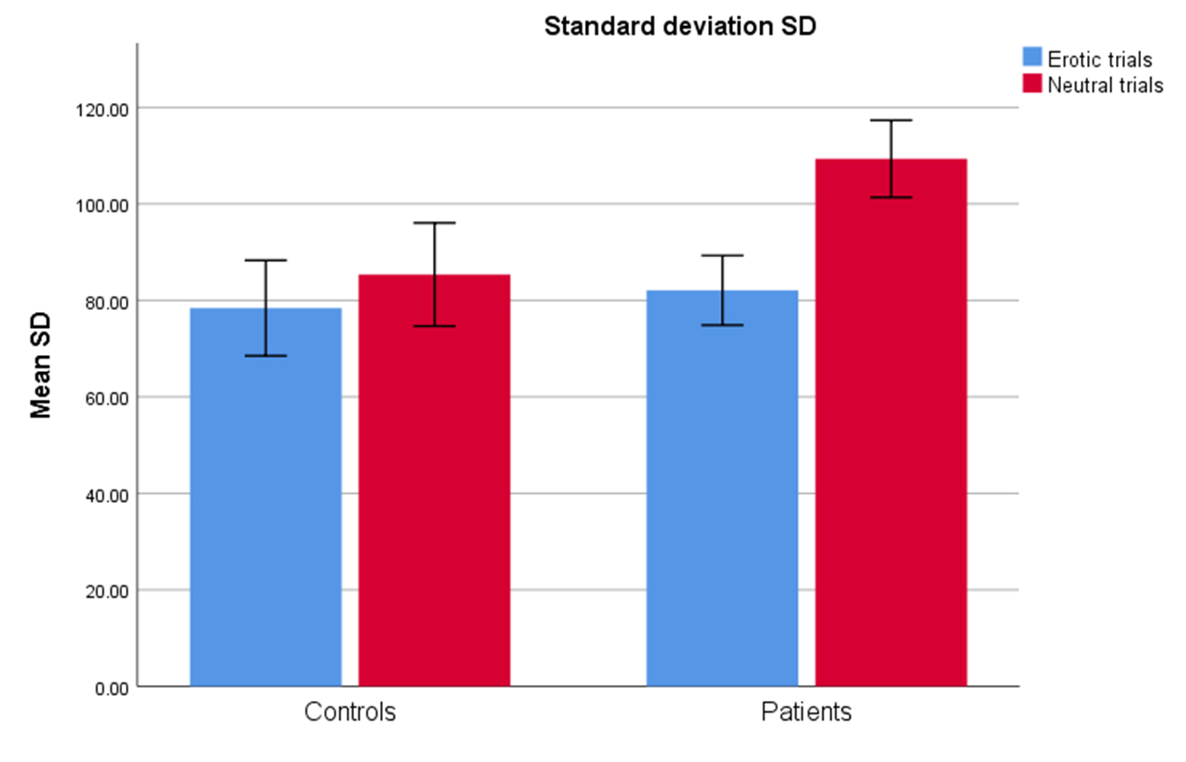

Rating of cravings, liking, arousal and other emotional responses during the fMRI task
Detailed results of the fMRI experiment-related questionnaires can be found in Tables S4-S6. CSBD patients and HC did not differ in cravings/desire for food, spending money, consume nicotine, alcohol, or other drugs, but CSBD patients desired to engage in gambling and sexual activity more than HC before the experiment. After the experiment, CSBD patients still desired to engage in sexual activity more than HC, but desire ratings for gambling were not significant anymore. Thus, the gambling desire before the experiment, could have been associated with the desire to perform the upcoming experimental task. Comparing such ratings before and after the experiment revealed that desires for none of the items had increased after the experiment, except for the desire to engage in sexual activity. This effect was similar in both groups, indicating the task has specifically targeted and increased sexual desire.
There were no group differences with respect how much participants looked forward to view or liked erotic and non-erotic images, respectively. However, CSBD patients looked significantly more forward to view erotic images than non-erotic images, while corresponding ratings did not differ in HC. Compared to non-erotic images, both groups liked erotic images more and were more sexually aroused by erotic images, however, all image types received overall positive emotional ratings.
Moreover, CSBD patients, experienced significantly more feelings of shame and guilt and reported to have tried to control their sexual arousal during the experiment. CSBD and HC did not differ with respect to time passed since last climax, which was more than 24 hours on average (Table S7).
ΔRT correlated with the time passed from last climax, craving for food and engaging in sexual activity after the experiment, as well as how strong participants felt sexually aroused by the erotic stimuli (Table S13). VS mean activation during anticipation correlated negatively with feelings of embarrassment.
Moreover, regression analyses on the main rating of interest (looking forward to viewing erotic images) revealed that in patients, not in controls, VS activity during anticipation correlated positively with the ‘looking forward’ rating (r=.61, p=0.002; Figure 4). Such correlations with ΔRT were suggestive (see paragraph below).

Regression analyses testing for relationship between VS activation during anticipation (and ΔRT) and ‘looking forward to viewing erotic images’ in HC and CSBD
In these secondary analyses, we tested for the relationship between ‘looking forward’ rating scores and VS activation during anticipation (dependent variable), and for potential group-by-‘looking forward’ score interaction effects on VS activation. The latter was performed to test whether the VS activation vs. rating relationship differs between patients and controls. The same was done using ΔRT as dependent variable.
We observed a group-by-‘looking forward’ rating interaction on VS activation during anticipation (F=4.3, p=0.045) and non-significant main effects of age (p=0.051), group (p=0.115), and ‘looking forward’ ratings (p=0.144). Follow-up analyses on the interaction effect revealed that VS activity correlated with ‘looking forward’ rating in CSBD patients (r=.61, p=0.002) but not in controls (r=-.221, p=0.362). The correlation in patients remained when removing the outlier with highest VS activation (r=.586, p=0.005).
Regarding ΔRT, we observed a group-by-‘looking forward’ rating interaction on ΔRT (F=5.1, p=0.030) and a significant main effects of age (p=0.029) and ‘looking forward’ rating (p=0.035), and a non-significant main effect of group (p=0.556). Follow-up analyses on the interaction effect revealed a suggestive correlation between ΔRT and ‘looking forward’ rating in CSBD patients (r=-.38, p=0.09) but not in controls (r=.22, p=0.364).

Table S4: Cravings/desires before and after fMRI experiment:
Craving/desire for |  | Before |  | HC vs. CSBD | After |  | HC vs. CSBD | Before vs After
 | Group | Mean | SD | p | Mean | SD | p | p
Food | HC | 3.26 | 2.423 | 0.108 | 4.15 | 2.943 | 0.398 | 0.157
 | CSBD | 4.48 | 2.352 |  | 4.95 | 3.139 |  | 0.582
Gambling | HC | 0 | 0 | 0.028 | 0 | 0 | 0.076 | -
 | CSBD | 0.61 | 1.158 |  | 0.5 | 1.225 |  | 0.525
Spending money | HC | 0.84 | 1.573 | 0.224 | 0.7 | 1.625 | 0.668 | 0.755
 | CSBD | 1.48 | 1.729 |  | 0.91 | 1.509 |  | 0.045
Nicotine use | HC | 1.11 | 2.424 | 0.093 | 0.9 | 2.125 | 0.16 | 0.481
 | CSBD | 2.91 | 4.01 |  | 2.23 | 3.611 |  | 0.056
Alcohol use | HC | 0.89 | 2.208 | 0.917 | 1.05 | 2.038 | 0.994 | 0.684
 | CSBD | 0.96 | 1.581 |  | 1.05 | 1.759 |  | 0.898
Drug use | HC | 0.16 | 0.501 | 0.521 | 0.1 | 0.447 | 0.317 | 0.33
 | CSBD | 0.35 | 1.191 |  | 0.45 | 1.503 |  | 0.162
Engaging in sex | HC | 2.11 | 2.132 | 0.014 | 3.55 | 2.743 | 0.025 | 0.002*
 | CSBD | 4.3 | 3.169 |  | 5.64 | 3.032 |  | 0.019*
*Note: Comparing the before-after increase in sexual desire between groups was not significant (p=0.506). Hence the increase was similar in both groups

Table S5: Picture and emotion ratings (fMRI):
Picture and emotion ratings | Group | Mean | SD | HC vs CSBD p
looking forward to erotic images (asked before fMRI) | HC | 4.53 | 2.22 | 0.822
 | CSBD | 4.7 | 2.548
looking forward to non-erotic images (asked before fMRI) | HC | 3.95 | 2.368 | 0.549
 | CSBD | 3.57 | 1.727
Liking of erotic images | HC | 5.4 | 1.93 | 0.058
 | CSBD | 6.64 | 2.15
Liking of non-erotic images | HC | 4.15 | 1.927 | 0.461
 | CSBD | 3.73 | 1.751
sexual arousal induced by erotic images | HC | 4.2 | 2.215 | 0.172
 | CSBD | 5.18 | 2.343
sexual arousal induced by non-erotic images | HC | 0.8 | 0.894 | 0.128
 | CSBD | 1.59 | 2.108
Negative-positive feeling induced by erotic images (5=neutral) | HC | 6.85 | 1.309 | 0.233
 | CSBD | 6.36 | 1.293
Negative-positive feelings induced by non-erotic images (5=neutral) | HC | 6.25 | 1.209 | 0.068
 | CSBD | 5.45 | 1.503
Felt embarrassed during experiment | HC | 0.65 | 1.182 | 0.076
 | CSBD | 1.73 | 2.394
Experienced feeling of shame during experiment | HC | 0.35 | 0.671 | 0.028
 | CSBD | 1.5 | 2.155
Experienced feeling of guilt during experiment | HC | 0.15 | 0.671 | 0.005
 | CSBD | 1.64 | 2.15
Tried to control sexual arousal during experiment | HC | 0.4 | 1.142 | 0.002
 | CSBD | 2.45 | 2.464

Tables S6: Comparing erotic vs non-erotic image ratings
erotic vs. non erotic | Group | p-value
looking forward | HC | 0.231
 | CSBD | 0.008
liking | HC | 0.002
 | CSBD | <0.001
sexual arousal | HC | <0.001
 | CSBD | <0.001
positive-negative | HC | 0.055
 | CSBD | 0.012

Table S7: Hours since last sexual orgasm/climax
Hours since last climax | < 8 hours | > 8 hours | > 12 hours | > 24 hours | > 48 hours | p-value
HC | 0 | 0 | 2 | 7 | 10 | 0.330
CSBD | 0 | 1 | 6 | 9 | 7 | 0.330

Sensitivity analyses (controlling for potential confounders)
For both, VS activity and ΔRT we performed follow-up analyses to test for potential confounding by demographic and clinical variables in group comparisons. Therefore, we repeated group comparisons while using each variable listed in Table 1 and 2 (except for ΔRT) as additional covariates (one at a time). We further corrected for desire, liking, and emotional ratings that either showed group differences or correlated with ΔRT and VS activation during anticipation (see Results and Table S13). We did not correct for CSBD symptom scores, as those directly relate to the phenotype of interest, and correcting for these measured would remove important variance of interest (Hyatt et al., 2020). For follow-up tests controlling for comorbidity and medication use variables, where the number of participants with a specific comorbidity or medication use was low, we repeated the group comparisons while excluding these participants. The variables tested and results of these tests are provided in Table S8.

Table S8: Sensitivity analyses
Group differences (follow-up sensitivity tests)
ΔRT (p-value) | VS activity (p-value) | Control variable
0.009 | 0.457 | age
0.010 | 0.238 | BMI
0.047 | 0.721 | snus
0.080 | 0.909 | smoking
0.069 | 0.961 | handedness
0.010 | 0.479 | Kinsey score
0.017 | 0.499 | Excl. homosexuals
0.736 | 0.456 | MADRS
0.039 | 0.871 | AUDIT
0.016 | 0.499 | DUDIT
0.078 | 0.412 | RAADS
0.088 | 0.581 | ASRS
0.087 | 0.272 | BIS11
0.100 | 0.578 | BAS, drive
0.053 | 0.617 | BAS, fun
0.021 | 0.533 | BAS, reward
0.076 | 0.743 | BIS-11
0.021 | 0.283 | RAVEN
0.005 | 0.625 | Adj. pumps
0.007 | 0.501 | Adj. pumps (blue)
0.005 | 0.592 | number of explosions
0.008 | 0.363 | SSRT
0.039 | 0.388 | Antihistamine use
0.011 | 0.480 | Stimulant use
0.012 | 0.615 | blood pressure med.
0.026 | 0.245 | Antidepressant use
0.016 | 0.286 | Panic disorder
0.009 | 0.264 | GAD
0.007 | 0.430 | ADHD
0.009 | 0.457 | Chronic pain
0.009 | 0.520 | Hypomania
0.017 | 0.500 | Depression
0.044 | 0.955 | STAI
0.006 | 0.466 | may like on-erotic (before fMRI)
0.091 | 0.951 | craving for sex (before fMRI)
0.021 | 0.826 | craving for gambling (before fMRI)
0.014 | 0.62 | hours since last climax
0.002 | 0.529 | craving for food (after fMRI)
0.081 | 0.904 | craving for sex (after fMRI)
0.037 | 0.094* | feeling embarrassed during fMRI
0.047 | 0.056 | feelings of shame during fMRI
0.058 | 0.186 | feeling of guilt during fMRI
0.026 | 0.271 | controlled arousal during fMRI

P-values for group comparisons in ΔRT and ventral striatum (VS) activity during anticipation (contrast 1) while controlling for age (main analysis as reported in the main text) and additional control variables are listed. We did not control for symptom scores related to CSBD as they relate to the phenotype of interest.
Note: several of these variables tested may relate to CSBD, such as MADRS, smoking status, RAADS, ASRS, BIS/BAS, RAVEN, risk taking, SSRT, medication use, and comorbidities.
*Note: Group differences in VS during anticipation was significant (p=0.046) when simultaneously correcting for BMI and feeling embarrassed during fMRI with adjust means (SD) for HC: 35.9 (140) and CSBD: 453.6 (133).

Figure S2. Correlation between VS activation during anticipation and RT difference (ΔRT) after removing the visual outlier in Figure 4 (main text).

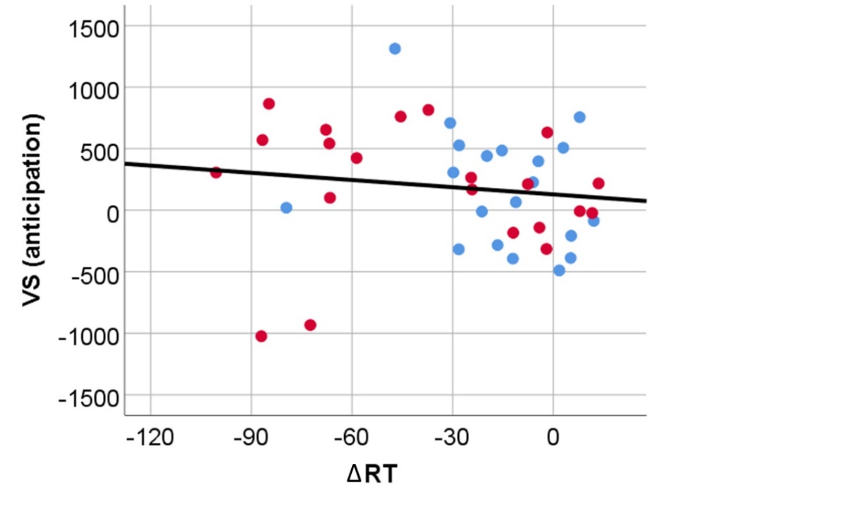
The significance of the correlation reduced when excluding the outlier (p=0.072), but the strength and direction of the correlation remained (r = -.28). Note: the visual outlier showed the highest CSBD symptoms scores among all subjects (see below), and we did not identify reasons to exclude this outlier (no erroneous data). We deem the non-parametric results including the outlier as more reliable.

Multivariate outlier analysis
Using linear regression in SPSS, we tested whether aforementioned visual outlier can be regarded as multivariate outlier. The set of variables tested were ΔRT, VS activity during anticipation, the four investigated CSBD symptom measures (HDSI, HBI, SDI, and SCS). The subject who appeared as visual outlier above exhibited the highest Mahalanobis distance and the lowest corresponding probability of 0.0013. Although, per definition, this was not regarded a multivariate outlier, the obtained probability value was close to 0.001, which is the widely agreed on threshold under which it could be considered as such. Given that and the fact this subject had the highest Mahalanobis distance across all subjects and the highest CSBD symptom scores, these results speak against erroneous VS activity or ΔRT measures, further strengthening our group-level findings. Importantly, these results were also indicative for potential CSBD subgroups.

Table S9: Intercorrelations of VS activity, ΔRT, and CSBD symptom scores. Results are from non-parametric Spearman rank correlations.
Measure | Results | VS contrast 1 (anticipation) | ΔRT
VS contrast 1 (anticipation) | Correlation Coefficient |  | -0.334
 | Sig. (2-tailed) |  | 0.031
 | N |  | 42
VS contrast 2 (viewing) | Correlation Coefficient | 0.006 | 0.181
 | Sig. (2-tailed) | 0.969 | 0.250
 | N | 42 | 42
ΔRT | Correlation Coefficient | -0.334
 | Sig. (2-tailed) | 0.031
 | N | 42
HDSI | Correlation Coefficient | 0.094 | -0.319
 | Sig. (2-tailed) | 0.553 | 0.04
 | N | 42 | 42
HBI | Correlation Coefficient | 0.208 | -0.387
 | Sig. (2-tailed) | 0.186 | 0.011
 | N | 42 | 42
SDI | Correlation Coefficient | 0.131 | -0.299
 | Sig. (2-tailed) | 0.416 | 0.058
 | N | 41 | 41
SCS | Correlation Coefficient | 0.189 | -0.406
 | Sig. (2-tailed) | 0.231 | 0.008
 | N | 42 | 42
pornography, time per week | Correlation Coefficient | 0.328 | -0.224
 | Sig. (2-tailed) | 0.039 | 0.165
 | N | 40 | 40
pornography, hours per week | Correlation Coefficient | 0.476 | -0.225
 | Sig. (2-tailed) | 0.002 | 0.174
 | N | 38 | 38
pornography, age first time | Correlation Coefficient | -0.157 | 0.074
 | Sig. (2-tailed) | 0.326 | 0.644
 | N | 41 | 41
planned analyses
exploratory
significant exploratory

No significant correlations were observed for contrast 2 (viewing phase).
Table S10: Intercorrelations of VS activity, ΔRT, and CSBD symptom scores as reported in Table S9 when removing the visual outlier in Figure 4.
Note: There was no indication for erroneous data and this subject scored the highest on all CSBD symptoms scores among all CSBD patients. Hence, there was no reason to remove this outlier from analyses. These analyses were done to test for robustness of the findings.

Measure | Results | VS contrast 1 (anticipation) | ΔRT
VS contrast 1 (anticipation) | Correlation Coefficient |  | -0.284
 | Sig. (2-tailed) |  | 0.072
 | N |  | 41
VS contrast 2 (viewing) | Correlation Coefficient | 0.082 | 0.12
 | Sig. (2-tailed) | 0.612 | 0.455
 | N | 41 | 41
ΔRT | Correlation Coefficient | -0.284
 | Sig. (2-tailed) | 0.072
 | N | 41
HDSI | Correlation Coefficient | 0.069 | -0.307
 | Sig. (2-tailed) | 0.667 | 0.051
 | N | 41 | 41
HBI | Correlation Coefficient | 0.148 | -0.341
 | Sig. (2-tailed) | 0.355 | 0.029
 | N | 41 | 41
SDI | Correlation Coefficient | 0.064 | -0.245
 | Sig. (2-tailed) | 0.696 | 0.128
 | N | 40 | 40
SCS | Correlation Coefficient | 0.136 | -0.362
 | Sig. (2-tailed) | 0.395 | 0.02
 | N | 41 | 41
pornography, time per week | Correlation Coefficient | 0.274 | -0.162
 | Sig. (2-tailed) | 0.091 | 0.323
 | N | 39 | 39
pornography, hours per week | Correlation Coefficient | 0.437 | -0.162
 | Sig. (2-tailed) | 0.007 | 0.339
 | N | 37 | 37
pornography, age first time | Correlation Coefficient | -0.154 | 0.068
 | Sig. (2-tailed) | 0.344 | 0.677
 | N | 40 | 40

No significant correlations were observed for contrast 2 (viewing).
Table S11: Cluster statistics for whole brain fMRI analyses (exploratory) for contrasts 1 and 2 (erotic > non-erotic).
Controls, Anticipation
Cluster Index | Voxels | -log10(P) | Z-MAX | X | Y | Z | Brain region (Brodmann area)
3 | 25014 | 40.4 | 5.06 | 52 | 2 | 42 | Right premotor suppl. Motor (6)
2 | 3161 | 09.59 | 4.50 | -52 | 2 | 10 | Left premotor suppl. Motor (6)
1 | 1957 | 07.15 | 5.05 | 54 | 6 | 4 | Right Broca Operc (44)
Patients, Anticipation
Cluster Index | Voxels | -log10(P) | Z-MAX | X | Y | Z
1 | 47901 | 62.7 | 5.24 | -52 | -30 | 46 | Left Supramarginal gyr (40)
Controls, Viewing
Voxels | Voxels | -log10(P) | Z-MAX | X | Y | Z
4 | 22861 | 43.7 | 6.54 | -38 | -44 | 46 | Left VisMotor (7)
3 | 12137 | 28.3 | 6.18 | -40 | 12 | -6 | Left Insula (13)
2 | 6043 | 17.5 | 6.21 | -2 | 38 | 8 | Left VentANtCing (24)
1 | 272 | 01.45 | 4.24 | 20 | -80 | 10 | Right PrimVisual (17)
Patients, Viewing
Cluster Index | Voxels | -log10(P) | Z-MAX | X | Y | Z
5 | 20842 | 41 | 7.12 | 34 | -56 | 60 | Right VIsMotor (7)
4 | 5282 | 15.9 | 6.42 | -4 | 36 | 16 | Left DorsalACC (32)
3 | 4032 | 13.1 | 6.34 | -42 | 12 | -4 | Left Insula (13)
2 | 3873 | 12.8 | 6.30 | 40 | 12 | -8 | Right Insula (13)
1 | 3311 | 11.4 | 6.23 | 4 | -28 | -12 | Right superior cerebellar peduncle,  midbrain (JHU atlas)

Group-wise cluster statistics after correction (-log10(p)), number of main clusters, maximal z value (z-max), and corresponding MNI coordinates (x,y,z), and brain regions are indicated (https://bioimagesuiteweb.github.io/webapp/mni2tal.html).
Note: Clusters cover larger regions with several local maxima, which are provided in Table S12.

Table S12: MNI coordinates of local maxima within clusters provided in Table S11.
Group, phase | Cluster Index | Z | x | y | z
Controls, Anticipation | 3 | 5.06 | 52 | 2 | 42
 | 3 | 5.18 | -50 | -68 | 2
 | 3 | 5.16 | 6 | -2 | 68
 | 3 | 5.11 | -8 | 14 | 38
 | 3 | 5.11 | 34 | -10 | 52
 | 3 | 5.08 | -44 | -4 | 60
 | 2 | 4.50 | -52 | 2 | 10
 | 2 | 4.45 | -42 | 12 | 12
 | 2 | 4.22 | -28 | 18 | 2
 | 2 | 4.14 | 30 | -26 | 24
 | 2 | 4.13 | -46 | 2 | 38
 | 2 | 4.09 | -50 | 8 | -2
 | 1 | 5.05 | 54 | 6 | 4
 | 1 | 4.54 | 42 | 20 | 10
 | 1 | 4.52 | 44 | 18 | 4
 | 1 | 4.33 | 24 | 14 | 12
 | 1 | 4.02 | 20 | -8 | 4
 | 1 | 4.39 | 44 | 2 | 2
Patients, Anticipation | 1 | 5.24 | -52 | -30 | 46
 | 1 | 5.21 | 38 | -52 | 36
 | 1 | 5.2 | -46 | -30 | 48
 | 1 | 5.15 | -26 | -56 | 48
 | 1 | 5.15 | -32 | -58 | 48
 | 1 | 5.14 | -32 | -58 | 56
Controls, Viewing
 | 4 | 6.54 | -38 | -44 | 46
 | 4 | 6.32 | -56 | -24 | 34
 | 4 | 6.30 | -26 | -78 | 34
 | 4 | 6.28 | -46 | -64 | -4
 | 4 | 6.20 | -32 | -50 | 50
 | 4 | 6.17 | -46 | -38 | 40
 | 3 | 6.18 | -40 | 12 | -6
 | 3 | 6.16 | -48 | 2 | 28
 | 3 | 6.12 | -38 | -6 | 14
 | 3 | 6.09 | 40 | 12 | -10
 | 3 | 6.09 | 30 | 24 | 2
 | 3 | 5.52 | 46 | 8 | 26
 | 2 | 6.21 | -2 | 38 | 8
 | 2 | 6.18 | -2 | 34 | 16
 | 2 | 6.15 | 0 | 30 | 20
 | 2 | 6.13 | 2 | 38 | 22
 | 2 | 6.09 | -10 | 30 | 26
 | 2 | 6.02 | 4 | 16 | 28
 | 1 | 4.24 | 20 | -80 | 10
 | 1 | 4.2 | 18 | -80 | 16
 | 1 | 4.18 | 18 | -74 | 16
 | 1 | 4.16 | 14 | -74 | 18
Patients, Viewing
 | 5 | 7.12 | 34 | -56 | 60
 | 5 | 6.55 | 34 | -56 | 52
 | 5 | 6.48 | -50 | -62 | 0
 | 5 | 6.47 | -22 | -66 | 60
 | 5 | 6.32 | -20 | -68 | 36
 | 5 | 6.29 | -22 | -72 | 40
 | 4 | 6.42 | -4 | 36 | 16
 | 4 | 6.18 | -6 | 40 | 4
 | 4 | 6.10 | 4 | 36 | 18
 | 4 | 6.03 | 2 | 34 | 24
 | 4 | 5.52 | 6 | 42 | 14
 | 4 | 5.29 | -2 | -4 | 30
 | 3 | 6.34 | -42 | 12 | -4
 | 3 | 6.08 | -38 | 8 | -6
 | 3 | 6.31 | -28 | -2 | 48
 | 3 | 6.26 | -32 | 10 | -8
 | 3 | 5.55 | -32 | -4 | 52
 | 3 | 5.51 | -38 | 26 | 4
 | 2 | 6.30 | 40 | 12 | -8
 | 2 | 5.39 | 48 | 32 | 8
 | 2 | 5.34 | 38 | 26 | -2
 | 2 | 5.03 | 50 | 6 | 30
 | 2 | 5.33 | 32 | -2 | 50
 | 2 | 5.32 | 46 | 40 | 10
 | 1 | 6.23 | 4 | -28 | -12
 | 1 | 6.03 | 6 | -4 | 0
 | 1 | 6.02 | 6 | -20 | -14
 | 1 | 5.22 | -4 | -18 | -8
 | 1 | 5.37 | -22 | -38 | 0
 | 1 | 5.33 | -18 | -36 | 0

Table S13: Correlations with desire, liking, and emotional rating scales (before/after fMRI)
Measure | Results | ΔRT | VS (ant.)
Craving food (before fMRI) | Correlation Coefficient | 0.169 | -0.179
 | Sig. (2-tailed) | 0.285 | 0.257
 | N | 42 | 42
Craving gambling (before fMRI) | Correlation Coefficient | -0.093 | 0.154
 | Sig. (2-tailed) | 0.56 | 0.329
 | N | 42 | 42
Craving spending money (before fMRI) | Correlation Coefficient | -0.073 | 0.157
 | Sig. (2-tailed) | 0.646 | 0.321
 | N | 42 | 42
Craving nicotine (before fMRI) | Correlation Coefficient | -0.243 | -0.089
 | Sig. (2-tailed) | 0.122 | 0.575
 | N | 42 | 42
Craving alcohol (before fMRI) | Correlation Coefficient | -0.15 | 0.111
 | Sig. (2-tailed) | 0.343 | 0.483
 | N | 42 | 42
Craving dugs (before fMRI) | Correlation Coefficient | -0.159 | 0.136
 | Sig. (2-tailed) | 0.316 | 0.389
 | N | 42 | 42
Craving engaging in sex (before fMRI) | Correlation Coefficient | -0.278 | 0.187
 | Sig. (2-tailed) | 0.074 | 0.235
 | N | 42 | 42
looking forward to erotic images | Correlation Coefficient | -0.25 | 0.239
 | Sig. (2-tailed) | 0.114 | 0.132
 | N | 41 | 41
looking forward non-erotic images | Correlation Coefficient | -0.063 | -0.014
 | Sig. (2-tailed) | 0.697 | 0.929
 | N | 41 | 41
Utlos_timmer | Correlation Coefficient | 0.308 | -0.098
 | Sig. (2-tailed) | 0.05 | 0.54
 | N | 41 | 41
Craving food (after fMRI) | Correlation Coefficient | 0.434 | 0.014
 | Sig. (2-tailed) | 0.004 | 0.932
 | N | 42 | 42
Craving gambling (after fMRI) | Correlation Coefficient | -0.085 | 0.073
 | Sig. (2-tailed) | 0.59 | 0.644
 | N | 42 | 42
Craving spending money (after fMRI) | Correlation Coefficient | 0.041 | -0.028
 | Sig. (2-tailed) | 0.799 | 0.862
 | N | 42 | 42
Craving nicotine (after fMRI) | Correlation Coefficient | -0.097 | -0.087
 | Sig. (2-tailed) | 0.54 | 0.586
 | N | 42 | 42
Craving alcohol (after fMRI) | Correlation Coefficient | -0.134 | 0.005
 | Sig. (2-tailed) | 0.397 | 0.977
 | N | 42 | 42
Craving dugs (after fMRI) | Correlation Coefficient | -0.194 | 0.1
 | Sig. (2-tailed) | 0.218 | 0.529
 | N | 42 | 42
Craving engaging in sex (after fMRI) | Correlation Coefficient | -0.437 | 0.241
 | Sig. (2-tailed) | 0.004 | 0.125
 | N | 42 | 42
Liking of erotic images | Correlation Coefficient | -0.264 | 0.286
 | Sig. (2-tailed) | 0.091 | 0.067
 | N | 42 | 42
Liking of non-erotic images | Correlation Coefficient | 0.007 | 0.228
 | Sig. (2-tailed) | 0.963 | 0.146
 | N | 42 | 42
sexual arousal induced by erotic images | Correlation Coefficient | -0.431 | 0.226
 | Sig. (2-tailed) | 0.004 | 0.15
 | N | 42 | 42
sexual arousal induced by non-erotic images | Correlation Coefficient | -0.009 | 0.068
 | Sig. (2-tailed) | 0.957 | 0.669
 | N | 42 | 42
Negative-positive feeling induced by erotic images | Correlation Coefficient | 0.107 | 0.198
 | Sig. (2-tailed) | 0.499 | 0.208
 | N | 42 | 42
Negative-positive feeling induced by non-erotic images | Correlation Coefficient | 0.148 | 0.264
 | Sig. (2-tailed) | 0.349 | 0.091
 | N | 42 | 42
Felt embarrassed | Correlation Coefficient | -0.194 | -0.31
 | Sig. (2-tailed) | 0.217 | 0.046
 | N | 42 | 42
feeling of shame | Correlation Coefficient | -0.164 | -0.272
 | Sig. (2-tailed) | 0.299 | 0.082
 | N | 42 | 42
feeling of guilt | Correlation Coefficient | -0.231 | -0.131
 | Sig. (2-tailed) | 0.14 | 0.41
 | N | 42 | 42
Tried to control sexual arousal | Correlation Coefficient | -0.282 | 0.042
 | Sig. (2-tailed) | 0.07 | 0.793
 | N | 42 | 42

Table S14: Correlations with BIS and BAS
Measure | Results | ΔRT | VS (ant.)
BIS-11 | Correlation Coefficient | -0.14 | -0.059
 | Sig. (2-tailed) | 0.382 | 0.714
 | N | 41 | 41
BIS/BAS (drive) | Correlation Coefficient | -0.538 | 0.284
 | Sig. (2-tailed) | <0.001 | 0.072
 | N | 41 | 41
BIS/BAS (fun seeking) | Correlation Coefficient | -0.292 | 0.128
 | Sig. (2-tailed) | 0.064 | 0.423
 | N | 41 | 41
BIS/BAS (reward response) | Correlation Coefficient | -0.353 | 0.229
 | Sig. (2-tailed) | 0.023 | 0.149
 | N | 41 | 41
BIS/BAS (BIS) | Correlation Coefficient | -0.301 | 0.089
 | Sig. (2-tailed) | 0.056 | 0.581
 | N | 41 | 41

Whole brain analyses of task-related activations in HC and CSBD and exploratory whole brain group comparisons.

Figure S3: Uncorrected (threshold at p=0.01) group comparison (CSBD > HC) of contrast 1 (anticipation). See main text for within group mean activations.
Note: The displayed results are uncorrected at threshold P=0.01. There were no significant differences in direct group comparisons after correction. Same applied to the reversed contrast (HC>CSBD).

Figure S4: Task-related fMRI mean activations (erotic > non-erotic) for contrast 2 (viewing) in HC.
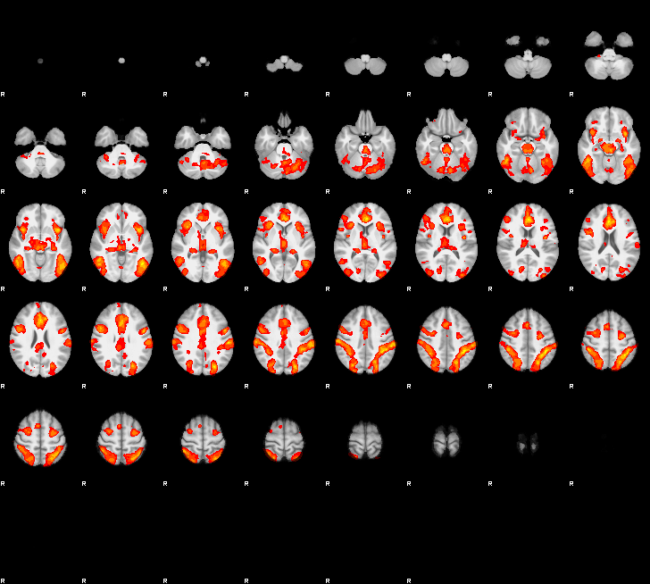
3.1 6.7

Figure S5: Task-related fMRI mean activations (erotic > non-erotic) for contrast 2 (viewing) in CSBD.
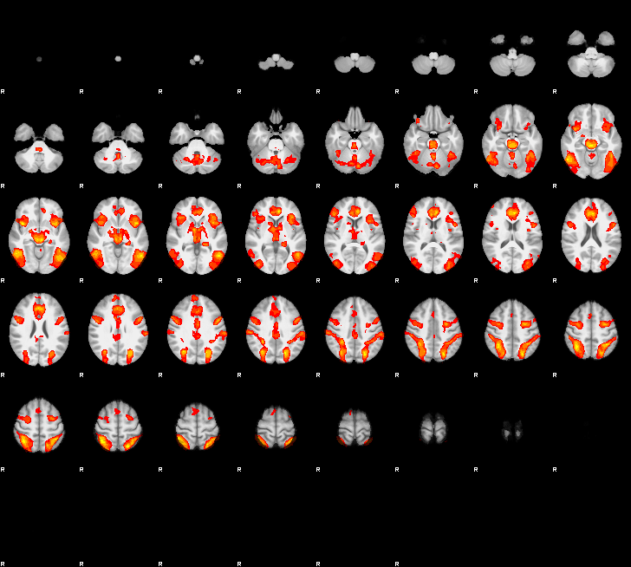
3.1 6.7

In summary, within-group task-related activations were focal to regions previously reported during both anticipation (main text) and processing of visual sexual stimuli, e.g., VS, anterior cingulate cortex, orbitofrontal cortex, insula, (pre)motor, visual, and occipitotemporal regions (Georgiadis et al., 2012; Jauhar et al., 2021; Oldham et al., 2018), supporting the validity and applicability of the task.

Figure S6: Uncorrected (threshold at p=0.01) group comparison (CSBD > HC) of contrast 2 (anticipation).
Note: The displayed results are uncorrected at threshold P=0.01. There were no significant differences in direct group comparisons after correction. Same applied to the reversed contrast (HC>CSBD).

Figure S7: Anatomical location of VS-ROI from which mean activations were extracted for main fMRI analyses.
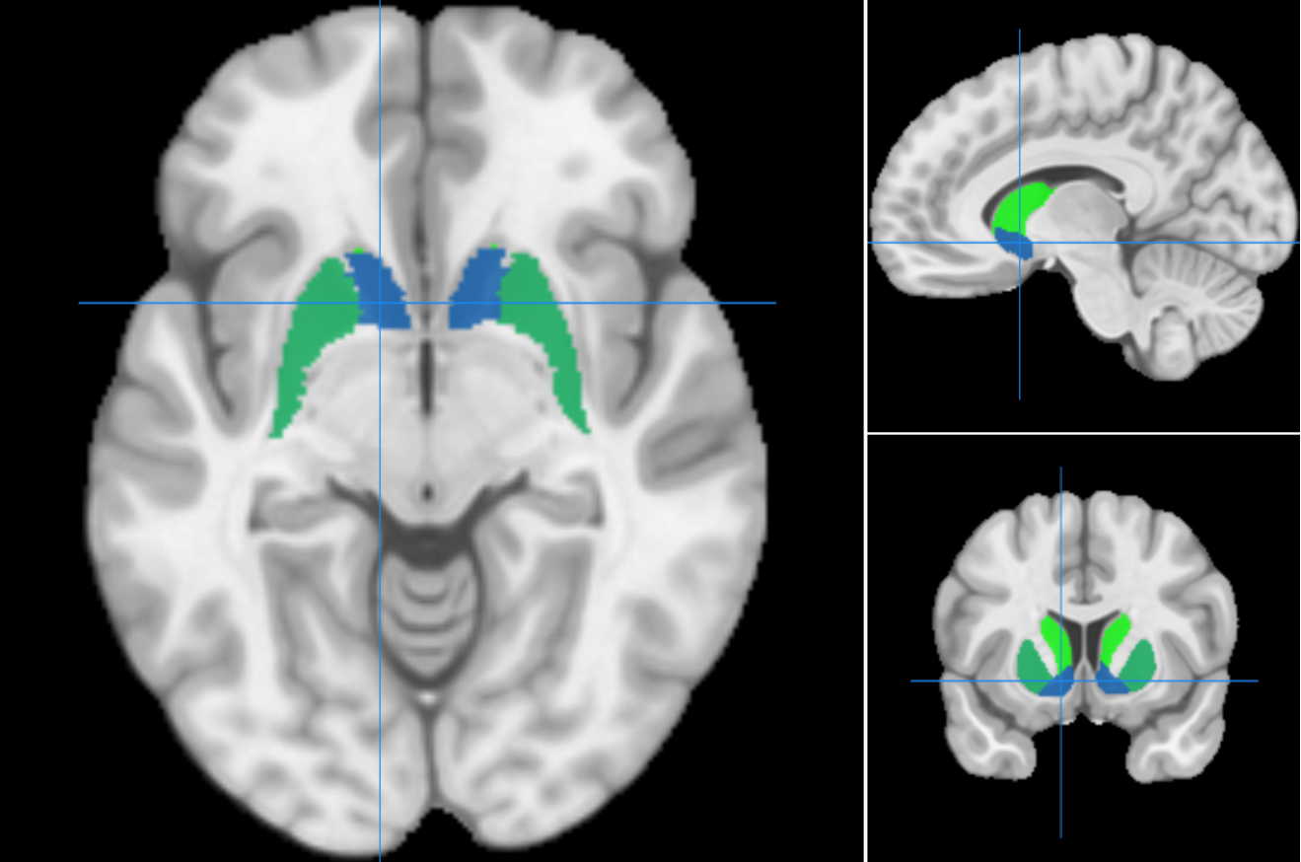
Structural segmentation as defined in the Oxford-GSK-Imanova Structural–anatomical Striatal Atlas (Tziortzi et al., 2011).
The bilateral ventral striatum (VS) ROI used in this study is shown in blue. Anatomical location aligns with meta-analysis-based VS activation during anticipation in Oldham et. al. [MNI coordinates VS (left): -10, 10, -6; VS(right): 12, 10, -4].

One sample t-tests comparing VS activity for contrast 1 and 2 against zero.
While one-sample t-tests revealed that mean VS activity for anticipation (contrast 1) was significantly different from zero (p=0.018), mean VS activity during the viewing phase (contrast 2) was not (p=0.193), indicating that VS activation can be attributed to anticipation rather than viewing of sexual stimuli. This suggests that VS activity observed using paradigms that contain viewing phases only, could potentially be attributed to anticipation processes rather than processing of sexual image content.

Supplemental References:
Andersson, J. L. R., Jenkinson, M., & Smith, S. (2007). Non-linear registration, aka Spatial normalisation FMRIB technical report TR07JA2. FMRIB Analysis Group of the University of Oxford, 2(1), e21.
Banca, P., Morris, L. S., Mitchell, S., Harrison, N. A., Potenza, M. N., & Voon, V. (2016). Novelty, conditioning and attentional bias to sexual rewards. Journal of psychiatric research, 72, 91-101. doi:10.1016/j.jpsychires.2015.10.017
Fiorillo, C. D., Tobler, P. N., & Schultz, W. (2003). Discrete coding of reward probability and uncertainty by dopamine neurons. Science, 299(5614), 1898-1902. doi:10.1126/science.1077349
Georgiadis, J. R., & Kringelbach, M. L. (2012). The human sexual response cycle: brain imaging evidence linking sex to other pleasures. Prog Neurobiol, 98(1), 49-81. doi:10.1016/j.pneurobio.2012.05.004
Gola, M., Wordecha, M., Marchewka, A., & Sescousse, G. (2016). Visual Sexual Stimuli-Cue or Reward? A Perspective for Interpreting Brain Imaging Findings on Human Sexual Behaviors. Front Hum Neurosci, 10, 402. doi:10.3389/fnhum.2016.00402
Gola, M., Wordecha, M., Sescousse, G., Lew-Starowicz, M., Kossowski, B., Wypych, M., . . . Marchewka, A. (2017). Can Pornography be Addictive? An fMRI Study of Men Seeking Treatment for Problematic Pornography Use. Neuropsychopharmacology : official publication of the American College of Neuropsychopharmacology, 42(10), 2021-2031. doi:10.1038/npp.2017.78
Hyatt, C. S., Owens, M. M., Crowe, M. L., Carter, N. T., Lynam, D. R., & Miller, J. D. (2020). The quandary of covarying: A brief review and empirical examination of covariate use in structural neuroimaging studies on psychological variables. Neuroimage, 205, 116225. doi:10.1016/j.neuroimage.2019.116225
Jauhar, S., & Fortea, L. (2021). Brain activations associated with anticipation and delivery of monetary reward: A systematic review and meta-analysis of fMRI studies. 16(8), e0255292. doi:10.1371/journal.pone.0255292
Jenkinson, M., Bannister, P., Brady, M., & Smith, S. (2002). Improved optimization for the robust and accurate linear registration and motion correction of brain images. Neuroimage, 17(2), 825-841.
Jenkinson, M., Beckmann, C. F., Behrens, T. E. J., Woolrich, M. W., & Smith, S. M. (2012). Fsl. Neuroimage, 62(2), 782-790.
Kafka, M. P. (2010). Hypersexual disorder: a proposed diagnosis for DSM-V. Arch Sex Behav, 39(2), 377-400. doi:10.1007/s10508-009-9574-7
Knutson, B., Westdorp, A., Kaiser, E., & Hommer, D. (2000). FMRI visualization of brain activity during a monetary incentive delay task. Neuroimage, 12(1), 20-27. doi:10.1006/nimg.2000.0593
Lang, P. J., Bradley, M. M., & Cuthbert, B. N. (2008). International Affective Picture System (IAPS): Affective Ratings of Pictures and Instruction Manual Technical Report A-8, University of Florida.
Marchewka, A., Zurawski, L., Jednorog, K., & Grabowska, A. (2014). The Nencki Affective Picture System (NAPS): introduction to a novel, standardized, wide-range, high-quality, realistic picture database. Behav Res Methods, 46(2), 596-610. doi:10.3758/s13428-013-0379-1
Oldham, S., Murawski, C., Fornito, A., Youssef, G., Yücel, M., & Lorenzetti, V. (2018). The anticipation and outcome phases of reward and loss processing: A neuroimaging meta-analysis of the monetary incentive delay task. Hum Brain Mapp, 39(8), 3398-3418. doi:10.1002/hbm.24184
Parsons, J. T., Rendina, H. J., Ventuneac, A., Cook, K. F., Grov, C., & Mustanski, B. (2013). A psychometric investigation of the hypersexual disorder screening inventory among highly sexually active gay and bisexual men: an item response theory analysis. J Sex Med, 10(12), 3088-3101. doi:10.1111/jsm.12117
Politis, M., Loane, C., Wu, K., O'Sullivan, S. S., Woodhead, Z., Kiferle, L., . . . Piccini, P. (2013). Neural response to visual sexual cues in dopamine treatment-linked hypersexuality in Parkinson's disease. Brain, 136(Pt 2), 400-411. doi:10.1093/brain/aws326
Ponseti, J., Bosinski, H. A., Wolff, S., Peller, M., Jansen, O., Mehdorn, H. M., . . . Siebner, H. R. (2006). A functional endophenotype for sexual orientation in humans. Neuroimage, 33(3), 825-833. doi:10.1016/j.neuroimage.2006.08.002
Reid, R. C., Garos, S., & Carpenter, B. N. (2011). Reliability, validity, and psychometric development of the Hypersexual Behavior Inventory in an outpatient sample of men. Sexual Addiction & Compulsivity, 18(1), 30-51. doi:10.1080/10720162.2011.555709
Sheehan, D. V., Lecrubier, Y., Sheehan, K. H., Amorim, P., Janavs, J., Weiller, E., . . . Dunbar, G. C. (1998). The Mini-International Neuropsychiatric Interview (M.I.N.I.): the development and validation of a structured diagnostic psychiatric interview for DSM-IV and ICD-10. J Clin Psychiatry, 59 Suppl 20, 22-33;quiz 34-57. Retrieved from http://www.ncbi.nlm.nih.gov/entrez/query.fcgi?cmd=Retrieve&db=PubMed&dopt=Citation&list_uids=9881538
Smith, S. M., Jenkinson, M., Woolrich, M. W., Beckmann, C. F., Behrens, T. E. J., Johansen-Berg, H., . . . Matthews, P. M. (2004). Advances in functional and structural MR image analysis and implementation as FSL. Neuroimage, 23, S208-S219. doi:https://doi.org/10.1016/j.neuroimage.2004.07.051
Tziortzi, A. C., Searle, G. E., Tzimopoulou, S., Salinas, C., Beaver, J. D., Jenkinson, M., . . . Gunn, R. N. (2011). Imaging dopamine receptors in humans with [11C]-(+)-PHNO: dissection of D3 signal and anatomy. Neuroimage, 54(1), 264-277. doi:10.1016/j.neuroimage.2010.06.044
Walter, M., Bermpohl, F., Mouras, H., Schiltz, K., Tempelmann, C., Rotte, M., . . . Northoff, G. (2008). Distinguishing specific sexual and general emotional effects in fMRI-subcortical and cortical arousal during erotic picture viewing. Neuroimage, 40(4), 1482-1494. doi:10.1016/j.neuroimage.2008.01.040
Wierzba, M., Riegel, M., Pucz, A., Lesniewska, Z., Dragan, W. L., Gola, M., . . . Marchewka, A. (2015). Erotic subset for the Nencki Affective Picture System (NAPS ERO): cross-sexual comparison study. Front Psychol, 6, 1336. doi:10.3389/fpsyg.2015.01336

