Supplementary Metarial

Supplemetary Table1
Antibodies used in the study
antibody name | Factory | Cat.number | Lot number | conc (mg/mL) | diluent
anti-CD63 | Sigma | SAB4301607 | 20N3140192 | 1.500 | 1:1000
anti-ALIX | Sigma | HPA011905 | 000009374 | 0.200 | 1:1000
anti-flotilin | Sigma | F1180 | 128M4839V | 1.000 | 1:1000
anti-TSG101 | Sigma | T5701 | 03M4775V | 2.000 | 1:1000
anti-rabbit IgG-HRP | abcam | ab205718 | GR3234362-1 | 2.000 | 1:25000

Supplemetary Table2
miRNAs studied
miR | assay ID | Mature miRNA Sequence
hsa-let-7a-5p | 478575_mir | UGAGGUAGUAGGUUGUAUAGUU
hsa-let-7g-5p | 478580_mir | UGAGGUAGUAGUUUGUACAGUU
hsa-miR-126-3p | 477887_mir | UCGUACCGUGAGUAAUAAUGCG
hsa-miR-148a-3p | 477814_mir | UCAGUGCACUACAGAACUUUGU
hsa-miR-15b-5p | 478313_mir | UAGCAGCACAUCAUGGUUUACA
hsa-miR-16-5p | 477860_mir | UAGCAGCACGUAAAUAUUGGCG
hsa-miR-200b-3p | 477963_mir | UAAUACUGCCUGGUAAUGAUGA
hsa-miR-223-5p | 477984_mir | CGUGUAUUUGACAAGCUGAGUU
hsa-miR-26a-5p | 477995_mir | UUCAAGUAAUCCAGGAUAGGCU
hsa-miR-423-5p | 478090_mir | UGAGGGGCAGAGAGCGAGACUUU
hsa-miR-425-5p | 478094_mir | AAUGACACGAUCACUCCCGUUGA
hsa-miR-484 | 478308_mir | UCAGGCUCAGUCCCCUCCCGAU

Supplemetary Table3
NormFinder test results
 | U937 | THP-1
Name | Stability value
miR-425 | 0,278 | 0,265
let-7a | 0,583 | 0,318
let-7g | 0,516 | 0,504
miR-126 | 6,072 | 6,781
miR-148 | 0,556 | 0,654
miR-15 | 0,398 | 0,495
miR-16 | 0,541 | 0,627
miR-200b | 0,358 | 1,043
miR-223 | 0,523 | 0,824
miR-26 | 0,611 | 0,591
miR-423 | 0,675 | 0,401
miR-484 | 1,301 | 0,658

Supplementary Figure 1
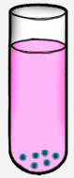
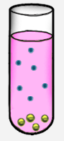
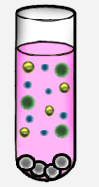
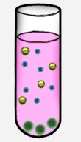
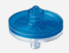
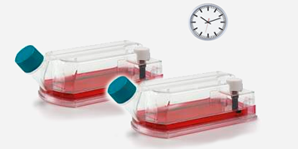

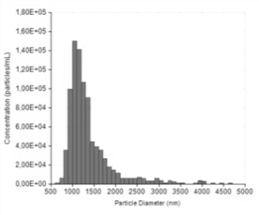

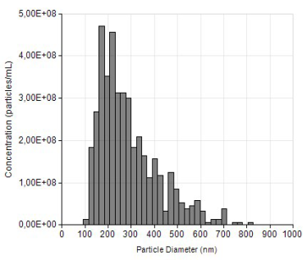
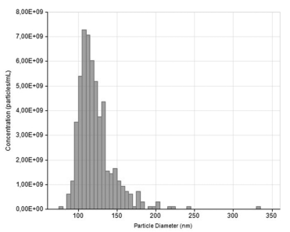
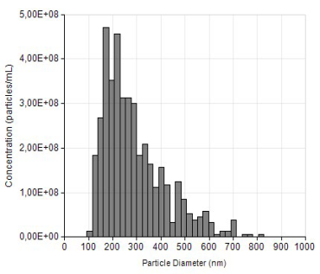
cell
2x
200g
lEV
5.0μm
2.000g
0.8μm
12.500g
0.2μm
100.000g
sEV
A
C
24h
B
D
90-100 kDa
30-60 kDa
49 kDa
45 kDa
5/4E8
CD63
Flotillin
TSG101
cell lEV mEV sEV
cell lEV mEV sEV
cell lEV mEV sEV
Alix
U937
THP-1

mEV

A: Schematic illustration of the EV separation protocol. Briefly, the conditioned media were first centrifuged at 200g 5 min twice to pellet cells, followed by a 5.00 μm pore size filtration by gravity to remove any remaining cells. The filtrate was then centrifuged at 2,000 for 20 min to pellet large EVs. The supernatant was subjected to a 0.8μm pore size hydrostatic filtration to remove any remaining large EVs. Medium sized EVs were pelleted at 12,500 for 20 min. This was followed by a final filtration through a 0.2 μm pore size filter and subjected to a 100,000g 70 min centrifugation. B: TEM of lEVs, mEVs and sEVs. C: Representative size distribution histograms of U937- derived EV subpopulations obtained with tunable resistive pulse sensing analysis (TRPS, qNano, IZON) D: Characterization of size-based EV subcategories by Western blot. Western blot analysis of EVs markers (Alix, CD63, TSG101 and flotillin).

Supplementary Figure 2
MicroRNA expression of cells and size-based EV subpopulations
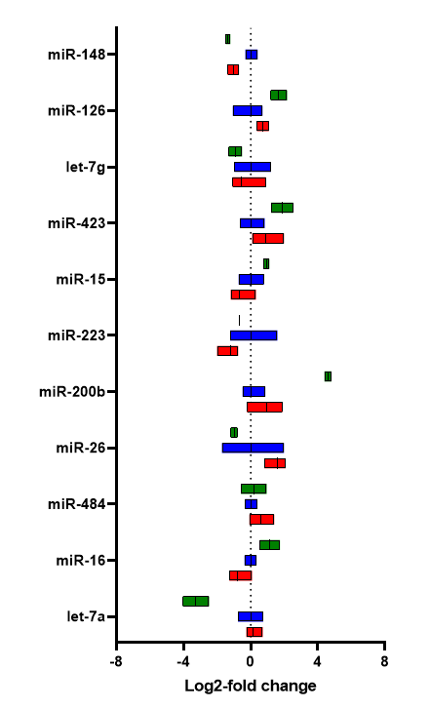
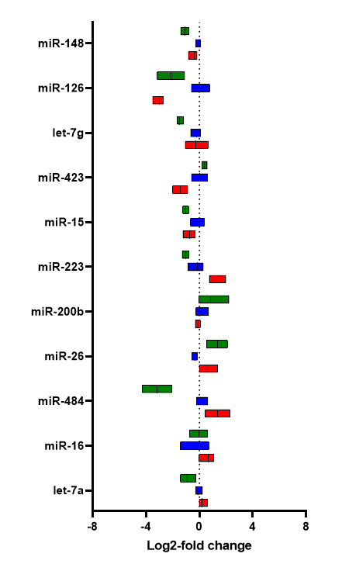
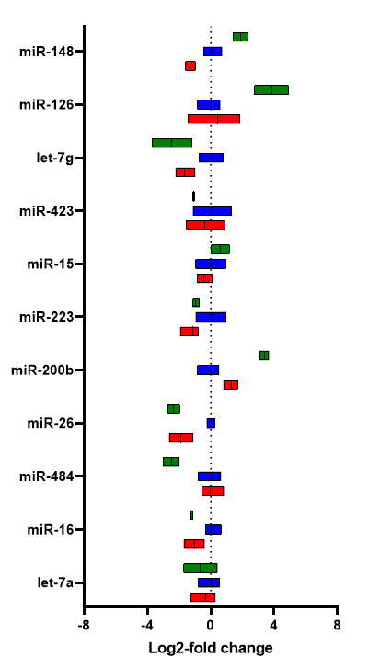
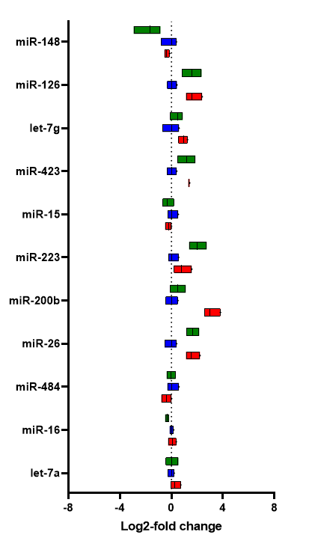
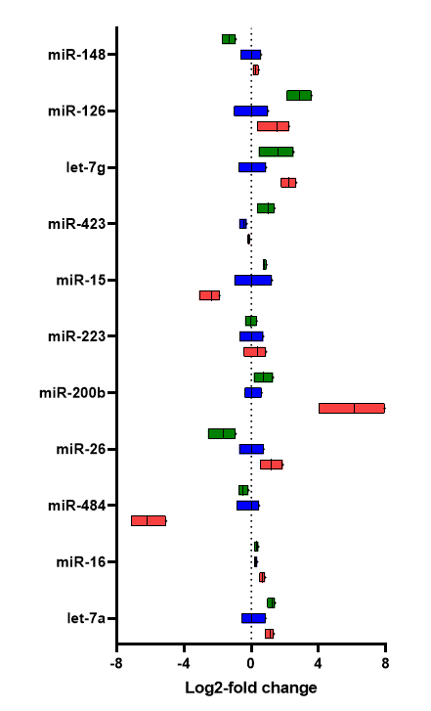
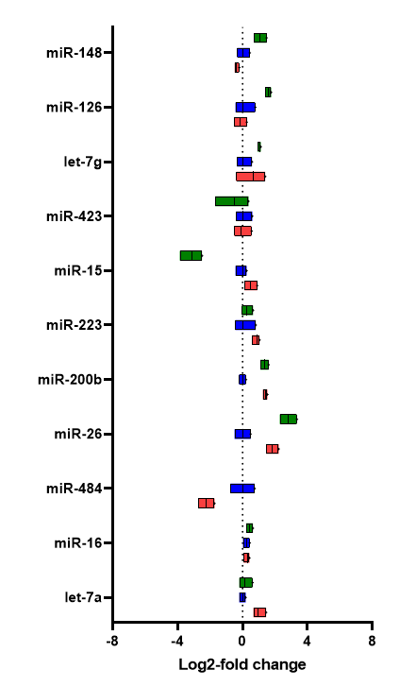



A
B
LMB

Control

LPS

LMB

Control

PMA

Comparison of the relative miRNAs expression (2^{-∆∆Ct}) in U937 (A), THP1 (B) cells and their EV subpopulations (mEVs and sEVs) referred to steady state condition (n=4). In vitro treatments of cells included LPS (n=3), PMA (n=3) and LMB (n=3). Mean values are shown as floating bars (min-max values).

