Supplementary files

Suppl. Table 1. Temperature and relativ humidity values (average, maximum, minimum, range) at the exposed and shaded sites at 30 cm and 5 cm heigh for the whole period.
 |  | T (°C) |  |  |  | RH (%)
 |  | aver | max | min | range | aver | max | min | range
Shaded | 5 cm | 3.97 | 25.95 | -16.02 | 41.97 | 91.45 | 100.00 | 39.80 | 60.20
Shaded | 30 cm | 4.84 | 28.07 | -16.16 | 44.23 | 82.02 | 97.39 | 38.18 | 59.21
Exposed | 5 cm | 7.02 | 47.43 | -16.68 | 64.11 | 79.94 | 100.00 | 23.40 | 76.60
Exposed | 30 cm | 5.70 | 38.00 | -17.17 | 55.18 | 77.23 | 95.87 | 26.28 | 69.59

Suppl. Table 2. Comparisons of daily temperature and relative humidity records (average, maximum, minimum, range) for the whole sampled period with ANOVA on ranks (Kruskal-Wallis test) at the four microclimate dataloggers (N=148). Number of significant differences identified by the Dunn’s tests are added. Results of paired comparison for records from 5 cm height (cryptogam layer) of the exposed and shaded roof performed by Wilcoxon test are presented in grey columns in Italics.
 | T (°C) |  |  |  |  | RH (%)
 | H | p | significant differences (out of 6) Dunn's test | Z | p | H | p | significant differences (out of 6) Dunn's test | Z | p
aver | 5.312 | ns | 0 | 8.808 | <0.001 | 138.80 | <0.001 | 5 | -6.983 | <0.001
max | 35.817 | <0.001 | 3 | 10.077 | <0.001 | 85.797 | <0.001 | 4 | 0.0643 | ns
min | 0.190 | ns | 0 | 1.234 | ns | 193.70 | <0.001 | 4 | -9.393 | <0.001
range | 145.75 | <0.001 | 6 | 10.290 | <0.001 | 216.42 | <0.001 | 5 | 9.899 | <0.001

Suppl. Table 3. Monthly mean (daily mean, daily max, daily min, daily range) at the exposed and shaded sites at 5 cm height for air humidity (RH %).
2016/17 | shaded |  |  |  | exposed
2016/17 | mean | max | min | range | mean | max | min | range
September (n=30) | 95.012 | 99.653 | 84.703 | 14.950 | 58.818 | 83.430 | 32.743 | 50.687
October (n=31) | 97.463 | 99.319 | 94.119 | 5.200 | 86.856 | 97.068 | 62.010 | 35.058
November (n=30) | 95.496 | 97.300 | 92.187 | 5.113 | 86.709 | 97.060 | 63.317 | 33.743
December (n=26*) | 89.549 | 91.569 | 87.042 | 4.527 | 87.922 | 95.677 | 70.062 | 25.615
January (n=31) | 79.652 | 82.945 | 76.184 | 6.761 | 80.205 | 87.606 | 68.265 | 19.342
*5 days of data deficiency at a logger

Suppl. Table 4. Monthly means (daily mean, daily max, daily min, daily range) at the exposed and shaded sites at 30 cm height.
a) temperature (T, °C)
2016/17 | shaded |  |  |  | exposed
2016/17 | mean | max | min | range | mean | max | min | range
September (n=30) | 16.636 | 22.546 | 12.014 | 10.532 | 19.304 | 29.306 | 11.860 | 17.446
October (n=31) | 9.423 | 12.832 | 6.225 | 6.607 | 10.135 | 15.281 | 5.868 | 9.414
November (n=30) | 4.486 | 7.689 | 1.694 | 5.995 | 4.995 | 9.938 | 1.366 | 8.572
December (n=26*) | -1.183 | 1.110 | -3.400 | 4.510 | -1.149 | 2.311 | -3.897 | 6.208
January (n=31) | -5.748 | -2.638 | -8.801 | 6.163 | -5.457 | -0.306 | -9.455 | 9.149
b) relative humidity (RH, %)
2016/17 | shaded |  |  |  | exposed
2016/17 | mean | max | min | range | mean | max | min | range
September (n=30) | 76.729 | 92.430 | 51.501 | 40.929 | 67.078 | 89.382 | 36.876 | 52.506
October (n=31) | 84.263 | 92.641 | 69.121 | 23.520 | 79.155 | 91.786 | 59.395 | 32.390
November (n=30) | 83.247 | 91.151 | 71.587 | 19.564 | 78.790 | 89.749 | 60.960 | 28.789
December (n=26*) | 85.777 | 91.521 | 77.036 | 14.484 | 83.971 | 91.228 | 71.395 | 19.833
January (n=31) | 80.573 | 86.302 | 71.939 | 14.363 | 77.976 | 86.161 | 62.156 | 24.006
*5 days of data deficiency at a logger
Suppl. Table 5. Comparison of monthly means between the four dataloggers (at 5 and 30 cm at the exposed and shaded roof, respectively) with ANOVA on ranks (Kruskal-Wallis test). Number of significant differences from pairwise comparison of the four dataloggers by Dunn’s tests (max. 6) and their summaries (max. 24) is shown in grey columns.
a) temperature (T, °C) |  |  |  |  |  |  |  |  |  |  |  |  |  |  |  |  | all sign. by Dunn's test
date |  | mean |  |  | maximum |  |  | minimum |  |  | range |  |  | in total |  |  | all sign. by Dunn's test
date | n | H | p | no. of sign. diff.s ** | H | p | no. of sign. diff.s | H | p | no. of sign. diff.s | H | p | no. of sign. diff.s | p <0.001 | p = 0.001-0.05 | ns | all sign. by Dunn's test
2016 IX | 30 | 33.040 | <0.001 | 3 | 74.492 | <0.001 | 5 | 1.880 | ns | 0 | 82.385 | <0.001 | 5 | 3 | 0 | 1 | 13
2016 X | 31 | 7.779 | ns | 0 | 40.753 | <0.001 | 4 | 0.761 | ns | 0 | 33.535 | <0.001 | 4 | 2 | 0 | 2 | 8
2016 XI | 30 | 10.354 | 0.016 | 2 | 33.026 | <0.001 | 3 | 1.970 | ns | 0 | 43.999 | <0.001 | 3 | 2 | 1 | 1 | 8
2016 XII | 26* | 2.912 | ns | 0 | 18.986 | <0.001 | 2 | 3.639 | ns | 0 | 23.984 | <0.001 | 3 | 2 | 0 | 2 | 5
2017 I | 31 | 5.954 | ns | 0 | 39.327 | <0.001 | 4 | 4.157 | ns | 0 | 34.145 | <0.001 | 4 | 2 | 0 | 2 | 8
in total |  |  |  | 5 |  |  | 18 |  |  | 0 |  |  | 19 |  |  |  | 42
b) relative humidity (RH, %) |  |  |  |  |  |  |  |  |  |  |  |  |  |  |  |  | all sign. by Dunn's test
 | mean |  |  |  | maximum |  |  | minimum |  |  | range |  |  | in total |  |  | all sign. by Dunn's test
date | n | H | p | no. of sign. diff.s | H | p | no. of sign. diff.s | H | p | no. of sign. diff.s | H | p | no. of sign. diff.s | p <0.001 | p = 0.001-0.05 | ns | all sign. by Dunn's test
2016 IX | 30 | 71.13 | <0.001 | 5 | 61.752 | <0.001 | 3 | 74.082 | <0.001 | 5 | 55.312 | <0.001 | 5 | 4 | 0 | 0 | 18
2016 X | 31 | 69.951 | <0.001 | 4 | 78.917 | <0.001 | 4 | 62.320 | <0.001 | 3 | 59.419 | <0.001 | 3 | 4 | 0 | 0 | 14
2016 XI | 30 | 56.056 | <0.001 | 4 | 62.725 | <0.001 | 4 | 60.055 | <0.001 | 3 | 62.584 | <0.001 | 3 | 4 | 0 | 0 | 14
2016 XII | 26* | 5.513 | ns | 0 | 22.807 | <0.001 | 3 | 13.833 | 0.003 | 2 | 31.634 | <0.001 | 3 | 2 | 1 | 1 | 8
2017 I | 31 | 4.691 | ns | 0 | 16.708 | <0.001 | 2 | 14.598 | 0.002 | 1 | 47.764 | <0.001 | 4 | 2 | 1 | 1 | 7
in total |  |  |  | 13 |  |  | 16 |  |  | 14 |  |  | 18 |  |  |  | 61
* 5 days data deficiency at a logger
** maximum 6 significant differences are possible among the four compared data series
Suppl. Table 6. Mean temperature values (daily mean, daily max, daily min, daily range) at the exposed and shaded sites at 30 cm and 5 cm height as well as at standard measurements at 2 m height, respectively, on selected days.
date | shaded 30 cm |  |  |  | shaded 5 cm |  |  |  | exposed 30 cm |  |  |  | exposed 5 cm |  |  |  | standard 2 m
date | aver | max | min | range | aver | max | min | range | aver | max | min | range | aver | max | min | range | aver | max | min | range
2016.IX.07. | 19.74 | 25.16 | 15.80 | 9.37 | 17.79 | 21.33 | 15.23 | 6.10 | 22.76 | 33.63 | 15.37 | 18.26 | 25.43 | 40.59 | 15.23 | 25.36 | 21.10 | 28.78 | 15.39 | 13.39
2016.IX.12. | 20.08 | 26.97 | 14.91 | 12.05 | 18.70 | 22.86 | 15.23 | 7.63 | 24.82 | 38.00 | 15.25 | 22.76 | 29.59 | 47.43 | 16.38 | 31.05 | 21.93 | 30.43 | 14.43 | 16.00
2016.IX.21. | 15.14 | 21.08 | 10.86 | 10.22 | 13.59 | 17.52 | 10.21 | 7.31 | 17.71 | 26.35 | 11.37 | 14.98 | 20.70 | 37.44 | 11.38 | 26.06 | 16.79 | 24.29 | 11.22 | 13.07
2016.X.07. | 6.98 | 10.03 | 3.49 | 6.54 | 7.22 | 11.38 | 3.31 | 8.07 | 6.58 | 12.65 | 0.93 | 11.72 | 8.60 | 17.52 | 1.60 | 15.92 | 9.22 | 13.30 | 5.79 | 7.51
2016.X.12. | 8.35 | 10.76 | 6.03 | 4.74 | 8.22 | 10.60 | 5.40 | 5.20 | 8.65 | 12.29 | 5.90 | 6.39 | 9.38 | 14.47 | 5.40 | 9.07 | 10.08 | 12.23 | 7.51 | 4.72
2016.X.21. | 10.52 | 11.71 | 9.58 | 2.13 | 10.70 | 11.77 | 9.82 | 1.95 | 10.56 | 12.22 | 9.61 | 2.61 | 11.01 | 13.32 | 9.82 | 3.50 | 12.21 | 14.76 | 10.58 | 4.18
2016.XI.07. | 6.52 | 9.78 | 3.41 | 6.37 | 0.54 | 6.22 | -1.97 | 8.19 | 8.17 | 14.24 | 3.41 | 10.84 | 9.40 | 22.09 | 3.31 | 18.78 | 7.91 | 12.22 | 3.68 | 8.54
2016.XI.12. | 1.30 | 3.12 | -0.14 | 3.26 | 3.68 | 8.63 | 2.03 | 6.60 | 1.36 | 3.54 | -0.70 | 4.24 | 1.02 | 4.99 | -1.97 | 6.96 | 1.32 | 3.44 | -1.09 | 4.53
2016.XI.21. | 6.05 | 11.05 | 2.98 | 8.07 | 3.83 | 4.99 | 1.60 | 3.39 | 7.64 | 17.08 | 2.48 | 14.61 | 7.77 | 20.57 | 2.03 | 18.54 | 6.35 | 15.26 | 1.21 | 14.05
2016.XII.07. | -3.13 | -1.41 | -6.29 | 4.88 | 1.95 | 4.15 | -0.16 | 4.31 | -3.49 | -0.93 | -7.16 | 6.23 | -2.69 | 2.89 | -7.85 | 10.74 | -3.48 | -0.08 | -6.64 | 6.56
2016.XII.12. | -3.51 | -1.53 | -5.08 | 3.55 | -2.38 | -1.97 | -2.90 | 0.93 | -2.60 | 3.14 | -5.33 | 8.47 | -2.39 | 8.63 | -6.82 | 15.45 | -2.90 | 0.58 | -5.10 | 5.68
2016.XII.21. | -2.17 | -1.47 | -3.42 | 1.95 | -1.59 | -0.61 | -2.44 | 1.83 | -2.45 | -1.36 | -3.54 | 2.18 | -1.29 | 0.29 | -1.97 | 2.26 | -2.41 | -0.47 | -3.69 | 3.22
2017.I.07. | 13.88 | 11.72 | 16.04 | 4.32 | 13.75 | 12.29 | 15.36 | 3.07 | 13.40 | 10.55 | 15.95 | 5.41 | 11.10 | -2.90 | 14.73 | 11.83 | 13.22 | 10.68 | 15.57 | 4.89
2017.I.12. | 0.49 | 1.97 | -2.71 | 4.68 | -1.41 | -0.16 | -4.33 | 4.17 | 0.69 | 2.40 | -2.60 | 4.99 | -0.79 | 0.29 | -3.37 | 3.66 | 0.55 | 2.23 | -2.92 | 5.15
2017.I.21. | -6.90 | -3.12 | 10.09 | 6.97 | -7.35 | -5.31 | -9.46 | 4.15 | -6.32 | 1.91 | 11.08 | 12.99 | -4.55 | 1.60 | -7.85 | 9.45 | -4.22 | 2.69 | -7.64 | 10.33

Suppl. Table 7: Results of paired comparisons of hourly temperature readings of reference measurements with differently positioned dataloggers on selected days (three days per month) throughout the sampling period. Distribution of significance classes by Wilcoxon signed ranks tests is summarized per month and per comparison class, respectively, in grey cells.
Wilcoxon signed rank test | reference vs. shaded 30 cm |  | reference vs. shaded 5 cm |  | reference vs. exposed 30 cm |  | reference vs. exposed 5 cm |  | distribution of Wilcoxon signed rank tests
N=24 (hours) | Z | p | Z | p | Z | p | Z | p | p <0.001 | p = 0.001-0.05 | ns
2016.IX.07. | 3.314 | <0.001 | 4.086 | <0.001 | 3.114 | 0.002 | 3.514 | <0.001 | 9 | 2 | 1
2016.IX.12. | 3.343 | <0.001 | 3.343 | <0.001 | 4.286 | <0.001 | 4.286 | <0.001 | 9 | 2 | 1
2016.IX.21. | 4.286 | <0.001 | 4.286 | <0.001 | 0.314 | ns | 2.229 | 0.027 | 9 | 2 | 1
2016.X.07. | 4.286 | <0.001 | 4.2 | <0.001 | 3.371 | <0.001 | 1.086 | ns | 10 | 1 | 1
2016.X.12. | 4.286 | <0.001 | 4.286 | <0.001 | 4.171 | <0.001 | 1.986 | 0.049 | 10 | 1 | 1
2016.X.21. | 4.286 | <0.001 | 4.286 | <0.001 | 4.286 | <0.001 | 4.143 | <0.001 | 10 | 1 | 1
2016.XI.07. | 4.143 | <0.001 | 4.286 | <0.001 | 0.943 | ns | 0.486 | ns | 4 | 1 | 7
2016.XI.12. | 0.486 | ns | -3.771 | <0.001 | -0.229 | ns | 1.200 | ns | 4 | 1 | 7
2016.XI.21. | 0.314 | ns | 1.400 | ns | 3.514 | <0.001 | 2.771 | 0.006 | 4 | 1 | 7
2016.XII.07. | 2.743 | 0.006 | 4.286 | <0.001 | 2.286 | 0.023 | 2.000 | 0.047 | 4 | 4 | 4
2016.XII.12. | 2.457 | 0.015 | 1.571 | ns | 0.114 | ns | 0.543 | ns | 4 | 4 | 4
2016.XII.21. | 3.457 | <0.001 | 3.971 | <0.001 | 0.200 | ns | 4.086 | <0.001 | 4 | 4 | 4
2017.I.07. | 4.286 | <0.001 | 2.800 | 0.005 | 1.314 | ns | 2.657 | 0.008 | 7 | 3 | 2
2017.I.12. | 0.857 | ns | 4.286 | <0.001 | 2.143 | 0.033 | 4.286 | <0.001 | 7 | 3 | 2
2017.I.21. | 4.286 | <0.001 | 4.286 | <0.001 | 3.543 | <0.001 | 2.086 | 0.038 | 7 | 3 | 2
p <0.001 |  | 10 |  | 12 |  | 6 |  | 5
p = 0.001-0.05 |  | 2 |  | 1 |  | 3 |  | 6
ns |  | 3 |  | 2 |  | 6 |  | 4

Suppl. Table 8. List of bryophyte and lichen species.
site name | Life Sciences Building, Debrecen University | Waterworks Building, Botanical Garden, Debrecen University | 4th Nurse Hostel, Clinics Centre, Debrecen University | Old Warehouse of Chemicals, Debrecen University | Old boiler room, Debrecen University | New boiler room, Debrecen University | Northern block, Lehel street kindergarten, city of Debrecen | Home for visually impaired, city of Debrecen | Big garage of Nursery Home, city of Debrecen | Small garage of Nursery Home, city of Debrecen | freq.
site code | 1 | 2 | 3 | 4 | 5 | 6 | 7 | 8 | 9 | 10
lichens
Acarospora sp. |  |  |  |  | 1 |  | 1 | 1 |  |  | 3
Aspicilia contorta (Hoffm.) Körb. |  |  |  | 1 |  |  |  |  |  |  | 1
Caloplaca cf. citrina (Hoffm.) Th. Fr. |  |  | 1 | 1 |  |  | 1 | 1 |  |  | 4
Caloplaca cf. pusilla (A. Massal.) Zahlbr. |  |  |  |  |  |  | 1 | 1 |  |  | 2
Caloplaca decipiens (Arnold) J. Steiner |  |  |  | 1 | 1 |  | 1 | 1 |  |  | 4
Caloplaca sp. |  |  | 1 |  | 1 | 1 | 1 | 1 | 1 |  | 6
Candelariella aurella (Hoffm.) Zahlbr. |  |  | 1 | 1 | 1 |  | 1 | 1 | 1 |  | 6
Cladonia coniocrea (Flörke) Spreng. |  |  | 1 |  |  |  |  |  | 1 |  | 2
Cladonia fimbriata (L.) Fr. | 1 |  | 1 |  |  |  |  | 1 | 1 |  | 4
Cladonia furcata (Huds.) Schrad. | 1 |  |  |  |  |  |  |  |  |  | 1
Cladonia humilis (With.) J. R. Laundon | 1 |  |  |  |  |  |  |  |  |  | 1
Cladonia macilenta Hoffm. / C. floerkeana (Fr.) Flörke |  |  |  |  |  |  |  |  | 1 |  | 1
Cladonia rangiformis Hoffm. | 1 |  |  |  |  |  |  |  |  |  | 1
Cladonia rei Schaer. | 1 | 1 | 1 | 1 | 1 |  | 1 | 1 | 1 |  | 8
Lecanora albescens (Hoffm.) Branth & Rostr. |  |  | 1 |  |  |  |  |  |  |  | 1
Lecanora dispersa (Pers.) Röhl. |  |  | 1 | 1 | 1 | 1 | 1 | 1 |  |  | 6
Lecanora muralis (Schreb.) Rabenh. |  |  | 1 | 1 | 1 | 1 | 1 | 1 | 1 |  | 7
Lecidea sp. |  |  |  |  | 1 |  |  |  |  |  | 1
Lecidella sp. |  |  |  |  | 1 |  |  |  |  |  | 1
Phaeophyscia nigricans (Flörke) Moberg |  |  |  | 1 | 1 |  | 1 | 1 |  |  | 4
Phaeophyscia orbicularis (Neck.) Moberg |  |  |  | 1 | 1 | 1 |  | 1 |  |  | 4
Physcia adscendens H. Olivier |  |  |  |  |  | 1 |  | 1 |  |  | 2
Physcia caesia (Hoffm.) Hampe ex Fürnr. |  |  |  | 1 |  |  | 1 | 1 |  |  | 3
Placynthium sp. |  |  |  |  | 1 |  |  |  |  |  | 1
Porina chloroticula P.M. McCarthy | 1 |  |  |  |  |  |  |  |  |  | 1
Porpidia crustulata (Ach.) Hertel & Knoph | 1 |  |  |  |  |  |  |  |  |  | 1
Rhizocarpon sp. |  |  |  |  | 1 |  |  |  |  |  | 1
Sarcogyne regularis Körb. |  |  | 1 | 1 | 1 |  |  |  |  |  | 3
Stereocaulon tomentosum Fr. | 1 |  |  |  |  |  |  |  |  |  | 1
Trapelia coarctata (Turner ex Sm.) M. Choisy | 1 |  |  |  |  |  |  |  |  |  | 1
Verrucaria muralis Ach. |  |  |  |  | 1 |  |  |  |  |  | 1
Verrucaria nigrescens Pers. |  |  | 1 | 1 | 1 | 1 | 1 | 1 |  |  | 6
Verrucaria sp. |  |  |  |  |  |  | 1 |  |  |  | 1
Xanthoparmelia conspersa (Ehrh. ex Ach.) Hale |  |  | 1 |  |  |  |  | 1 | 1 |  | 3
Xanthoria elegans (Link) Th. Fr. |  |  | 1 | 1 | 1 |  | 1 |  |  |  | 4
Xanthoria parietina (L.) Beltr. |  |  |  | 1 |  |  |  | 1 |  |  | 2
number of lichen taxa | 9 | 1 | 13 | 14 | 17 | 6 | 14 | 17 | 8 | 0 | 99
site name | Life Sciences Building, Debrecen University | Waterworks Building, Botanical Garden, Debrecen University | 4th Nurse Hostel, Clinics Centre, Debrecen University | Old Warehouse of Chemicals, Debrecen University | Old boiler room, Debrecen University | New boiler room, Debrecen University | Northern block, Lehel street kindergarten, city of Debrecen | Home for visually impaired, city of Debrecen | Big garage of Nursery Home, city of Debrecen | Small garage of Nursery Home, city of Debrecen | freq.
site code | 1 | 2 | 3 | 4 | 5 | 6 | 7 | 8 | 9 | 10
bryophytes
Amblystegium serpens c.spg. (Hedw.) Schimp. | 1 |  |  |  |  |  |  |  |  |  | 1
Atrichum undulatum (Hedw.) P. Beauv. | 1 |  |  |  |  |  |  |  |  |  | 1
Brachythecium albicans (Hedw.) Schimp. |  | 1 |  |  |  |  |  |  |  |  | 1
Brachythecium populeum (Hedw.) Schimp. | 1 |  |  |  |  |  |  |  |  |  | 1
Brachythecium rutabulum (Hedw.) Schimp. | 1 |  |  |  |  | 1 |  |  |  | 1 | 3
Brachythecium salebrosum c.spg. (Hoffm. ex F. Weber & D. Mohr) Schimp. | 1 | 1 |  |  |  |  |  |  |  |  | 2
Brachythecium velutinum (Hedw.) Ignatov et Huttunen | 1 |  |  |  |  |  |  |  |  |  | 1
Bryum argenteum Hedw. |  |  | 1 |  | 1 | 1 | 1 | 1 | 1 |  | 6
Bryum moravicum Podp. (syn.: B. flaccidum) | 1 |  |  |  |  |  |  |  |  |  | 1
Ceratodon purpures (Hedw.) Brid. | 1 | 1 | 1 | 1 | 1 | 1 | 1 | 1 | 1 |  | 9
Ctenidium molluscum (Hedw.) Mitt. | 1 |  |  |  |  |  |  |  |  |  | 1
Dicranum scoparium Hedw. | 1 |  |  |  |  |  |  |  |  |  | 1
Grimmia pulvinata (Hedw.) Sm. |  |  | 1 | 1 |  |  | 1 | 1 | 1 |  | 5
Hedwigia ciliata (Hedw.) P. Beauv. |  | 1 | 1 |  |  |  | 1 | 1 |  |  | 4
Hypnum cupressiforme Hedw. | 1 |  |  | 1 |  |  |  |  |  |  | 2
Orthotrichum diaphanum Brid. |  |  |  |  |  |  |  | 1 |  |  | 1
Plagiomnium cuspidatum (Hedw.) T. J. Kop. | 1 |  |  |  |  |  |  |  |  |  | 1
Pohlia nutans (Hedw.) Lindb. | 1 |  |  |  |  |  |  |  |  |  | 1
Polytrichum juniperinum Hedw. | 1 |  |  |  |  |  |  |  |  |  | 1
Ptychostomum elegans (Nees in Brid.) D. Bell & Holyoak (syn.: Bryum elegans) | 1 |  |  |  |  |  |  |  |  |  | 1
Racomitrium canescens (Hedw.) Brid. | 1 | 1 |  | 1 | 1 |  |  |  |  |  | 4
Rhynchostegium megapolitanum c.spg. (Blandow ex F. Weber & D. Mohr) Schimp. | 1 |  |  |  |  |  |  |  |  |  | 1
Schistidium crassipilum H. H. Blom |  |  |  |  |  |  |  |  | 1 |  | 1
Syntrichia ruralis (Hedw.) F. Weber & D. Mohr |  |  |  |  | 1 | 1 | 1 | 1 |  | 1 | 5
Tortula muralis Hedw. |  |  |  |  |  |  |  | 1 |  |  | 1
number of bryophyte taxa | 17 | 5 | 4 | 4 | 4 | 4 | 5 | 7 | 4 | 2 | 56
lichens + bryophytes | 26 | 6 | 17 | 18 | 21 | 10 | 19 | 24 | 12 | 2 | 155

Suppl. Figure 1: Daily regimes of microclimatic parameters in September 2016 measured at 30 cm height on exposed (NH) and shaded (LSB) flatroofs. Hourly readings have been used in constructing diagrams. Temperature records are shown on linear while relative humidity records on logarithmic scale.
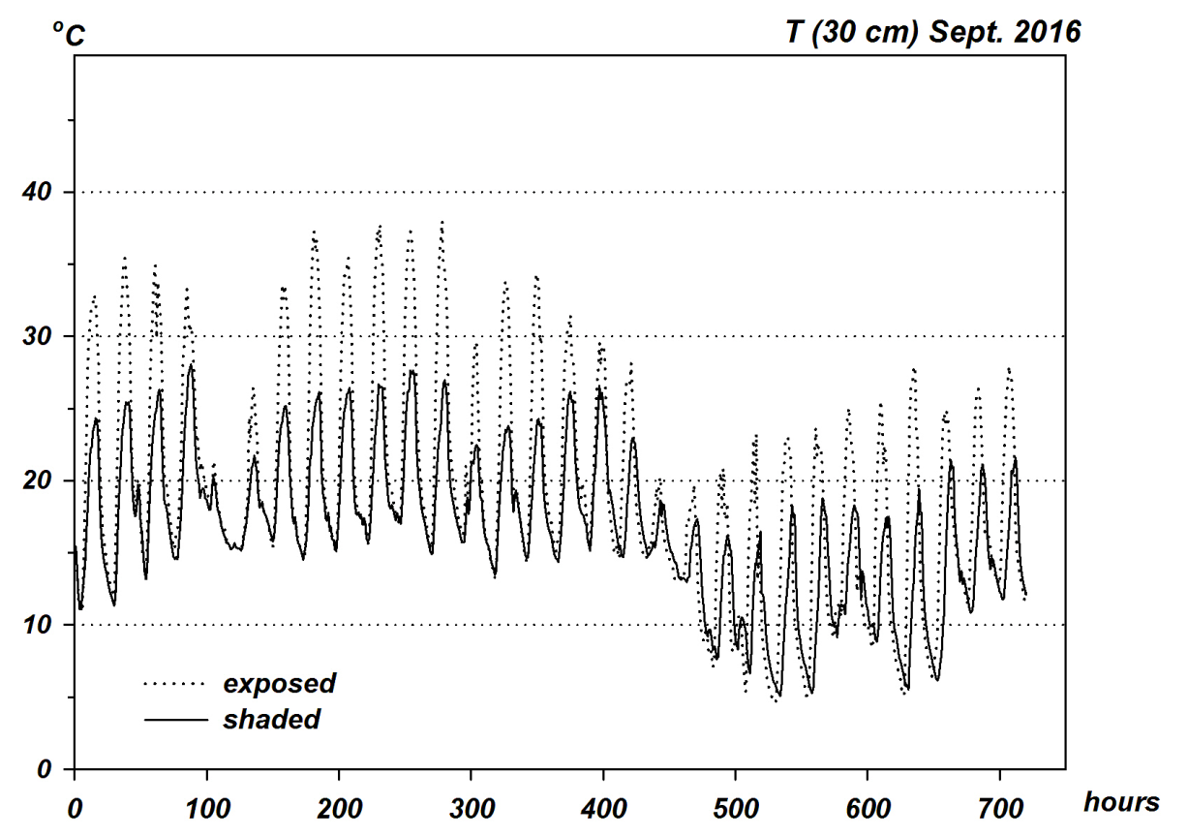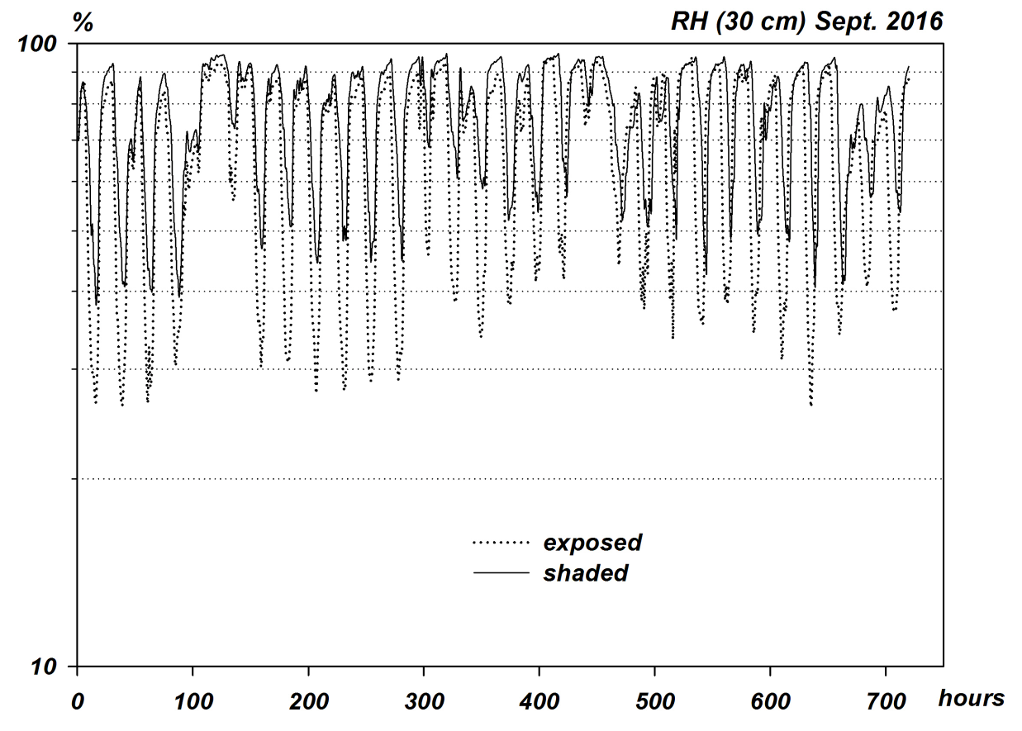

Suppl. Figure 2: Daily regimes of relative humidity measured at 30 cm height at a shaded and an exposed flatroof. Filled circles: shaded site; empty circles: exposed site; dashed lines: on 12th September and 15th October 2016, respectively; solid line: reference measurement.
