Economic assessment of maize cultivation in terms of hybrids, years and biostimulator treatment

Economics assessment took into account the costs of cultivation, sales and income without state aid. The efficiency of cultivation was evaluated with the following efficiency indicators, which were calculated in the current year (http1).:
Cost (HUF / t) = Total Cost (HUF) / Yield (t)
Profitability (production area) (HUF/ha) = Income (HUF) / Field of production (ha)
Profitability (Yield) (HUF/t) = Income (HUF) / Yield (t)
Profitability (Total Cost) (HUF) = Income (HUF/ha) /Total cost (HUF/ha)
Thrift (kg/1000 HUF) = Yield (t/ha) /Total cost (HUF/ha) × 1000
The microorganisms present in the biofertilizers employ several mechanisms to provide benefits to the crop plants. They can either be efficient in nitrogen fixation, phosphate solubilization, and plant growth promotion or can possess a combination of all such traits. Biofertilizers can fix atmospheric N₂ through the biological nitrogen fixation (BNF) process, solubilize nutrients required by the plants, such as phosphate, zinc, and potassium, and also secrete plant growth promoting substances, including various hormones. Further, when applied as seed or soil inoculants, biofertilizers can multiply, participate in nutrient cycling, and help in crop production for sustainable farming. The technology does not require new investment. It can be applied with an existing field sprayer and worked into the soil in as little as one session. Additional costs for the farmer are due to the purchase of a biostimulator and its introduction into the soil. The price of commercially available biostimulators is high. This increases from year to year, as does the cost of getting into the soil. Since the biofertilizer exhibits specificity, it should only be used for the crop(s) specified on the commercially available product packet. Therefore, it is important to choose a biostimulator in which microbes are able to form a symbiosis with a particular plant. In this case, we can expect that the plant will be able to realize a surplus of the crop, thus providing the farmer with extra profit. Otherwise, the farmer will pay for it due to the additional costs. The economic results of the hybrids and biostimulator treatments used in our experiment are presented in Table 1. Detailed calculations are found in the annexes.
Table 1.: Costs, revenues and extra profits broken down into years, hybrids and treatments.
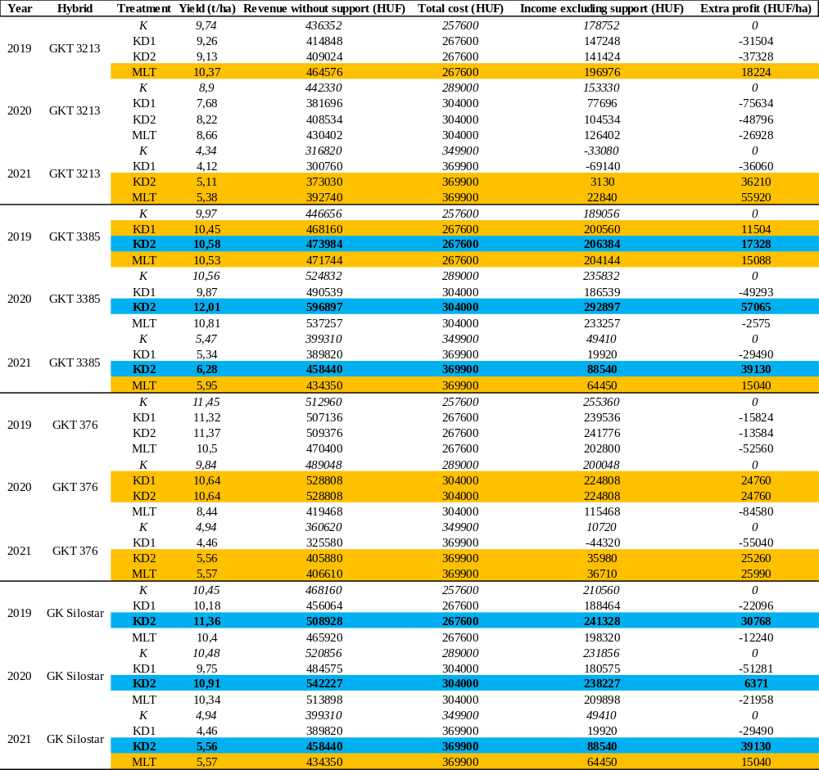
In our case, we can say for the KD2 (Bacillus pumilus + Pseudomonas putida) treatment that in the given climatic conditions, in the given growing area, in accordance with the given agrotechnical parameters, in the case of the GKT 3385 and GK Silostar hybrid, it resulted in an excess of yields and, in parallel, extra profit.
References
http1: https://www.ksh.hu/?lang=en
Annexes
Economic assessment of maize production without state aid based in arable land per 1 ha area on the results of the small-plot experiment.
GKT 3213 (2019)
The cost structure of maize growing 2019
Cost type | HUF/ha | Cost ratio (%)
Material cost | 138000 | 52
Machine cost | 129600 | 48
Total cost | 267600 | 100
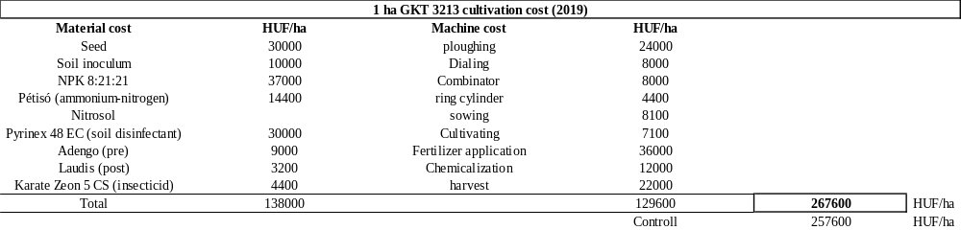
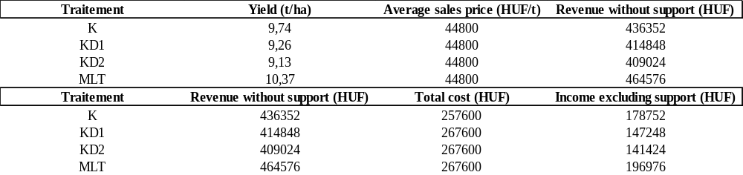
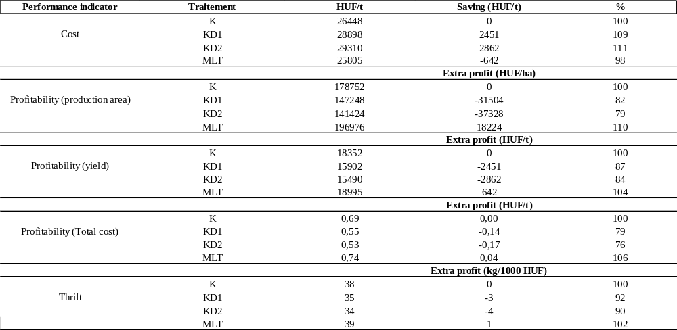
GKT 3213 (2020)
The cost structure of maize growing 2020
Cost type | HUF/ha | Cost ratio (%)
Material cost | 174400 | 57
Machine cost | 129600 | 43
Total cost | 304000 | 100

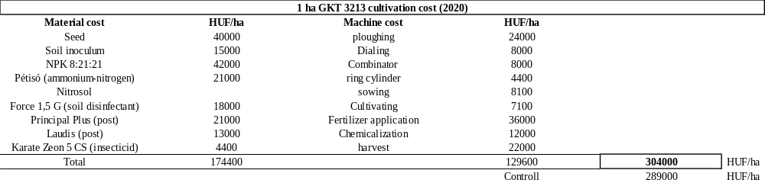
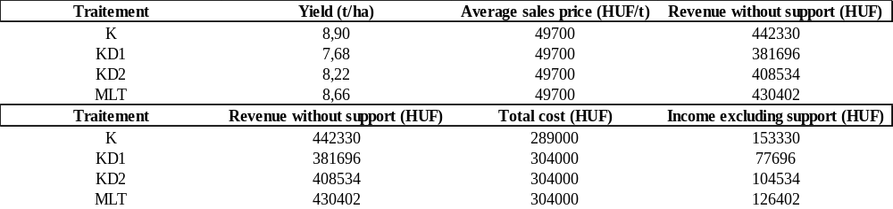
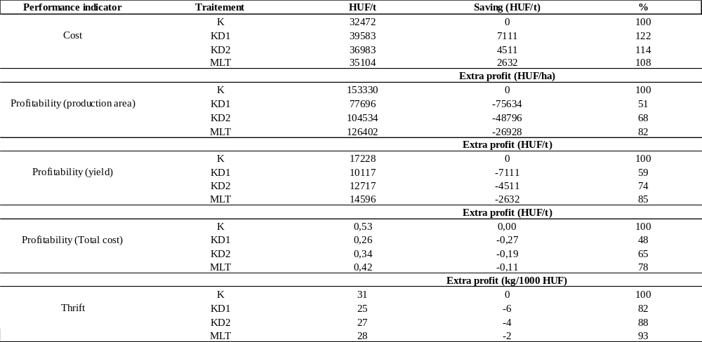
GKT 3213 (2021)
The cost structure of maize growing 2021
Cost type | HUF/ha | Cost ratio (%)
Material cost | 217400 | 59
Machine cost | 152500 | 41
Total cost | 369900 | 100

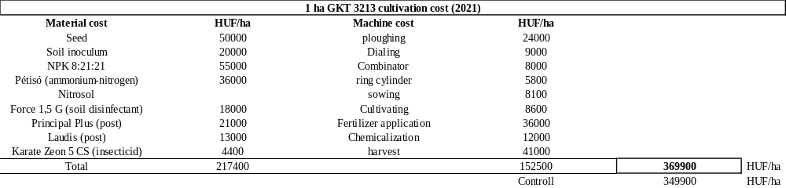
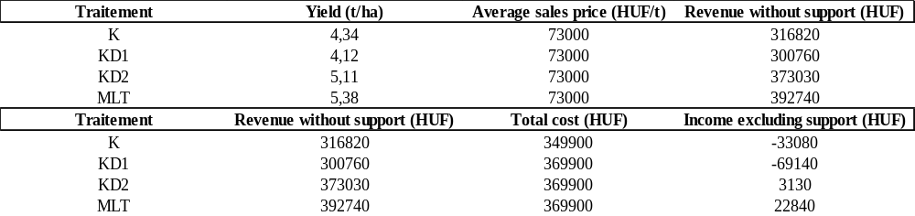
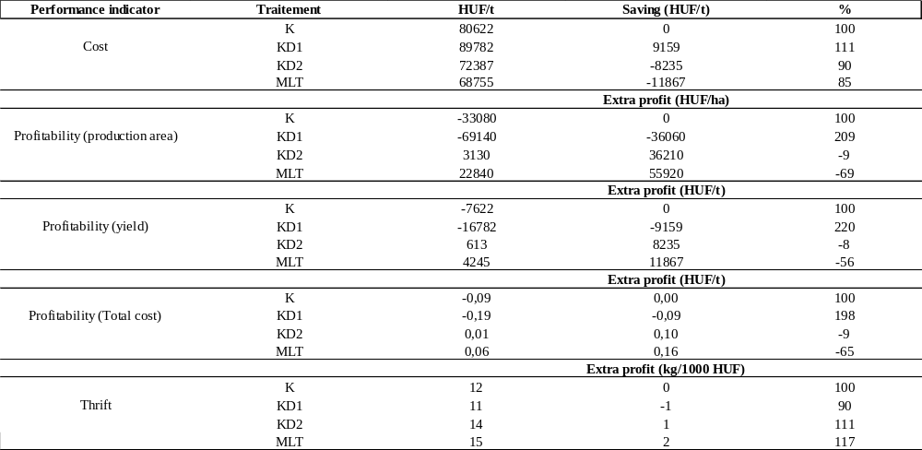
GKT 3385 (2019)
The cost structure of maize growing 2019
Cost type | HUF/ha | Cost ratio (%)
Material cost | 138000 | 52
Machine cost | 129600 | 48
Total cost | 267600 | 100

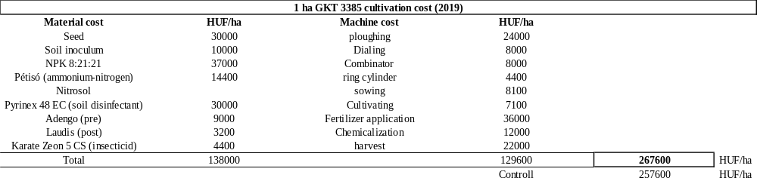
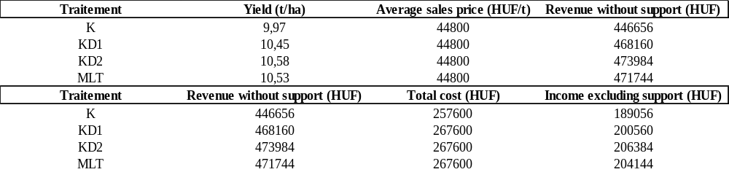
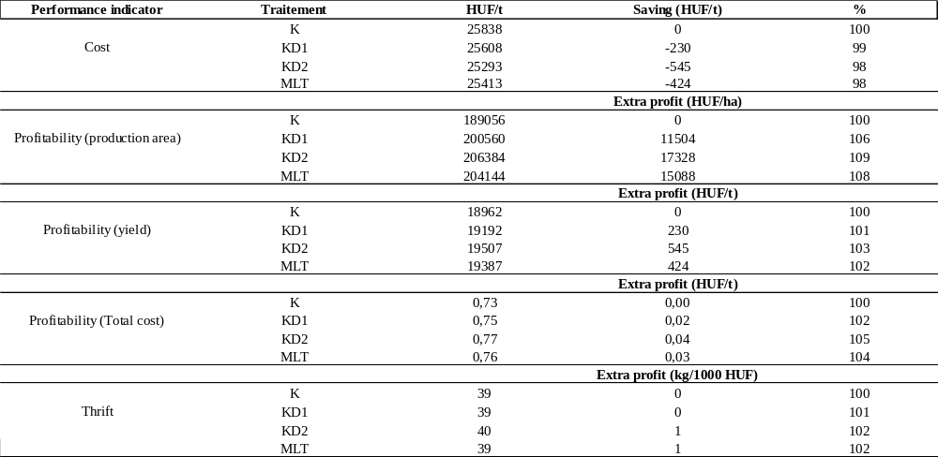

GKT 3385 (2020)
The cost structure of maize growing 2020
Cost type | HUF/ha | Cost ratio (%)
Material cost | 174400 | 57
Machine cost | 129600 | 43
Total cost | 304000 | 100

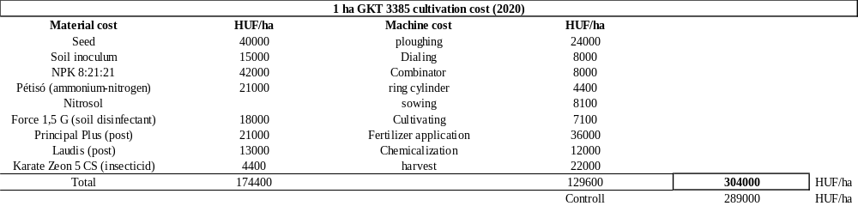
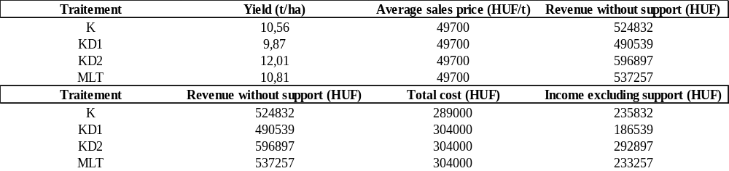
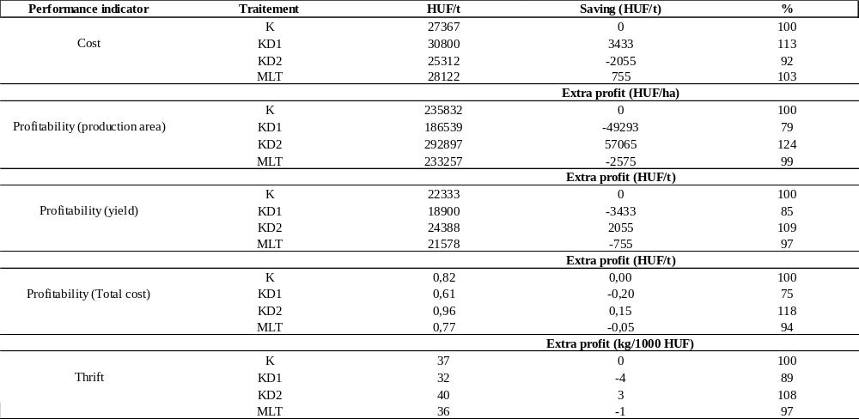

GKT 3385 (2021)
The cost structure of maize growing 2021
Cost type | HUF/ha | Cost ratio (%)
Material cost | 217400 | 59
Machine cost | 152500 | 41
Total cost | 369900 | 100

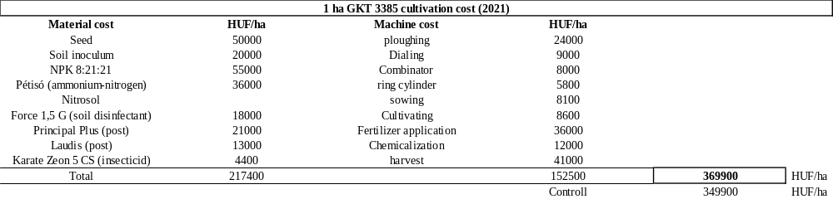
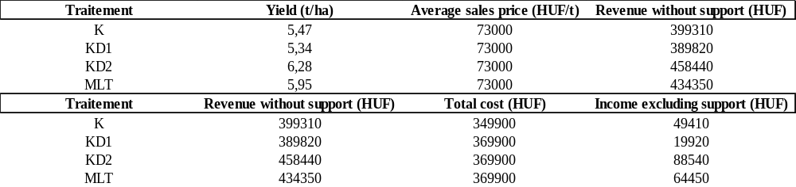
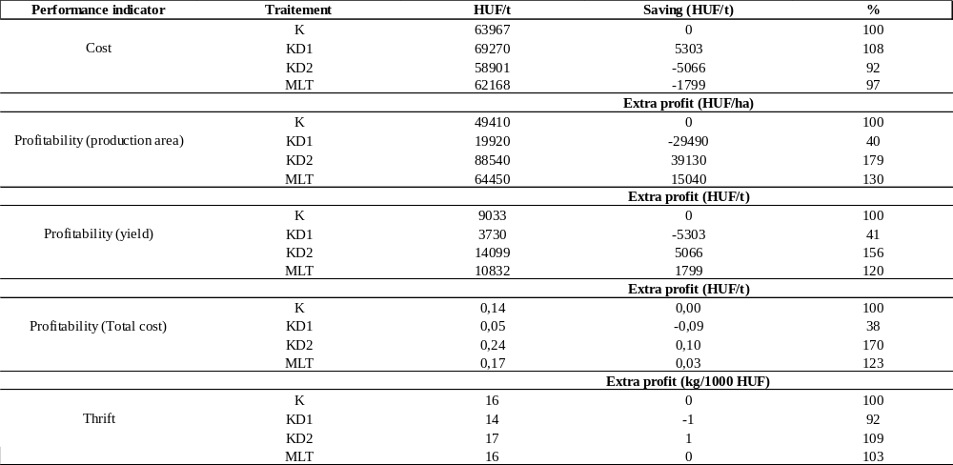

GKT 376 (2019)
The cost structure of maize growing 2019
Cost type | HUF/ha | Cost ratio (%)
Material cost | 138000 | 52
Machine cost | 129600 | 48
Total cost | 267600 | 100

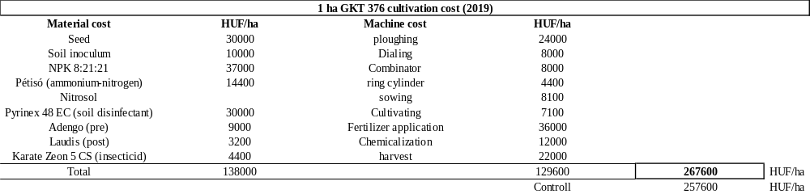
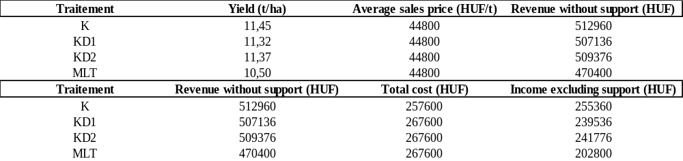
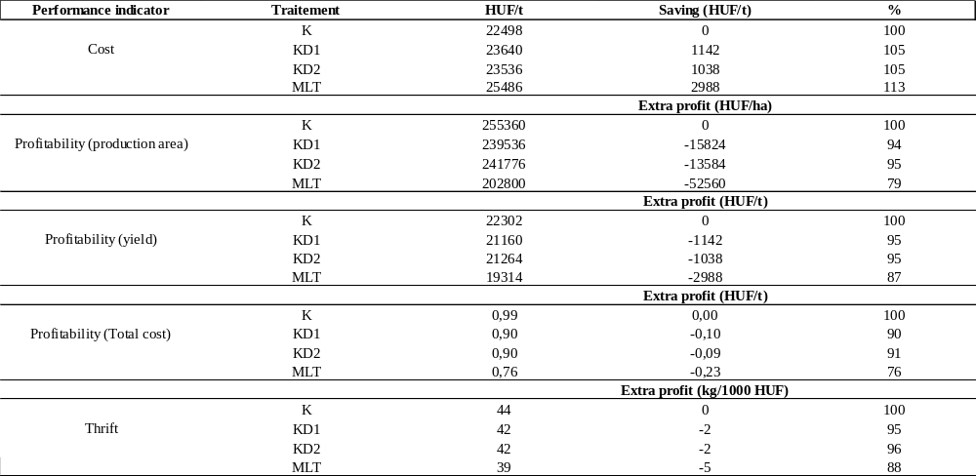

GKT 376 (2020)
The cost structure of maize growing 2020
Cost type | HUF/ha | Cost ratio (%)
Material cost | 174400 | 57
Machine cost | 129600 | 43
Total cost | 304000 | 100

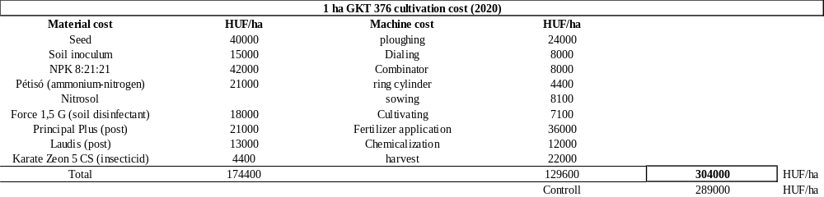
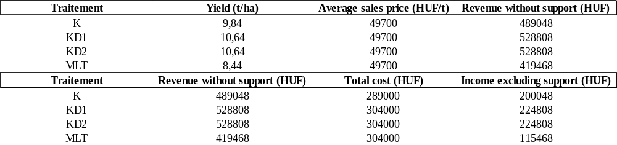
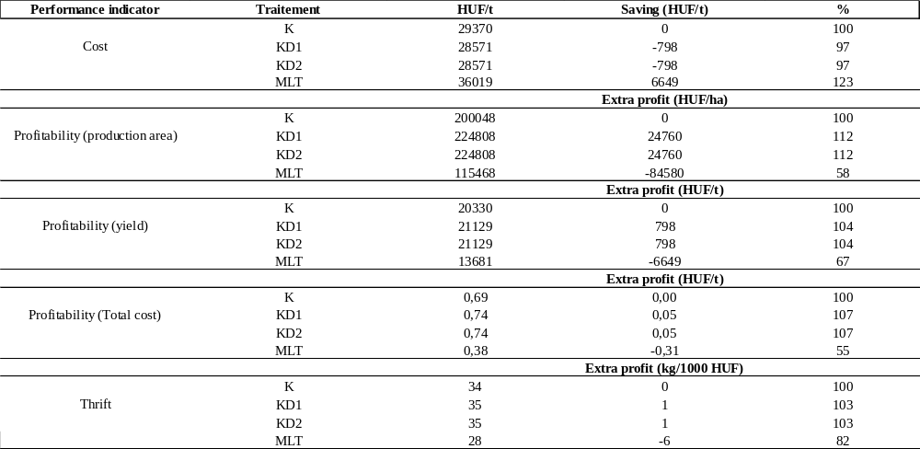

GKT 376 (2021)
The cost structure of maize growing 2021
Cost type | HUF/ha | Cost ratio (%)
Material cost | 217400 | 59
Machine cost | 152500 | 41
Total cost | 369900 | 100

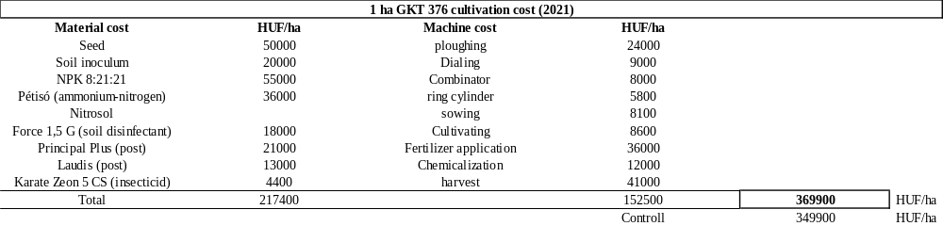
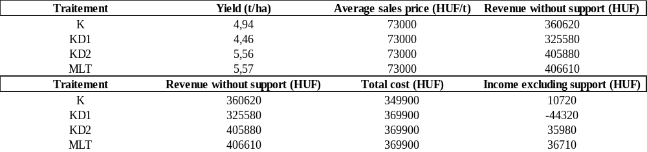
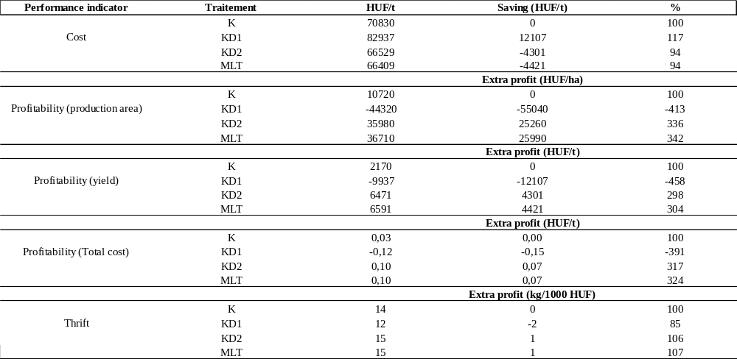

GK Silostar (2019)
The cost structure of maize growing 2019
Cost type | HUF/ha | Cost ratio (%)
Material cost | 138000 | 52
Machine cost | 129600 | 48
Total cost | 267600 | 100

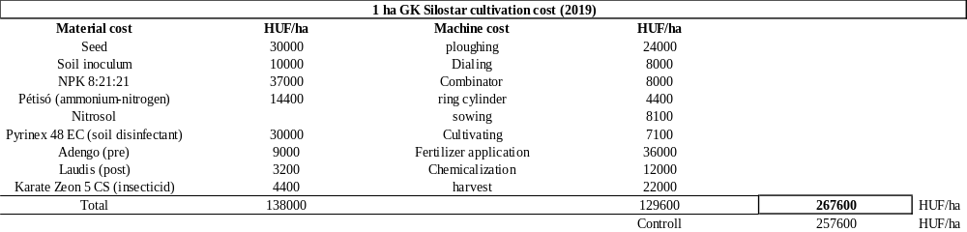
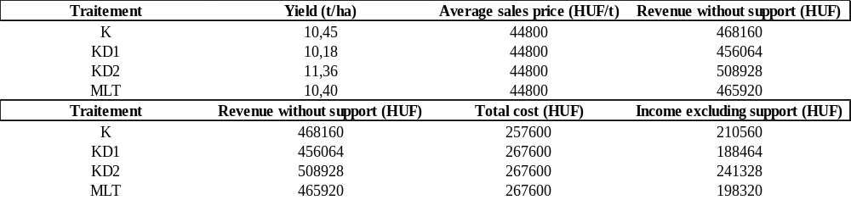
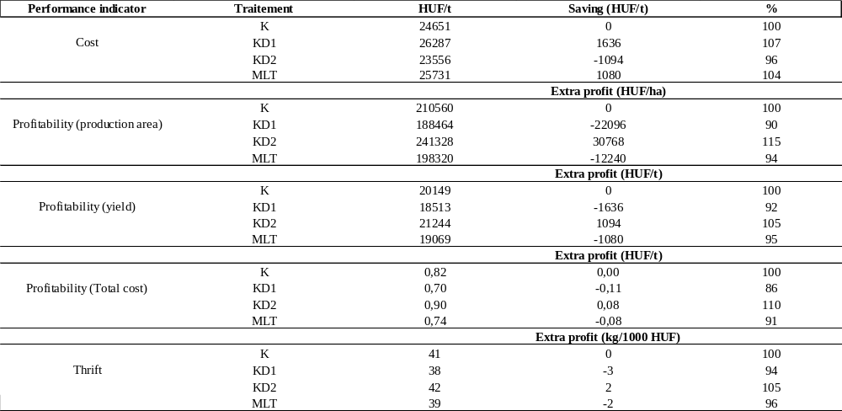

GK Silostar (2020)
The cost structure of maize growing 2020
Cost type | HUF/ha | Cost ratio (%)
Material cost | 174400 | 57
Machine cost | 129600 | 43
Total cost | 304000 | 100

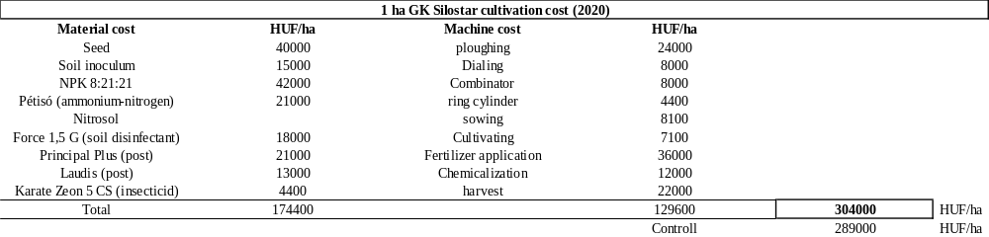
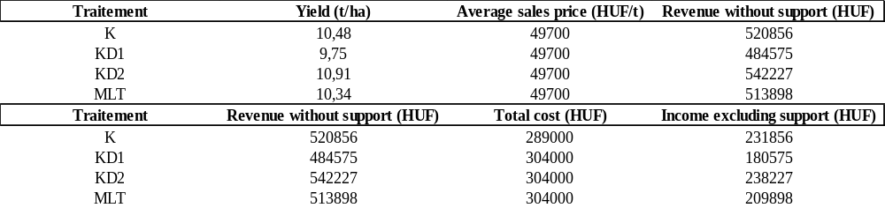
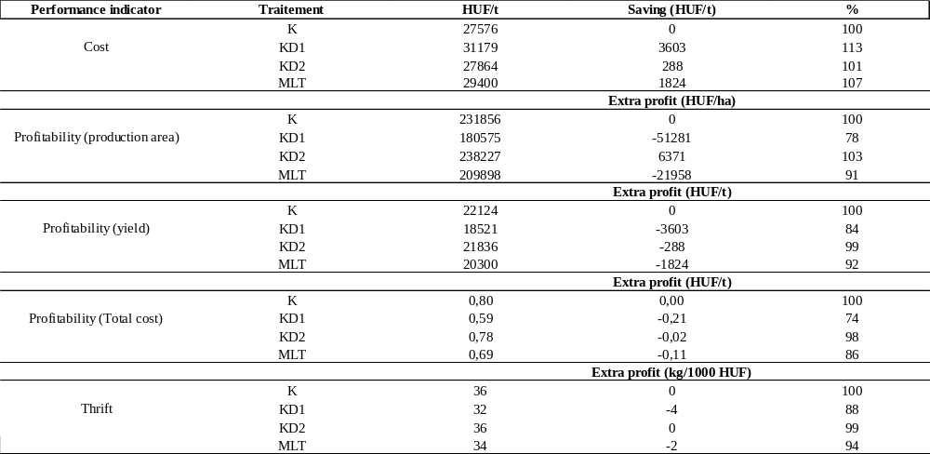

GK Silostar (2021)
The cost structure of maize growing 2021
Cost type | HUF/ha | Cost ratio (%)
Material cost | 217400 | 59
Machine cost | 152500 | 41
Total cost | 369900 | 100

