Zeng, X. et al: Abnormal structural alterations and disrupted functional connectivity in behavioral addiction: a meta-analysis of VBM and fMRI studies. https://doi.org/10.1556/2006.2023.00025

Supplementary Information
Supplementary Methods
Supplementary Figures
Figure S1-8 funnel plots of BA.
Supplementary Tables
Table S1 Summary of Seed-Networks and Seed ROIs of Studies Included in Meta-analysis
Table S2 Demographic and clinical characteristics of behavioral addictions (BA) in rs-FC included in the Meta-analysis
Table S3 Demographic and clinical characteristics of behavioral addictions (BA) in VBM included in the Meta-analysis
Table S4 Summary of Methods Implemented in Studies Included in rs-FC Meta-analysis
Table S5 Summary of Methods Implemented in Studies Included in VBM Meta-analysis
Table S6 Results of Jackknife Sensitivity Analysis of Addiction-HC

Supplementary Methods
Details of literature search
Firstly, a comprehensive search strategy was combined by MeSH term and free text words described in the bellowing in the four electronic database, PubMed, OVID Embase, OVID Medline, and Web of Science:
((((behavior, addictive[MeSH Terms]) OR (Oncogene Addiction[MeSH Terms])) OR (Food Addiction[MeSH Terms])) OR (Internet Addiction Disorder[MeSH Terms])) AND ("Magnetic Resonance Imaging"[Mesh]) AND (Resting state OR Voxel-based morphometry OR VBM OR Gray matter volume OR GMV)
After searching this comprehensive search strategy, search strategy about single type of addiction was conducted:
((((behavior, addictive[MeSH Terms]) OR (Addictive Behavior)) OR (Addictive Behaviors)) OR (Behaviors, Addictive)) AND ("Magnetic Resonance Imaging"[Mesh]) AND (Resting state OR Voxel-based morphometry OR VBM OR Gray matter volume OR GMV)
("Magnetic Resonance Imaging"[Mesh]) AND ((((gambling[MeSH Terms]) OR (Gambling, Pathological)) OR (Pathological Gamblings)) OR (Gambling, Pathologic)) AND (Resting state OR Voxel-based morphometry OR VBM OR Gray matter volume OR GMV)
("Magnetic Resonance Imaging"[Mesh]) AND (((((((Internet Addiction Disorder[MeSH Terms]) OR (Addiction Disorder, Internet)) OR (Disorder, Internet Addiction)) OR (Internet Addiction)) OR (Social Media Addiction)) OR (Social Media Addiction)) OR (Internet Gaming Disorder))) AND (Resting state OR Voxel-based morphometry OR VBM OR Gray matter volume OR GMV)
(((((((((((compulsive buying) OR (compulsive shopping)) OR (shopping addiction)) OR (pathological shopping)) OR (shopping disorder)) OR (Internet shopping disorder)) OR (buying disorder)) OR (buying addiction)) OR (pathological buying)) OR (compulsive buying)) AND ("Magnetic Resonance Imaging"[Mesh]) AND (Resting state OR Voxel-based morphometry OR VBM OR Gray matter volume OR GMV)
Literature searches was carried out without restrictions on time of publication or publication status. Filters was used to constrain database searches to studies of human participants written in English.

Supplementary Figures
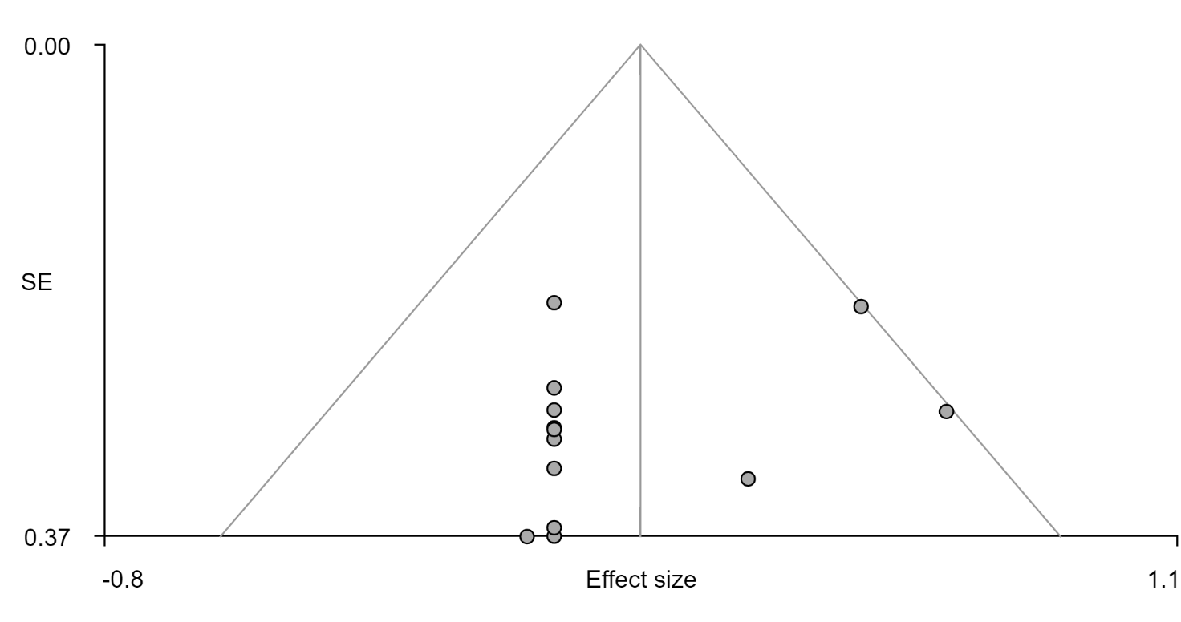
Figure S1, the funnel plot of cluster Superior Frontal Gyrus in frontoparietal network (FPN) seeds related rs-FC changes, Bias: 1.49, t: 1.13, df: 11, p: 0.283

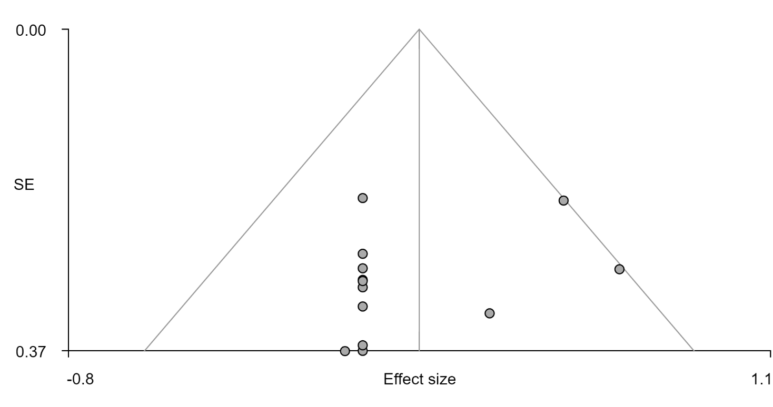
Figure S2, the funnel plot of cluster Posterior Cingulate Cortex in FPN seeds related rs-FC changes, Bias: 1.49, t: 1.13, df: 11, p: 0.283
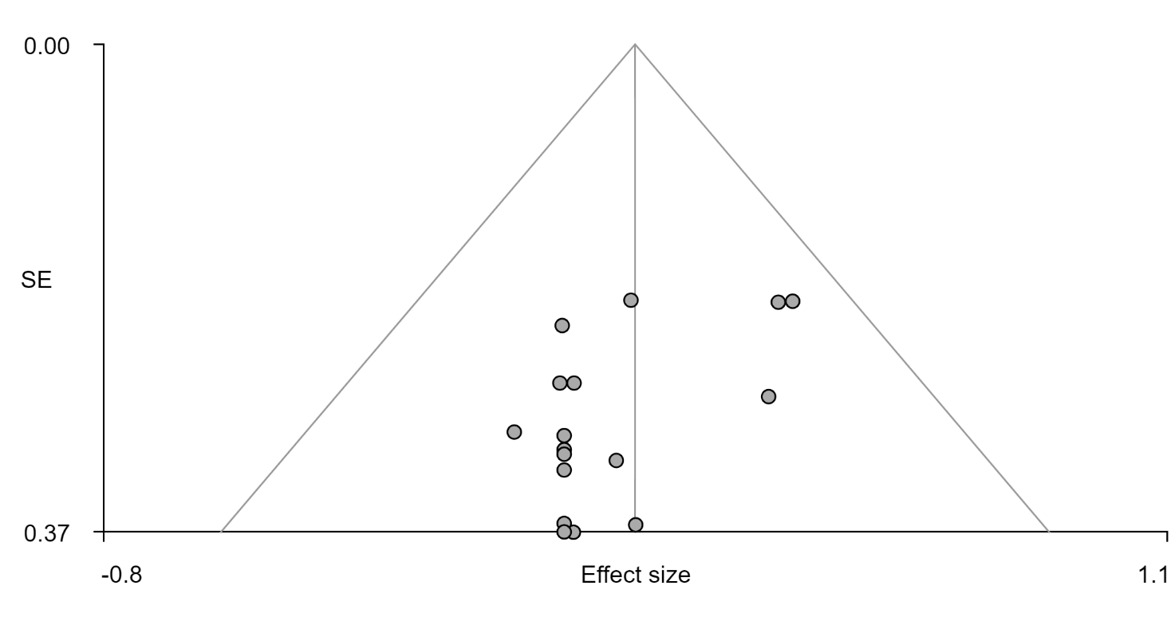
Figure S3, the funnel plot of Inferior Frontal Gyrus in affective network (AN) seeds related rs-FC changes, Bias: -2.40, t: -2.58, df: 15, p: 0.021
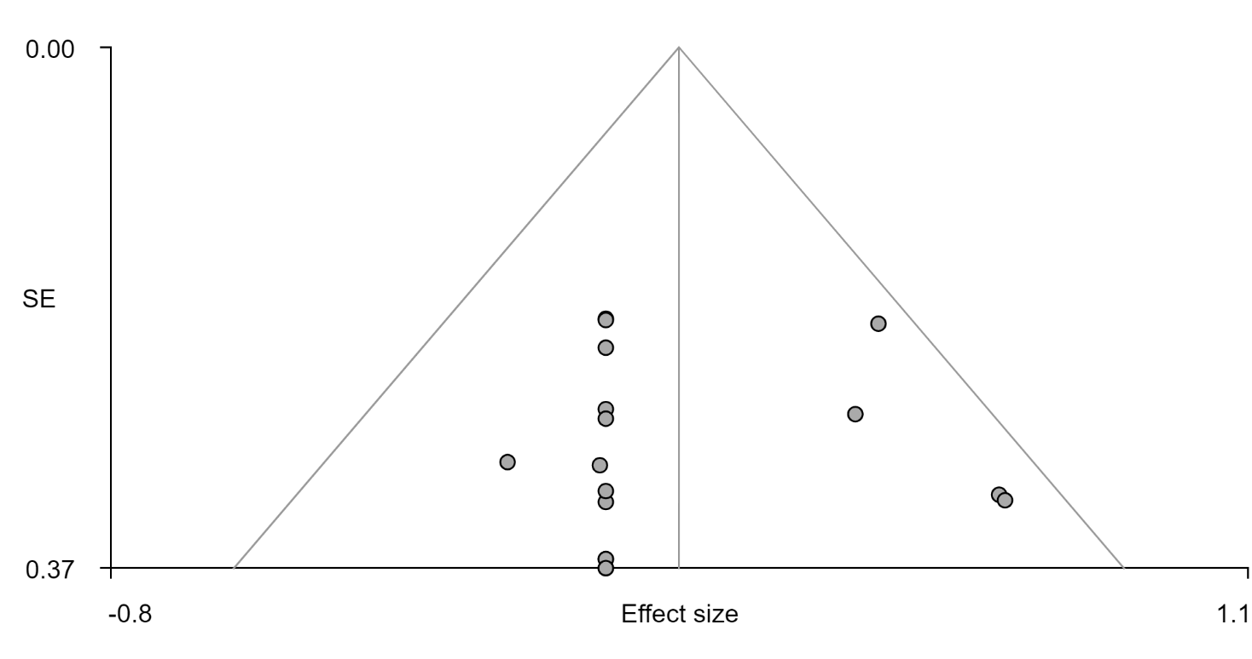
Figure S4, the funnel plot of Corpus Callosum in AN seeds related rs-FC changes, Bias: -0.06, t: -0.06, df: 15, p: 0.952
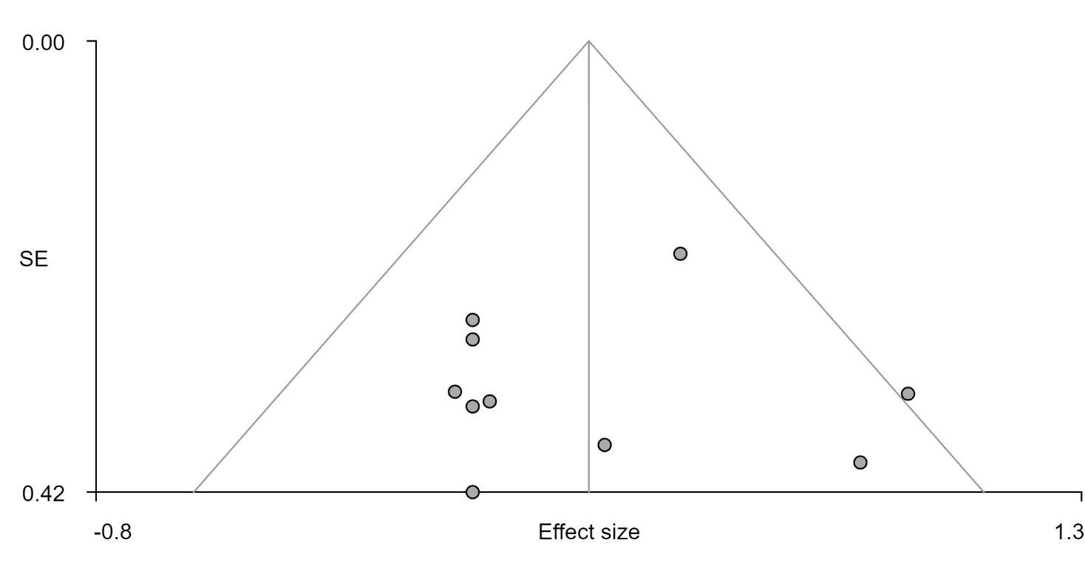
Figure S5, the funnel plot of Left Middle Cingulate Cortex in ventral attention network (VAN) seeds related rs-FC changes, Bias: -0.25, t: -0.16, df: 8, p: 0.879
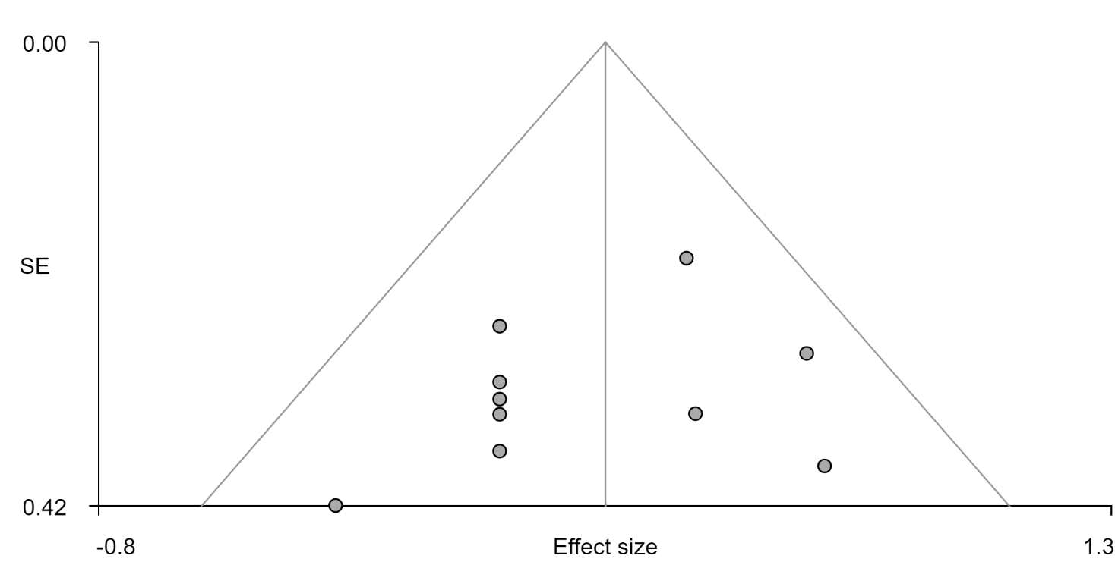
Figure S6, the funnel plot of Right Rolandic Operculum in VAN seeds related rs-FC changes, Bias: -1.41, t: -1.03, df: 8, p: 0.333
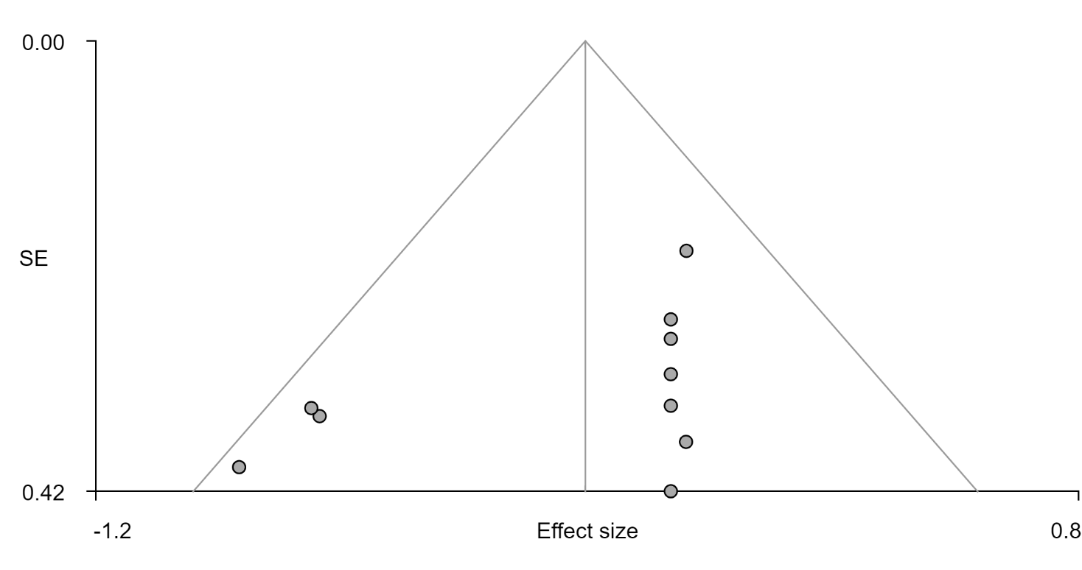
Figure S7, the funnel plot of Left Supplementary Motor Area in VAN seeds related rs-FC changes, Bias: -2.38, t: -1.67, df: 8, p: 0.133
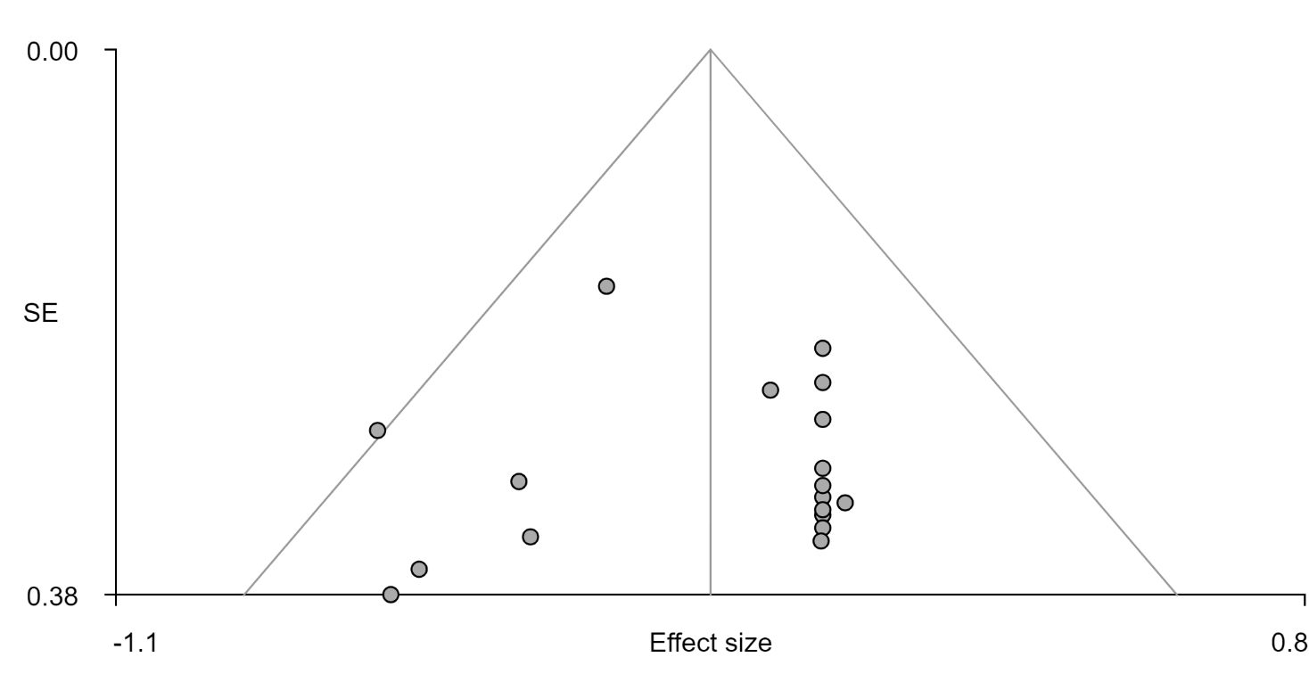
Figure S8, the funnel plot of Anterior Cingulate Cortex in gray matter volume analysis, Bias: -0.12, t: -0.12, df: 16, p: 0.907

Supplementary Tables

Table S1 Summary of Seed-Networks and Seed ROIs of Studies Included in Meta-analysis
Reference | Seed-Networks and Direction of Effects
Reference | DMN |  |  | FPN |  |  | AN |  |  | VAN |  |  | SSN |  |  | DAN |  |  | Visual
Reference | Addiction  >TD | Addiction  <TD | No  Sig | Addiction  >TD | Addiction  <TD | No  Sig | Addiction  >TD | Addiction  <TD | No  Sig | Addiction  >TD | Addiction  <TD | No  Sig | Addiction  >TD | Addiction  <TD | No  Sig | Addiction  >TD | Addiction  <TD | No  Sig | Addiction  >TD | Addiction  <TD | No  Sig
Bae et al., 2017 IGD | PCC |  |  | DLPFC |  |  | Amyg
Bae et al., 2017 ibGD | PCC |  |  |  | DLPFC |  | Amyg
Chen, C et al 2016 |  |  |  |  |  |  | NAcc | NAcc |  | Insula | Insula
Chen, J et al 2020 |  |  |  |  | DLPFC
Chen, X et al 2014_NI | PCC | PCC
Chen, X et al 2014_SI
Contreras et al 2015 PG | Caud
Ding et al 2013 | PCC | PCC
Dong et al 2012 |  |  |  |  |  |  |  |  |  | IPL
Ge et al 2017 IGD |  |  |  | DLPFC | DLPFC
Han et al 2019 |  | MCG |  |  | MFG  MCG |  |  |  |  | Insula
Han et al 2018 |  |  |  | DLPFC | DLPFC
Han,X te al 2018 |  |  |  |  |  |  | OFC
Hong et al 2015 |  |  |  |  |  |  |  |  |  |  | Putamen
Jung et al 2014 |  | PCC
Kang et al 2018 |  |  |  |  |  |  |  | Amyg
Kim et al 2019 |  |  |  |  |  |  |  | OFC
Kim et al 2021 | mPFC |  |  |  |  | DLPFC | NAcc  Amyg
Ko et al 2015 |  |  |  |  |  |  | Amyg | Amyg
Koehler et al 2013 |  |  |  | MFG | MFG |  | VS
Lee et al 2017 IGD | PCC
Lee et al 2017 IGD+ADHD | PCC
Lee et al 2018 IGD | ACC |  |  |  |  |  | ACC |  |  | ACC
Lee et al 2018 IGD+DEP | ACC | ACC |  |  |  |  |  | ACC
Lee et al 2021 |  |  |  |  |  |  |  |  |  |  | Putamen
Lee et al 2020 |  | PCC |  |  |  |  |  |  |  | Insula
Lin et al 2015 |  | Caud |  |  | Caud  Putam |  |  | Caud |  | Putam | Putam  Caud
Liu et al 2021 | AG | AG |  |  |  |  | NAcc | NAcc
Liu et al 2018 |  |  |  |  |  |  | Amyg
Seok et al 2018 | Caud
Sun et al 2019 |  |  |  |  | SFG
Yuan et al 2017 |  |  |  |  |  |  | Stria
Zhang,M et al 2018 |  |  |  |  |  |  | VS
Zhang,M et al 2015 |  |  |  |  |  |  |  | NAcc
Zhang,Y_a et al 2016 |  |  |  |  |  |  |  |  |  | Insula
Zhang,Y_b et al 2016 | PCC
Zhang et al 2016 |  |  |  |  |  |  |  |  |  |  | Insula
Contreras et al 2016PG |  |  |  |  |  |  | OFC  Amyg | Amyg
Lee et al 2021 |  |  |  |  |  |  |  |  |  |  |  |  | FEF | IPS
Total | 13 | 8 | 0 | 4 | 11 | 1 | 15 | 9 | 0 | 7 | 6 | 0 | 1 | 1 | 0 | 0 | 0 | 0 | 0 | 0 | 0
 | 21 |  |  | 16 |  |  | 24 |  |  | 13 |  |  | 2 |  |  | 0 |  |  | 0
ACC: anterior cingulate cortex; AG: Angular gyrus; Amyg: Amygdala; AN: affective network; Caud: Caudata; DAN: dorsal attention network; DLPFC: dorsolateral prefrontal cortex; DMN: default mode network; FEF: Frontal Eye Field; FG: fusiform gyri; FPN: frontoparietal network; Hippo: Hippocampus; IFS: inferior frontal sulcus; IPL: inferior parietal lobule; IPS: intraparietal sulcus; MCG: middle cingulate gyrus; MFG: middle frontal gyrus; mPFC: medial prefrontal cortex; NAcc: nucleus accumbens; OFC: orbitofrontal cortex; Putam: Putamen; Precu: precuneus; PMA: Primary motor cortex; SFG: superior frontal gyrus; STG: Superior Temporal Gyrus; Thalam: Thalamus; TP: temporal pole; SOG: Superior Occiptal Gyrus; SPL: superior parietal lobe; Stria: striatum; SSN: sensorimotor network; VAN: ventral attention network; VTA: ventral tegmental area; VS: ventral striatum
AUD: alcohol use disorder; CD: cocaine dependence; DEP: depression; IGD: internet gaming disorder; IbGD: internet-based gambling disorder; NI: internet gaming disorder without smoking; PG: pathological gambling; SI: internet gaming disorder with smoke; SND: smokers with nicotine dependence

Table S2 Demographic and clinical characteristics of behavioral addictions (BA) in rs-FC included in the Meta-analysis
Studies | Sample |  | Mean Age (addiction / HC) | Gender(male) | Co-morbidity | Clinic Measurement |  |  |  | Severity
Studies | HC | Addiction | Mean Age (addiction / HC) | Gender(male) | Co-morbidity | Anxiety | Depression | Impulsivity | Other | Severity
IGD
Bae et al., 2017 | 15 | 15 | 25.7/25.7 | 100% | 66.7% alcoho  53.3% smoke | NA | BDI | BIS-11 | K-ARS | YIAS
Chen, C et al 2016 | 28 | 28 | 23.6/24.1 | 100% | NA | NA | NA | BIS-11 | NA | CIAS
Chen, J et al 2020 | 26 | 22 | 14.1/ 13.9 | 77.2%/73.1% | NA | NA | NA | BIS-11 | NA | IAT
Chen, X et al 2014 SI | 30 | 29 | 22.1/20.8 | 100% | 100% smoke | SAS | SDS | BIS-11 | FTND | CIAS
Chen, X et al 2014 NI | 30 | 22 | 21/20.8 | 100% | Na | SAS | SDS | BIS-11 | NA | CIAS
Ding et al 2013 | 24 | 17 | 16.9/15.9 | 76.5%/66.6% | NA | SAS | SDS | BIS | NA | CIAS
Dong et al 2012 | 14 | 15 | 24.2/24.6 | 100% | NA | NA | NA | NA | NA | IAT
Ge et al 2017 IGD | 33 | 27 | 20.78/20.8 | 70.4%/81.8% | NA | SAS | SDS | BIS-11 | NA | CIAS
Han et al 2019 | 38 | 49 | 14.6/14.8 | NA | 59.2%ADHD | BAI | CDI | BIS | NA | YIAS
Han,Wu et al 2018 | 30 | 30 | 21.2/20.83 | 40%/43.3% | NA | SAS | SDS | BIS-11 | NA | CIAS
Han,X te al 2018 | 30 | 26 | 16.81/17.0 | 100% | NA | SAS | SDS | BIS-11 | NA | CIAS
Hong et al 2015 | 11 | 12 | 13.41/14.8 | 100% | NA | NA | NA | NA | NA | YIAS
Kang et al 2018 | 15 | 15 | 15.6/15.7 | 100% | NA | NA | CDI | NA | K-ARS | YIAS
Kim et al 2019 | 24 | 22 | 28.27/28.17 | 100% | NA | NA | NA | DII | NA | IGD scale
Kim et al 2021 | 23 | 22 | 24.30/23.5 | 100% | NA | HADS | HADS | BIS-11 | NA | IAT
Ko et al 2015 | 30 | 30 | 23.57/24.3 | 100% | NA | NA | NA | BIS-11 | NA | CIAS
Lee et al 2017 IGD | 19 | 24 | 24.3/23.6 | 100% | NA | BAI | BDI | BIS-11 | WURS  AUDIT | IAT
Lee et al 2017 IGD+ADHD | 19 | 20 | 23.6/23.6 | 100% | 100%ADHD | BAI | BDI | BIS-11 | WURS  AUDIT | IAT
Lee et al 2018 IGD | 20 | 22 | 24.0/24.0 | 100% | NA | BAI | BDI | BIS-11 | AUDIT | IAT
Lee et al 2018 IGD+DEP | 20 | 22 | 24.0/24.0 | 100% | 100%Depression | BAI | BDI | BIS-11 | AUDIT | IAT
Lee et al 2021 | 18 | 18 | 23.8/23.9 | 100% | NA | BAI | BDI | BIS-11 | AUDIT | IAT
Lee et al 2020 | 18 | 17 | 13.7/13.4 | 100% | NA | BAI | BDI | BIS-11 | CASS | KS
Lin et al 2015 | 15 | 14 | 17.1/17.9 | 100% | NA | SCARED | NA | BIS-11 | NA | YIAS
Liu et al 2021 | 41 | 74 | 22.3/23.0 | 100% | NA | BAI | BDI | NA | NA | CIAS
Liu et al 2018 | 41 | 74 | 22.3/23.0 | 100% | 77.0% alcohol  10.8% smoke | BAI | BDI | NA | NA | CIAS
Seok et al 2018 | 20 | 20 | 21.7/22.4 | 100% | NA | NA | BDI | BIS-11 | AUDIT | IAT
Sun et al 2019 | 52 | 53 | 21.9/20.9 | 56.6%/57.7% | NA | NA |  | BIS-11 |  | CIAS
Yuan et al 2017 | 44 | 43 | 19.0/19.5 | 74.4%/77.3% | NA | NA | BDI |  |  | IAT
Zhang,M et al 2018 | 41 | 74 | 22.3/23.0 | 100% | 77.0% alcohol  10.8% smoke | BAI | BDI | BIS-11 | Craving | CIAS
Zhang,M et al 2015 | 24 | 35 | 22.5/23.1 | NA | 80.0% alcohol  14.3% smoke | BAI | BDI | NA | Craving | CIAS
Zhang,Y b et al 2016 | 41 | 74 | 22.3/23.0 | 100% | 77.0% alcohol  10.8% smoke | BAI | BDI | NA | FTND | CIAS
Zhang,JT et al 2016 | 19 | 36 | 22.1/22.9 | 100% | NA | BAI | BDI | NA | FTND  Craving  AUDIT | CIAS
Zhang, Y a et al 2016 | 19 | 19 | 20.8/21.5 | 89.5% | NA | NA | NA | NA |  | YIAS
Lee et al 2021 | 49 | 39 | 22.9/22.4 | 74.4%/65.3% | NA | BAI | BDI | BIS | AUDIT | IAT, SAPS
Gambling
Contreras et al 2015 PG | 21 | 19 | 33.8/31 | 89.5%/95% | NA | NA | NA | NA | NA | NA
Contreras 2016 PG | 21 | 19 | 33.8/31 | 89.5%/95% | NA | NA | NA | NA | NA | NA
Jung et al 2014 | 15 | 15 | 27.9/26.6 | 100% | NA | BAI | BDI | NA | NA | PG-YBOCS, SOGS
Koehler et al 2013 | 19 | 19 | 32.79/37 | 100% | NA | NA | NA | BIS-10 | NA | KFG, G-SAS
Bae et al 2017 | 15 | 14 | 26.0/25.7 | 100% | 78.6% alcohol 64.3% smoke | NA | NA | NA | NA | NA
AUDIT: Alcohol Use Disorder Identification Test; BDI: Beck Depression Inventory; BIS-11: Barratt Impulsiveness Scale -11; CASS: Conners/Wells Adolescent Self-report Scale; CDI: Child Depression Inventory; CIAS: Chen Internet Addiction Scale; DII: Dickman Impulsivity Inventory; FTND: Fagerstrom Test for Nicotine Dependence; G-SAS: Gambling Symptom Assessment Scale; HADS: Hospital Anxiety and Depression Scale; IAT: Internet Addiction Test; IGD scale: Self-reported Internet Gaming Disorder Scale; K-ARS: Korean ADHD Rating Scale; KFG, “Kurzfragebogen zum Glücksspielverhalten” (gambling questionnaire); KS: Korean Internet Addiction Proneness Scale, SAS: Self-Rating Anxiety Scale; PG-YBOCS, Pathological Gambling Modification of Yale-Brown Obsessive Com pulsive Scale; SAPS, Smartphone Addiction Proneness Scale; SCARED: The Screen for Child Anxiety Related Emotional Disorders; SDS: Self-Rating Depression Scale; SOGS, South Oaks Gambling Screen; WURS: WURS: Wender Utah Rating Scale; YIAS: Young Internet Addiction Scale.

Table S3 Demographic and clinical characteristics of behavioral addictions (BA) in VBM included in the Meta-analysis
Studies | Sample |  | Mean Age (addiction / HC) | Gender(male) | Co-morbidity | Clinic Measurement |  |  |  | Severity
Studies | HC | Addiction | Mean Age (addiction / HC) | Gender(male) | Co-morbidity | Anxiety | Depression | Impulsivity | Other | Severity
IGD
Choi et al 2017 | 24 | 22 | 29.45/27.21 | 100% | NA | NA | SCL-90-R: Depression | DDⅡ | NA | IGD scale
Han et al 2012 | 18 | 20 | 20.9/20.9 | 1 | 35%smoke  45%drink | NA | BDI | BIS | NA | YIAS
Jin et al 2016 | 21 | 25 | 19.12/18.76 | 64%/66.67% | NA | NA | NA | NA | NA | IAT
Ko et al 2015 | 30 | 30 | 23.57/24.23 | 1 | NA | NA | NA | BIS | NA | CIAS
Lee et al 2017 | 30 | 31 | 24/23 | 1 | NA | BAI | BDI | BIS | WURS | IAT
Seok et al 2018a | 20 | 20 | 21.7/22.4 | 1 | NA | NA | BDI | BIS | AUDTI | IAT
Sun et al 2014 | 21 | 18 | 20.5/21.95 | 83.3%/85.7% | NA | SAS | SDS | BIS | NA | CIAS
Weng et al 2013 | 17 | 17 | 16.25/15.54 | 76.5%/88.2% | NA | NA | NA | BIS | NA | YIAS
Yoon et al 2017 | 25 | 19 | 22.9/25.4 | 84.2%/80% | NA | BAI | BDI | BIS | AUDIT | IAT
Yuan et al 2011 | 18 | 18 | 19.4/19.5 | 66.7%/66.7% | NA | SAS | SDS | NA | NA | NA
Zhou et al 2011 | 15 | 18 | 17.23/17.81 | 88.9%/86.7% | NA | NA | NA | NA | NA | IGD scale
Gambling
Van Holst et al 2012 | 54 | 36 | 43.2/35.3 | 1 | 56% smoke | NA | NA | NA | AUDIT | SOGS
Koehler et al 2015 | 21 | 20 | 33.65/39.19 | 1 | NA | NA | NA | BIS | NA | G-SAS
Mohammadi et al 2016 | 15 | 15 | 36.7/36.8 | 1 | NA | NA | NA | NA | NA | SOGS
Yip et al 2018 | 35 | 37 | 38.4/38 | 72.9%/75.7% | 57.1% alcohol  28.6% cannabis | NA | NA | BIS | NA
Zois et al 2017 | 98 | 60 | 36.7/36.1 | 1 | NA | STAI | BDI | NA | NA | SOGS  PG-YBOCS
Hypersexual
Seok et al 2018 b | 19 | 17 | 26.9/25.1 | 1 | NA | BAI | BDI | BIS | NA | HBI  SAST-R
BAI: Beck Anxiety Inventory, BDI: Beck Depression Inventory; DDII: Dickman’s Dysfunctional Impulsivity Inventory; G-SAS: gambling symptom assessment scale; HBI, Hypersexual Behavior Inventory; PG-YBOCS: Yale–Brown Obsessive Compulsive Scale adapted for Pathological Gambling; SAST-R, Sexual Addiction Screening Test; SCL-90-R: Symptom Checklist-90-Revised; SOGS: South Oaks Gambling Screen; YIAS: Young Internet Addiction Scale

Table S4 Summary of Methods Implemented in Studies Included in Meta-analysis
TAL | Scanner | Duration (min) | TR/TE (ms) | EO/C | seed type | Software | Preprocessing  Nuisance Regressors | Coordinate  System | Motion Inclusion Criteria
Bae et al., 2017 | Philips 3T | 12 | 3000/40 | NA | NA | SPM8, REST | NA | TAL | 2mm or 2°
Chen, C et al 2016 | GE 3T | 10.3 | 2000/35 | C | 3.5mm sphere | SPM8 | 6MP, CSF, WM, GS | MNI | NA
Chen, J et al 2020 | Siemens 3T | 2.9 | 1650/27 | C | 6mm sphere | SPM12, DPABI, REST | NA | MNI | NA
Chen, X et al 2014 | GE 3T | 7.3 | 2000/30 | C | NA | DPARSF, SPM8, REST | 6MP, CSF, WM | MNI | 1mm or 1°
Contreras et al 2015 PG | Philips 3T | 6 | 2000/35 | C | 3.5mm sphere | SPM8 | CSF, WM | MNI | NA
Contreras et al 2016 PG | Philips 3T | 6 | 2000/35 | C | 3.5mm sphere | SPM8 | CSF, WM | MNI | NA
Ding et al 2013 | GE 3T | 7.3 | 2000/30 | C | mask | MRIcorn, REST, SPM5, Data Processing Assistant for  Resting-State fMRI V 2.0 | 6MP, CSF, WM, GS | MNI | 1mm or 1°
Dong et al 2012 | Siemens 3T | 8 | 2000/30 | C | mask | DPARSF | NA | MNI | 2mm or 1°
Ge et al 2017 | GE 3T | 7.3 | 2000/30 | C | mask | DPABI, SPM8 | 6MP, CSF, WM, GS | MNI | 1.5mm or 1.5°
Han et al 2019 | Philips 3T | 12 | 3000/40 | NA | NA | DPARSF, SPM12, REST, CONN-fMRI FC | CSF, WM, gray matter | MNI | 3mm or 2°
Han et al 2018 | GE 3T | 7.3 | 2000/30 | C | mask | SPM12, DPABI | 24MP, CSF, WM | MNI | 1.5mm or 1.5°
Han,X te al 2018 | GE 3T | 7.3 | 2000/30 | C | mask | SPM12, DPABI | 6MP, CSF, WM, GS | MNI | 1mm or 1°
Hong et al 2015 | Siemens 3T | 6.75 | 2700/30 | C | mask | SPM8 | CSF, WM, GS | MNI | 2mm or 2°
Jung et al 2014 | Siemens 1.5T | 4.68 | 2340/52 | C | mask | FMRIB, ANFI | NA | MNI | NA
Kang et al 2018 | Siemens 3T | NA | 3000/30 | C | mask | REST | CSF, WM | TAL | 3mm or 3°
Kim et al 2019 | Siemens 3T | NA | 2000/30 | O | NA | SPM8, DPARSF | NA | MNI | NA
Kim et al 2021 | Siemens 3T | 6 | 2000/30 | O | NA | CONN | CSF, WM, gray matter | MNI | 3mm
Ko et al 2015 | Siemens 3T | NA | 2000/35 | C | mask | DARTEL, SPM8, REST | CSF, WM, gray matter | MNI | 2mm or 2°
Koehler et al 2013 | Siemens 3T | NA | 2500/35 | NA | NA | FMRIB, AFNI | CSF, WM | MNI | NA
Lee et al 2017 | Siemens 3T | 6 | 2200/30 | O | 6mm sphere | SPM8, CONN-fMRI | NA | MNI | 3mm
Lee et al 2018 | Siemens 3T | 6 | 2200/30 | O | 5mm sphere | SPM8, CONN-fMRI | NA | MNI | 2mm
Lee et al 2021 | Siemens 3T | NA | 2500/30 | NA | 4mm sphere | SPM12 | CSF, WM, gray matter | MNI | 3mm
Lee et al 2020 | Siemens 3T | 15 | 2200/30 | O | 5mm sphere | SPM12 ，CONN-fMRI | CSF, WM, gray matter | MNI | 3mm
Lin et al 2015 | Philips 3T | NA | 2000/30 | C | 6mm sphere | SPM8 | CSF, WM, GS | MNI | 2mm or 2°
Liu et al 2021 | Siemens 3T | NA | 2000/30 | NA | mask | DPABI, SPM8 | CSF, WM, gray matter | MNI | 3mm or 3°
Liu et al 2018 | Siemens 3T | NA | 2000/30 | O | mask | DPABI, SPM8 | NA | MNI | 3mm or 3°
Seok et al 2018 | 3T Philips | NA | 2000/28 | O | mask | SPM8, VBM8, CONN | CSF, WM, | MNI | NA
Sun et al 2019 | 3T GE | 7.3 | 2000/30 | C | mask | SPM8, REST, DPABI, AFNI | 6MP, CSF, WM | MNI | 1.5mm or 1.5°
Yuan et al 2017 | GE 3T | 6.1 | 2000/30 | C | NA | FreeSurfer, ANFI, FSL | 6MP, CSF, WM | MNI | 3mm
Zhang,J et al 2018 | Siemens 3T | NA | 2000/30 | O | NA | DPARSF | 24MP, CSF, WM | MNI | 3mm or 3°
Zhang,J et al 2015 | Siemens 3T | NA | 2000/30 | O | NA | DPARSF, REST | 6MP, CSF, WM, GS | MNI | 3mm or 3°
Zhang,J et al 2016 | Siemens 3T | NA | 2000/30 | O | 6 sphere | DPARSF, REST, SPM8 | CSF, WM | MNI | 3mm or 3°
Zhang,JT et al 2016 | Siemens 3T | NA | 2000/30 | O | 6 sphere | DPARSF, SPM8 | CSF, WM | MNI | 3mm or 3°
Zhang et al 2016 | Siemens 3T | NA | 2000/35 | C | mask | SPM8, DPARSF, REST | 6MP, CSF, WM,GS | MNI | 3mm or 3°

AFNI: Analysis of Functional NeuroImages; CONN: Functional Connectivity Toolbox; CSF: cerebrospinal fluid; DPARFS: Data Processing Assistant for Resting-State fMRI; DPABI: Data Processing & Analysis for Brain Imaging; FD:framewise displacement; FSL: FMRIB Software Library; GIFT: Group ICA of fMRI Toolbox; GS= global signal; MP= motion parameters; REST: Resting-State fMRI Data Analysis Toolkit; RMS: root mean square; SPM: Statistical Parametric Mapping; TR: repetition time; TE: echo time; WM: white matter.

Table S5 Summary of Methods Implemented in Studies Included in VBM Meta-analysis
Author | Teslas | MRI-system | MRI-model | Head-coil | T1w sequence | TR/TE (ms) | Voxel size (mm) | Analysis Software
Choi et al 2017 | 3 | Siemens | Verio | 8-channel | MPRAGE | 2,300/2.22 | 1x1x1 | VBM8, SPM8
Han et al 2012 | 1.5 | Siemens | Espree | NA | MPRAGE | 1500/3 | 1x1x1.3 | VBM5, SPM5
Jin et al 2016 | 3 | General Electric | NA | 8-channel | 3D | 1900/2.26 | 1x1x1 | FSL-VBM
Ko et al 2015 | 3 | General Electric | Signa | NA | SPGR | 6.6/2.8 | 1x1x1 | SPM8
Koehler et al 2015 | 3 | Siemens | Trio | NA | MPRAGE | 1570/2.74 | 1x1x1 | VBM8, SPM8
Lee et al 2017 | 3 | Siemens | NA | 8-channel | 3D | 1780/2.8 | 1x1x1 | SPM8
Lin et al 2015 | 3 | Siemens | Trio | NA | 3D | 1700/3.93 | 1x1x1 | SPM 8
Mohammadi et al 2016 | 3 | Siemens | Trio | 32-channel | MPRAGE | 2500/4.77 | 1x1x1 | FSL-VBM
Seok et al 2018a | 3 | Philips | Achieva | NA | 3D | 280/14 | 1x1x1 | SPM 8 VBM 8
Seok et al 2018b | 3 | Philips | Achieva | NA | 3D | 280/14 | 1x1x1 | SPM8
Sun et al 2014 | 3 | General Electric | Signa | 8-channel | 3D | 331/4.6 | 0.5x0.5x4 | SPM8
Van et al 2012 | 3 | Philips | Intera | Multi-channel | 3D | 9/4.2 | 1x1x1 | SPM8
Weng et al 2013 | 3 | Philips | Intera | NA | 3D | 1900/3.37 | 1x1x1 | FSL-VBM
Yip et al 2018 | 3 | Siemens | Trio | NA | 3D | 2530/3.34 | 1x1x1 | FSL-VBM
Yoon et al 2017 | 3 | Philips | Achieva | 12-channel | 3D | 9.9/4.6 | 0.98x0.98x1 | SPM8
YuanQ et al 2011 | 3 | Siemens | Allegra | Birdcage | 3D | 1900/2.6 | 1x1x1 | FSL-VBM
Zhou et al 2011 | 3 | Philips | Achieva | NA | MPRAGE | 331/4.6 | 1x1x1 | SPM2
Zois et al 2017 | 3 | Siemens | Trio | 12-channel | 3D | 2.3/3.03 | 1x1x1 | VBM8

FSL:FMRIB Software Library; MPRAGE: Magnetization-prepared Rapid Gradient-echo; SPM:Statistical Parametric Mapping; SPGR: Spoiled Gradient Echo; VBM: Voxel-based morphometry.

Table S6 Results of Jackknife Sensitivity Analysis of Behavioral Addiction-HC
Discarded datasets | Seed Networks and effect anatomy |  |  |  |  |  |  | VBM results
Discarded datasets | FPN |  | AN |  | VAN |  |  | GMV
Discarded datasets | Right SFG | Left PCC | Right IFG | Corpus callosum | Left MCC | Right RO | Left SMA | Left ACC
Bae et al., 2017 IGD | Yes | Yes | Yes | Yes
Bae et al., 2017 ibGD | Yes | Yes | Yes | Yes
Chen, C et al 2016 |  |  | Yes | Yes | Yes | Yes | Yes
Chen, J et al 2020 | Yes | Yes
Dong et al 2012 |  |  |  |  | Yes | Yes | Yes
Ge et al 2017 IGD | Yes | Yes
Han et al 2019 | Yes | Yes |  |  | Yes | Yes | Yes
Han et al 2018 | Yes | Yes
Haynos et al 2021 | Yes | Yes
Hong et al 2015 |  |  |  |  | Yes | Yes | Yes
Kang et al 2018 |  |  | Yes | Yes
Kim et al 2019 |  |  | Yes | Yes
Kim et al 2021 | Yes | Yes | Yes | Yes
Ko et al 2015 |  |  | Yes | Yes
Koehler et al 2013 | Yes | Yes | Yes | Yes
Lee et al 2018 IGD |  |  | Yes | Yes | Yes | Yes | Yes
Lee et al 2018 IGD+DEP |  |  | Yes | Yes
Lee et al 2021 |  |  |  |  | Yes | Yes | Yes
Lee et al 2020 |  |  |  |  | Yes | Yes | Yes
Lin et al 2015 | Yes | Yes | Yes | Yes | Yes | Yes | Yes
Liu et al 2021 |  |  | Yes | Yes
Liu et al 2018 |  |  | Yes | Yes
Oliva et al 2020 | Yes | Yes
Sun et al 2019 | Yes | Yes
Yuan et al 2017 |  |  | Yes | Yes
Zhang,M et al 2018 |  |  | Yes | No
Zhang,M et al 2015 |  |  | Yes | Yes
Zhang,Y_a et al 2016 |  |  |  |  | Yes | Yes | Yes
Zhang et al 2016 | Yes | Yes |  |  | Yes | No | Yes
Contreras et al 2016PG |  |  | Yes | Yes
Choi et al 2017 |  |  |  |  |  |  |  | Yes
Han et al 2012 |  |  |  |  |  |  |  | Yes
Jin et al 2016 |  |  |  |  |  |  |  | Yes
Ko et al 2015 |  |  |  |  |  |  |  | Yes
Koehler et al 2015 |  |  |  |  |  |  |  | Yes
Lee et al 2017 |  |  |  |  |  |  |  | Yes
Lin et al 2015 |  |  |  |  |  |  |  | Yes
Mohammadi et al 2016 |  |  |  |  |  |  |  | Yes
Seok et al 2018a |  |  |  |  |  |  |  | Yes
Seok et al 2018b |  |  |  |  |  |  |  | Yes
Sun et al 2014 |  |  |  |  |  |  |  | Yes
Van et al 2012 |  |  |  |  |  |  |  | Yes
Weng et al 2013 |  |  |  |  |  |  |  | Yes
Yip et al 2018 |  |  |  |  |  |  |  | Yes
Yoon et al 2017 |  |  |  |  |  |  |  | Yes
YuanQ et al 2011 |  |  |  |  |  |  |  | Yes
Zhou et al 2011 |  |  |  |  |  |  |  | Yes
Zois et al 2017 |  |  |  |  |  |  |  | Yes
Overall | 12/12 | 12/12 | 17/17 | 16/17 | 10/10 | 9/10 | 10/10 | 18/18
ACC: anterior cingulate cortex; IFG: inferior frontal gyrus; MCC: median cingulate cortex; PCC: posterior cingulate cortex; RO: rolandic operculum; SFG: superior frontal gyrus; SMA: supplementary motor area.

Table S7 Meta-analysis of aberrant intrinsic functional connectivity in IGD compared to HC
Seed network | Effect anatomy | Effect network | MNI coordinate | Voxels | SDM Z-value | p value | Breakdown (Main clusters)
Rs-FC alternations
IGD > HC
AN | Right IFG | FPN | 54, 14, 24 | 974 | 2.777 | <0.0001 | Right IFG (677)  Right precentral gyrus (123)
AN | Corpus callosum | VAN | -48, 2, 22 | 309 | 2.240 | <0.0001 | Left IFG, BA44 (123)  Left FAT (46)  Left SLF (44)  Corpus callosum (36)
VAN | Left MCC | VAN | -12, -14, 38 | 265 | 2.469 | <0.0001 | Left MCC (147)  Left SLF (40)
VAN | Right RO | VAN | 50, -30, 22 | 131 | 2.396 | 0.0005 | Right STG, BA42 (58)  Right supramarginal gyrus (30)  Right RO (15)
IGD < HC
FPN | Corpus callosum | DMN | -2, -32, 24 | 286 | -2.181 | <0.0001 | Left PCG (28)  Left median network (28)  Corpus callosum (28)
FPN | Left Putamen | AN | -32, 6, -2 | 152 | -1.829 | 0.0004 | Left putamen (60)  Left insular (25)
VAN | Left SMA | VAN | 0, 20, 48 | 1184 | -1.850 | <0.0001 | Left MCC (297)  Left SFG (167)  Left SMA (167)

FAT: frontal aslant tract; IFG: inferior frontal gyrus; MCC: median cingulate cortex; PCC: posterior cingulate cortex; RO: rolandic operculum; SFG: superior frontal gyrus; SLF: superior longitudinal fasciculus; SMA: supplementary motor area; STG: superior temporal gyrus.

Table S8 Meta-analysis of grey matter volume in IGD compared to HC
Anatomy | MNI coordinate | SDM Z-value | p value | Voxel | Breakdown (Main cluster)
Left ACC | 4, 36, 12 | -2.604 | 0.00003 | 993 | Left ACC (447)  Right ACC (203)  Left MCC (90)  Right MCC (68)  Left SFG (36)
Right SMA | 4, 0, 60 | -2.726 | 0.00002 | 789 | Right SMA (417)  Left SMA (347)
Left caudate nucleus | -8, 10, 10 | 1.008 | 0.00035 | 119 | Left caudate nucleus (37)  Left ATP (82)

ACC: anterior cingulate cortex; ATP: anterior thalamus projection; MCC: median cingulate cortex; SFG: superior frontal gyrus; SMA: supplementary motor area.

