Shaun S. Garea et. al.:
The potential relationship between loot box spending, problem gambling, and obsessive-compulsive gamers.
https://doi.org/10.1556/2006.2023.00038

SUPPLEMENTARY MATERIALS

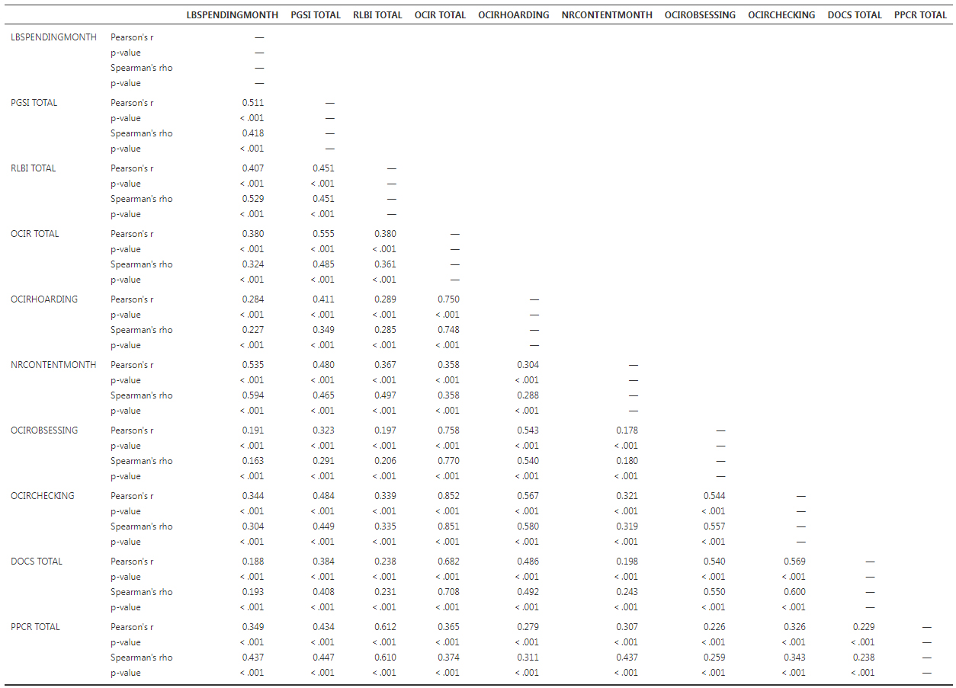

Table S1.
Correlation matrix with Spearman rho’s, Pearsons, and p-values (LB filter off)

NOTE: All correlation data comes from a n=1049 (Raw n=1200 before exclusion filters).

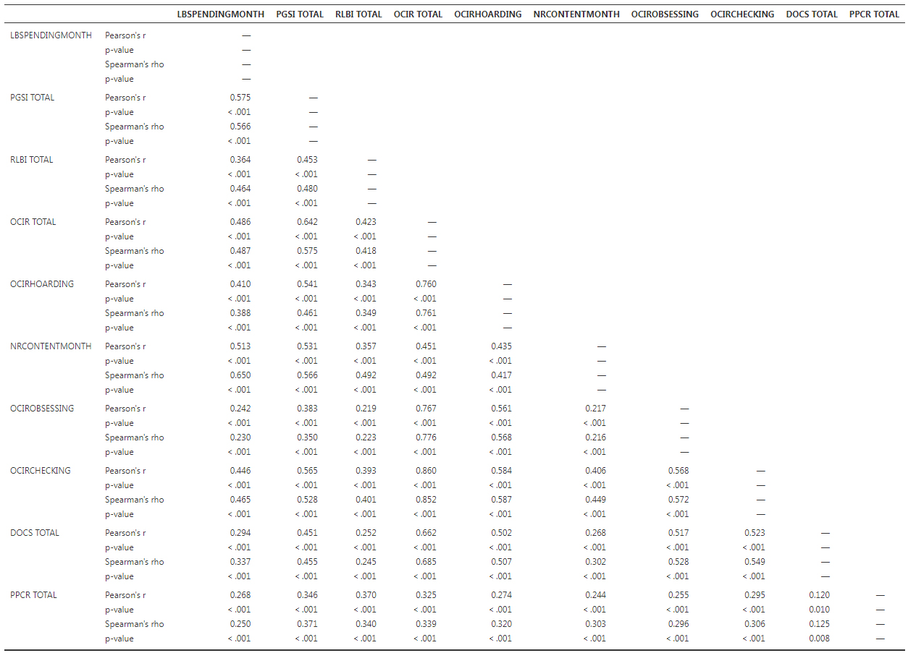
NOTE: All correlation data comes from a n=1200.

Table S2.
Correlation matrix with Spearman rho’s, Pearsons, and p-values (all filters on).

Moderation tables with ‘loot box purchase’ filter off.

Table S3.
Moderation analysis between PGSI totals and loot box monthly spending with hoarding scores (OCI-R subscale) as the moderator.
 |  |  |  |  |  | 95% Confidence Interval
 |  | Estimate |  | SE |  | Lower |  | Upper |  | Z |  | p
PGSI TOTAL |  | 3.511 |  | 0.389 |  | 2.7496 |  | 4.273 |  | 9.03 |  | < .001
OCIRHOARDING |  | 3.007 |  | 0.746 |  | 1.5459 |  | 4.468 |  | 4.03 |  | < .001
PGSI TOTAL ✻ OCIRHOARDING |  | 0.207 |  | 0.121 |  | -0.0300 |  | 0.444 |  | 1.71 |  | 0.087

Table S4.
Simple slope estimates between Hoarding score (OCI-R subscale), PGSI totals, and loot box monthly spending.
 |  |  |  |  |  | 95% Confidence Interval
 |  | Estimate |  | SE |  | Lower |  | Upper |  | Z |  | p
Average |  | 3.51 |  | 0.390 |  | 2.75 |  | 4.28 |  | 9.01 |  | < .001
Low (-1SD) |  | 2.93 |  | 0.656 |  | 1.65 |  | 4.22 |  | 4.47 |  | < .001
High (+1SD) |  | 4.09 |  | 0.318 |  | 3.47 |  | 4.71 |  | 12.86 |  | < .001
Note. shows the effect of the predictor (PGSI TOTAL) on the dependent variable (loot box monthly spending) at different levels of the moderator (OCIRHOARDING)

Table S5.

Simple slope plot outlining moderation the effect between Hoarding scores (OCI-R subscale), PGSI totals, and loot box monthly spending (LBSPENDINGMONTH).
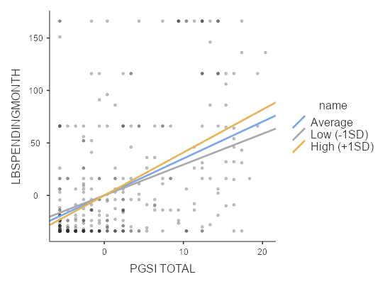

Table S6.
Moderation estimates between OCI-R, PGSI totals, and loot box monthly spending.
 |  |  |  |  |  | 95% Confidence Interval
 |  | Estimate |  | SE |  | Lower |  | Upper |  | Z |  | p
PGSI TOTAL |  | 3.1308 |  | 0.4048 |  | 2.3374 |  | 3.9242 |  | 7.73 |  | < .001
OCIR TOTAL |  | 0.7237 |  | 0.1302 |  | 0.4685 |  | 0.9789 |  | 5.56 |  | < .001
PGSI TOTAL ✻ OCIR TOTAL |  | 0.0314 |  | 0.0220 |  | -0.0117 |  | 0.0746 |  | 1.43 |  | 0.153

Table S7.
Simple slope estimates between OCI-R, PGSI totals, and loot box spending.
 |  |  |  |  |  | 95% Confidence Interval
 |  | Estimate |  | SE |  | Lower |  | Upper |  | Z |  | p
Average |  | 3.13 |  | 0.405 |  | 2.34 |  | 3.93 |  | 7.72 |  | < .001
Low (-1SD) |  | 2.63 |  | 0.690 |  | 1.28 |  | 3.98 |  | 3.82 |  | < .001
High (+1SD) |  | 3.63 |  | 0.311 |  | 3.02 |  | 4.24 |  | 11.65 |  | < .001
Note. shows the effect of the predictor (PGSI TOTAL) on the dependent variable (loot box monthly spending) at different levels of the moderator (OCIR TOTAL)

Table S8.

Simple slope plot outlining moderation the effect between OCI-R, PGSI totals, and loot box monthly spending (LBSPENDINGMONTH).
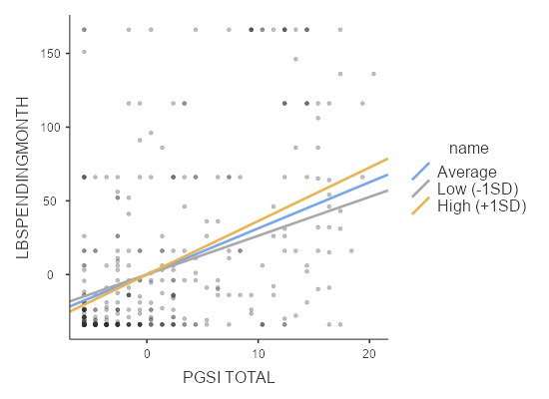

Table S9.
Moderation estimates between DOCS, PGSI totals, and loot box spending.
 |  |  |  |  |  | 95% Confidence Interval
 |  | Estimate |  | SE |  | Lower |  | Upper |  | Z |  | p
PGSI TOTAL |  | 4.251 |  | 0.3320 |  | 3.6005 |  | 4.902 |  | 12.80 |  | < .001
DOCS TOTAL |  | 0.539 |  | 0.5048 |  | -0.4503 |  | 1.529 |  | 1.07 |  | 0.285
PGSI TOTAL ✻ DOCS TOTAL |  | 0.108 |  | 0.0739 |  | -0.0365 |  | 0.253 |  | 1.47 |  | 0.143

Table S10.
Simple Slope Estimates between DOCS, PGSI, and loot box spending.
 |  |  |  |  |  | 95% Confidence Interval
 |  | Estimate |  | SE |  | Lower |  | Upper |  | Z |  | p
Average |  | 4.25 |  | 0.333 |  | 3.60 |  | 4.90 |  | 12.78 |  | < .001
Low (-1SD) |  | 3.80 |  | 0.534 |  | 2.75 |  | 4.85 |  | 7.11 |  | < .001
High (+1SD) |  | 4.70 |  | 0.354 |  | 4.01 |  | 5.39 |  | 13.30 |  | < .001
Note. shows the effect of the predictor (PGSI TOTAL) on the dependent variable (LBSPENDINGMONTH) at different levels of the moderator (DOCS TOTAL)

Table S11.

Simple slope plot outlining moderation the effect between DOCS, PGSI totals, and loot box spending.
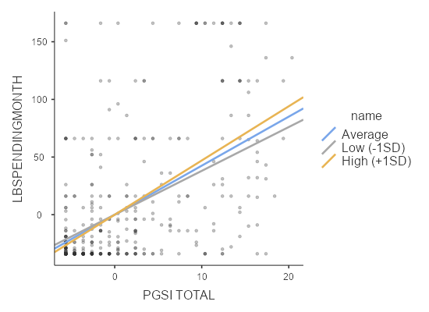

Currency conversion information

Participants number broken down by country: 197 (170) from Australia, 68 (62) from New Zealand, 935 (815) from United States.
For Australian and New Zealand participants, conversion rates of dollar amounts to USD are listed as below:
Via XE.com Using the 16:00UTC time option for rates on 02/09/2021: 1 NZD = 0.7109 USD
Via XE.com Using the 16:00UTC time option for rates on 02/09/2021: 1 AUD = 0.7400 USD
XE rates were used as they did not differ meaningfully from PoundSterlingLive.com; NZD to USD was converted at 0.7109USD and AUD to USD was converted at 0.7400USD.
For validity…
Via Poundsterlinglive.com Using the MID-day option for rates on 02/09/2021: 1 NZD = 0.7093 USD
Via Pountsterlinglive.com using the MID-day option for rates on 02/09/2021: 1 AUD = 0.7390 USD

