Hing, N. et al.: Feature preferences of sports betting platforms: A discrete choice experiment shows why young bettors prefer smartphones.
https://doi.org/10.1556/2006.2023.00073

SUPPLEMENTARY MATERIALS

Table S1. Recruitment numbers, screening and eligibility exclusions, completion and response rates
Started | 3979
Ineligible – not within betting frequency | 2020
Ineligible – no consent | 331
Ineligible – IP address not in Australia | 258
Ineligible – not within age range | 82
Ineligible – likely to be automated responses (bots) | 13
Ineligible – total sample size reached | 305
Removed – straightlining or inconsistent responses | 64
Removed – failed attention check | 55
Removed – speeding | 5
Minus Total ineligible and removed | 3133
= Eligible responses (a) | 846
Minus Did not complete | 230
= Good completes (b) | 616
Completion rate (b)/(a) | 72.8%

Table S2. Demographic characteristics of the sample (N=616)
Variable | Total
Gender | n | %
Men | 203 | 33.0
Women | 413 | 67.0
Marital Status
Single/never married | 297 | 48.2
Living with partner/de facto | 221 | 35.9
Married | 92 | 14.9
Divorced or separated | 6 | 1.0
Household composition
Single person | 172 | 27.9
One parent family with children | 51 | 8.3
Couple with children | 144 | 23.4
Couple with no children | 148 | 24
Group household | 89 | 14.4
Other | 12 | 1.9
State or territory of residence
New South Wales | 222 | 36.0
Victoria | 179 | 29.1
Queensland | 107 | 17.4
South Australia | 39 | 6.2
Western Australia | 38 | 6.2
Tasmania | 21 | 3.4
Australian Capital Territory | 7 | 1.1
Northern Territory | 3 | 0.5
Are you Aboriginal or Torres Strait Island origin?
No | 546 | 88.6
Aboriginal | 61 | 9.9
Torres Strait Islander | 3 | 0.5
Both Aboriginal and Torres Strait Islander | 6 | 1.0
Country of birth
Australia | 576 | 93.5
Other | 40 | 6.5
Main language spoken at home
English | 598 | 97.0
A language other than English | 18 | 3.0
Highest level of education
Year 10 or below | 59 | 9.6
Year 12 or equivalent | 187 | 30.4
A trade, technical certificate, or diploma | 117 | 19.0
A university or college degree | 215 | 34.9
Postgraduate qualifications | 38 | 6.2
Employment
Full-time work | 272 | 44.2
Part-time or casual work | 154 | 25.0
Self-employed | 48 | 7.8
Unemployed (looking for work) | 50 | 8.1
Full-time student | 48 | 7.8
Full-time home duties | 33 | 5.4
Sick or disability pension | 6 | 1.0
Other | 5 | 0.8
Annual household pre-tax income
$0 to $19,999 | 97 | 15.7
$20,000 to $39,999 | 109 | 17.7
$40,000 to $59,999 | 114 | 18.5
$60,000 to $79,999 | 93 | 15.1
$80,000 to $99,999 | 60 | 9.7
$100,000 to $119,999 | 62 | 10.1
$120,000 to $139,999 | 25 | 4.1
$140,000 to $159,999 | 15 | 2.4
$160,000 or more | 9 | 1.5
Don’t know | 32 | 5.2
Note: Most common country of birth responses for the total sample – ‘United Kingdom (10) and India (7).

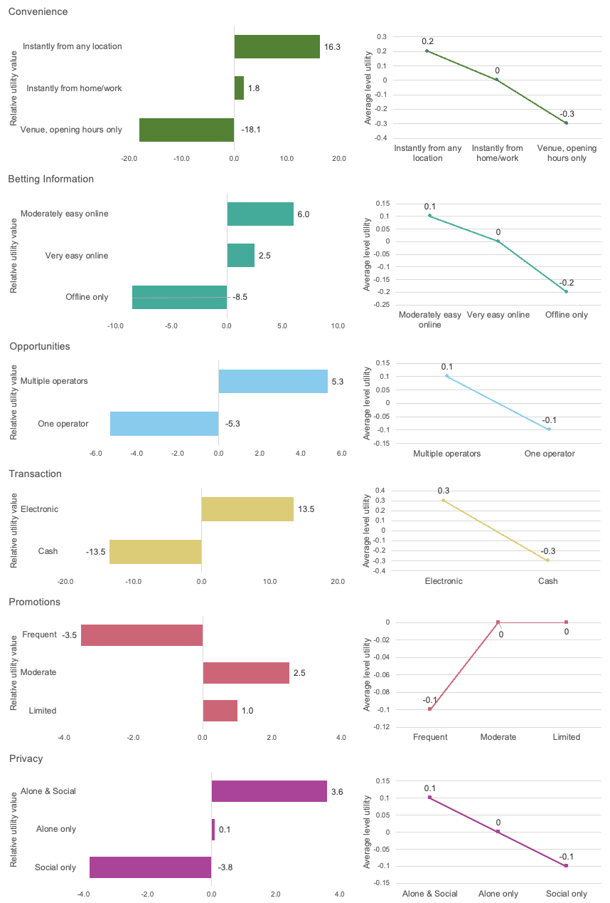Figure S1. Relative utility for each level of each feature in the discrete choice experiment
Table S3. Importance of features of betting platforms by gender (N = 616)
 | Men  n = 203 |  | Women  n=413 |  | Significance
 | M | SD | M | SD
Being able to easily place bets | 2.99 | 0.87 | 2.85 | 0.92 | Welch t(420.76)=3.28, p=.071
Being able to instantly place bets | 3.00 | 0.90 | 2.91 | 0.91 | F(1,614)=1.34, p=.247
Being able to bet from any location | 3.02 | 0.92 | 2.93 | 0.98 | Welch t(426.02)=1.38, p=.240
Being able to bet at any time of the day or night | 2.97 | 0.88 | 2.75 | 1.03 | Welch t(462.21)=7.68, p=.006
Being able to easily research betting information | 2.81 | 0.86 | 2.82 | 0.94 | Welch t(449.05)=.039, p=.843
Being able to bet while doing other things | 2.80 | 0.83 | 2.81 | 0.97 | Welch t(458.94)=0.02, p=.887
Being able to bet with more than one operator | 2.74 | 0.92 | 2.55 | 0.99 | Welch t(430.75)=5.90, p=.016
Being able to access a wide range of bets | 2.97 | 0.88 | 2.80 | 0.93 | Welch t(424.81)=4.83, p=.029
Being able to bet with electronic money | 2.95 | 0.87 | 2.93 | 0.98 | Welch t(444.48)=.030, p=.862
Being able to bet with cash | 2.55 | 0.97 | 2.30 | 0.95 | F(1,614)=9.30, p=.002
Being able to quickly access and transfer money for betting | 2.98 | 0.87 | 2.89 | 0.99 | Welch t(453.15)=1.38, p=.240
Being able to use a credit card for betting | 2.69 | 1.00 | 2.47 | 1.10 | Welch t(434.93)=6.28, p=.013
Being able to access a wide range of betting promotions | 2.88 | 0.81 | 2.84 | 0.93 | Welch t(453.07)=.22, p=.640
Seeing frequent betting promotions | 2.84 | 0.91 | 2.73 | 0.91 | F(1,614)=1.78, p=.183
Being able to access betting promotions instantly | 2.97 | 0.84 | 2.86 | 0.89 | F(1,614)=2.00, p=.158
Being able to link directly to betting promotions from your betting device | 2.90 | 0.86 | 2.79 | 0.93 | Welch t(428.37)=1.99, p=.159
Being able to bet in social settings | 2.61 | 0.89 | 2.58 | 0.93 | F(1,614)= 0.10, p=.753
Being able to bet alone, without other people around | 2.71 | 0.94 | 2.64 | 1.02 | F(1,614)=10.555, p=.001
Being able to keep your betting private, without anyone else knowing | 2.79 | 0.96 | 2.51 | 1.04 | Welch t(429.57)=11.10, p=.001
Being able to bet anonymously so there is no record of your betting | 2.85 | 1.02 | 2.34 | 1.11 | Welch t(436.72)=31.56, p<.001
Being able to avoid other people when you are betting | 2.72 | 0.91 | 2.33 | 1.04 | Welch t(452.67)=22.48, p<.001
Being able to bet without having to travel somewhere | 2.95 | 0.89 | 2.82 | 1.02 | Welch t(452.96)=2.81, p=.094
Being able to place in-play bets (bets placed after a match has started) | 2.80 | 0.86 | 2.68 | 1.00 | Welch t(460.35)=2.66, p=.103
Being able to access responsible gambling tools | 2.88 | 0.91 | 2.67 | 0.99 | Welch t(435.58)=6.46, p=.011
Note: higher betting features scores reflect a higher rating of importance

Table S4. Importance of features of betting platforms by PGSI group (N = 616)
 | Non-problem/low risk gambler  n = 205 |  | Moderate risk/problem gambler  n=411 |  | Significance
 | M | SD | M | SD
Being able to easily place bets | 3.00 | 0.98 | 2.84 | 0.86 | F(1,614)=4.32, p=.038
Being able to instantly place bets | 3.00 | 0.97 | 2.91 | 0.86 | Welch t(368.04)=1.47, p=.226
Being able to bet from any location | 3.07 | 1.00 | 2.91 | 0.94 | F(1,614)=3.84, p=.051
Being able to bet at any time of the day or night | 2.81 | 1.07 | 2.83 | 0.95 | Welch t(367.96)=0.04, p=.843
Being able to easily research betting information | 2.86 | 1.01 | 2.81 | 0.90 | Welch t(368.92)=0.41, p=.523
Being able to bet while doing other things | 2.92 | 1.00 | 2.75 | 0.88 | Welch t(364.46)=4.52, p=.034
Being able to bet with more than one operator | 2.45 | 1.03 | 2.69 | 0.93 | Welch t(373.98)=8.20, p=.004
Being able to access a wide range of bets | 2.86 | 0.97 | 2.86 | 0.89 | F(1,614)=001, p=.979
Being able to bet with electronic money | 3.08 | 1.02 | 2.86 | 0.90 | Welch t(365.43)=6.84, p=.009
Being able to bet with cash | 2.12 | 1.01 | 2.51 | 0.90 | Welch t(369.21)=22.20, p<.001
Being able to quickly access and transfer money for betting | 2.96 | 1.01 | 2.90 | 0.92 | F(1,614)=0.60, p=.438
Being able to use a credit card for betting | 2.20 | 1.14 | 2.71 | 0.99 | Welch t(360.24)=29.72, p<.001
Being able to access a wide range of betting promotions | 2.87 | 0.97 | 2.84 | 0.85 | Welch t(363.98)=0.13, p=.718
Seeing frequent betting promotions | 2.66 | 0.97 | 2.82 | 0.87 | Welch t(371.58)=4.17, p=.042
Being able to access betting promotions instantly | 2.86 | 0.92 | 2.92 | 0.85 | F(1,614)=0.52, p=.472
Being able to link directly to betting promotions from your betting device | 2.76 | 1.00 | 2.86 | 0.86 | Welch t(357.48)=4.59, p=.209
Being able to bet in social settings | 2.53 | 0.98 | 2.62 | 0.89 | Welch t(374.67)=1.13, p=.288
Being able to bet alone, without other people around | 2.52 | 1.06 | 2.73 | 0.95 | Welch t(368.67)=5.74, p=.017
Being able to keep your betting private, without anyone else knowing | 2.39 | 1.10 | 2.71 | 0.96 | Welch t(363.53)=12.67, p<.001
Being able to bet anonymously so there is no record of your betting | 2.11 | 1.15 | 2.71 | 1.03 | Welch t(372.24)=40.46, p<.001
Being able to avoid other people when you are betting | 2.07 | 1.07 | 2.65 | 0.93 | Welch t(361.67)=43.86, p<.001
Being able to bet without having to travel somewhere | 2.84 | 1.07 | 2.87 | 0.94 | Welch t(365.60)=0.13, p=.715
Being able to place in-play bets (bets placed after a match has started) | 2.54 | 1.04 | 2.81 | 0.91 | Welch t(363.92)=9.62, p=.002
Being able to access responsible gambling tools | 2.65 | 1.04 | 2.78 | 0.93 | Welch t(367.40)=2.28, p=.132
Note: higher betting features scores reflect a higher rating of importance

