Oka, T., Kubo, T., Murakami, M., & Kobayashi, N.: The relationship of game genres, in-game purchases, and playing duration with probable gaming disorder in two independent, large-scale online surveys of Japanese adults
Supplementary information
https://doi.org/10.1556/2006.2023.00076

Supplementary Methods
Table S1
Questions about gaming time on each device and in-game purchases.
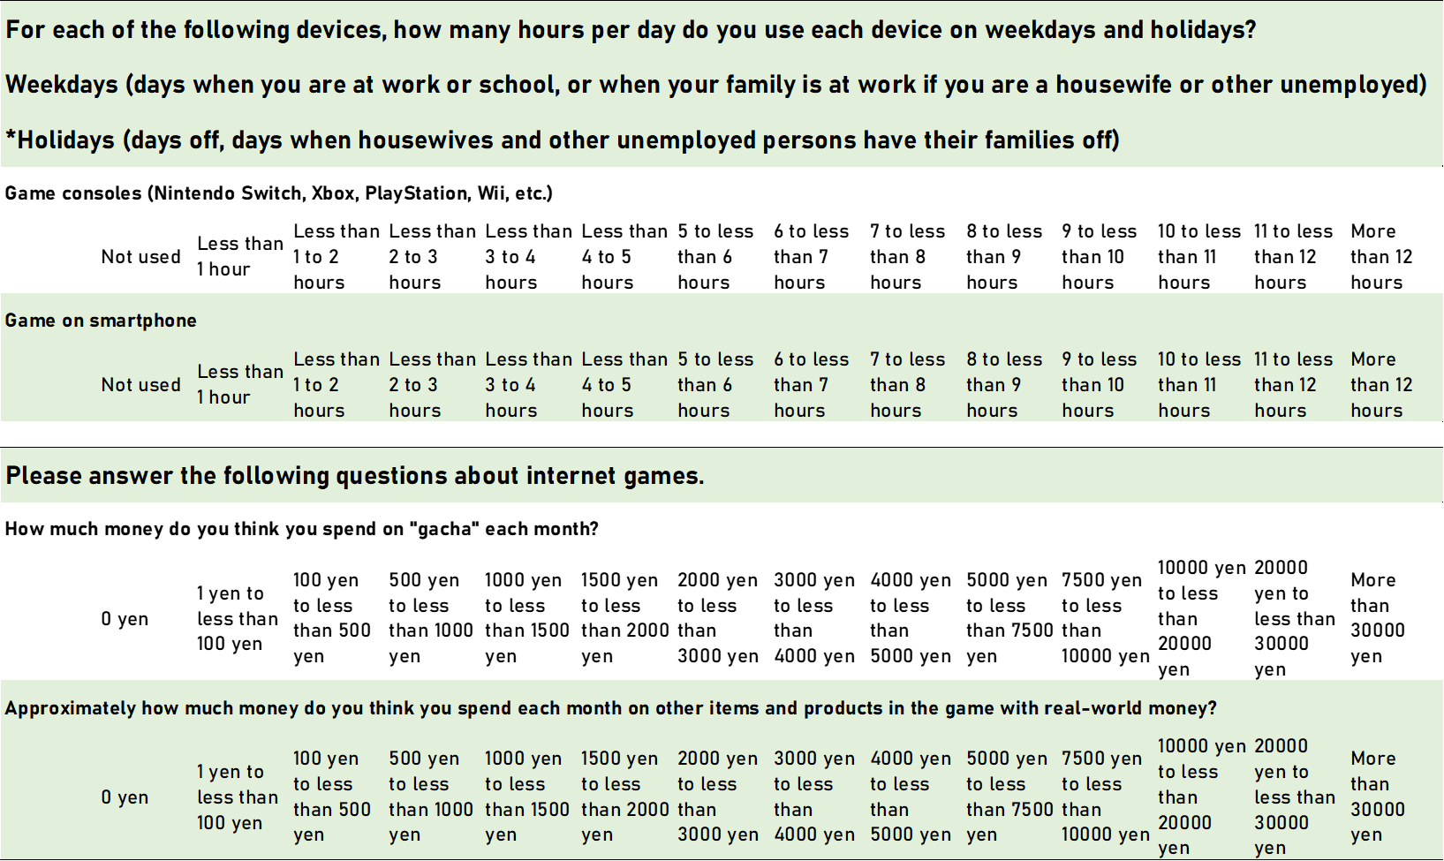
Supplementary Results
Study 1
The prevalence of probable GD was 5.7% (95%CI [5.5%–6.0%]), close to a previous meta-analysis of the prevalence in East Asia (Liao et al., 2022). Table S2 indicates the demographic characteristics of each gender and age group. Details about players playing each game genre are provided in Supplementary Table 3.
Table S2
Demographic characteristics
Table S3
Demographic characteristics of age-gender groups and time spent gaming on each device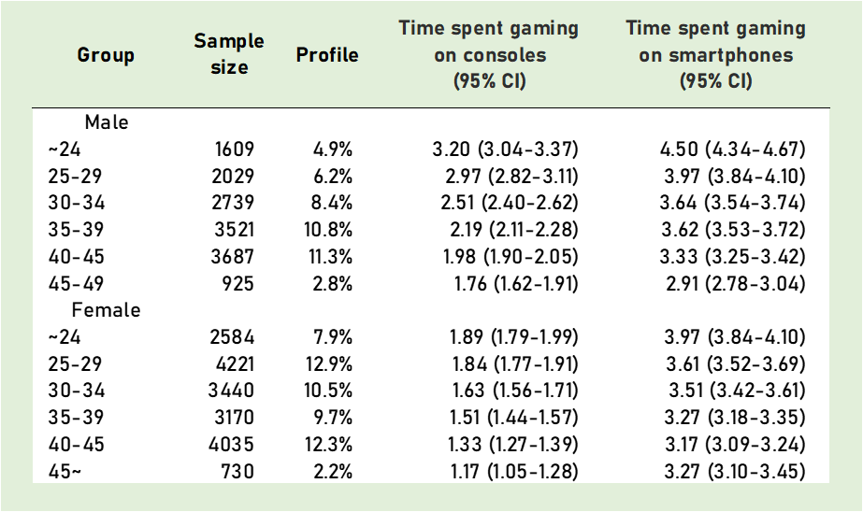
Table S4
Demographic characteristics of each game genre in Study 1
Each game example: Puzzle: Woodoku, Role-playing: Pokémon Masters EX, Simulation: Animal Crossing: Pocket Camp, Action: NEW STATE MOBILE, Adventure: Pokémon GO, Casual: Bubble Shooter, Sports: FIFA Mobile, Music: Deemo, Strategy: Dino Bash: Dinosaur Battle, Card: Shadowverse, Casino: Coin Mania: Farm Dozer, Board: Chess, Arcade: Dragon Drill, Racing: Top Drives, Educational: Coloring Book Kids Paint, Trivia: QuizzLand, Word: Word Connect

Table S5
Correlation matrix of continuous independent variables
GD severity: gaming disorder severity based on IGDS-J.
Table S6
Multiple logistic regression analysis with main effects only. 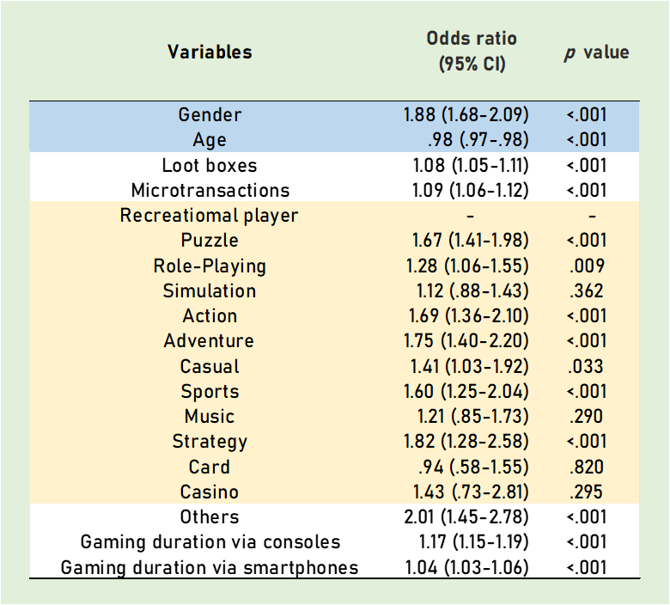
Nagelkerke R squared value was 0.161.
Dependent variable: probable GD or not.
Blue color: control variables.
Yellow color: Game genres were self-reported and on mobile games only.
Participants who played any smartphone games.
Each game example: Puzzle: Woodoku, Role-playing: Pokémon Masters EX, Simulation: Animal Crossing: Pocket Camp, Action: NEW STATE MOBILE, Adventure: Pokémon GO, Casual: Bubble Shooter, Sports: FIFA Mobile, Music: Deemo, Strategy: Dino Bash: Dinosaur Battle, Card: Shadowverse, Casino: Coin Mania: Farm Dozer, Board: Chess, Arcade: Dragon Drill, Racing: Top Drives, Educational: Coloring Book Kids Paint, Trivia: QuizzLand, Word: Word Connect
Table S7
Multiple logistic regression analysis with only the interaction terms.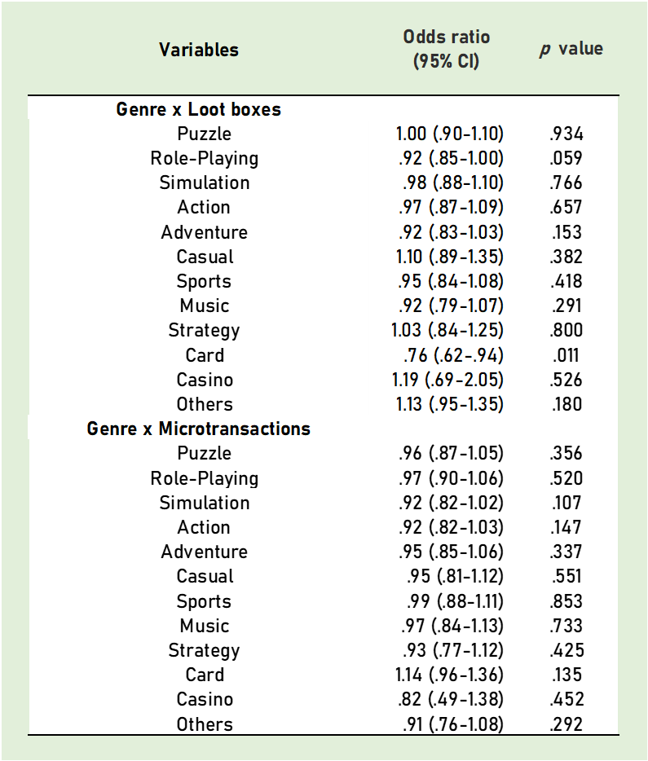
The Nagelkerke R squared value was 0.164.
Each game example: Puzzle: Woodoku, Role-playing: Pokémon Masters EX, Simulation: Animal Crossing: Pocket Camp, Action: NEW STATE MOBILE, Adventure: Pokémon GO, Casual: Bubble Shooter, Sports: FIFA Mobile, Music: Deemo, Strategy: Dino Bash: Dinosaur Battle, Card: Shadowverse, Casino: Coin Mania: Farm Dozer, Board: Chess, Arcade: Dragon Drill, Racing: Top Drives, Educational: Coloring Book Kids Paint, Trivia: QuizzLand, Word: Word Connect

Table S8
Multiple logistic regression analysis with main effects only about participants who played smartphone games more than consoles.
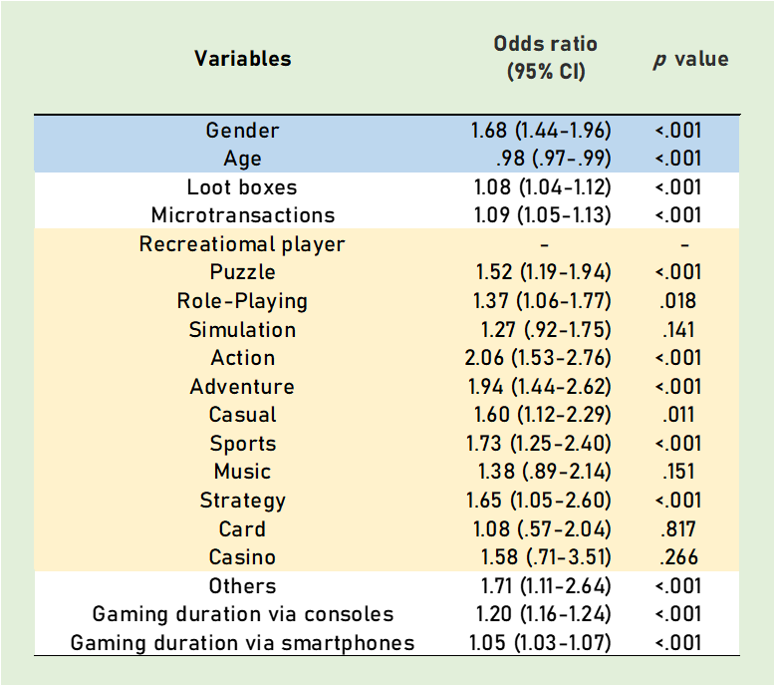
The Nagelkerke R squared value was 0.143.
Dependent variable: probable GD or not.
Blue color: control variables.
Yellow color: Game genres were self-reported and on mobile games only.
Participants who played any smartphone games.
Each game example: Puzzle: Woodoku, Role-playing: Pokémon Masters EX, Simulation: Animal Crossing: Pocket Camp, Action: NEW STATE MOBILE, Adventure: Pokémon GO, Casual: Bubble Shooter, Sports: FIFA Mobile, Music: Deemo, Strategy: Dino Bash: Dinosaur Battle, Card: Shadowverse, Casino: Coin Mania: Farm Dozer, Board: Chess, Arcade: Dragon Drill, Racing: Top Drives, Educational: Coloring Book Kids Paint, Trivia: QuizzLand, Word: Word Connect

Table S9
Multiple logistic regression analysis with only the interaction terms from participants who played smartphone games more than consoles. 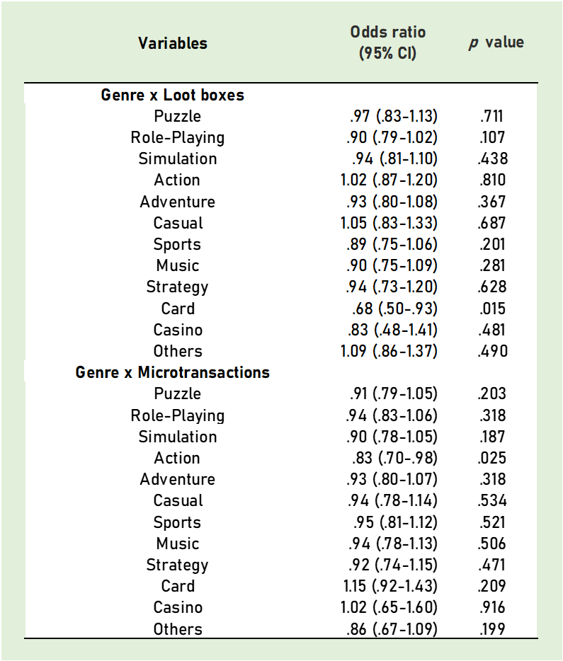
The Nagelkerke R squared value was 0.148.
Dependent variable: probable GD or not.
Blue color: control variables.
Yellow color: Game genres were self-reported and on mobile games only.
Participants who played any smartphone games.
Each game example: Puzzle: Woodoku, Role-playing: Pokémon Masters EX, Simulation: Animal Crossing: Pocket Camp, Action: NEW STATE MOBILE, Adventure: Pokémon GO, Casual: Bubble Shooter, Sports: FIFA Mobile, Music: Deemo, Strategy: Dino Bash: Dinosaur Battle, Card: Shadowverse, Casino: Coin Mania: Farm Dozer, Board: Chess, Arcade: Dragon Drill, Racing: Top Drives, Educational: Coloring Book Kids Paint, Trivia: QuizzLand, Word: Word Connect
Study 2
The prevalence of probable GD was 5.2% (95%CI [4.4%–6.0%]), close to the previous meta-analysis in East Asia (Liao et al., 2022) and Study 1. Table S10 indicates the demographic characteristics of each gender and age group.

Table S10
Demographic characteristics
Table S11
Demographic characteristics of age-gender groups about time spent gaming on each device
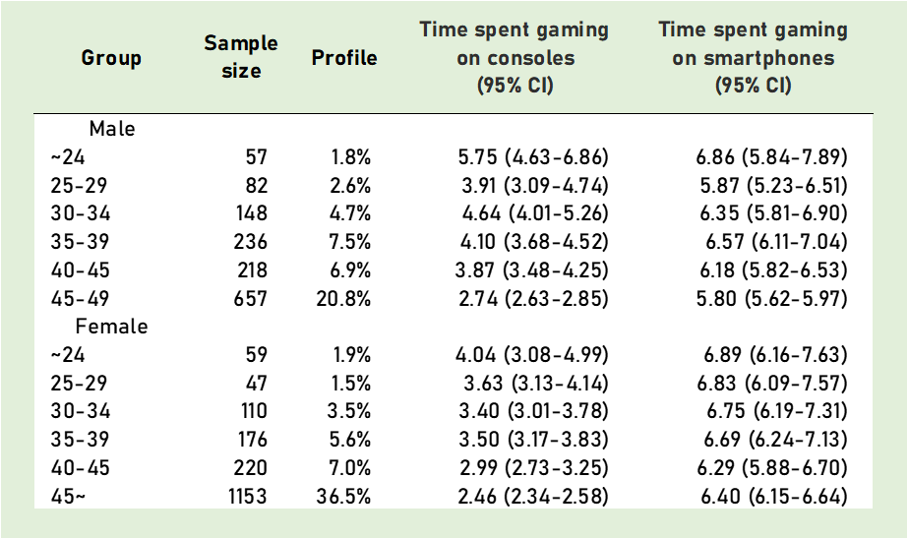

Table S12
Correlation matrix of continuous independent variables
This table includes variables that were not used in the analysis. Specifically, the number of gaming days during the term and average gaming time based on objective logged data. Each genre name indicates the average gaming time of the genre based on objective logged data. GD severity and general mental disorder indicated IGDS-J and K6 scores, respectively.

Table S13
Multiple logistic regression analysis with main effects.
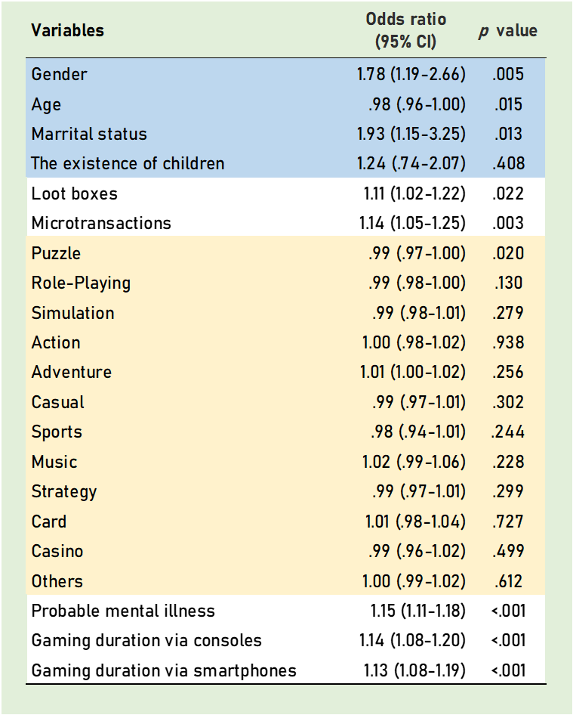
The Nagelkerke R squared value was 0.282.
Dependent variable: probable GD or not.
Blue color: control variables.
Yellow color: Game genres were self-reported and on mobile games only.
Participants who played any smartphone games.
Each game example: Puzzle: Woodoku, Role-playing: Pokémon Masters EX, Simulation: Animal Crossing: Pocket Camp, Action: NEW STATE MOBILE, Adventure: Pokémon GO, Casual: Bubble Shooter, Sports: FIFA Mobile, Music: Deemo, Strategy: Dino Bash: Dinosaur Battle, Card: Shadowverse, Casino: Coin Mania: Farm Dozer, Board: Chess, Arcade: Dragon Drill, Racing: Top Drives, Educational: Coloring Book Kids Paint, Trivia: QuizzLand, Word: Word Connect
Table S14
Multiple logistic regression analysis with main effects only from participants who played smartphone games more than console.
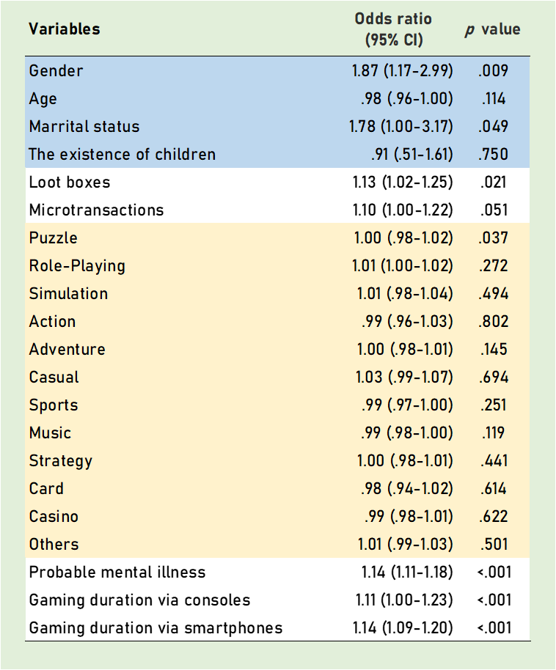
The Nagelkerke R squared value was 0.255.
The likelihood ratio test indicated that the interaction between in-game purchases and objective gaming duration did not significantly improve the model's fit (χ²(24) = 29.3, p = 0.21.)

Supplementary reference
Liao, Z., Chen, X., Huang, Q., & Shen, H. (2022). Prevalence of gaming disorder in East Asia: A comprehensive meta-analysis. Journal of Behavioral Addictions, 11(3), 727–738.

