Hoven, M., Luigjes, J., & van Holst, R.J.: Learning and metacognition under volatility in GD: lower learning rates and distorted coupling between action and confidence. https://doi.org/10.1556/2006.2023.00082

Supplementary Materials

Quasi-optimal Bayesian Observer Model
The same model as used in previous studies (Hoven, Mulder, Denys, van Holst, & Luigjes, 2023; Seow & Gillan, 2020; Vaghi et al., 2017)has been employed for the current study. The quasi-optimal Bayesian observer model uses trial-by-trial feedback to form a point-estimate of its belief about the mean of the Gaussian distribution that generates the particle’s landing locations. This current belief $B_{t}$ is updated on each trial in proportion to the prediction error $δ_{t}$, using a delta-rule:
$$B_{t+1}= B_{t}+α_{t}×δ_{t}$$
The degree to which prediction errors drive learning depends on the trial-by-trial learning rate $α_{t}$. Model prediction error is the difference between the estimated mean of the distribution $B$ and the actual landing location of the particle $X$ on each trial t.
$$δ_{t}= X_{t} – B_{t}$$
In contrast to the fixed learning rates commonly used in reinforcement learning models, the strength of Bayesian belief updating is its dynamic updating. For the reduced Bayesian model, this means that the model learning rate $α_{t}$ is updated on each trial in proportion to the surprise induced by the new evidence ($Ω_{t}$) and the confidence the model has in its own belief estimate ($υ_{t}$).
$$α_{t}= Ω_{t}+(1- Ω_{t})(1-υ_{t})$$
Surprise is quantified by change-point probability (CPP, $Ω_{t}$), and refers to the estimated probability that the mean of the sampling distribution has changed, given the current evidence. Model confidence (MC, $υ_{t}$), in turn, is a measure of the estimated reliability of the model’s beliefs about the mean. When model confidence is low, even small prediction errors will be strongly weighted. The values of CPP and MC interact in such a way that when new evidence is surprising (a change-point), the learning rate will increase even when model confidence is high.
CPP is calculated as the relative likelihood that the current evidence $X$ is generated by a uniform generative distribution over all possible locations $U(1,360)$ (i.e. during a change-point), as opposed to being drawn from the Gaussian ($N$) that generated the current belief $B_{t}$:
$$Ω_{t}= \frac{U\left(X_{t} \right| 1,360)H}{U\left(X_{t} \right| 1,360)H+N\left(X_{t} \right| B_{t}, σ_{t}^{2})(1-H)}$$
To calculate the CPP, the model takes into account three variables. First, the current evidence (i.e. landing location) $X_{t}$. Second, the hazard rate ($H$), referring to the degree of unexpected (transition) uncertainty intrinsic to the task. When H is maximal ($H$~ 1), each new observation is completely independent from previous observations. CPP is necessarily increased when $H$ is maintained at a higher value. In our task, $H$ is a constant at a value of 0.125. In contrast to the model, participants have no prior knowledge about the value of $H$ and must infer it from the data. Third, the variance of the predicted distribution $σ_{t}^{2}$. This term describes the estimated noise in the generative Gaussian distribution, by modulating known noise constant $σ_{N}^{ }$ by the current MC $υ_{t}$. The noise constant is a measure of expected uncertainty, and is inserted into the model as the true value of the generative variance ($σ_{N}^{ }$ = 12). Participants must also infer this from the data.
$$σ_{t}^{2}= σ_{N}^{ 2}+ \frac{(1- υ_{t})σ_{N}^{ 2}}{υ_{t}}$$
Model confidence ($υ$) interacts in a precision-weighting manner with the variance of the generative Gaussian $σ_{N}^{ }$. When model confidence is low (e.g. right after a change-point), estimated noise over the predictive distribution $σ_{t}^{2}$ will be higher, and as the model gains more evidence and becomes more confident of its predictions, the estimated noise $σ_{t}^{2}$ will decrease and approach the true value of $σ_{N}^{ }$. Because the value of $σ_{t}^{2}$ is used in the calculation of the CPP, the model will be less likely to attribute new evidence to the occurrence of a change-point when model confidence is low. Unlike the other model variables, model confidence does not depend on the current location of the particle $X_{t}$ and is calculated at the end of trial t for the subsequent trial. $υ_{t+1}$ represents the inverse of the fraction of total uncertainty about the next location of the particle that is due to imprecise estimation of the mean, relative to the known uncertainty due to noise $σ_{N}^{ 2}$.
$$υ_{t+1}= \frac{Ω_{t}σ_{N}^{ 2}+\left(1- Ω_{t}\right)\left(1- υ_{t}\right)σ_{N}^{ 2}+ Ω_{t}(1-Ω_{t}){(δ_{t}υ_{t})}^{2}}{Ω_{t}σ_{N}^{ 2}+\left(1- Ω_{t}\right)\left(1- υ_{t}\right)σ_{N}^{ 2}+ Ω_{t}\left(1-Ω_{t}\right){\left(δ_{t}υ_{t}\right)}^{2}+ σ_{N}^{ 2} }$$
The numerator consists of three terms. The first term represents the uncertainty of the generative distribution $σ_{N}^{ 2}$ weighted by the estimated probability that a change-point has occurred. In the second term, this uncertainty $σ_{N}^{ 2}$ is weighted by the estimated probability that no change-point occurred. The third term reflects the model’s uncertainty about whether or not a change-point occurred. These terms are repeated in the denominator, so that the value of this uncertainty can be calculated relative to the uncertainty that is due to noise. If a change-point occurred on the current trial ($Ω_{t}$ = 1), model confidence is automatically set to 0.5 (its minimum value) for trial t+1. Due to interdependencies intrinsic to the calculation of the parameters, they are expected to correlate.
Control Analyses
To compare various control variables between our groups, we used two sample t-tests. When variances were not equal between groups, Welch t-tests were used to approximate the degrees of freedom.
Accuracy (i.e. % hits) was equal between the groups (t₄₉=-0.95, p=0.345), as well as the average prediction error (t₄₉=-1.18, p=0.242) (Table S1). The percentage of excluded trials relative to the total number of trials per subject did not differ between groups (t₄₉=0.02, p=0.981). The percentage of trials per subject in which no action update was performed was higher in GD (t₄₉=2.48, p=0.017; GD = 60.1 %, HC = 50.5 %). The percentage of trials in which no confidence update was performed was equal between groups (t₄₉=1.29, p=0.202). The percentage of change-point trials per subject relative to their total number of trials did not differ between the groups (t₄₉=-0.58, p =0.566). Moreover, we calculated the number of trials between consecutive change-points, since change-points could occur at any moment in the task, which did differ between the groups, with a slightly higher number of trials in GD compared to HC (t_{27.07}=5.66, p<0.01; GD = 6.9 trials, HC = 6.7 trials). Since the landing location of the particle was drawn from a uniform distribution during a change-point, we calculated the average difference between the position of the particle preceding a change-point and at change-point per subject. This did not differ between the groups (t₄₉=0.60, p=0.55).
Results Excluding Outlier Participant Based on Task Accuracy
We did not use accuracy-based exclusion criteria in our analyses. However, the average accuracy of one GD participant was characterized as an outlier, being 18.2%. When removing this participant from our main analyses all results remained similar, however, the effect of a weaker action-confidence coupling in GD turned non-significant, but still indicated a trend effect (β = 3.07 +-1.65, t = 1.86, p = 0.063).

Hazard Rate Analyses
The hazard rate $H$ in our task is a constant of 0.125. However, it is possible that participants inferred a different value of $H$ from the evidence, since they have no prior knowledge about the value of $H$. Our main analyses were carried out using a constant $H$ of 0.125. In addition, for each participant, we carried out an exhaustive search for the best fitting $H$ parameter between 0 and 1. The best fitting value was determined by using a minimum least squares fit between the bucket positions (i.e. participant behavior) and model belief $B_{t}$about the landing positions. As per the model, higher hazard rates result in higher values of CPP ($Ω$) and learning rate ($α_{t}$). When hazard rate equals 1, learning rate also equals 1, such that each new observation is independent from previous observations and consequently, the model belief is completely determined by the prediction error. When hazard rate become smaller, the model belief gradually is less influences by the prediction error, and mostly influenced by the belief in the previous trial.
Overall, the perceived hazard rates were higher than the constant of 0.125 (Figure S2). No significant differences were found between the GD (mean: 0.54, sd: 0.30) and HC (mean: 0.59, sd: 0.31) groups (t₄₉ = -0.61, p=0.542). Hazard rate was strongly positively correlated with action update (r = 0.72, p<.001) and learning rate (r = 0.74, p<.001), but not with accuracy (r = -0.03, p=0.85). No significant correlations were found within the GD group between hazard rate and PGSI or GBQ score.
Sensitivity analyses were performed using the individually fitted hazard rate parameter as covariate to control for potential effects of hazard rate on our group differences. We included hazard rate as a fixed effect in our mixed-effects models investigating (1) group differences on confidence, (2) group differences on action update, (3) interaction between group and prediction error bin on learning rate, (4) group differences in the effects of the Bayesian parameters on action and (5) on confidence. This did not change any of the effects reported in the main manuscript. In fact, including hazard rate as a covariate in the learning rate analyses strengthened the group effect of lower learning rates in GD compared to HC (general mixed-model: β = -0.10 (0.04), t = -2.89, p = 0.0056). When zooming in on different prediction error bins, the effect of lower learning rates for low and medium prediction errors strengthened as well (low: Z-ratio: 3.143, p = 0.002, medium: Z-ratio: 4.879, p<.001).
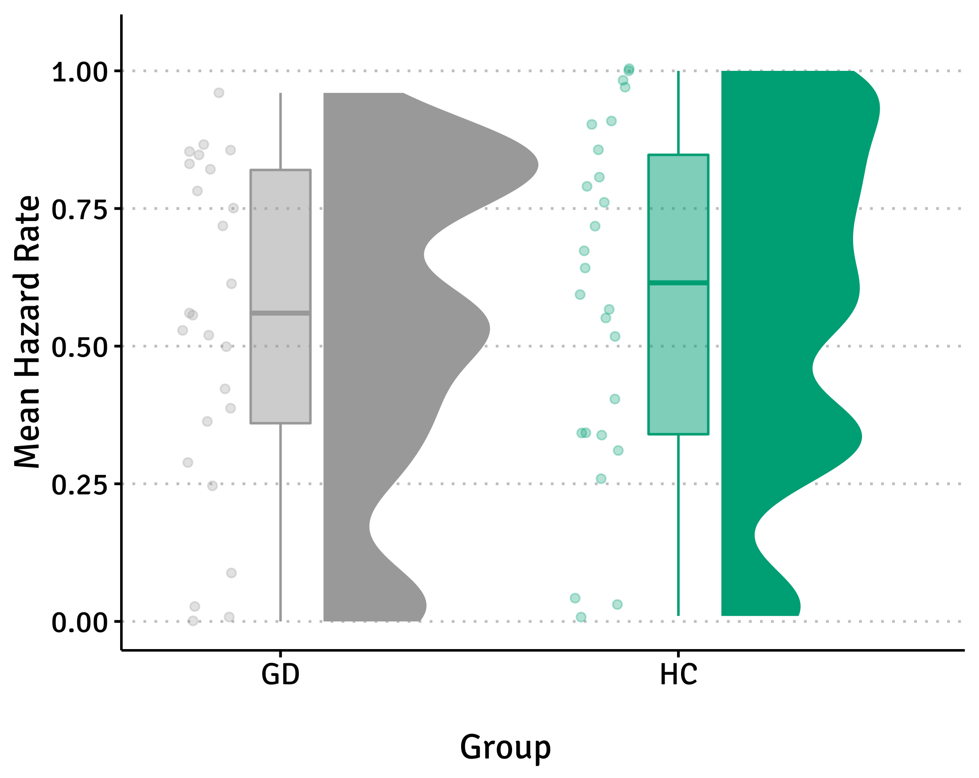

Figure S1: Hazard rate per group. Dots show data from individual participants, boxplots show median and upper/lower quantile with whiskers indicating the 1.5 interquartile range, distributions show the probability density function of all data points per group. HC = healthy control subjects, GD = gambling disorder.

High Volatility Analyses
A subset of our sample additionally performed the predictive inference task using a higher hazard rate $H$ of 0.20, for which we performed similar exclusion criteria and analyses as were developed in the main manuscript. The final sample consisted of 24 GD and 15 HC participants.
First, no group differences were found in the perceived hazard rate (Mean HC: 0.68, mean GD: 0.71, t₃₇ = 0.33, p=0.741). Again, no effects of group on confidence (β = -1.86 (6.13), t = -0.30, p=0.764) or action update (β = 0.44 (1.96), t = 0.23, p=0.822) were found. Here, no evidence was found of a weaker action-confidence coupling in GD (interaction effect: β = 2.85 (1.84), t = 1.55, p=0.122), and again no correlations were found between action-confidence coupling and PGSI score (r = 0.14, p = 0.503) or GBQ score (r = 0.14, p=0.507) in the GD sample.
No evidence was found for an overall group difference in learning rate (β = -0.10 (0.09), t = -1.10, p=0.278), however in post-hoc analyses it was shown that GD patients have higher learning rate particularly when prediction error was low (HC-GD Z-ratio = 2.307, p = 0.021). Regarding the Bayesian model-based analyses, no group differences were found on the effects of the latent parameters on either action or confidence.
Comparing High to Low Volatility
Using the subset of our sample that completed the original predictive inference task (termed here: low volatility task), as well as the high volatility task, we aimed to compare behavior between the groups on the two different variations of the task. After applying similar exclusion criteria, the final sample consisted of 23 GD and 14 HC participants.
First of all we compared perceived hazard rates between groups and between task type using a mixed ANOVA. As expected, perceived hazard rate was higher was higher in the high volatility versus low volatility task (F_{1,35} = 18.66, p<.001), but this did not differ between groups (F_{1,35} = 0.0008, p = 0.978), and no interaction between group and task type was found (F_{1,35} = 1.75, p = 0.195).
Then, using mixed-models, the effects of group and task type and their interaction on confidence, action update and learning rate were tested. The models showed significant effects of task type on confidence (β = 1.33 (0.48), t = 2.79, p=0.005),on action update (β = -8.51 (0.89), t = -9.56, p<.001), and on learning rate (β = -0.16 (0.01), t = -12.34, p<.001) with lower confidence, higher action update and higher learning rates in the high volatility task. However, no interactions between group and task type were found on confidence (β = 0.26 (0.60), t = 0.43, p=0.671), on action update (β = -1.31 (1.13), t = -1.16, p=0.246), or on learning rate (β = -0.03 (0.02), t = -1.58, p=0.115).
Using a mixed-model with action update as dependent variable and fixed effects of confidence, group, task type and their interactions, we again showed a significant main effect of confidence (β = -9.20 (1.29), t = -7.15, p<.001), indicating the c0upling of action and confidence. Moreover, a significant main effect of task type was found, with more action updating in the high versus low volatility task (β = -8.51 (0.87), t = -9.77, p<.001). A significant interaction between group and confidence showed a weaker confidence coupling in GD (β = 3.29 (1.63), t = 2.01, p=0.044), however there was no evidence for a three-way interaction between group, confidence and task type, indicating that the weaker coupling of action and confidence in GD was not exaggerated further in a high volatility context (β = -0.05 (1.10), t = -0.04, p=0.965).
For the model-based analyses we used mixed-models to test the interaction between group, task type and the various latent parameters from the model on action and confidence. For the action model, no significant interactions were found. For the confidence model, a significant interaction between group, task type and the hit parameter was found (β = -3.39 (0.74), t = -4.56, p<.001), which indicated that the effect of a hit on the previous trial on confidence was stronger in HC compared to GD when task volatility was low, but contrarily was stronger in GD compared to HC when the task volatility was high.
Overall, while increasing the volatility of the task directly impacts the amount of action updating, confidence and learning rates, there is little evidence that higher volatility of the task had different effects on task behavior in the GD versus the HC group.

Table S2: Results of linear mixed-effects models predicting the effects of computational variables and group on action and confidence in the original predictive inference task.
GD versus HC

 | Dependent Variable: Action |  |  | Dependent Variable: Confidence
Predictors | Beta (SE) | t | p | Beta (SE) | t | p
PE | 19.27 (2.82) | 6.83 | <.001 | -0.75 (0.55) | -1.38 | 0.167
CPP | 11.31 (2.58) | 4.38 | <.001 | -2.21 (1.06) | -2.09 | 0.042
(1-CPP)* (1-MC) | 2.09 (0.51) | 4.14 | <.001 | -1.81 (0.74) | -2.43 | 0.019
Hit | -5.57 (0.50) | -11.13 | <.001 | 3.91 (0.73) | 5.32 | <.001
PE * Group (GD) | -5.52 (4.04) | -1.37 | 0.178 | 0.40 (0.80) | 0.50 | 0.619
CPP * Group (GD) | 3.74 (3.69) | 1.01 | 0.316 | 1.07 (1.52) | 0.70 | 0.484
((1-CPP)* (1-MC)) * Group (GD) | 1.72 (0.72) | 2.37 | 0.022 | 0.59 (1.06) | 0.56 | 0.581
Hit * Group (GD) | -1.16 (0.72) | -1.62 | 0.111 | -0.96 (1.05) | -0.92 | 0.364

