Kwon , M. et al: Neural correlates of model-based behavior in internet gaming disorder and alcohol use disorder. https://doi.org/10.1556/2006.2024.00006

Supplementary Materials
Psychometric measures
In addition to the self-report surveys conducted to measure game addiction, alcohol addiction, depressive, and anxiety symptoms, we also assessed impulsivity, childhood attention-deficit hyperactivity disorder (ADHD) symptoms, and intelligence to account for potential group differences. Self-reported impulsivity was evaluated using the Barratt Impulsiveness Scale (BIS; Patton, Stanford, & Barratt, 1995), and childhood ADHD symptoms were assessed using the Wender Utah Rating Scale (WURS; Ward, Wender, & Reimherr, 1993). Verbal IQ and performance IQ were measured using the Korean version of the Wechsler Adult Intelligence Scale (K-WAIS IV; Wechsler, 2008).
To examine group differences in survey measures, we performed a one-way analysis of variance (ANOVA) with group factors (i.e., HC, IGD, AUD) (Table S1) and performed post-hoc pairwise comparisons using Tukey's test (Figure S2). The IGD group exhibited the highest internet addiction symptoms, while the AUD group showed the highest AUD symptoms. We also found significant group differences in depression, anxiety, impulsivity scores, and childhood ADHD symptoms. Specifically, the IGD group reported higher depression symptoms compared to the other two groups and higher anxiety symptoms compared to the HC group. Impulsivity was highest in the IGD group, followed by the AUD group and the HC group. Additionally, the IGD group reported the highest childhood ADHD symptoms, with a significant difference from the HC and AUD groups. IQ scores, including all subscales, and age did not show significant statistical differences.

Task instructions
Participants were instructed that they will be playing a treasure hunt game repeatedly, where earning more treasures would result in higher payment. Based on the schematic figure depicting the task (Figure S3), the instruction stated, "You choose a door from two rooms to find the treasure. First of all, it starts in a gray room with two doors, each distinguished by a unique picture. Choosing the left door has a higher probability of transitioning to the blue room and a lower probability of transitioning to the yellow room, while choosing the right door has a higher probability of transitioning to the yellow room and a lower probability of transitioning to the blue room. Throughout the game, these probabilities are fixed. Here is an example. Let's say you choose the left door in the first room (the gray room), and now you are in the blue room. In the second room, there are two doors, each with distinguishing pictures. Let's say you choose the right door this time. Opening the door will either reveal a "treasure" or result in a miss. The chances of finding the treasure gradually change from 25% to 75% over time, but the specific probabilities are not revealed. Please choose doors carefully to maximize the chances of discovering treasures." Subsequently, based on Figure 2B, we explained the entire process of the task once again, including the duration of each stage: 2.5 seconds for choosing the first door, a 1-second wait to move to the next door, 2 seconds for choosing the second door, a 1.5-second feedback check, and a 0.5-second wait for the next treasure hunt.
After the instruction, participants underwent extensive practice trials consisting of 30 trials of first-stage choice followed by transition to the second stage, 10 trials of the second-stage choice followed by the feedback phase, and finally, 67 trials of the complete trial (first- and second-stage choices in a row). Different fractal images were used in the practice trials compared to the actual task. Subsequently, participants were asked to answer three questions to assess their understanding of the task: "The first door is selected in the gray room (O/X)", "When you choose a door in the first room, the probability of transition (to the blue room or yellow room) does not change (O/X)", and "The door with the highest probability of receiving the treasure in the second room changes over time (O/X)." All participants successfully passed the final quiz, verifying their comprehension of the task structure. For a few participants who did not pass all the quiz initially, we provided instruction again until the participants fully understood the task.

fMRI data acquisition and preprocessing
MRI scanning was performed using a 3.0T MRI scanner (MagnetomVerio, Siemens Medical Solutions, Erlangen, Germany). Functional images were acquired with three 8.5-minutes runs using a T2*-weighted gradient echo-planar imaging sequence (30 axial slices, 4 mm thickness with 1 mm interslice gap; repetition time = 2,000 ms, echo time = 30 ms; flip angle = 90°; in-plane matrix size = 64 × 64 pixels; and field of view = 240 mm) while participants performed the two-stage task. Additionally, a structural T1-weighted gradient echo image was acquired (matrix size = 256 × 256, number of slices = 176, slice thickness = 1 mm, echo time = 2.46 ms, repetition time = 1,900 ms, field of view = 250 mm, flip angle = 9°, bandwidth = 170Hz/Px). Preprocessing of the fMRI data was conducted using fMRIPrep version 20.2.1. This included spatial normalization, susceptibility distortion correction, co-registration, and slice timing correction using fMRIPrep (Esteban et al., 2019).

Computational modeling
To select the best fitting model, we tested three different models: a seven-parameter model used in Daw, Gershman, Seymour, Dayan, & Dolan (2011), a six-parameter model (see below), and a four-parameter model (Wunderlich, Smittenaar, & Dolan, 2012). After fitting each model separately for each group using hierarchical Bayesian modeling (Rouder & Lu, 2005), we computed the leave-one-out information criterion (LOOIC) using "loo" package in R (Vehtari, Gelman, & Gabry, 2017). Table S2 presents the LOOIC of each model for each group. As a lower LOOIC indicates a better model fit, the six-parameter model was the best fitting model for all three groups. Consequently, we used the six-parameter model for further analyses.
We fit each participant's trial-by-trial responses in the task with a hybrid reinforcement learning (RL) model described in previous literature (Daw et al., 2011; Gläscher, Daw, Dayan, & O’Doherty, 2010). The model assumes that participants make choices based on a weighted combination of both model-free and model-based RL algorithms, with a free model-based weight parameter $ω$ estimated for each participant ($ω=1$ reflects a purely model-based agent).

$V_{s1}^{Net}= ω∙V_{s1}^{MB} + (1-ω)∙V_{s1}^{MF}$ [1]

The model-free algorithm, based on the temporal difference learning (Rummery & Niranjan, 1994), updates the model-free value of each first-stage option, $V_{s1}^{MF}$, by the reward prediction error (RPE) multiplied by a free first-stage learning rate parameter $α_{1}$ at the onset of the second stage and reward outcome.

$V_{s1}^{MF}(t+1)= V_{s1}^{MF}(t) + α_{1}∙(V_{s2, chosen}(t)-V_{s1}^{MF}(t)$) at the second-stage onset,
$V_{s1}^{MF}(t+1)= V_{s1}^{MF}(t) + α_{1}∙({reward - V}_{s2}(t)$) at the reward onset.

In contrast, the model-based algorithm computes the utility of each first-stage option by considering the transition structure.

$V_{s1}^{MB}= p∙max(V_{3}, V_{4}) + (1-p)∙max(V_{5}, V_{6})$,

where $p=0.7$ for the common transition and $p=0.3$ for the rare transition. The second-stage options' value is updated only by the model-free algorithm since there is only a reward outcome without further transition in the task. Thus, the model-based and model-free values are identical for the second-stage options.

$V_{s2}(t+1)= V_{s2}(t)+ α_{2}∙({reward - V}_{s2}(t)$)

The model then submits the model-based and model-free value to the softmax function, in which free inverse temperature parameters of each stage (i.e., $β_{1}$, $β_{2}$) determine the stochasticity in the participant's choice, to estimate the probability of choosing each option. For instance, the probability of choosing option 2 in the first stage is computed as:

$$P_{2}^{stage1}= \frac{1}{1+ exp(-β_{1}∙(V_{2}^{Net}-V_{1}^{Net}) - π∙(C_{1}-C_{2}))}$$

where $V_{2}^{Net}$ and $V_{1}^{Net}$ indicate the net value of each option in the first stage, computed by Equation 1 above, and $C_{i}=1$ if the previous choice is $i$, otherwise $C_{i}=0$. $π$ is a free perseverance parameter that captures whether the participant chose the same option as on the previous trial. Thus, a higher $β$ value indicates that choices are strongly influenced by the difference in values, and a higher $π$ value indicates the participant has a tendency to repeat the same choices. Overall, the model consists of 6 parameters ($α_{1}, α_{2, } β_{1}, β_{2}, π, ω$).
We separately fitted the model for each group using hierarchical Bayesian modeling, which incorporates group-level information about parameter values to constrain parameter estimation at an individual level. This modeling framework improves the accuracy of parameter estimation (Ahn, Krawitz, Kim, Busemeyer, & Brown, 2011; Lehmann & Casella, 2006; Rouder & Haaf, 2019) by regularizing within-individual variability in parameter estimates (i.e., shrinkage; Efron & Morris, 1977). We then extracted the group-level estimates of the six model parameters and examined group differences for each pair (IGD vs. AUD; IGD vs. HC; AUD vs. HC) (Figure S4). To determine that parameter estimates of two groups show a significant difference, 95% highest density interval (HDI) of the subtracted values of each parameter estimate (e.g., $ω_{IGD}-ω_{AUD}$) should not include zero.

Functional connectivity analysis - Psychophysiological interaction analysis [Information about Salience network]
Brain regions related to the salience network were defined based on the Neurosynth (http://neurosynth.org) on 06/22/2023 using terms "salience", "salience network", and "reward' (using a total of 1,444 studies).

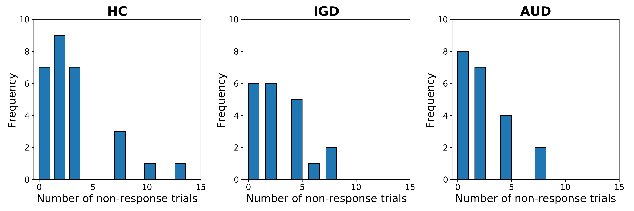
Figure S1. Histogram of the number of non-response trials
Each figure displays the histogram of non-response trials for each group. We confirmed that there is no significant group difference in the number of non-response trials by conducting a one-way analysis of variance (ANOVA) with group factors (F(2, 66)=0.980, p=0.381).

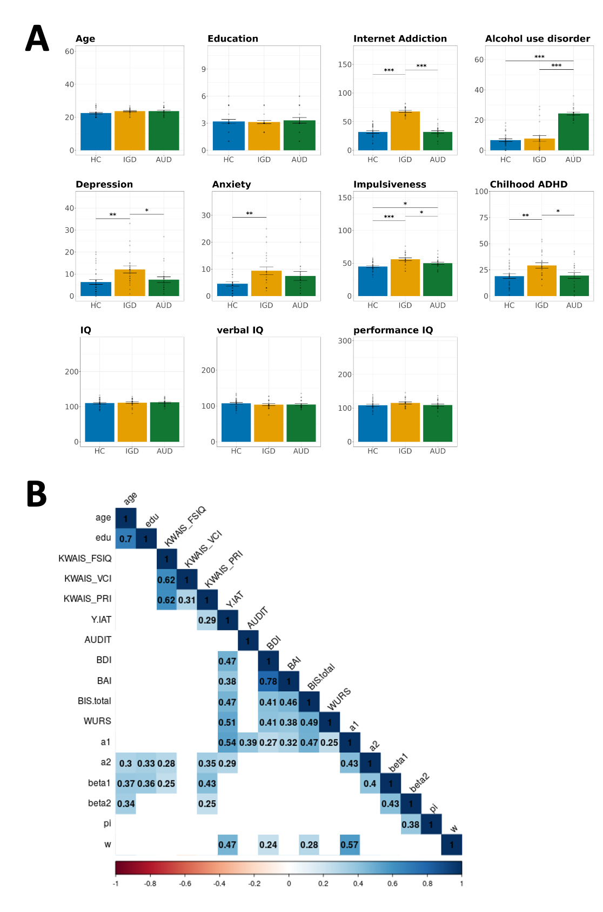

Figure S2. Group differences and correlations between psychometric measures
(A) Group differences in psychometric measures. Each bar represents the means of each group, with error bars indicating the 95% confidence interval. Dots correspond to individual participant data. Asterisks denote significant group differences (*, p < 0.05; **, p < 0.005; ***, p < 0.001). Please refer to Table S1 for detailed values of the measures for each group and the group comparison results. (B) Correlations between the psychometric measures. Each number represents the Pearson's correlation coefficient between the measures corresponding to the x and y axes of each block. Blocks with coefficients indicate a significant correlation between the measures (p < 0.05), while blocks without number indicate a nonsignificant correlation. The abbreviations used in the figures are as follows: K-WAIS, Korean version of the Wechsler Adult Intelligence Scale; FSIQ, full scale IQ; VCI, Verbal Comprehension Index Scale (Verbal IQ); PRI, Perceptual Reasoning Index Scale (performance IQ); Y.IAT, Young Internet Addiction Test; AUDIT, Alcohol Use Disorder Identification Test; BDI, Beck Depression Inventory; BAI, Beck Anxiety Inventory; BIS, Barratt Impulsiveness Scale; WURS, Wender Utah Rating Scale; a1, learning rate parameter in the first stage ($α_{1}$); a2, learning rate parameter in the second stage ($α_{2, }$); beta1, inverse temperature parameter in the first stage ($β_{1}$); beta2, inverse temperature parameter in the second stage ($β_{2}$); pi, perseverance parameter ($π$); w, model-based weight parameter ($ω$).

Figure S3. Schematic figures of the two-stage task used in task instruction
A schematic figure of exemplar choices used in the task instruction, in which human icon in each stage indicates choices.

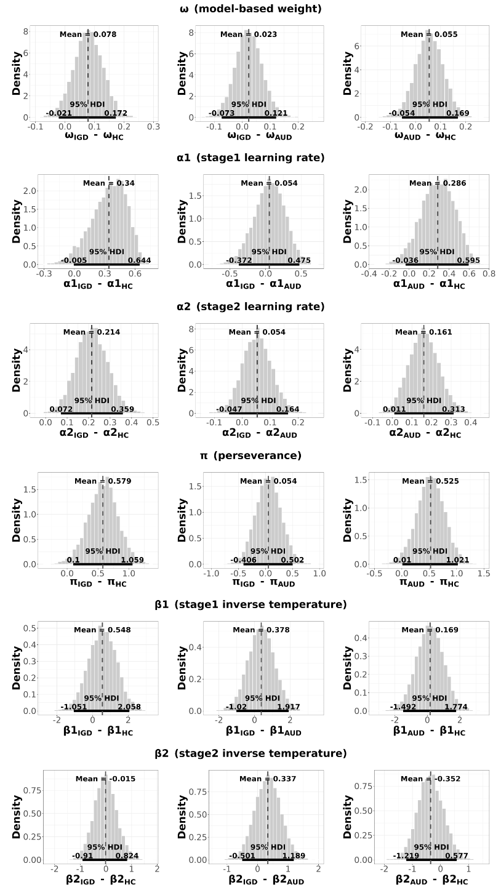
Figure S4. Distributions of group differences in model parameter estimates
To assess group differences in the model parameter estimates, we computed the differences between each pair (HC vs. IGD; IGD vs. AUD; HC vs. AUD). The distributions represent the subtracted values of each parameter estimate from one group to the other group (e.g., $ω_{IGD}-ω_{AUD}$). The black lines under the distributions indicate the 95% highest density interval (HDI). Group differences were considered significant when the 95% HDI did not include zero.

Table S1. Group differences in psychometric measures
Note. The data presented in the first three columns represent the means (95% confidence interval) for each group (HC, IGD, and AUD), or the sample size. The results of a one-way analysis of variance (ANOVA) with group factors (i.e., HC, IGD, AUD) are shown in the rightmost column, including the F-statistics and p value. The abbreviations used in the table are as follows: IAT, Young Internet Addiction Test; AUDIT, Alcohol Use Disorder Identification Test; BDI, Beck Depression Inventory; BAI, Beck Anxiety Inventory; BIS, Barratt Impulsiveness Scale; WURS, Wender Utah Rating Scale; K-WAIS, Korean version of the Wechsler Adult Intelligence Scale; VCI, Verbal Comprehension Index Scale; PRI, Perceptual Reasoning Index Scale.

Table S2. Model comparison results
Note. The table presents the leave-one-out information criterion (LOOIC) values for three different models: a seven-parameter model, a six-parameter model, and a four-parameter model, for each group (HC, healthy control; IGD, internet gaming disorder; AUD, alcohol use disorder). The six-parameter model, highlighted in blue, exhibited the lowest LOOIC value, indicating the best model fit among the three models.

Table S3. Results of linear mixed effects logistic regression for stay probability

Note. The table presents the coefficients, 95% confidence intervals (CI), and p-values for the main effects of reward, transition probability, and the interaction between the two. The residual degree of freedom of each group are as follows: HC = 5,969, IGD = 4,370, AUD = 4,385.

Table S4. Second-level results of the model-based fMRI

Note. The table displays significant results of the second-level one-sample t-tests conducted for the model-based fMRI analysis, using a model-based reward prediction error (RPE) as a parametric modulator (p < 0.001, uncorrected; cluster size, k $≥$ 10). The asterisks (*) indicate significant results with p < 0.001, and the cross symbols (†) indicate significant results with p < 0.05.

Table S5. PPI second-level results of the internet gaming disorder (IGD) group

Note. The table presents the significant psychophysiological interaction (PPI) analysis results obtained from the second-level one-sample t-tests conducted for the IGD group, using a model-based reward prediction error (RPE) as the psychological variable (p < 0.001, uncorrected; cluster size, k $≥$ 10). After applying small volume correction using an extent brain mask created by combining meta-analysis brain maps of "salience", "salience network", and "reward" extracted from the Neurosynth, the resulting clusters within the specified volume displayed smaller sizes than the initially applied threshold of k $≥$ 10. The asterisks (*) indicate results with p < 0.001, and the cross symbols (†) indicate results with p < 0.05.

Table S6. Second-level group comparison results of the PPI analysis

Note. The table presents the results of the second-level group comparisons using two-sample t-tests in the psychophysiological interaction (PPI) analysis (p < 0.001, uncorrected; cluster size, k $≥$ 10). After applying small volume correction using an extent brain mask created by combining meta-analysis brain maps of "salience", "salience network", and "reward" extracted from the Neurosynth, the resulting clusters within the specified volume displayed smaller sizes than the initially applied threshold of k $≥$ 10. The asterisks (*) indicate results with p < 0.001, and the cross symbols (†) indicate results with p < 0.05.

References

Ahn, W.-Y., Krawitz, A., Kim, W., Busemeyer, J. R., & Brown, J. W. (2011). A Model-Based fMRI Analysis With Hierarchical Bayesian Parameter Estimation. Journal of Neuroscience, Psychology, and Economics, 4(2), 95–110. https://doi.org/10.1037/a0020684
Daw, N. D., Gershman, S. J., Seymour, B., Dayan, P., & Dolan, R. J. (2011). Model-Based Influences on Humans’ Choices and Striatal Prediction Errors. Neuron, 69(6), 1204–1215. https://doi.org/10.1016/j.neuron.2011.02.027
Efron, B., & Morris, C. (1977). Stein’s Paradox in Statistics. Scientific American, 236(5), 119–127. https://doi.org/10.1038/scientificamerican0577-119
Esteban, O., Markiewicz, C. J., Blair, R. W., Moodie, C. A., Isik, A. I., Erramuzpe, A., … Gorgolewski, K. J. (2019). fMRIPrep: a robust preprocessing pipeline for functional MRI. Nature Methods, 16(1), 111–116. https://doi.org/10.1038/s41592-018-0235-4
First, M. B., Spitzer, R. L., Gibbon, M., & Williams, J. B. W. (1997). Structured Clinical Interview for DSM-IV Axis I Disorders. New York: Amer Psychiatric Pub Inc.
Gläscher, J., Daw, N., Dayan, P., & O’Doherty, J. P. (2010). States versus Rewards: Dissociable Neural Prediction Error Signals Underlying Model-Based and Model-Free Reinforcement Learning. Neuron, 66(4), 585–595. https://doi.org/10.1016/j.neuron.2010.04.016
Lehmann, E. L., & Casella, G. (2006). Theory of point estimation. Springer Science & Business Media.
Patton, J. H., Stanford, M. S., & Barratt, E. S. (1995). Factor structure of the barratt impulsiveness scale. Journal of Clinical Psychology, 51(6), 768–774. https://doi.org/10.1002/1097-4679(199511)51:6<;768::aid-jclp2270510607>3.0.co;2-1
Power, J. D., Barnes, K. A., Snyder, A. Z., Schlaggar, B. L., & Petersen, S. E. (2012). Spurious but systematic correlations in functional connectivity MRI networks arise from subject motion. NeuroImage, 59(3), 2142–2154. https://doi.org/10.1016/j.neuroimage.2011.10.018
Rouder, J. N., & Haaf, J. M. (2019). A psychometrics of individual differences in experimental tasks. Psychonomic Bulletin & Review, 26(2), 452–467. https://doi.org/10.3758/s13423-018-1558-y
Rouder, J. N., & Lu, J. (2005). An introduction to Bayesian hierarchical models with an application in the theory of signal detection. Psychonomic Bulletin & Review, 12(4), 573–604. https://doi.org/10.3758/bf03196750
Rummery, G. A., & Niranjan, M. (1994). On-Line Q-Learning Using Connectionist Systems. Department of Engineering, University of Cambridge, Cambridge.
Vehtari, A., Gelman, A., & Gabry, J. (2017). Practical Bayesian model evaluation using leave-one-out cross-validation and WAIC. Statistics and Computing, 27(5), 1413–1432. https://doi.org/10.1007/s11222-016-9696-4
Ward, M. F., Wender, P. H., & Reimherr, F. W. (1993). The Wender Utah Rating Scale: an aid in the retrospective diagnosis of childhood attention deficit hyperactivity disorder [published erratum appears in Am J Psychiatry 1993 Aug;150(8):1280]. American Journal of Psychiatry, 150(6), 885–890. https://doi.org/10.1176/ajp.150.6.885
Wechsler, D. (2008). Wechsler Adult Intelligence Scale—Fourth Edition Administration and Scoring Manual. San Antonio: TX: NCS Pearson.
Wunderlich, K., Smittenaar, P., & Dolan, R. J. (2012). Dopamine Enhances Model-Based over Model-Free Choice Behavior. Neuron, 75(3), 418–424. https://doi.org/10.1016/j.neuron.2012.03.042

