Liu, L. et al.: Compulsivity-related behavioral features of problematic usage of the internet: A scoping review of paradigms, progress, and perspectives. https://doi.org/10.1556/2006.2024.00023

Supplementary materials

Table S1. Study quality check based on the Newcastle-Ottawa scale (NOS) for case-control study
 | Study | Selection |  |  |  | Comparability |  | Exposure |  |  | Total scores
 |  | Q1 | Q2 | Q3 | Q4 | Q5-1 | Q5-2 | Q6 | Q7 | Q8
1 | Banca et al., 2016 | yes | no | yes | yes | yes | yes | no description | yes | yes | 7
2 | Raj et al., 2023 | yes | yes | yes | yes | yes | no | no description | yes | yes | 7
3 | Lei et al., 2022 | yes | yes | no description | yes | yes | yes | no description | yes | yes | 7
4 | Aydin et al., 2020 | yes | yes | yes | yes | yes | yes | no description | yes | yes | 8
5 | Firoozabadi et al., 2023 | yes | yes | yes | yes | yes | no | no description | yes | yes | 7
6 | Han et al., 2016 | yes | yes | no | yes | yes | yes | no description | yes | yes | 7
7 | Kuo et al., 2018 | yes | yes | yes | yes | yes | no | no description | yes | yes | 7
8 | Zhou et al., 2014 | yes | yes | yes | yes | yes | yes | no description | yes | yes | 8
9 | Zhou et al., 2016 | yes | yes | yes | yes | yes | yes | no description | yes | yes | 8
10 | Chamberlain et al., 2018 | yes | yes | no | yes | yes | yes | no description | yes | yes | 7
11 | Choi, kim et al., 2014 | yes | yes | yes | yes | yes | no | no description | yes | yes | 7
12 | Choi, Park et al., 2014 | yes | yes | yes | yes | yes | yes | no description | yes | yes | 8
13 | Kim et al., 2017 | yes | yes | yes | yes | yes | no | no description | yes | yes | 7
14 | Lim et al., 2016 | yes | yes | yes | yes | yes | no | no description | yes | yes | 7
15 | Tekin et al., 2018 | yes | yes | yes | yes | yes | yes | no description | yes | yes | 8
16 | He et al., 2018 | yes | yes | yes | yes | yes | no | no description | yes | yes | 7
17 | Jeromin et al., 2016a | yes | no | yes | no | yes | yes | no description | yes | yes | 6
18 | Jeromin et al., 2016b | yes | yes | yes | no | yes | no | yes | yes | yes | 7
19 | Jiang et al., 2017 | yes | no | yes | no | yes | no | no description | yes | yes | 5
20 | Liu et al., 2023 | yes | yes | yes | no | yes | yes | no description | yes | yes | 7
21 | Lorenz et al., 2013 | yes | no | yes | yes | yes | yes | no description | yes | yes | 7
22 | Nikolaidou et al., 2019 | yes | yes | yes | no | yes | yes | no description | yes | yes | 7
23 | Wang and Huang, 2022 | yes | no | yes | yes | yes | yes | no description | yes | yes | 7
24 | Zhao et al., 2022 | yes | yes | yes | yes | yes | yes | no description | yes | yes | 8
25 | Zhou et al., 2022 | yes | yes | yes | no | yes | yes | no description | yes | yes | 7
26 | Metcalf and Pammer, 2011 | yes | yes | yes | no | yes | yes | no description | yes | yes | 7
27 | Zhang et al., 2016 | yes | yes | yes | no | yes | no | no description | yes | yes | 6
28 | Wang et al., 2018 | yes | yes | yes | yes | yes | yes | no description | yes | yes | 8
29 | Liu et al., 2014 | yes | yes | yes | yes | yes | yes | no description | yes | yes | 8
30 | Gou et al., 2023 | yes | no | yes | yes | yes | yes | no description | yes | yes | 7
31 | Yao et al., 2015 | yes | yes | yes | yes | yes | yes | no description | yes | yes | 8
32 | Zhou et al., 2018 | yes | yes | yes | yes | yes | yes | no description | yes | no | 7
33 | Zhou et al., 2021 | yes | yes | yes | yes | yes | yes | no description | yes | yes | 8
34 | Kim et al., 2017 | yes | yes | yes | yes | yes | yes | no description | yes | yes | 8
Key: Q1: Is the case definition adequate? (*); Q2: Representativeness of the cases (*); Q3: Selection of Controls (*); Q4: Definition of Controls (*); Q5: Comparability of cases and controls on the basis of the design or analysis (*for most important factor; for a second important factor*); Q6: Ascertainment of exposure (*); Q7: Same method of ascertainment for cases and controls (*); Q8: Non-Response rate (*)

Box 1. Description of the Neurocognitive Tasks Measuring the Four Domains of Compulsivity
Cognitive flexibility
A. The reversal learning task measures the ability to learn better patterns of action and flexibility of behavior. The reversal learning tasks with visual stimuli require the participant to make a visual discrimination between stimuli that are deterministically (i.e., 100:0 reward for the 2 alternatives) or probabilistically (e.g., 70:30) rewarded with positive or negative feedback. The participant should learn to respond to the stimulus that is most often rewarded. At reversal, the frequently rewarded stimulus becomes frequently punished and vice versa, so the participant should adapt to the opposite stimulus-reward mapping. Therefore, participants should adjust their behavior according to the change in the stimulus-reward rule. Persevering with a response that was once rewarded, but is later associated with negative consequences, may reflect a lack of flexibility in learning and can thus lead to compulsive behavior (adapted from Figure 1 in the study by den Ouden and colleagues¹). | 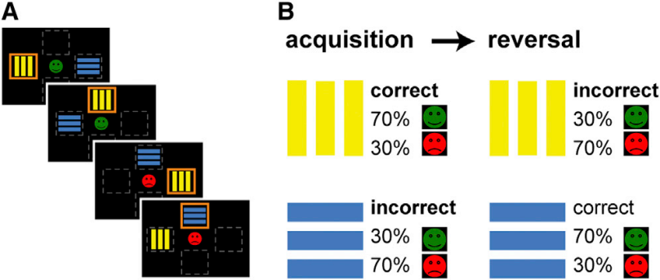
Set-shifting
- The Wisconsin card sorting task (WCST) consists of key cards and response cards with geometric figures that vary according to three perceptual dimensions (color, form, or number). The task requires participants to find the correct classification rule by trial and error and examiner feedback. Once the participant responds according to the correct rule, they must maintain this sorting principle (set) across changing stimulus conditions, ignoring the other dimensions. After ten consecutive correct matches, the sorting rule changes without warning, requiring a flexible shift of the set. The WCST is not timed, and sorting continues until all cards are sorted or a maximum of six correct sorting criteria have been reached. Scores commonly used as indices of performance include numbers of categories completed, perseverative errors, and non-perseverative errors. The left schematic figure is an analog of WCST, the Madrid Card Sorting Test (adapted from Figure 1 in the study by Nyhus and Barceló²). | 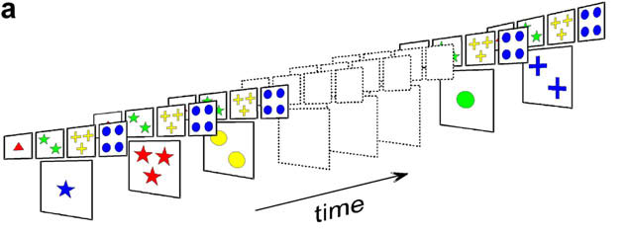
Attentional bias
- The dot-probe task measures preferential attention toward disorder-relevant stimuli. In this task, an addiction-related stimulus and a non-addiction stimulus (e.g., pictures or words) are presented simultaneously on either side of a fixation. The stimuli disappear after a fixed duration and are followed by a probe item (e.g., a dot, an asterisk) presented either on the addictive stimulus side (congruent condition) or on the control stimulus side (incongruent condition). Participants are asked to indicate the location of the probe as quickly as possible and reaction times are measured. Response latency to the probe is reduced when it appears in an attended rather than an unattended location. The relatively faster responses to the congruent condition compared to the incongruent condition are interpreted as an attentional bias (adapted from Figure 4 in the study by Nikolaidou and colleagues³). | 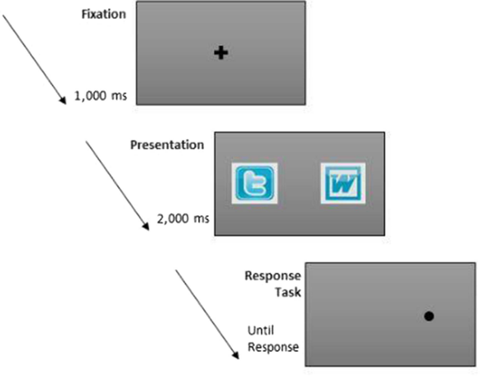
Habit learning
- The fabulous fruit game task measures the balance between goal-directed and habitual learning by manipulating outcome devaluation. The task consists of a discrimination learning phase and an outcome devaluation test phase. During the discrimination learning phase, participants learn by trial and error to press a left or right button (R) to stimuli (S) in order to gain outcomes (O) that yield points representing monetary rewards. Three trial types with different S-O contingencies can be distinguished: standard, congruent and incongruent.  Following the learning phase, an outcome-devaluation test phase assesses the strength of goal-directed R-O associations. Here, some of the outcomes are devalued and learned responses to the certain outcomes are no longer worth any points. Participants should therefore direct their choices towards the still-valuable outcomes according to the R-O relationships they have learnt. The final test, a slips-of-action test, assesses the strength of habitual learning S-R associations. Some of the outcomes are devalued, and participants are asked to respond to a stimulus paired with a still-valuable outcome and to refrain from responding if the outcome has been devalued (adapted from Figure 1 in the study by Gillan and colleagues⁴). | - Learning phase  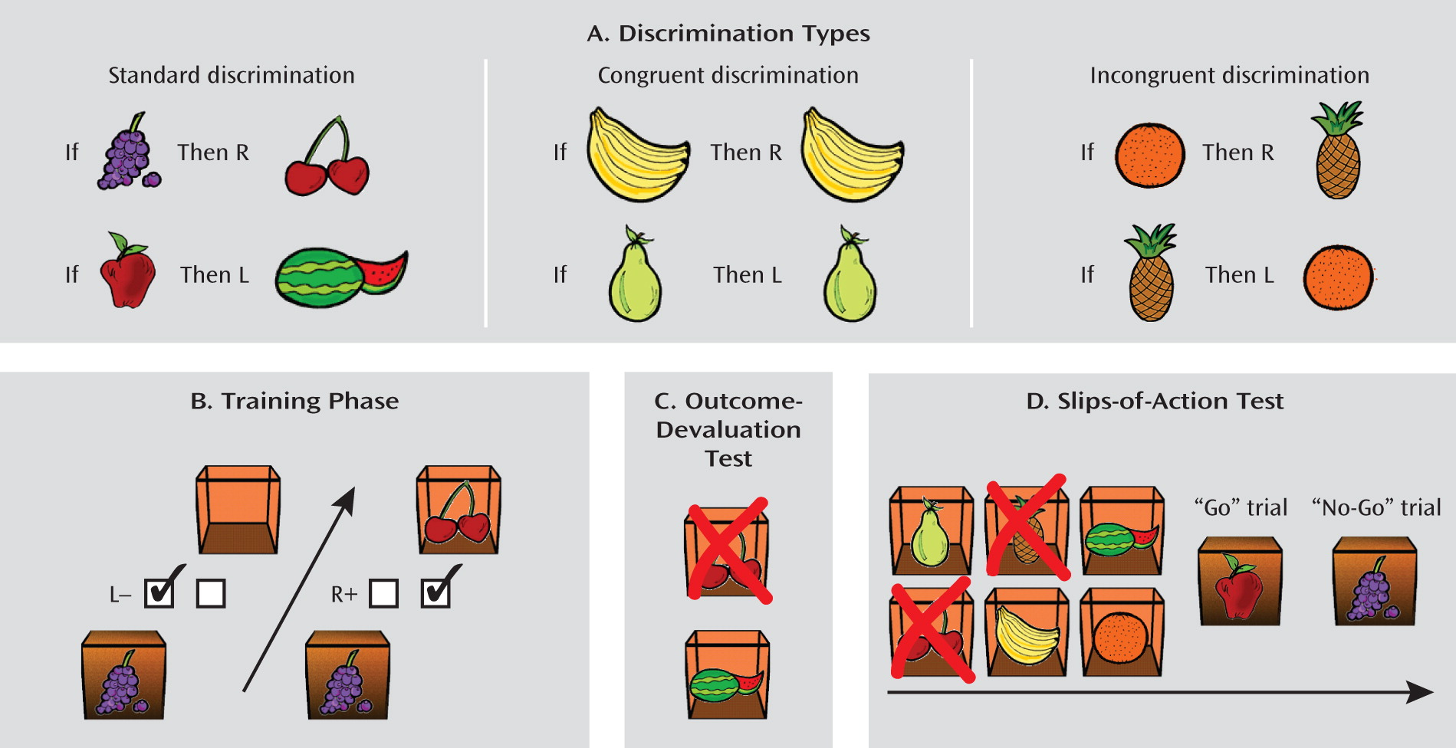  - Slips-of-action test  - Outcome-  devaluation test  - Outcome-  devaluation test

References
1 den Ouden HEM, Daw ND, Fernandez G, Elshout JA, Rijpkema M, Hoogman M et al. Dissociable effects of dopamine and serotonin on reversal learning. Neuron 2013; 80: 1090–1100.
2 Nyhus E, Barceló F. The Wisconsin Card Sorting Test and the cognitive assessment of prefrontal executive functions: a critical update. Brain Cogn 2009; 71: 437–451.
3 Nikolaidou M, Fraser DS, Hinvest N. Attentional bias in Internet users with problematic use of social networking sites. Journal of Behavioral Addictions, 2019; 8: 733–742.
4 Gillan CM, Papmeyer M, Morein-Zamir S, Sahakian BJ, Fineberg NA, Robbins TW et al. Disruption in the balance between goal-directed behavior and habit learning in obsessive-compulsive disorder. American Journal of Psychiatry, 2011; 168: 718–726.

