Su, S. et al: From Everyday Life to Measurable Problematic Smartphone Use: The Development and Validation of The Smartphone Use Problems Identification Questionnaire (SUPIQ). https://doi.org/10.1556/2006.2024.00010

Supplemental Material
Content:
Table S1. Questionnaires and scales for measuring problematic smartphone use (PSU)
Table S2. The initial version of the Smartphone Use Problems Identification Questionnaire (SUPIQ)
Figure S3. The data screening procedure of the current study
Table S4. Factor Loadings of the initial 24 items based on EFA with the university community sample (N=292)
Table S5. Factor Loadings of the 27 items based on EFA with the university community sample (N=292)
Table S6. Item-Total Correlations and Cronbach’s α of the 27 items version SUPIQ if single item gets deleted with the university community sample (N=292)
Table S7. Item-Total Correlations and Cronbach’s α of the 26 items version SUPIQ if single item gets deleted with the university community sample (N=292)
Figure S8. The Parallel Analysis Results and Scree Plot with the university community sample (N=292)
Table S9. The Cronbach’s α of the three factors if the restored three item gets deleted with the university community sample (N=292)
Figure S10. The network for the SUPIQ items with the university community sample (N=292)
Figure S11. The centrality indices for the network of the SUPIQ items with the university community sample (N=292)
Figure S12. The bridge centrality indices for the network of the SUPIQ items with the university community sample (N=292)
Table S13. Standardized Factor Loadings of the 26 items of the SUPIQ based on the CFA with the general population sample (N=397)
Table S14. Standardized Correlations between factors of the SUPIQ based on the CFA with the general population sample (N=397)
Figure S15. Stability test with bootstrapping (nboots=2000) for the network modeling (Fig 1.) with the university community sample (N=292)
Figure S16. The centrality indices for the network modeling (Fig 1.) with the university community sample (N=292)
Figure S17. The bridge centrality indices for the network modeling (Fig 1.) with the university community sample (N=292)
Figure S18. The estimation of significant differences between edge weights and bootstrapped (nboots=100) confidence intervals of edge weights for the network modeling (Fig 1.) with the university community sample (N=292)
Figure S19. Stability test with bootstrapping (nboots=2000) for network modeling with students sample (Fig 2.) with the general population sample (N=397)
Figure S20. The centrality indices for the network modeling (Fig 2.) with the general population sample (N=397)
Figure S21. The bridge centrality indices for the network modeling (Fig 2.) with the general population sample (N=397)
Figure S22. The estimation of significant differences between edge weights and bootstrapped (nboots=100) confidence intervals of edge weights for the network modeling (Fig 2.) with the general population sample (N=397)

Table S1
Questionnaires and scales for measuring problematic smartphone use (PSU)
Paper title | Questionnaire name | Authors | Sources of items | Students or general population | Item format | Are the calculations based on the polychoric correlation matrix | EFA or CFA? | Sample Size | Factors | Fit indexes based on CFA | Internal consistencies: Cronbach’s α or McDonald’s ω? | External validities or correlates
Psychological Predictors of Problem Mobile Phone Use | Mobile Phone Problem Use Scale (MPPUS) | Bianchi & Phillips (2005) | Literatures related to addiction and questions related with the social side of mobile phone use | University students and the general population (aged 18-85 years) | From 1 (“not true at all”) to 10 (“extremely true”), 27 items | No | - | 195 | Tolerance, escape from other problems, withdrawal, craving, and negative life consequences in the areas of social, familial, work, and financial difficulties, loss of control over the amount of mobile phone usage and time spent on mobile phone–related activities, social motivational  aspects of mobile phone use | - | Cronbach’s α of the whole scale= 0.93 | MMPI-2 Addiction Potential Scale, Coopersmith Self Esteem Inventory, Eysenck Personality Questionnaire—Revised Short Scale, and mobile phone usage including social calls, business calls, and other features
Problematic internet and cell-phone use: Psychological,  behavioral, and health correlates | Cell-Phone Over-Use Scale (COS) | Jenaro et al. (2007) | Seven of the ten pathological gambling criteria in DSM–IV | College students (aged 18-32 years) in Spain | From 1(‘‘Never’’) to 6 (‘‘Always’’), 23 items | No | - | 337 | - | - | Cronbach’s α of the whole scale= 0.87 | anxiety measured by BAI, depression measured by BDI, and other psychiatric disorders measured by GHQ-28
The Role of Impulsivity in Actual and Problematic Use of the Mobile Phone | Problematic Mobile Phone Use Questionnaire (PMPUQ) | Billieux et al. (2008) | Previous studies, for example Bianchi & Phillips (2005), Billieux et al. (2007) | Young adults (aged 20-35 years) from the community | From 1 (“I strongly agree”) to 4 (“I strongly disagree”), 30 items | No | EFA and CFA | 339 | dangerous/prohibited use, financial problems and dependence-related  symptoms | χ²(399) = 1093.78, RMSEA=0.072, AIC=1225.78,BIC=1862.81 | Cronbach’s α values: dangerous use = 0.65, prohibited use = 0.73, financial problems = 0.85, dependence = 0.84 | impulsivity measured by UPPS., and the number and duration of phone calls, number of SMSs sent per day
Characteristics of excessive cellular phone use in Korean adolescents | Excessive Cellular Phone Use Survey (ECPUS) | Ha et al. (2008) | Clinical experience and hypothesis from the authors | Technical high school students (aged 15.9±0.8 years) in South Korea | - | No | - | 595 | control difficulty, a persistent need for connection with others, and specific communication patterns via cellular phone | - | Cronbach’s α of the whole scale= 0.87 | Beck Depression Inventory (BDI), Toronto Alexithymia Scale (TAS-20), Interactional Anxiousness Scale, Rosenberg Self-Esteem Scale, and Young’s Internet Addiction Scale (IAS)
Leisure boredom, sensation seeking, self-esteem, addiction | Mobile Phone Addiction Index (MPAI) | Leung (2008) | The Phone Problem Use Scale (MPPUS) developed by Bianchi & Phillips (2005) and the diagnostic criteria of pathological gambling from Diagnostic and Statistical Manual of Mental Disorders (DSM-IV) | Teenagers and young adults (aged 14-28 years) in Hong Kong | From 1(“not at all”) to 5(“always”), 27 items | No | EFA | 624 | inability to control craving, anxiety and feeling lost, withdrawal and escape, productivity loss | - | Cronbach’s α values: inability to control craving = 0.78, anxiety and feeling lost = 0.76, withdrawal and escape = 0.81, productivity loss = 0.79 | Leisure Boredom, Sensation-seeking, Self-esteem, Mobile Phone Call Usage, and Features Use
Symptoms of problematic cellular phone use, functional impairment and its association with depression among adolescents in Southern Taiwan | Problem Cellular Phone Use Questionnaire (PCPU-Q) | Yen et al. (2009) | The taxonomies of substance use dependence on the DSM-IV-TR | Junior high and senior high/vocational schools students (aged 12-19 years) in Southern Taiwan | Yes or no,12 items | No | - | 10191 | Symptoms of problematic cellular phone use including tolerance, withdrawal, cellular phone use longer than intention, persistent desire and/or unsuccessful attempts to cut down or reduce cellular phone use, excessive time spent on cellular phone use or excessive effort spent on activities necessary to obtain cellular phone, giving up or reducing important social, academic, or recreational activities because of cellular phone use and continued heavy cellular phone use despite knowledge of having a persistent or recurrent physical or psychological problem likely to have been caused or exacerbated by cellular phone use  Functional impairment caused by cellular phone use including poor relationship with friends or classmates, poor academic performance, poor relationship with family members, compromised physical or psychological function and problems in financial affairs | - | Cronbach’s α of the whole scale= 0.854 | Depression measured by Center for Epidemiological Studies’ Depression Scale (CES-D)
Needing to connect: The effect of self and others on young people’s involvement with their mobile phones | Mobile Phone Involvement Questionnaire (MPIQ) | Walsh et al. (2010) | Previous research on mobile phone, especially the framework of Brown’s (1993, 1997) behavioral addiction components including cognitive and behavioral salience, interpersonal and other activities conflict, relief/euphoria, loss of control/ tolerance, withdrawal, relapse and reinstatement | Australian youths (aged 15-24 years) | From 1 (strongly disagree) to 7 (strongly agree), 8 items | No | EFA | 946 | Cognitive salience, behavioral salience, interpersonal conflict, conflict with other activities, euphoria, loss of control, withdrawal, relapses and reinstatement | - | Cronbach’s α of the whole scale= 0.78 | Mobile phone use frequency, self-identity, and validation from others
Problematic mobile phone use in adolescence: a cross-sectional study | Mobile Addiction Test (MAT) | Martinotti et al. (2011) | Self-developed questionnaire from Italian authors to assess problematic mobile phone use | High school students (aged 15-24 years) in southern Italy | A (1 point), B (2 points), C (3 points), 10 items | No | - | 2790 | - | - | - | South Oaks Gambling Screen-Revised for Adolescents (SOGS-RA), Compulsive Buying Scale (CBS), Internet Addiction Test (IAT), Work Addiction Risk Test (WART), Exercise Addiction Inventory (EAI)
Mobile-phone addiction in adolescence: the test of mobile phone dependence (TMD) | The Test of Mobile Phone Dependence (TMD) | Choliz (2012) | Dependence disorder criteria from Diagnostic and Statistical Manual for Mental Disorders-Fourth Edition-Text Revision (DSM-IV-TR) | Adolescents (aged 12–18 years) | Likert-type scale ranging from 0 (never) to 4 (frequently) for 18 items; Likert-type scale ranging from 0 (completely disagree) to 4 (completely agree for another 28 items | No | EFA | 2486 | Abstinence, Lack Control/ Problems, Tolerance/ Interference | - | Cronbach’s α of the whole scale= 0.94 | Basic parameters of mobile-phone use
Development of a problematic mobile phone use scale for Turkish adolescents | Problematic Mobile Phone Use Scale (PMPUS) | Güzeller & Coşguner (2012) | PMPUS developed by Billieux et al. (2008) | Turkish public high school students (EFA: aged 16.12±0.86;  CFA: aged 16.01±0.90) | 1 (never) to 5 (always); 32 items | No | EFA and CFA | 950 in total;  EFA:309;  CFA:641 | interference with negative effect, compulsion/persistence, and withdrawal/tolerance | χ²(126) = 477.23, GFI=0.97, AGFI=0.90, NFI=0.95, TLI=0.96, CFI =0.97, RMSEA=0.066, SRMR=0.052 | Cronbach’s α of the whole scale= 0.94 | Beck Depression Inventory, UCLA Loneliness Scale
A model of the relationship between psychological characteristics, mobile  phone addiction and use of mobile phones by Taiwanese university female students | Mobile Phone Addiction Scale (MPAS) | Hong et al. (2012) | The internet addiction criteria by Young (1998) | Female  undergraduate students from three  universities in Taiwan | From 1 (‘‘incompletely agreed’’) to 6 (‘‘completely agreed’’), 11 items | No | - | 269 | (1) Time  Management and its Problems  (2) Academic Problems in School and its Influence  (3) Reality Substitute | - | Cronbach’s α values: the whole scale= 0.8645, Time  Management and its Problems = 0.8342, Academic Problems in School and its Influence = 0.8435, Reality Substitute = 0.6712 | the most frequently used mobile phone functions, mobile phone usage situation (mobile phone usage time per day, monthly money spent on mobile phone), mobile phone usage behavior (the number of calls per day, daily number of text messages sent), self-esteem, social extroversion and anxiety
Development and Validation of a Smartphone Addiction Scale (SAS) | Smartphone Addiction Scale (SAS) | Kwon, Lee, et al. (2013) | K-scale revised from Kimberly Young’s scale (Kim et al., 2008; Young, 2009) and items describing the features of smartphone | Adults (aged 18-53 years, 26.06±5.96 years) from two companies and two universities in South Korea | From 1 (‘‘strongly disagree’’) to 6 (‘‘strongly agree’’), 33 items | No | EFA | 197 | daily-life disturbance, positive anticipation, withdrawal, cyberspace-oriented relationship, overuse, and tolerance | - | Cronbach’s α values: the whole scale= 0.967, daily-life disturbance = 0.858, positive anticipation = 0.913, cyberspace-oriented relationship = 0.876, overuse = 0.825, tolerance = 0.865 | Internet addiction measure by K-scale., Y-scale with replacing “Internet’’ with ‘‘smartphone’’, substance dependence and abuse diagnosis of DSMIV.
The Smartphone Addiction Scale: Development and Validation of a Short Version for Adolescents | The short version of Smartphone Addiction Scale (SAS-SV) | Kwon, Kim, et al. (2013) | SAS developed by Kwon, Lee, et al. (2013) | 2nd year junior high school students (average age =14.5 years) in South Korea | From 1 (‘‘strongly disagree’’) to 6 (‘‘strongly agree’’), 10 items | No | - | 540 | One factor as smartphone addiction | - | Cronbach’s α of the whole scale= 0.91 | Smartphone Addiction Proneness Scale (SAPS) and he Korean self-reporting internet addiction scale short-form scale (KS-scale)
Measuring Problematic Mobile Phone Use: Development and Preliminary Psychometric Properties of the PUMP Scale | Problematic Use of Mobile Phones (PUMP) Scale | Merlo et al. (2013) | informal interviews with several self-identified “cell phone addicts” with the first author; (2) the DSM-IV criteria for substance use disorders; (3) existing questionnaires measuring consequences of excessive internet use. | Participants from public locations and university (aged 18-75 years, 29.8±14.1 years) | From 1 (“strongly disagree”) to 5 (“strongly agree”), 20 items | No | EFA | 244 | One factor as Problematic Use of Mobile Phones (PUMP) | - | Cronbach’s α of the whole scale= 0.94 | Cellular Phone Dependency Tendency Questionnaire (CPDQ), the Cell Phone Use Questionnaire (CUQ), and the self-assessed smartphone use
The validity and reliability of the Turkish version of the smartphone addiction scale-short form for adolescent | The short version of Smartphone Addiction Scale (SAS-SV), the same as Kwon, Kim, et al. (2013) | Akın et al. (2014) | SAS-SV developed by Kwon, Kim, et al. (2013) | high school students (average age=16.2 years) | From 0 (“largely untrue”) to 4 (“largely true”), 10 items | No | CFA | 312 | One factor as smartphone addiction | χ²(31) = 56.92, RMSEA= 0.052, NFI= 0.96, CFI= 0.98, IFI= 0.98, RFI= 0.94, GFI= 0.96, and SRMR= .040 | The internal consistency coefficient of the whole scale= 0.88 | Smartphone Addiction Proneness Scale (SAPS), The Korean self-reporting internet addiction scale short-form (KS-Scale)
Psychometric properties of smartphone addiction questionnaire (SPAQ) among sultan qaboos university undergraduate students | Smartphone Addiction Questionnaire (SPAQ) | Al-Barashdi et al. (2014) | From previous studies measuring smartphone addiction | undergraduate students aged 18-27 years | 17 items | No | EFA | 140 | Productivity loss, feeling anxious and lost, disregard of harmful consequences, preoccupation, inability to control craving | - | Cronbach’s α of the whole scale= 0.764 | Level of smartphone usage, level of smartphone addiction symptoms appearances, smartphone addiction scale (SAS)
The invisible addiction: cell-phone activities and addiction among male and female college students | Manolis/Roberts Cell-Phone Addiction Scale (MRCPAS). | Roberts et al. (2014) | Two items adapted from a cell-phone addiction scale and two self-developed items | College undergraduates in Texas (aged 19-22 years; average age=21 years) | 7-liket type response, 4 items | No | CFA | 164 | One factor as cell-phone addiction | χ²(2) = 18.71, CFI = 0.94; IFI = 0 .94; BBNFT= 0.93 and RMSEA = 0.02. | Cronbach’s α of the whole scale= 0.87 | daily engagements with activities on cell-phone
A preliminary investigation into the prevalence and prediction of problematic cell phone use | The Adapted Mobile Phone Use Habits (AMPUH) and The Adapted Cell Phone Addiction Test (ACPAT) | Smetaniuk (2014) | AMPUH: pathological gambling criteria based on pathological gambling in DSM-IV; ACPAT: Internet addiction Test developed by Young (1998) | Study1: undergraduate students (mean age = 21 years, age range: 18–59 years);  Study2: working adults (average age = 32, age range: 18–74 years) | AMPUH: yes or no, 10 items; ACPAT: from 1 (“rarely”) to 5 (“always”), 20 items | No | - | Study1: 301; Study2: 362 | - | - | Cronbach’s α of the whole scale= 0.96 | Zung’s Self-Rating Depression Scale, Emotional Stability Scale, Rosenberg’s Self-Esteem Scale, Impulse Control scale, The Mobile Phone Problem Use Scale
Development and Validation of the Smartphone Addiction Inventory (SPAI) | Smartphone Addiction Inventory (SPAI) | Lin et al. (2014) | Chen Internet Addiction Scale  (CIAS; S. H. Chen et al., 2003) | Young adults (aged 22.9±2.0 years) of two universities in Northern Taiwan | From 1 (“strongly disagree”) to 4 (“strongly agree”), 26 items | No | EFA | 283 | compulsive behavior, functional impairment, withdrawal and tolerance | - | Cronbach’s α values: the whole scale= 0.94, compulsive behavior = 0.87, functional impairment = 0.88, withdrawal = 0.81, tolerance = 0.72 | phantom vibration/ringing
Development of Korean Smartphone Addiction Proneness Scale for youth | Smartphone Addiction Proneness Scale (SAPS) | D. Kim et al. (2014) | Previous research about internet/phone addiction and the clinical experiences from the experts involved in this study | Elementary, middle, and high school students in south Korea | From 1 (“strongly disagree”) to 4 (“strongly agree”), 15 items | No | CFA | 795 | Disturbance of adaptive functions, virtual life orientation, withdrawal, and tolerance | NFI=0.943, TLI=0.902, CFI=0.962, RMSEA=0.034 | Cronbach’s α of the whole scale= 0.880 | Mental health problems scale
Prevalence of Problematic Mobile Phone Use in British Adolescents | Mobile Phone Problem Use Scale for Adolescents (MPPUSA) | Lopez-Fernandez et al. (2014) | MPPUS developed by Bianchi & Phillips (2005) | Secondary school pupils aged  between 11 and 18 years (young adolescents, 11–14 years, and older adolescents, 15–18 years) in London, UK | From 1 (‘totally false”) to 10 (“completely true”), 26 items | No | EFA | 1026 | Tolerance, escape from problems, withdrawal, craving, negative consequences, social motivational | - | Cronbach’s α of the whole scale= 0.97 | Mobile phone use
Validation of a Malay Version of the Smartphone Addiction Scale among Medical Students in Malaysia | Malay version of the SAS (SAS-M) | Ching et al., (2015) | SAS developed by Kwon, Lee, et al. (2013) | First- and second-year medical students from Universiti Putra Malaysia | From 1 (‘‘strongly disagree’’) to 6 (‘‘strongly agree’’), 33 items | No | EFA | 228 | daily-life disturbance, positive anticipation, withdrawal, cyberspace-oriented relationship, overuse, and tolerance | - | Cronbach’s α values: the whole scale= 0.94, daily-life disturbance = 0.843, positive anticipation = 0.865, cyberspace-oriented relationship = 0.877, overuse = 0.837, primacy = 0.865, withdrawal = 0.861 | Internet Addiction Test
Development of a Brief Instrument to Measure Smartphone Addiction Among Nursing Students | Brief Instrument to Measure Smartphone Addiction for Nursing Students | Cho & Lee (2015) | A survey among nursing students, existing literatures and interviews with 6 nursing students who used smartphone over 2 and overused smartphone | Nursing school students in south Korea | From 1 (‘‘Never) to 5 (‘‘Always’’), 18 items | No | EFA and CFA | EFA and CFA with the same sample, n=528 | Withdrawal, Tolerance, Positive expectancy, Interference with daily routines | χ²(126)=441.814, GFI =0.909, AGFI = 0.876, and NFI = 0.907 | Cronbach’s α values: the whole scale = 0.902, withdrawal = 0.854, tolerance = 0.793, positive expectancy = 0.793, interference with daily routines = 0.801 | Distractions caused by smartphones and opinions about smartphone use policies
Problematic mobile phone use in adolescents: derivation of a short scale MPPUS-10 | The shortened scale of Mobile Phone Problem Use Scale (MPPUS-10) | Foerster et al. (2015) | Mobile Phone Problem Use Scale developed by Bianchi & Phillips (2005) | 7th, 8th and 9th grade students (aged 12–17 years) attending secondary schools in Central Switzerland | From 1 (‘‘not true at all’’) to 10 (‘‘extremely true’’), 10 items | No | EFA | First time: 377;  Follow-up:378 | Loss of Control, Withdrawal, Negative Life Consequences and Craving, Peer Dependence | - | Cronbach’s α of the whole scale = 0.85 | Objective mobile phone use traffic data, and original Mobile Phone Problem Use Scale (MPPUS-27)
Exploring smartphone addiction: insights from long-term telemetric behavioral measures | Smartphone Addiction Measurement Instrument (SAMI) | Tossell et al. (2015) | Cellular Phone Addiction Scale (Koo, 2009) and Internet Addiction Test (Young, 1998) | 10 community college students and 24 major university students | From never (1) to always (5), 15 items | No | -- | 34 | One factor as smartphone addiction | - | - | Objective mobile phone use data
Exploring the dimensions of nomophobia: Development and validation of a self-reported questionnaire | Nomophobia Questionnaire (NMP-Q) | Yildirim & Correia (2015) | Interviews with nine undergraduate students who had smartphone use problems identified by Test of Mobile Phone Dependence (TMD; Choliz, 2012) | Undergraduate students (mean age = 20 years) from a Midwestern university in the U.S | From 1 (‘‘strongly disagree’’) to 7 (‘‘strongly agree’’), 20 items | No | EFA | 301 | Not being able to communicate, losing connectedness, not  being able to access information, and giving up convenience. | - | Cronbach’s α values: whole scale = 0.945, not being able to communicate = 0.939, losing connectedness = 0.874, not being able to access information = 0.827, giving up convenience = 0.814 | Mobile Phone Involvement Questionnaire (MPIQ)
A growing fear: Prevalence of nomophobia among Turkish college students | Nomophobia Questionnaire (NMP-Q) | Yildirim et al. (2016) | Nomophobia Questionnaire (NMP-Q) developed by Yildirim & Correia (2015) | College students (aged 20.02±1.65 years) at a public university in Turkey | From 1 (‘‘strongly disagree’’) to 7 (‘‘strongly agree’’), 20 items | No | - | 537 | Not being able to communicate, losing connectedness, not  being able to access information, and giving up convenience. | - | Cronbach’s α values: the whole scale = 0.92, not being able to communicate = 0.90, losing connectedness = 0.74, not being able to access information = 0.94, giving up convenience = 0.91. | Duration of mobile phone and smartphone ownership
Smartphone Addiction Inventory (SPAI): Psychometric properties and confirmatory factor analysis | Smartphone Addiction Inventory -Italian (SPAI-I) | Pavia et al. (2016) | Smartphone Addiction Inventory (SPAI) developed by Lin et al. (2014) | College students (aged 20.02±1.65 years) at a public university in Italy | From 1 (strongly disagree) to 4 (strongly agree), 26 items | No | CFA | 485 | Functional Impairment, Withdrawal, Compulsive Behavior and Tolerance | χ²(44)=2303.40, CFI = 0.87, TLI = 0.95, RMSEA = 0.07; WRMW = 1.28 | Cronbach’s α values: the whole scale = 0.90, Time Spent = 0.73, Compulsivity = 0.70, Daily Life Interference = 0.74, Craving = 0.75, Sleep Interference = 0.81. | Internet Addiction Test (IAT)
Smartphone addiction among university students in the light of some variables | a smartphone addiction questionnaire | Aljomaa et al. (2016) | Previous literatures and questionnaires relevant to this topic | Students using smartphones and attending one University in Saudi Arabia | From 1 (“never or almost never true of me”) to 5 (“always or almost always true of me”), 80 items | No | - | 416 | overuse of smartphone, the technological dimension, the psychological social dimension, preoccupation with smartphones, and the health dimension | - | Cronbach’s α of the whole scale = 0.97, Cronbach’s α of five dimensions ranged from 0.84 to 0.94 | Gender, social status, educational level, hours of daily use, monthly income
Development of a Brief Multicultural Version of the Test of Mobile Phone Dependence (TMDbrief) Questionnaire | Test of Mobile Phone Dependence-Brief (TMDbrief) | Chóliz et al. (2016) | The test of mobile phone dependence (TMD) developed by Choliz (2012) | Graduate or postgraduate students (aged 18-27 years) from six regions: Southern Europe, Northwest Europe, South-America, Mesoamerica, Pakistan, and India | From 0 (completely disagree) to 4 (completely agree), 12 items | No | EFA | 2028 | Abstinence, Abuse and interference with other activities, Tolerance and Lack of control | - | Cronbach’s α values: Abstinence = 0.81, Abuse and interference with other activities = 0.70, Tolerance = 0.75, Lack of control = 0.64. | Gender
Development and psychometric validation of the Brief Smartphone Addiction Scale (BSAS) with schoolchildren | Brief Smartphone Addiction Scale (BSAS) | Csibi et al. (2016) | The 'components' model of addiction proposed by (Griffiths, 2005) | Hungarian speaking schoolchildren aged 13.4± 2.22 years | 6-point agree-disagree Likert scale, 6 items | No | EFA | 441 | One single factor of smartphone addiction | - | Cronbach’s α of the whole scale = 0.82 | Smartphone Addiction Inventory (SPAI; Lin et al., 2014)
Development and validation of the mobile addiction scale: the components model approach | Mobile Addiction Scale (MAS) | Fidan (2016) | Previous relevant questionnaires and the components model proposed by Brown (1986) and Griffiths (1995) | Most pf the participants aged 15-45 years and lived in city-center the towns of Turkey | - | No | EFA and CFA | 284 | withdrawal, relapse, tolerance, and salience | χ²/df = 3.215, CFI = 0.916, RMR=0.078, GFI = 0.918, NFI = 0.905 and RMSEA = 0.088 | Cronbach’s α of the whole scale = 0.910 | -
Development of a Problematic Mobile Phone Use Scale for university students: Validity and reliability study | Problematic Mobile Phone Use Scale (PMPUS) | Pamuk & Atli (2016) | The previous relevant papers, university students’ answers for the open-ended questions on smartphone use and the criteria for substance use disorder and internet gaming disorder in the DSM V | Students from a University in Turkey | From 1 (“Not at all appropriate”) to 5 (“Completely appropriate”), 26 items | No | EFA and CFA | 725 in total; EFA:362; CFA:363 | Deprivation, Adverse outcomes, Control problem, Interaction avoidance | GFI = 0.91, AGFI = 0.89, CFI=0.96, TLI = 0.95, RMSEA = 0.044, SRMR = 0.0419 | Cronbach’s α of the whole scale = 0.94 | Mobile Phone Problem Use Scale (MPPUS)
Developing a shorter version of the Estonian smartphone addiction proneness scale (E-SAPS18) | Estonian smartphone addiction proneness scale (E-SAPS18) | Rozgonjuk et al. (2016) | SAS developed by Kwon, Lee, et al. (2013) | Adults (aged 18-71 years, mean age=26.10± 6.73 years) from social media posts and university mailing lists | From 1 (‘‘strongly disagree’’) to 6 (‘‘strongly agree’’), 18 items | No | EFA and CFA | 767 in total; EFA:427; CFA:340 | Tolerance, positive anticipation, cyberspace-oriented relationships, withdrawal and physical symptoms | χ²(125) = 269, RMSEA = 0.058, CFI=0.93, SRMR = 0.056 | Cronbach’s α of the whole scale = 0.87, Cronbach’s α of the five factors ranged from 0.68 to 0.82. | The Estonian Internet Addiction Test, and the Visual Analogue Scale measuring subjective severity of smartphone addiction
Development of a mobile phone addiction craving scale and its validation in a Spanish adult population | Mobile Phone Addiction Craving Scale (MPACS) | De-Sola et al. (2017) | The Spanish scale of cocaine craving developed | Participants aged 16- 65 years, , mean age=32.8± 11.67 years in Spain | From 1 (not at all true) to 10 (completely true), 8 items | No | EFA and CFA | 1126 | One factor as mobile phone addiction craving | CFI = 0.939, RMSEA = 0.124,SRMR = 0.040 | Cronbach’s α of the whole scale = 0.919 | The state anxiety of the State-Trait Anxiety Inventory, problematic cell phone use measured by MPPUS and impulsivity measured UPPS-P by, including the urgency, premeditation, perseverance, and sensation seeking scales
An investigation into problematic smartphone use: The role of narcissism, anxiety, and personality factors | Problematic Smartphone Use Scale | Hussain et al. (2017) | Modified DSM-5 criteria of Internet Gaming Disorder and the Internet Gaming Disorder Scale Short-Form (IGDS9-SF) developed by Pontes & Griffiths (2014, 2015) | Smartphone users aged 13-69 years, mean age= 24.89 ±8.54 years | From 1 (‘‘strongly disagree’’) to 5 (‘‘strongly agree’’), 9 items | No | - | 640 | One factor as problematic smartphone use | - | Cronbach’s α of the whole scale = 0.86 | Narcissism measured by the Narcissistic Personality Inventory, anxiety measured by the Narcissistic Personality Inventory, and personality factors measured by the Ten-Item Personality Inventory
Assessment of the accuracy of a new tool for the screening of smartphone addiction | The Brazilian version SPAI (SPAI-BR) | Khoury et al. (2017) | Smartphone Addiction Inventory (SPAI) developed by Lin et al. (2014) | Undergraduate students in Brazil | From 1 (“strongly disagree”) to 4 (“strongly agree”), 26 items | No | CFA | 415 | Compulsive behavior, functional impairment, withdrawal syndrome and tolerance syndrome | χ²(293) = 767.861, CFI =0.913, TLI =0.905, RMSE =0.061, WRMR =1.465 | The Kuder-Richardson Coefficient of the whole scale = 0.887 | Addictions criteria proposed by Goodman (1990)
Development and validation study of the Smartphone Overuse Screening Questionnaire | Smartphone Overuse Screening Questionnaire (SOS-Q) | Lee et al. (2017) | Previous research about smartphone/cell phone related scales, existing criteria, subject interviews | Participants from six ‘I will center’ locations in South Korea, mainly adolescents and young adults (mean age=22.12 ± 7.56 years) | 4-point scale (Not at all, Sometimes, Often, or Always). 28 items | No | EFA | 158 | Preoccupation, loss of control, craving, insight, overuse, and neglect of other areas | - | Cronbach’s α values: the whole scale = 0.95, Preoccupation = 0.886, Loss of control = 0.874, Craving = 0.727, Insight = 0.902, Overuse = 0.630, Neglect = 0.718 | Young's internet addiction scale, Korean scale for internet addiction, and Smartphone Scale for Smartphone Addiction (S-Scale)
Development of short-form and screening cutoff point of the Smartphone Addiction Inventory (SPAI-SF) | Short-Form of Smartphone Addiction Inventory (SPAI-SF) | Lin et al. (2017) | Smartphone Addiction Inventory (SPAI) developed by Lin et al. (2014) | Undergraduate and graduate students (aged 18-31 years, mean age=20.89± 1.58 years) in Taiwan | From 1 (strongly disagree) to 4 (strongly agree), 10 items | No | CFA | 268 | compulsive behaviors, tolerance, withdrawal, and functional impairment | CFI = 0.97, NFI = 0.94, IFI = 0.97, and RMSEA =0.061 | Cronbach’s α of the whole scale = 0.84 | Self-report time spent on smartphone use and Smartphone Addiction Inventory (SPAI)
Short version of the Smartphone Addiction Scale adapted to Spanish and French: Towards a cross-cultural research in problematic mobile phone use | The short version of Smartphone Addiction Scale (SAS-SV) | Lopez-Fernandez, (2017) | The short version of Smartphone Addiction Scale (SAS-SV) developed by Kwon, Kim, et al. (2013) | Adults in Spain (aged 18-68 years, mean age=25.61± 11.65 years) and adults in Belgium (aged 18-73 years, mean age=29.111± 15.33 years) | From 1 (‘‘strongly disagree’’) to 6 (‘‘strongly agree’’), 10 items | No | EFA | Spanish adults: 281  Belgian adults: 144 | One factor as smartphone addiction | - | Cronbach’s α values: the whole scale for Spain = 0.88, the whole scale for Belgium = 0.90 | -
Addiction-like Behavior Associated with Mobile Phone Usage among Medical Students in Delhi | Mobile Phone Addiction Scale (MPAS) | Basu et al. (2018) | Self-administered questionnaire by the authors | Undergraduate medical students in India (aged 18-68 years, mean age=20.48± 11.65 years) | From 1 (‘‘strongly disagree’’) to 6 (‘‘strongly agree’’), 20 items | No | EFA | 388 | Intense desire, impaired control, withdrawal, tolerance, decreased interest in alternate pleasures, and harmful use | - | Cronbach’s α of the whole scale = 0.90 | -
The Psychometric Properties of the Smartphone Application-Based Addiction Scale (SABAS) | Smartphone Application-Based Addiction Scale (SABAS) | Csibi et al., (2018) | The Smartphone Application-Based Addiction Scale (SABAS) developed by Csibi | English-speaking adults (aged 18-69 years, mean age=25.4 years) | From 1 (‘‘strongly disagree’’) to 6 (‘‘strongly agree’’), 6 items | No | EFA | 240 | A single factor as Smartphone Application-Based Addiction | - | Cronbach’s α of the whole scale = 0.81 | SABAS, the NMP-Q, the Brief Sensation Seeking Scale, the Deprivation Sensation Scale, and the Patient Health Questionnaire Depression Scale
Smartphone Restriction and Its Effect on Subjective Withdrawal Related Scores | Smartphone Withdrawal Scale (SWS) | Eide et al. (2018) | Cigarette Withdrawal Scale (CWS) developed by Etter (2005) | Participants aged 18-48 years (mean age=25± 4.5 years), 79.5% of the sample were full-time students attending higher education in Bergen | From 1 (totally disagree) to 5 (totally agree), 15 items | No | - | 127 | Depression-Anxiety, Craving, Irritability-Impatience, Difficulty Concentrating | - | Cronbach’s α of the whole scale ranged from 0.88 to 0.92 | the Fear of Missing Out Scale (FoMOS) and the Positive and Negative Affect Schedule (PANAS)
Problematic Smartphone Use: Investigating Contemporary Experiences Using a Convergent Design | Problematic Mobile Phone Use Questionnaire-Revised (PMPU-Q-R) | Kuss et al. (2018) | PMPUQ developed by Billieux et al. (2008) | Participants aged 13-68 years (mean age=25.5 years) | From 1 (strongly disagree) to 4 (strongly agree), 17 items | No | EFA and CFA | 512 | Smartphone dependence, dangerous driving, and antisocial smartphone use factors | χ²(101) = 190.424, CFI = 0.927, TLI = 0.906, RMSEA = 0.062, SRMR = 0.054 | Cronbach’s α of the whole scale = 0.88 | Smartphone Addiction Scale (SAS), Social Media Disorder Scale (SMD), psychopathological symptoms including depression, anxiety, stress (measured by Depression-Anxiety-Stress Scale, DASS-21), and ADHD symptoms, impulsivity measure by short form of the Barratt Impulsiveness Scale (BIS-15), and the big five personality traits (i.e., neuroticism, extraversion, conscientiousness, agreeableness and openness)
Measurement Invariance of the Short Version of the Problematic Mobile Phone Use Questionnaire (PMPUQ-SV) across Eight Languages | Short Version of the Problematic Mobile Phone Use Questionnaire (PMPUQ-SV) | Lopez-Fernandez et al. (2018) | PMPUQ developed by Billieux et al. (2008) | Participants from eight European countries, mean age=26.505 ±9.395 years | From 1 (‘I strongly agree’) to 4 (‘I strongly disagree’), 15 items | Polychoric method was used in CFA | Multigroup CFA | 3038 | Dangerous, prohibited, and dependent use | χ²(87) = 1858.371, CFI = 0.947, TLI = 0.936, RMSEA = 0.082, SRMR = 0.074 | Cronbach’s α of the Dangerous use ranged from 0.77 to 0.90, Cronbach’s α of the Dangerous use ranged from 0.56 to 0.75, Cronbach’s α of the Dangerous use ranged from 0.82 to 0.90. | -
Short version of the Smartphone Addiction Scale in Chinese adults: Psychometric properties, sociodemographic, and health behavioral correlates | The short version of Smartphone Addiction Scale (SAS-SV) | Luk et al. (2018) | The short version of Smartphone Addiction Scale (SAS-SV) developed by Kwon, Kim, et al. (2013) | Participants (aged 18–96 years, mean age=43.3 ±15.7 years) in Hong Kong | From 1 (‘‘strongly disagree’’) to 6 (‘‘strongly agree’’), 10 items | No | - | 3211 | One factor as smartphone addiction | - | Cronbach’s α of the whole scale = 0.844 | Sociodemographic factors, health behaviors, and chronic disease status
Validation of a Spanish Questionnaire on Mobile Phone Abuse | The Mobile Phone Abuse Questionnaire (ATeMo) | Olivencia-Carrión et al. (2018) | DSM-5 diagnostic criteria for addiction (American Psychiatric Association, 2013) and craving | Participants (aged 17–45 years, mean age=21.12 ± 3.05 years) Granada, Spain | From 0 (strongly disagree) to 4 (strongly agree), 25 items | Polychoric method was used in CFA | - | 856 | Craving, loss of control, negative life consequences, and withdrawal syndrome | χ²(265) = 274.18, GFI = 0.97, CFI = 1, AGFI = 0.97, NFI= 1, RMSEA = 0.021, SRMR = 0.06 | Cronbach’s α values: the whole scale = 0.91, Craving = 0.74, Loss of Control = 0.70, Negative Life Consequences = 0.77, Withdrawal Syndrome = 0.77. | History of drug abuse and addiction behavior measure by the ULTICAGE CAD-4
Reliability of the Arabic smartphone addiction scale and smartphone addiction scale-short version in two different Moroccan samples | The Arabic Smartphone Addiction Scale (SAS); The short version of Smartphone Addiction Scale (SAS-SV) | Sfendla et al. (2018) | SAS developed by Kwon, Lee, et al. (2013); The short version of Smartphone Addiction Scale (SAS-SV) developed by Kwon, Kim, et al. (2013) | Sample 1: aged 14–64 years, mean age = 27.4 ± 6.4 years); Sample 2: mean age = 23.1 ± 4.6 years) | From 1 (‘‘strongly disagree’’) to 6 (‘‘strongly agree’’), 33 items in SAS; From 1 (‘‘strongly disagree’’) to 6 (‘‘strongly agree’’), 10 items in SAS-SV | No | EFA | 750 in total; Sample 1: 440; Sample 2: 310 | Six factors of SAS: daily life disturbance, positive anticipation, withdrawal, cyberspace-oriented relationship, overuse, tolerance; one factor for SAS-SV | - | Cronbach’s α values: the whole SAS = 0.94, daily life disturbance = 0.81, positive anticipation = 0.86, withdrawal = 0.84, cyberspace-oriented relationship = 0.83, overuse = 0.78, tolerance = 0.81 | The short version of Smartphone Addiction Scale (SAS-SV)
Psychometric Properties and Demographic Correlates of the Smartphone Addiction Scale-Short Version among Chinese Children and Adolescents in Hong Kong | The short version of Smartphone Addiction Scale (SAS-SV) | Cheung et al. (2019) | The short version of Smartphone Addiction Scale (SAS-SV) developed by Kwon, Kim, et al. (2013) | Primary school children and secondary school pupils (aged 7-17 years) in Hong Kong | From 1 (‘‘strongly disagree’’) to 6 (‘‘strongly agree’’), 10 items | No | EFA and CFA | 1901 | SAS-SV Factor 1: Dependence; SAS-SV Factor 2: Problems; SAS-SV Factor 3: Time spent. | χ²= 153, CFI = 0.96, TLI = 0.95, RMSEA = 0.06, CR = 0.90, AVE = 0.48 | Cronbach’s α of the whole scale = 0.86 | Time spent on phones per day, the Smart Device Addiction Screening Tool (SDAST), the Pittsburgh Sleep Quality Index (PSQI), the Multidimensional Scale of Perceived Social Support (MSPSS), and the Center for Epidemiological Studies Depression Scale for Children (CES-DC)
Development Of A Smartphone Overuse Classification Scale | Smartphone Overuse Classification Scale (SOCS) | Ding et al. (2019) | Individual and focus-group interviews and the experts | University students in Shanghai | From 1 (‘‘strongly disagree’’) to 5 (‘‘strongly agree’’), 24items | No | EFA and CFA | 1296 in total;  EFA:849; CFA: 447 | Three subscales including social network app overuse (S-scale), recreational app overuse (R-scale), and information overload (I-scale). Each subscale contains three factors including cognitive disorder, behavioral disorder, and mood disorder. | χ²/df of the three subscales were 2.20, 2.11 and 7.81 for the S-scale, R-scale and I-scale, respectively; the CFI values were 0.97, 0.98 and 0.91; the NFI values were 0.94, 0.97 and 0.89; and the RMSEA values were 0.052, 0.050 and 0.124. | Cronbach’s α values: the whole scale = 0.849, social network app overuse (S-scale) = 0.813, recreational app overuse (R-scale) = 0.726, information overload (I-scale). = 0.706. | Young’s Diagnosis Questionnaire (Young’s DQ) and the demographic information
Reliability and construct validity testing of a questionnaire to assess nomophobia (QANP) | Questionnaire to assess nomophobia (QANP) | Ferri-García & Olivencia-Carrión (2019) | Previous literatures on scales measuring Nomophobia and the views from experts | Participants (aged 17–55 years, mean age=23.19 ± 7.23 years) in Granada, Spain | 5 numeric responses, 11 items | No | EFA and CFA | 968 in total;  484 for EFA and CFA respectively | Mobile Phone Abuse, Loss of Control, Negative Consequences | GFI = 0.966, TLI = 0.936, RMSEA = 0.055 | Cronbach’s α values: the whole scale = 0.80, Mobile Phone Abuse = 0.75, Loss of Control = 0.64, Negative Consequences = 0.57. | -
An urdu adaptation of smartphone addiction scale-short version (SAS-SV) | The short version of Smartphone Addiction Scale (SAS-SV) | Khalily et al. (2019) | The short version of Smartphone Addiction Scale (SAS-SV) developed by Kwon, Kim, et al. (2013) | Participants (aged 11-30 years) at school schools, colleges and universities within Rawalpindi and Islamabad in Urdu | From 1 (‘‘strongly disagree’’) to 6 (‘‘strongly agree’’), 10 items | No | CFA | 348 | One factor as smartphone addiction | CFI = 0.95, TLI = 0.93, NFI = 0.92, RMSEA = 0.05 | Cronbach’s α of the whole scale = 0.81 | -
Metacognitions about problematic Smartphone use: Development of a self-report measure | Metacognitions about Smartphone use Questionnaire (MSUQ) | Casale et al. (2020) | Previous studies relevant to this topic | Participants (aged 15–70 years, mean age = 28.08 ± 9.81 years) in Italy | From 1 (“Do not agree”) to 4 (‘‘Agree very much’’), 24 items | No | EFA and CFA | 701 in total; EFA:350; CFA:351 | F1 = positive metacognitions about emotional and cognitive regulation (MSUQ – PM ECR); F2 = negative metacognitions about uncontrollability and cognitive harm (MSUQ – NM UH); F3 = positive metacognitions about social advantages (MSUQ – PM SR). | χ²(246) = 661.70, CFI = 0.95, RMSEA = 0.07, RMR = 0.04 | Cronbach’s α values: F1 = 0.91, F2 = 0.85, F3 = 0.74; Composite Reliabilities: F1 = 0.91, F2 = 0.86, F3 = 0.74. | Problematic Smartphone use measured by SAS-SV (Kwon, Kim, et al., 2013), anxiety and depressive symptoms assessed by The Hospital Anxiety and Depression Scale (Zigmond & Snaith, 1983)
Development and validation of a Smartphone Impact Scale among  healthcare professionals | Smartphone Impact Scale (SIS) | Altamimi et al. (2020) | Previous literatures related to the impacts of smartphone | Participants (most aged 25–45 years, mean age = 40.72 ± 9.10 years) in Saudi | From 1 (‘‘strongly disagree’’) to 5 (‘‘strongly agree’’), 23 items | No | EFA | 1436 | The extent of smartphone use, and the impact of smartphone use on personal and professional life. | - | Cronbach’s α of the whole scale = 0.91 | -
Translation of the Chinese version of the Nomophobia Questionnaire and its validation among college students: Factor analysis | Nomophobia Questionnaire (NMP-Q) | Gao et al. (2020) | Nomophobia Questionnaire (NMP-Q) developed by Yildirim & Correia (2015) | College students (aged 16-25 years) in China | From 1 (‘‘strongly disagree’’) to 7 (‘‘strongly agree’’), 18 items | No | EFA and CFA | 2000 in total; EFA:1022; CFA:978 | Factor 1: losing connectedness; Factor 2: giving up convenience; Factor 3: not being able to communicate; Factor 4: not being able to access information | χ²/df = 4.967, GFI = 0.933, AGFI = 0.909, TLI = 0.942, IFI = 0.952, CFI = 0.952, RMSEA = 0.064, SRMR = 0.049 | Cronbach’s α values: the whole scale = 0.925, losing connectedness = 0.882, giving up convenience = 0.843, not being able to communicate = 0.895, not being able to access information = 818. | Number of hours of mobile phone use and demographic information
Factor structure and measurement invariance of the problematic mobile phone use questionnaire-short version across gender in Chinese adolescents and young adults | Chinese version of the Problematic Mobile Phone Use Questionnaire-Short Version (C-PMPUQ-SV) | Wang et al. (2020) | PMPUQ-SV developed by Lopez-Fernandez et al. (2018) | College and University students (aged 14-25 years) in China | From 1 (‘‘strongly disagree’’) to 7 (‘‘strongly agree’’), 11 items | No | EFA and CFA | 2086 in total; 1043 for EFA and CFA respectively | Dangerous use, perceived dependence, and prohibited use | S-Bχ² = 134.716, df = 41, P < 0.01; RMSEA = 0.047; CFI = 0.942; TLI = 0.922; SRMR = 0.41 | Cronbach’s α of the whole scale = 0.742 | Socio-demographic variables, patterns of mobile phone use, the Chinese version of the Smartphone Addiction Proneness Scale (C-SAPS), and the Depression Anxiety Stress Scales (DASS-21).
Translation and psychometric evaluation of Smartphone Addiction Scale—Short Version (SAS-SV) among Chinese college students | Smartphone Addition Scale—Chinese Short Version (SAS-CSV) | Zhao et al. (2022) | The short version of Smartphone Addiction Scale (SAS-SV) developed by Kwon, Kim, et al. (2013) | Chinese college students (most aged 17–24 years, mean age = 20.49 ± 1.398 years) | From 1 (‘‘strongly disagree’’) to 6 (‘‘strongly agree’’), 10 items | No | CFA | 557 | Tolerance, withdrawal and negative effect | χ²/df = 1.883, RMSEA = 0.056, NFI = 0.954, RFI =0.935, IFI =0.978, TLI =0.969, CFI =0.978 | Cronbach’s α of sample 1= 0.829, Cronbach’s α of sample 1= 0.881. | -
Psychometric properties of the Smartphone Addiction Inventory-Short Form (SPAI-SF) in Brazilian adolescents | Smartphone Addiction Inventory-Short Form (SPAI-SF) | Andrade et al. (2022) | Smartphone Addiction Inventory-Short Form (SPAI-SF) developed by Lin et al. (2017) | Brazilian adolescents (mean age = 12.76 ± 1.00 years) | 10 dichotomous items (0= yes, 1= no) | No | CFA | 392 | Compulsive behavior, Functional Impairment, Withdrawal, Tolerance | χ²/df = 1.07, RMSEA = 0.013, TLI =0.996, SRMR =0.037, CFI =0.997 | Cronbach’s of the whole scale = 0.722, McDonald’s ω of the whole scale = 0.725. | Smartphone Addiction Scale - Short Version (SAS-SV), Internet Addiction Test (IAT), Depression, Anxiety and Stress Scale (DASS-21)
The Italian version of the mobile phone problematic use scale for adults (MPPUS): A validation study | Mobile Phone Problematic Use Scale for Adults (MPPUS) | Agus et al. (2022) | Mobile Phone Problem Use Scale (MPPUS) developed by Bianchi & Phillips (2005) | Italian adults (aged 18–60 years, mean age = 21.7 ± 6.4 years) | From 1 (“not at all true”) to 5 (“very true”) | No | EFA and CFA | 568 in total; EFA:260; CFA:308 | Factor 1: Withdrawal and social aspects  Factor 2: craving and escape from other problems | χ²/df = 1.75, RMSEA = 0.05, TLI =0.95, WRMR =0.87, CFI = 0.96 | The ordinal reliability of factor 1 was 0.87. The ordinal reliability of factor2 was 0.91. | Smartphone Addiction Scale (SAS)
Short version of the smartphone addiction scale: Measurement invariance across gender | The short version of Smartphone Addiction Scale (SAS-SV) | Yue et al. (2023) | The short version of Smartphone Addiction Scale (SAS-SV) developed by Kwon, Kim, et al. (2013) | Chinese university students (aged 18–25 years, mean age = 20.28 ± 1.43 years) | From 1(strongly disagree) to 6(strongly agree) | Weighted least squares means and variance adjusted (WLSMV) estimator was employed | CFA | 1112 | One factor as smartphone addiction | χ²/df = 5.227, RMSEA = 0.062, CFI = 0.985, TLI =0.980, SRMR =0.029 | Cronbach’s α values: the whole scale = 0.883, male participants = 0.895, female participants = 0.872. | -
Validity, reliability, and correlates of the Smartphone Addiction Scale–Short Version among Japanese adults | The short version of Smartphone Addiction Scale (SAS-SV) | Hamamura et al. (2023) | The short version of Smartphone Addiction Scale (SAS-SV) developed by Kwon, Kim, et al. (2013) | Japanese adults who aged over 20 years old and had smartphone | From 1(strongly disagree) to 6(strongly agree) | - | CFA | Study 1: 99156.  Study2: 3419 | three-factor structure including Daily-life disturbance, Withdrawal, Others | χ²(19) = 419.34, RMSEA = 0.059, CFI = 0.99, TLI =0.97 | Cronbach’s of the whole scale = 0.88, McDonald’s ω of the whole scale = 0.76. | Another measure of PSU The short version of the Smartphone-based Internet Addiction Tendency Scale (SIATS-SV), Smartphone use time, Compulsive Internet Use Scale (CIUS), Internet Gaming Disorder Scale (IGD-9), The Alcohol Use Disorder Identification Test (AUDIT), The Adult ADHD Self-Report Scale-V.1.1 Symptoms Checklist (ASRS-V1.1), The Autism-Spectrum Quotient (AQ), Impulsiveness, Big-five personality traits, The Obsessive-Compulsive Inventory (OCI), The Center for Epidemiological Studies Depression (CES-D), The Liebowitz Social Anxiety Scale (LSAS), The State-Trait Anxiety Inventory (STAI)
Table S2
The Initial Version of The Smartphone Use Problems Identification Questionnaire (SUPIQ)
Designed Factor | Item | Order in Survey
Impaired Control | I use my smartphone longer than I intend to. | 17
 | I waste a lot of time on my smartphone. | 49
 | When I start checking my smartphone, I find it hard to stop. | 37
 | When I start checking my smartphone, I forget my initial aims of why I check my smartphone and get distracted by other content. | 11
 | People around me tell me that I use my smartphone too much. | 55
 | I try to restrict my smartphone use, but I fail to do so. | 18
 | I automatically unlock my smartphone. | 48
 | I automatically open apps on my smartphone. | 30
 | I automatically check my smartphone, even when I just checked it. | 31
Preoccupation | I am emotionally attached to my smartphone. | 38
 | I feel incomplete without my smartphone. | 45
 | I have illusions (ringing/vibrating/blinking) about getting a new notification on my smartphone when there is nothing. | 6
 | I have dreams about my smartphone (use). | 23
 | I do not notice other things around me when I am using my smartphone. | 32
Craving | I long for my smartphone when I cannot use it. | 34
 | I think about my smartphone even when I am not using it | 1
 | I feel a strong urge to check my smartphone. | 2
 | I feel a strong need to be available via my smartphone. | 35
Escapism/Relief/Coping | I know what to do in my free time without my smartphone. R | 56
 | Using my smartphone makes me feel better when I feel bad (e.g., sad, anxious, insecure, lonely, etc.). | 7
 | I distract myself from negative feelings (e.g., sad, anxious, insecure, lonely, etc.) by using my smartphone. | 43
 | My smartphone is the solution to my boredom. | 20
Negative effects/  Consequences/Risks | I miss planned school/work assignments due to my smartphone use. | 24
 | My school/work performance is negatively influenced by my smartphone use. | 12
 | I have conflicts with others (e.g., family, partner, friend, etc.) due to my smartphone use. | 19
 | I jeopardize important relationships (e.g., family, partner, friend, etc.) due to my smartphone use. | 25
 | I am distracted from my tasks at home (e.g., cleaning, cooking, household responsibilities, etc.) due to my smartphone use. | 9
 | I spend less time on hobbies due to my smartphone use. | 13
 | I cancel/miss in-person social activities with family/friends due to my smartphone use. | 51
 | I check my smartphone even when I am entertaining myself in other ways (e.g., watching movies, TV series, reading, etc.). | 57
 | I (almost) get into accidents (e.g., driving a car/cycling/walking/crossing the road) due to my smartphone use. | 5
 | I have physical complaints in some parts of my body (e.g., eyes/head/wrists/ fingers/ back/neck, etc.) due to my smartphone use. | 40
 | I have sleep problems (e.g., falling asleep, staying asleep, etc.) due to my smartphone use. | 47
 | I have diet problems (e.g., mindlessly eating more, forgetting to eat) due to my smartphone use. | 54
 | I have attention problems due to my smartphone use. | 36
 | I have memory problems due to my smartphone use. | 39
 | I can solve problems without my smartphone. R | 8
 | I use my smartphone in situations that could be physically dangerous (e.g., driving a car, cycling, operating heavy machinery, etc.). | 29
Ignorance of Negative Effects/Consequences/Risks | I continue using my smartphone after others ask me not to. | 15
 | I do not reduce my smartphone use when it negatively influences my personal life (e.g., work, school, family). | 52
 | I can use my smartphone in traffic (e.g., cycling/walking/crossing the road, etc.) without endangering myself or others. | 26
 | I use my smartphone in traffic (e.g., cycling/walking/crossing the road, etc.) even though I (almost) get into traffic accidents due to my smartphone use. | 53
 | I do not reduce my smartphone use when I have physical health risks (e.g., physical problems, sleep problems, diet problems etc.) due to my smartphone use. | 4
 | I do not reduce my smartphone use when I have cognitive problems (e.g., attention problems, memory problems, etc.) due to my smartphone use. | 28
 | I use my smartphone in situations where I am not allowed to use it (e.g., cinemas, meetings, etc.). | 44
 | I hide my smartphone use from others (e.g., family, partner, friend, etc.). | 21
 | I tell lies about my smartphone use. | 16
Tolerance | I need to spend more and more time on my smartphone to satisfy myself. | 14
 | I feel empty even though I spend a lot of time on my smartphone. | 3
 | I feel unsatisfied even though I spend a lot of time on my smartphone. | 27
 | I feel more and more impatient in boring situations due to my smartphone | 33
Withdrawal | I feel angry when I do not have access to my smartphone (e.g., exams, out of battery, etc.). | 22
 | I feel anxious/nervous when I do not have access to my smartphone (e.g., exams, out of battery, etc.). | 46
 | I feel angry when there are internet connection problems (e.g., unstable connection, no connection, etc.) on my smartphone. | 42
 | I feel anxious/nervous when there are internet connection problems (e.g., unstable connection, no connection, etc.) on my smartphone. | 10
 | Even though I am doing unimportant things on my smartphone, I feel angry when I get disturbed by others. | 50
 | I feel a rush of happiness to get my smartphone back after I could not access it (due to e.g., exams, out of battery, etc.). | 41
Note. R in the table means the item need to be reversed in calculation (i.e., the negatively worded item).

Figure S3
The data screening procedure of the current study

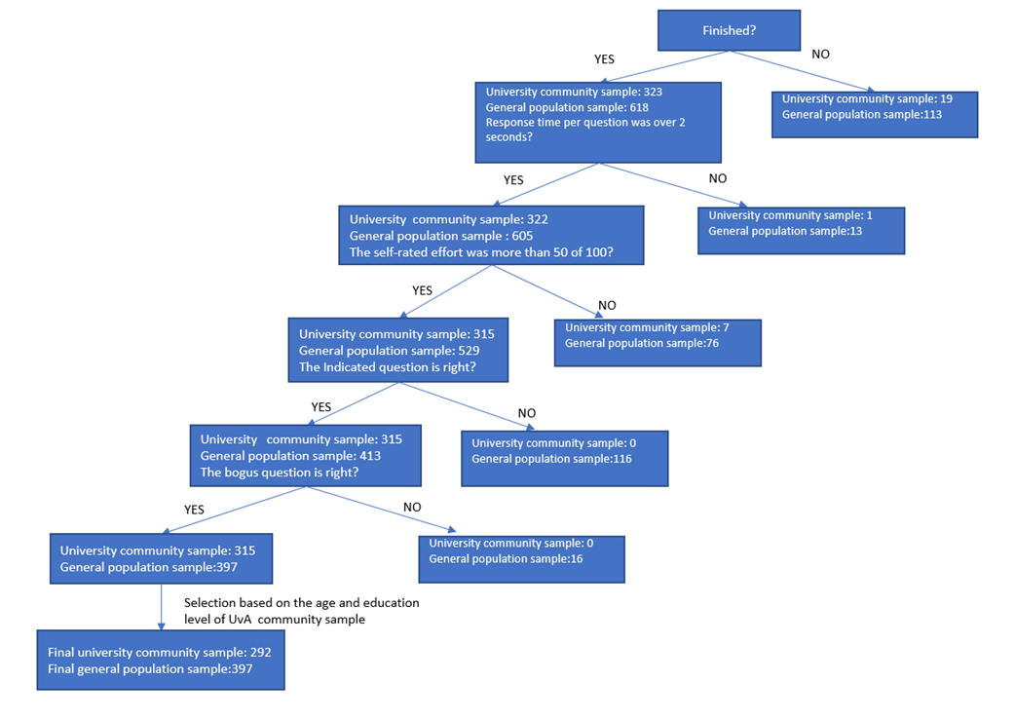
Table S4
Factor Loadings of the initial 24 items of SUPIQ based on EFA with the university community sample (N=292)
Final order | Initial order | Item | Factor 1-Craving | Factor 2-Tolerance | Factor 3-Social Conflicts | Factor 4-Coping | Factor 5-Risky Use | Factor 6-Withdrawal | Factor 7-Habitual Use
1 | 1 | I think about my smartphone when I am not using it. | .608
2 | 2 | I feel a strong urge to check my smartphone. | .627
3 | 3 | I feel empty even when I spend a lot of time on my smartphone. |  | .820
4 | 5 | I (almost) get into traffic accidents (e.g., when driving a car, when cycling, when walking, etc.) due to my smartphone use. |  |  |  |  | .822
5 | 7 | Using my smartphone makes me feel better when I feel bad (e.g., sad, anxious, insecure, lonely, etc.). |  |  |  | .871
6 | 10 | I feel anxious/nervous when there are internet connection problems (e.g., unstable connection, no connection, etc.) on my smartphone. |  |  |  |  |  | .862
7 | 15 | I continue using my smartphone after others ask me not to. |  |  | .537
8 | 16 | I tell lies about my smartphone use. |  |  | .863
9 | 19 | I have conflicts with others (e.g., family, partner, friend, etc.) due to my smartphone use. |  |  | .799
10 | 21 | I hide my smartphone use from others (e.g., family, partner, friend, etc.). |  |  | .794
11 | 22 | I feel angry when I do not have access to my smartphone (e.g., exams, out of battery, etc.). |  |  |  |  |  | .674
12 | 25 | I jeopardize important relationships (e.g., family, partner, friend, etc.) due to my smartphone use. |  |  | .749
13 | 26 | I can use my smartphone in traffic (e.g., driving a car, cycling, walking, etc.) without endangering myself or others. |  |  |  |  | .540
14 | 27 | I feel unsatisfied even when I spend a lot of time on my smartphone. |  | .555
15 | 29 | I use my smartphone in situations that could be physically dangerous (e.g., driving a car, cycling, crossing the road, operating heavy machinery, etc.). |  |  |  |  | .857
16 | 30 | I automatically open apps on my smartphone. |  |  |  |  |  |  | .906
17 | 31 | I automatically check my smartphone, even when I just checked it. |  |  |  |  |  |  | .693
18 | 42 | I feel angry when there are internet connection problems (e.g., unstable connection, no connection, etc.) on my smartphone. |  |  |  |  |  | .763
19 | 43 | I distract myself from negative feelings (e.g., sad, anxious, insecure, lonely, etc.) by using my smartphone. |  |  |  | .525
20 | 46 | I feel anxious/  nervous when I do not have access to my smartphone (e.g., exams, out of battery, etc.). |  |  |  |  |  | .795
21 | 48 | I automatically unlock my smartphone. |  |  |  |  |  |  | .875
22 | 53 | I still use my smartphone in traffic (e.g., driving a car, cycling, walking, etc.) even though I (almost) get into traffic accidents due to my smartphone use. |  |  |  |  | .861
23 | 55 | People around me tell me that I use my smartphone too much. |  |  | .689
24 | 57 | I check my smartphone when I am entertaining myself in other ways (e.g., watching movies, TV series, reading, etc.). |  |  |  |  |  |  | .569
Note. SUPIQ=The Smartphone Use Problems Identification Questionnaire. This version contains 24 items, 7 factors. Applied rotation method is oblimin in EFA. Only factor loadings >= .250 were listed in the table. The model fits were good: CFI = .991, TLI = .981, RMSEA = .036, SRMR = .032.

Table S5
Factor Loadings of the 27 items based on EFA with the university community sample (N=292)
Final order | Initial order | Item | Factor 1-Craving | Factor 2-Tolerance | Factor 3-Social Conflicts | Factor 4- Risky Use | Factor 5- Withdrawal | Factor 6- Habitual Use | Factor 7- Coping
1 | 1 | I think about my smartphone when I am not using it. | .608
2 | 2 | I feel a strong urge to check my smartphone. | .627
3 | 3 | I feel empty even when I spend a lot of time on my smartphone. |  | .860
4 | 5 | I (almost) get into traffic accidents (e.g., when driving a car, when cycling, when walking, etc.) due to my smartphone use. |  |  |  | .824
5 | 7 | Using my smartphone makes me feel better when I feel bad (e.g., sad, anxious, insecure, lonely, etc.). |  |  |  |  |  |  | .722
6 | 10 | I feel anxious/nervous when there are internet connection problems (e.g., unstable connection, no connection, etc.) on my smartphone. |  |  |  |  | .853
7 | 14 | I need to spend more and more time on my smartphone to satisfy myself. |  | .354 | .285
8 | 15 | I continue using my smartphone after others ask me not to. |  |  | .536
9 | 16 | I tell lies about my smartphone use. |  |  | .858
10 | 19 | I have conflicts with others (e.g., family, partner, friend, etc.) due to my smartphone use. |  |  | .795
11 | 20 | My smartphone is the solution to my boredom. |  |  |  |  |  | .309 | .373
12 | 21 | I hide my smartphone use from others (e.g., family, partner, friend, etc.). |  |  | .802
13 | 22 | I feel angry when I do not have access to my smartphone (e.g., exams, out of battery, etc.). |  |  |  |  | .658
14 | 25 | I jeopardize important relationships (e.g., family, partner, friend, etc.) due to my smartphone use. |  |  | .742
15 | 26 | I can use my smartphone in traffic (e.g., driving a car, cycling, walking, etc.) without endangering myself or others. |  |  |  | .536
16 | 27 | I feel unsatisfied even when I spend a lot of time on my smartphone. |  | .544
17 | 29 | I use my smartphone in situations that could be physically dangerous (e.g., driving a car, cycling, crossing the road, operating heavy machinery, etc.). |  |  |  | .855
18 | 30 | I automatically open apps on my smartphone. |  |  |  |  |  | .905
19 | 31 | I automatically check my smartphone, even when I just checked it. |  |  |  |  |  | .680
20 | 35 | I feel a strong need to be available via my smartphone. | .268 |  |  |  | .306 | .290
21 | 42 | I feel angry when there are internet connection problems (e.g., unstable connection, no connection, etc.) on my smartphone. |  |  |  |  | .760
22 | 43 | I distract myself from negative feelings (e.g., sad, anxious, insecure, lonely, etc.) by using my smartphone. |  |  |  |  |  |  | .648
23 | 46 | I feel anxious/  nervous when I do not have access to my smartphone (e.g., exams, out of battery, etc.). |  |  |  |  | .804
24 | 48 | I automatically unlock my smartphone. |  |  |  |  |  | .868
25 | 53 | I still use my smartphone in traffic (e.g., driving a car, cycling, walking, etc.) even though I (almost) get into traffic accidents due to my smartphone use. |  |  |  | .862
26 | 55 | People around me tell me that I use my smartphone too much. |  |  | .679
27 | 57 | I check my smartphone when I am entertaining myself in other ways (e.g., watching movies, TV series, reading, etc.). |  |  |  |  |  | .580
Note. SUPIQ=The Smartphone Use Problems Identification Questionnaire. This version contains 27 items, 7 factors after 3 items have been restored. Applied rotation method is oblimin in EFA. Only factor loadings >= .250 were listed in the table. The model fits were good: CFI = .991, TLI = .983, RMSEA = .032, SRMR = .031. The three restored items were marked in bold.
Table S6
Item-Total Correlations and Cronbach’s α of the 27 items version SUPIQ if single item gets deleted with the university community sample (N=292)
Factor | Final Order | Initial Order | Item | Item-Total Correlation | Corrected Item-Total Correlation | Cronbach’s α of the whole scale if the item got deleted | Cronbach’s α of the factor if the item got deleted
Craving
 | 1 | 1 | I think about my smartphone when I am not using it. | .54 | .51 | .89 | .67
 | 2 | 2 | I feel a strong urge to check my smartphone. | .68 | .65 | .89 | .54
 | 20 | 35 | I feel a strong need to be available via my smartphone. | .65 | .61 | .89 | .73
Coping
 | 5 | 7 | Using my smartphone makes me feel better when I feel bad (e.g., sad, anxious, insecure, lonely, etc.). | .38 | .32 | .89 | .61
 | 11 | 20 | My smartphone is the solution to my boredom. | .53 | .48 | .89 | .66
 | 22 | 43 | I distract myself from negative feelings (e.g., sad, anxious, insecure, lonely, etc.) by using my smartphone. | .63 | .59 | .89 | .45
Habitual Use
 | 18 | 30 | I automatically open apps on my smartphone. | .66 | .63 | .89 | .79
 | 19 | 31 | I automatically check my smartphone, even when I just checked it. | .73 | .69 | .89 | .80
 | 24 | 48 | I automatically unlock my smartphone. | .63 | .59 | .89 | .80
 | 27 | 57 | I check my smartphone when I am entertaining myself in other ways (e.g., watching movies, TV series, reading, etc.). | .56 | .50 | .89 | .86
Social Conflicts
 | 8 | 15 | I continue using my smartphone after others ask me not to. | .49 | .50 | .89 | .84
 | 9 | 16 | I tell lies about my smartphone use. | .54 | .60 | .89 | .79
 | 10 | 19 | I have conflicts with others (e.g., family, partner, friend, etc.) due to my smartphone use. | .48 | .53 | .89 | .81
 | 12 | 21 | I hide my smartphone use from others (e.g., family, partner, friend, etc.). | .46 | .51 | .89 | .83
 | 14 | 25 | I jeopardize important relationships (e.g., family, partner, friend, etc.) due to my smartphone use. | .35 | .40 | .89 | .84
 | 26 | 55 | People around me tell me that I use my smartphone too much. | .58 | .61 | .89 | .81
Risky Use
 | 4 | 5 | I (almost) get into traffic accidents (e.g., when driving a car, when cycling, when walking, etc.) due to my smartphone use. | .30 | .33 | .89 | .60
 | 15 | 26 | I can use my smartphone in traffic (e.g., driving a car, cycling, walking, etc.) without endangering myself or others. | .16 | .09 | .90 | .76
 | 17 | 29 | I use my smartphone in situations that could be physically dangerous (e.g., driving a car, cycling, crossing the road, operating heavy machinery, etc.). | .31 | .30 | .89 | .47
 | 25 | 53 | I still use my smartphone in traffic (e.g., driving a car, cycling, walking, etc.) even though I (almost) get into traffic accidents due to my smartphone use. | .31 | .34 | .89 | .55
Withdrawal
 | 6 | 10 | I feel anxious/nervous when there are internet connection problems (e.g., unstable connection, no connection, etc.) on my smartphone. | .57 | .52 | .89 | .79
 | 13 | 22 | I feel angry when I do not have access to my smartphone (e.g., exams, out of battery, etc.). | .62 | .63 | .89 | .80
 | 21 | 42 | I feel angry when there are internet connection problems (e.g., unstable connection, no connection, etc.) on my smartphone. | .56 | .52 | .89 | .80
 | 23 | 46 | I feel anxious/nervous when I do not have access to my smartphone (e.g., exams, out of battery, etc.). | .72 | .70 | .89 | .75
Tolerance
 | 3 | 3 | I feel empty even when I spend a lot of time on my smartphone. | .43 | .36 | .89 | .55
 | 7 | 14 | I need to spend more and more time on my smartphone to satisfy myself. | .65 | .48 | .89 | .66
 | 16 | 27 | I feel unsatisfied even when I spend a lot of time on my smartphone. | .49 | .63 | .89 | .56
Note. SUPIQ=The Smartphone Use Problems Identification Questionnaire. This version contains 27 items, 7 factors after 3 items have been restored. The Cronbach’s α values of the whole scale and the factors are as follows: the whole scale=.89, Craving=.73, Coping=.68, Habitual Use=.85, Social Conflicts=.85, Risky Use=.66, Withdrawal=.83, Tolerance=.69. Item-Total Correlation= correlation between the item and the total score from the scale, Corrected Item-Total Correlation= item-total correlation corrected for item overlap and scale reliability.
Table S7
Item-Total Correlations and Cronbach’s α of the 26 items version SUPIQ if single item gets deleted with the university community sample (N=292)
Factor | Final Order | Initial Order | Item | Item-Total Correlation | Corrected Item-Total Correlation | Cronbach’s α of the whole scale if the item got deleted | Cronbach’s α of the factor if the item got deleted
Craving
 | 1 | 1 | I think about my smartphone when I am not using it. | .55 | .51 | .90 | .67
 | 2 | 2 | I feel a strong urge to check my smartphone. | .68 | .65 | .89 | .54
 | 19 | 35 | I feel a strong need to be available via my smartphone. | .66 | .61 | .90 | .73
Coping
 | 5 | 7 | Using my smartphone makes me feel better when I feel bad (e.g., sad, anxious, insecure, lonely, etc.). | .38 | .32 | .90 | .61
 | 11 | 20 | My smartphone is the solution to my boredom. | .53 | .48 | .90 | .66
 | 21 | 43 | I distract myself from negative feelings (e.g., sad, anxious, insecure, lonely, etc.) by using my smartphone. | .63 | .59 | .90 | .45
Habitual Use
17 |  | 30 | I automatically open apps on my smartphone. | .66 | .62 | .90 | .79
18 |  | 31 | I automatically check my smartphone, even when I just checked it. | .73 | .69 | .89 | .80
23 |  | 48 | I automatically unlock my smartphone. | .64 | .59 | .90 | .80
26 |  | 57 | I check my smartphone when I am entertaining myself in other ways (e.g., watching movies, TV series, reading, etc.). | .57 | .50 | .90 | .86
Social Conflicts
 | 8 | 15 | I continue using my smartphone after others ask me not to. | .48 | .50 | .90 | .84
 | 9 | 16 | I tell lies about my smartphone use. | .55 | .60 | .90 | .79
 | 10 | 19 | I have conflicts with others (e.g., family, partner, friend, etc.) due to my smartphone use. | .48 | .54 | .90 | .81
 | 12 | 21 | I hide my smartphone use from others (e.g., family, partner, friend, etc.). | .47 | .51 | .90 | .83
 | 14 | 25 | I jeopardize important relationships (e.g., family, partner, friend, etc.) due to my smartphone use. | .36 | .40 | .90 | .84
 | 25 | 55 | People around me tell me that I use my smartphone too much. | .59 | .62 | .90 | .81
Risky Use
 | 4 | 5 | I (almost) get into traffic accidents (e.g., when driving a car, when cycling, when walking, etc.) due to my smartphone use. | .29 | .33 | .90 | .68
 | 16 | 29 | I use my smartphone in situations that could be physically dangerous (e.g., driving a car, cycling, crossing the road, operating heavy machinery, etc.). | .27 | .27 | .90 | .77
 | 24 | 53 | I still use my smartphone in traffic (e.g., driving a car, cycling, walking, etc.) even though I (almost) get into traffic accidents due to my smartphone use. | .29 | .33 | .90 | .61
Withdrawal
 | 6 | 10 | I feel anxious/nervous when there are internet connection problems (e.g., unstable connection, no connection, etc.) on my smartphone. | .57 | .52 | .90 | .79
 | 13 | 22 | I feel angry when I do not have access to my smartphone (e.g., exams, out of battery, etc.). | .62 | .63 | .90 | .80
 | 20 | 42 | I feel angry when there are internet connection problems (e.g., unstable connection, no connection, etc.) on my smartphone. | .56 | .53 | .90 | .80
 | 22 | 46 | I feel anxious/nervous when I do not have access to my smartphone (e.g., exams, out of battery, etc.). | .72 | .71 | .89 | .75
Tolerance
 | 3 | 3 | I feel empty even when I spend a lot of time on my smartphone. | .43 | .36 | .90 | .55
 | 7 | 14 | I need to spend more and more time on my smartphone to satisfy myself. | .66 | .64 | .90 | .66
 | 15 | 27 | I feel unsatisfied even when I spend a lot of time on my smartphone. | .52 | .47 | .90 | .56
Note. SUPIQ=The Smartphone Use Problems Identification Questionnaire. This version contains 27 items, 7 factors after 3 items have been restored. The Cronbach’s α values of the whole scale and the factors are as follows: the whole scale=.89, Craving=.73, Coping=.68, Habitual Use=.85, Social Conflicts=.85, Risky Use=.76, Withdrawal=.83, Tolerance=.69. Item-Total Correlation= correlation between the item and the total score from the scale, Corrected Item-Total Correlation= item-total correlation corrected for item overlap and scale reliability.

Figure S8. The Parallel Analysis Results and Scree Plot with the university community sample (N=292)
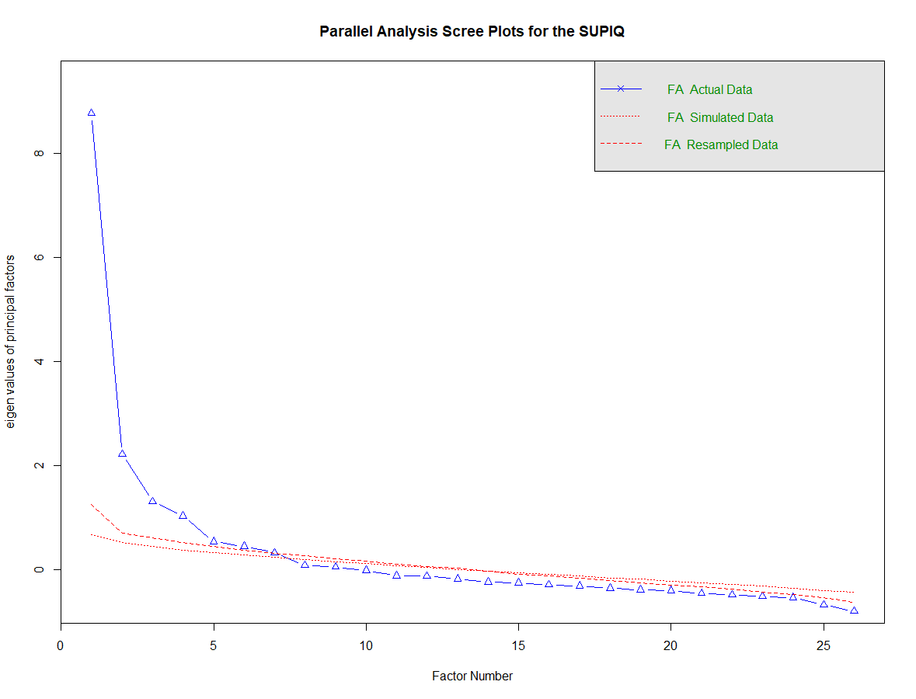

Table S9. The Cronbach’s α of the three factors if the restored three item gets deleted with the university community sample (N=292)
Factor | Final Order | Initial Order | Item | Cronbach’s α of the factor | Cronbach’s α of the factor if the item got deleted
Craving
 | 19 | 35 | I feel a strong need to be available via my smartphone. | .73 | .73
Coping
 | 11 | 20 | My smartphone is the solution to my boredom. | .68 | .66
Tolerance
 | 7 | 14 | I need to spend more and more time on my smartphone to satisfy myself. | .69 | .66

Figure S10
The network for the SUPIQ items with the university community sample (N=292)

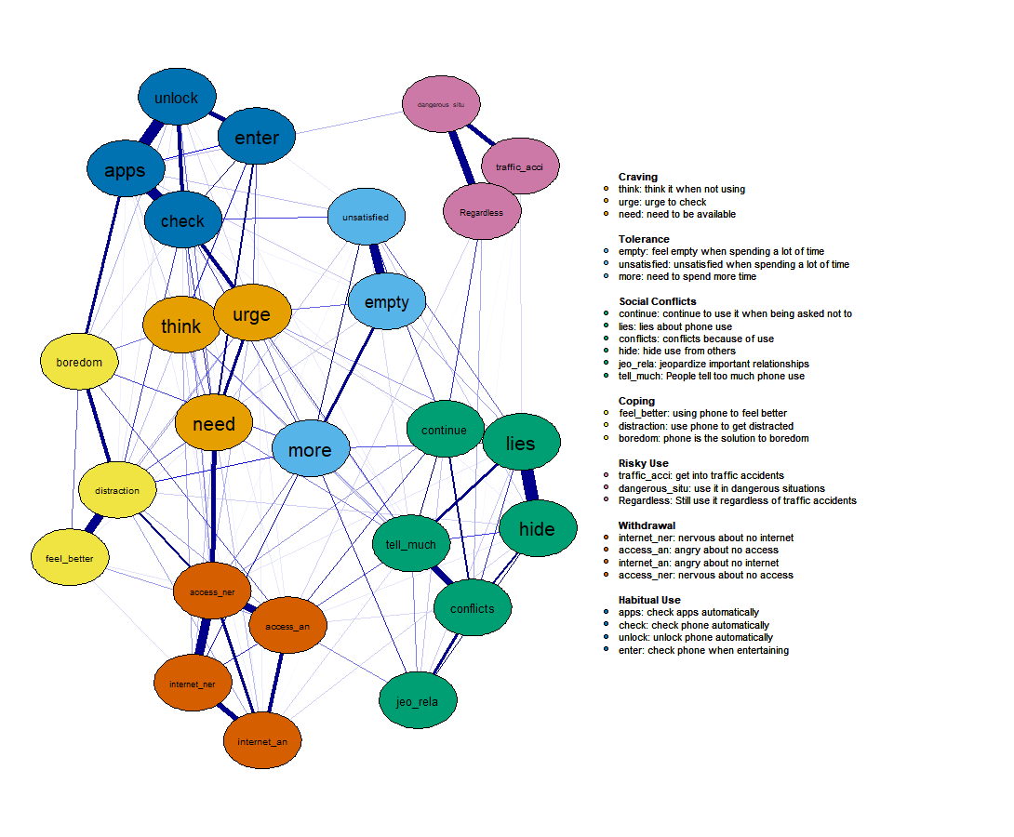
Figure S11
The centrality indices of the network for the SUPIQ items with the university community sample (N=292)
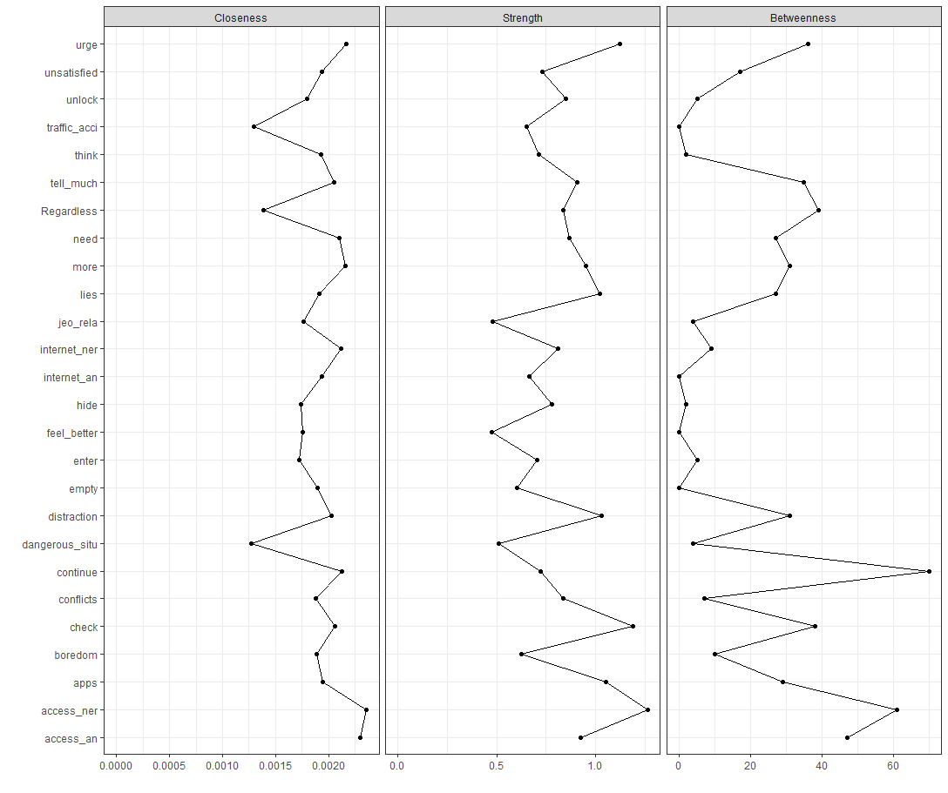
Figure S12
The bridge centrality indices of the network for the SUPIQ items with the university community sample (N=292)
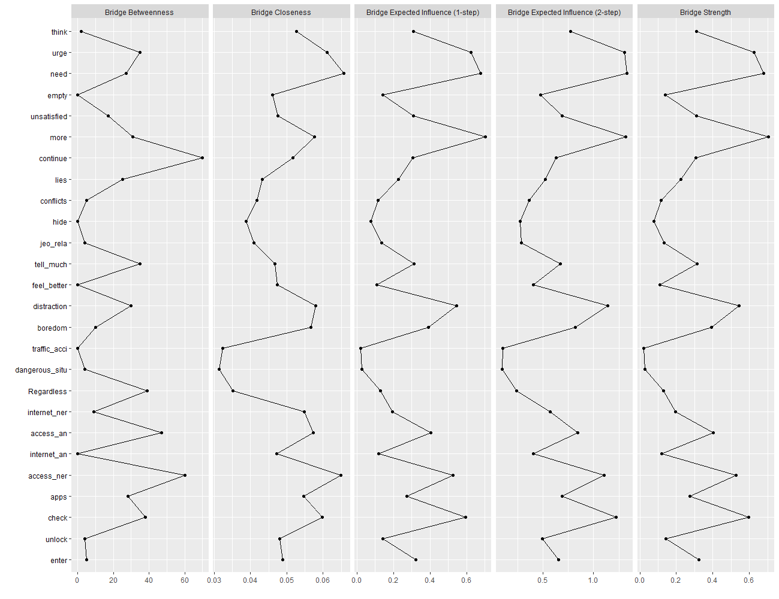

Table S13
Standardized Factor Loadings of the 26 items of the SUPIQ based on the CFA with the general population sample (N=397)
Final order | Initial order | Item | Factor 1-Craving | Factor 2-Tolerance | Factor 3-Social Conflicts | Factor 4- Risky Use | Factor 5- Withdrawal | Factor 6- Habitual Use | Factor 7- Coping
1 | 1 | I think about my smartphone when I am not using it. | .772
2 | 2 | I feel a strong urge to check my smartphone. | .595
3 | 3 | I feel empty even when I spend a lot of time on my smartphone. |  | .635
4 | 5 | I (almost) get into traffic accidents (e.g., when driving a car, when cycling, when walking, etc.) due to my smartphone use. |  |  |  | .863
5 | 7 | Using my smartphone makes me feel better when I feel bad (e.g., sad, anxious, insecure, lonely, etc.). |  |  |  |  |  |  | .713
6 | 10 | I feel anxious/nervous when there are internet connection problems (e.g., unstable connection, no connection, etc.) on my smartphone. |  |  |  |  | .721
7 | 14 | I need to spend more and more time on my smartphone to satisfy myself. |  | .773
8 | 15 | I continue using my smartphone after others ask me not to. |  |  | .836
9 | 16 | I tell lies about my smartphone use. |  |  | .885
10 | 19 | I have conflicts with others (e.g., family, partner, friend, etc.) due to my smartphone use. |  |  | .871
11 | 20 | My smartphone is the solution to my boredom. |  |  |  |  |  |  | .705
12 | 21 | I hide my smartphone use from others (e.g., family, partner, friend, etc.). |  |  | .785
13 | 22 | I feel angry when I do not have access to my smartphone (e.g., exams, out of battery, etc.). |  |  |  |  | .869
14 | 25 | I jeopardize important relationships (e.g., family, partner, friend, etc.) due to my smartphone use. |  |  | .859
15 | 27 | I feel unsatisfied even when I spend a lot of time on my smartphone. |  | .630
16 | 29 | I use my smartphone in situations that could be physically dangerous (e.g., driving a car, cycling, crossing the road, operating heavy machinery, etc.). |  |  |  | .807
17 | 30 | I automatically open apps on my smartphone. |  |  |  |  |  | .740
18 | 31 | I automatically check my smartphone, even when I just checked it. |  |  |  |  |  | .768
19 | 35 | I feel a strong need to be available via my smartphone. | .680
20 | 42 | I feel angry when there are internet connection problems (e.g., unstable connection, no connection, etc.) on my smartphone. |  |  |  |  | .682
21 | 43 | I distract myself from negative feelings (e.g., sad, anxious, insecure, lonely, etc.) by using my smartphone. |  |  |  |  |  |  | .661
22 | 46 | I feel anxious/  nervous when I do not have access to my smartphone (e.g., exams, out of battery, etc.). |  |  |  |  | .772
23 | 48 | I automatically unlock my smartphone. |  |  |  |  |  | .710
24 | 53 | I still use my smartphone in traffic (e.g., driving a car, cycling, walking, etc.) even though I (almost) get into traffic accidents due to my smartphone use. |  |  |  | .824
25 | 55 | People around me tell me that I use my smartphone too much. |  |  | 768
26 | 57 | I check my smartphone when I am entertaining myself in other ways (e.g., watching movies, TV series, reading, etc.). |  |  |  |  |  | .554
Note. SUPIQ=The Smartphone Use Problems Identification Questionnaire. This version contains 26 items, 7 factors. Applied estimation method is weighted least squares estimation.
Table S14
Standardized Correlations between factors of the SUPIQ based on the CFA with the general population sample (N=397)
Factors | Factor 1-Craving | Factor 2-Tolerance | Factor 3-Social Conflicts | Factor 4- Risky Use | Factor 5- Withdrawal | Factor 6- Habitual Use | Factor 7- Coping
Factor 1-Craving | 1
Factor 2-Tolerance | .846 | 1
Factor 3-Social Conflicts | .632 | .875 | 1
Factor 4- Risky Use | .494 | .803 | .943 | 1
Factor 5- Withdrawal | .845 | .903 | .846 | .733 | 1
Factor 6- Habitual Use | .886 | .797 | .507 | .475 | .733 | 1
Factor 7- Coping | .850 | .917 | .698 | .621 | .797 | .906 | 1
Note. SUPIQ=The Smartphone Use Problems Identification Questionnaire. This version contains 26 items, 7 factors. Applied estimation method is weighted least squares estimation. All the correlation coefficients are significant at .001 level.

Figure S15
Stability test with bootstrapping (nboots=2000) for network modeling (Fig 1.) with the university community sample (N=292)
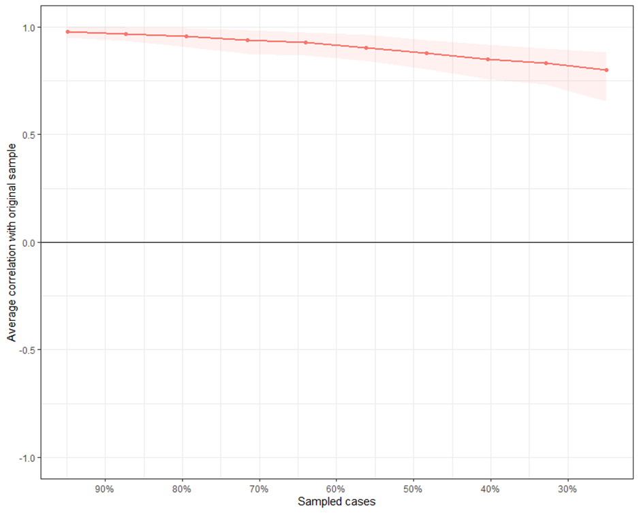
Figure S16. The centrality indices for the network modeling (Fig 1.) with the university community sample (N=292)
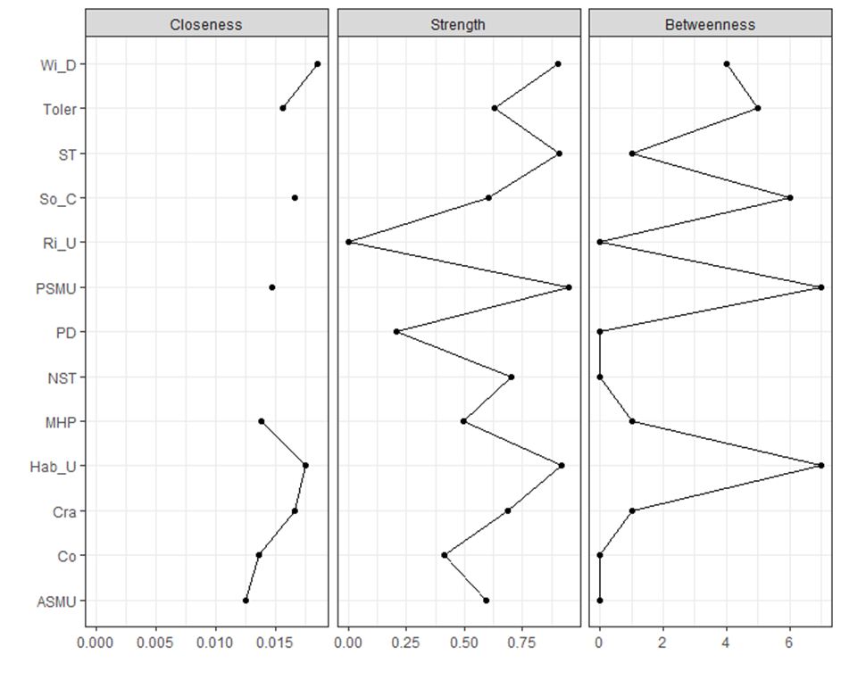

Figure S17. The bridge centrality indices for the network modeling (Fig 1.) with the university community sample (N=292)
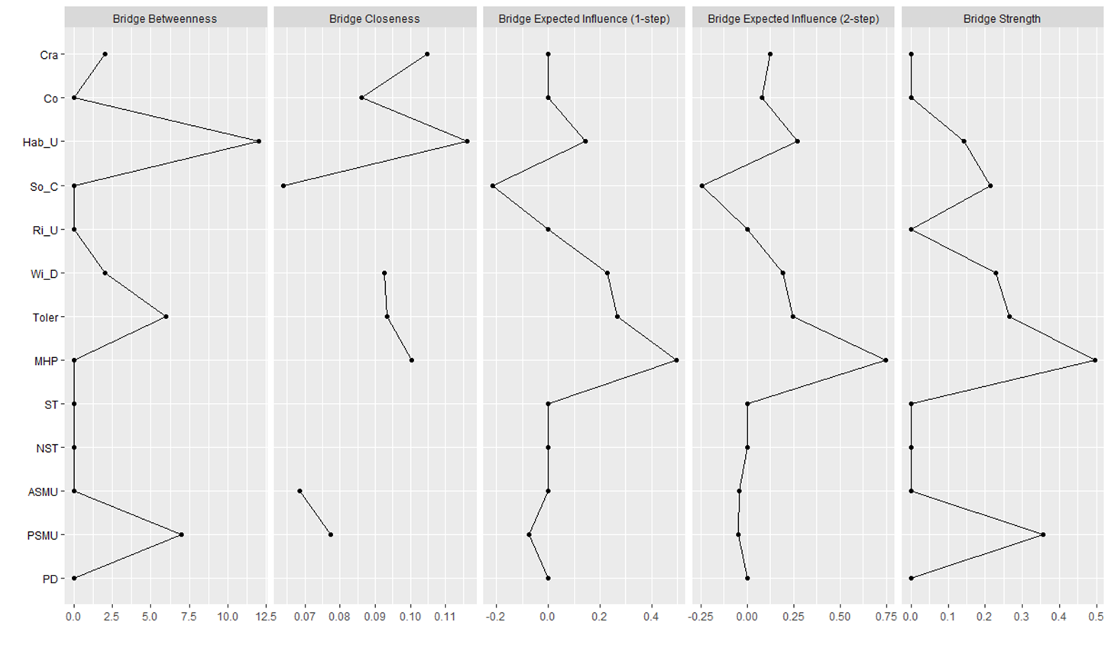
Figure S18. The estimation of significant differences between edge weights and bootstrapped (nboots=100) confidence intervals of edge weights for the network modeling (Fig 1.) with the university community sample (N=292)
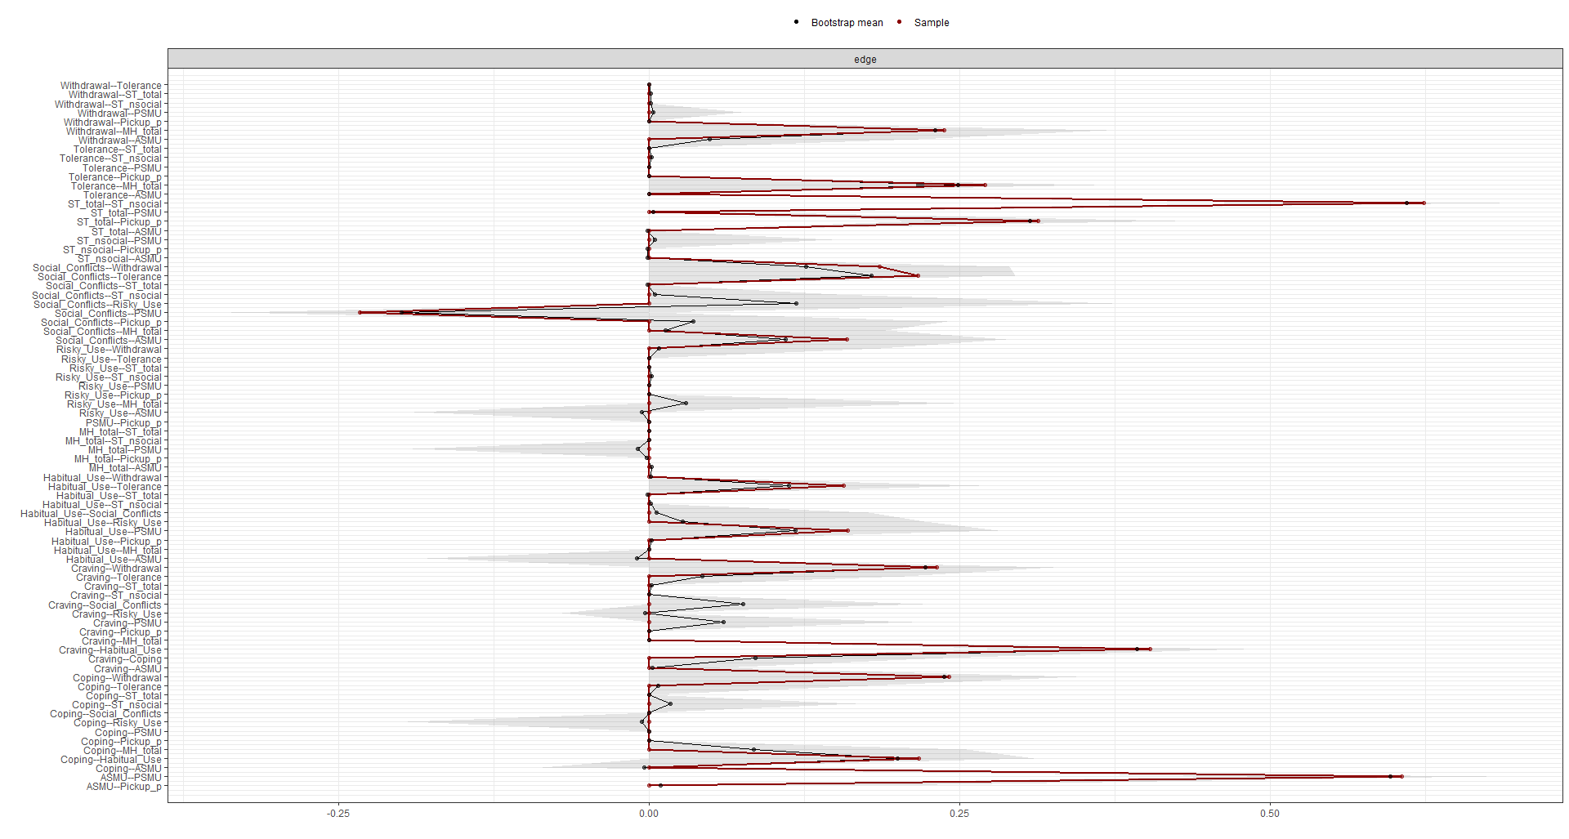
Figure S19. Stability test with bootstrapping (nboots=2000) for network modeling with students sample (Fig 2.) with the general population sample (N=397)
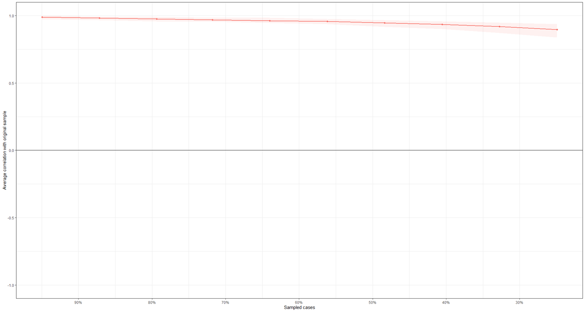

Figure S20. The centrality indices for the network modeling (Fig 2.) with the general population sample (N=397)
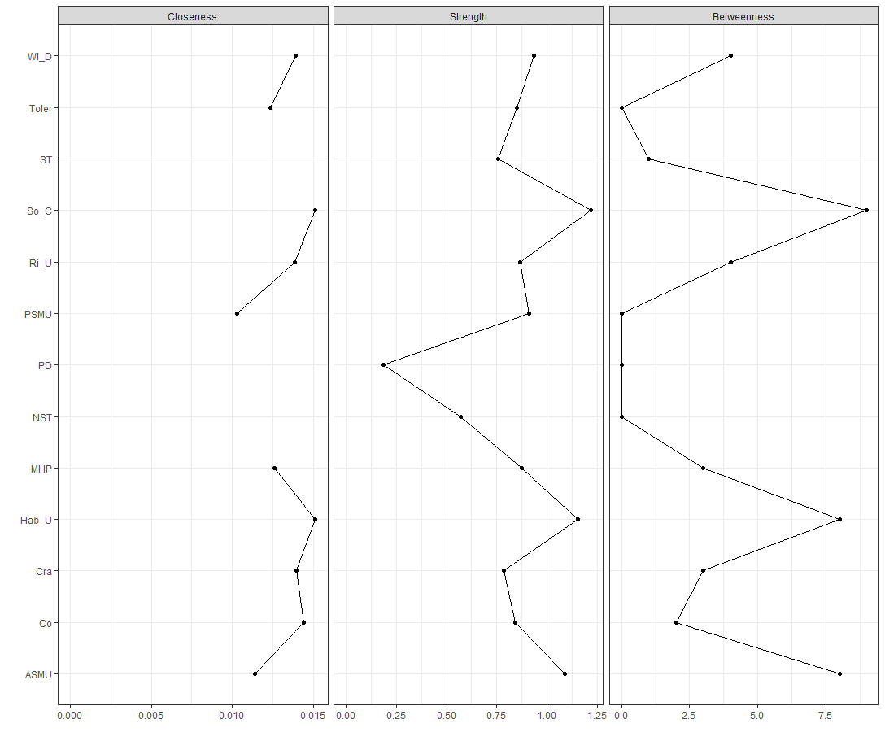
Figure S21. The bridge centrality indices for the network modeling (Fig 2.) with the general population sample (N=397)
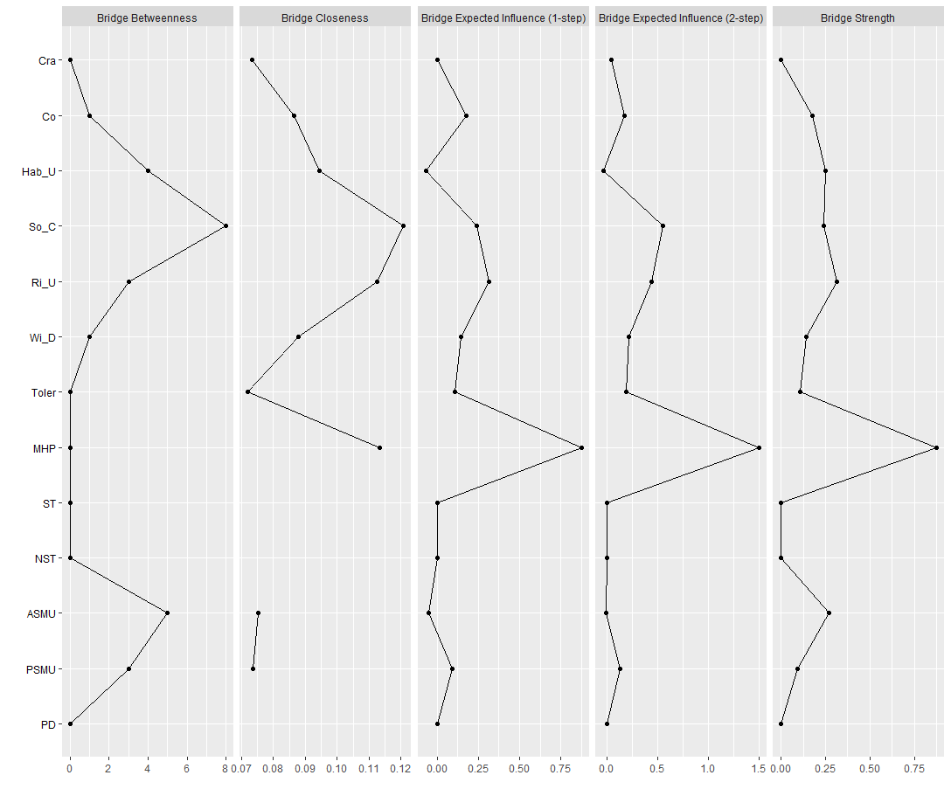
Figure S22. The estimation of significant differences between edge weights and bootstrapped (nboots=100) confidence intervals of edge weights for the network modeling (Fig 2.) with the general population sample (N=397)
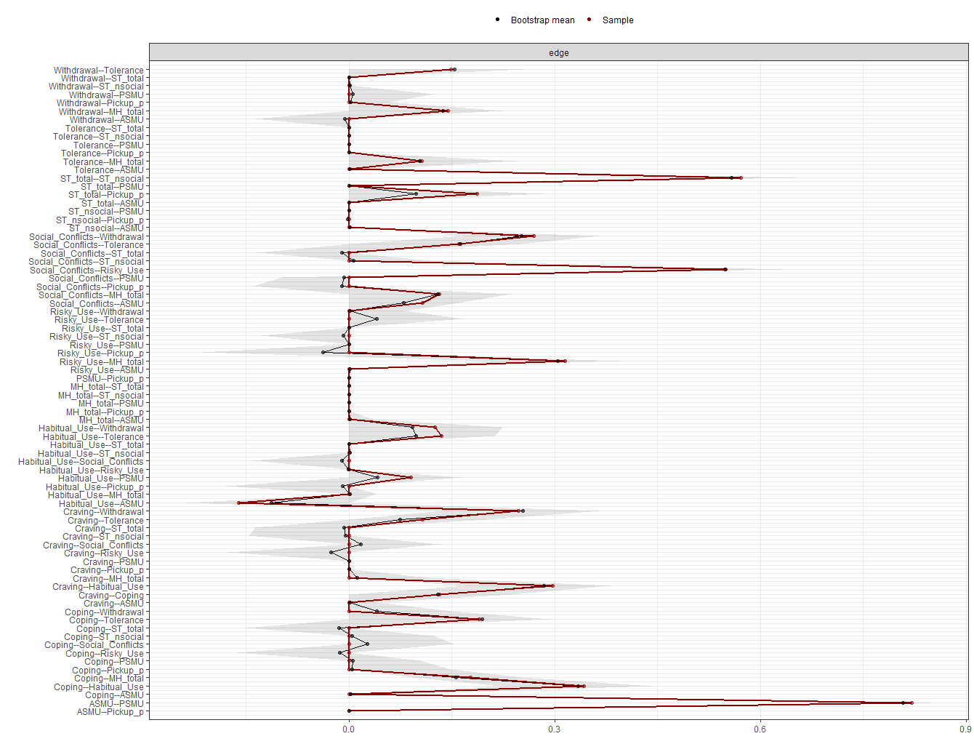
References
Agus, M., Mascia, M. L., Bonfiglio, N. S., & Penna, M. P. (2022). The Italian version of the mobile phone problematic use scale for adults (MPPUS): A validation study. Heliyon, 8(12), e12209. https://doi.org/10.1016/j.heliyon.2022.e12209
Akın, A., Altundağ, Y., Turan, M. E., & Akın, U. (2014). The Validity and Reliability of the Turkish Version of the Smart Phone Addiction Scale-short Form for Adolescent. Procedia - Social and Behavioral Sciences, 152, 74–77. https://doi.org/10.1016/j.sbspro.2014.09.157
Al-Barashdi, H. S., Bouazza, A., & Al Zubaidi, A. (2014). Psychometric properties of smartphone addiction questionnaire (SPAQ) among sultan qaboos university undergraduate. Journal of Educational and Psychological Studies-Sultan Qaboos University (Pages 637-644), 8(4).
Aljomaa, S. S., Mohammad, M. F., Albursan, I. S., Bakhiet, S. F., & Abduljabbar, A. S. (2016). Smartphone addiction among university students in the light of some variables. Computers in Human Behavior, 61, 155–164. https://doi.org/10.1016/j.chb.2016.03.041
Altamimi, T. N., Alex, J., Khan, M. M., & Nair, B. V. S. (2020). Development and validation of a Smartphone Impact Scale among healthcare professionals. Journal of Taibah University Medical Sciences, 15(5), 387–397. https://doi.org/10.1016/j.jtumed.2020.05.009
American Psychiatric Association. (2013). Diagnostic and statistical manual of mental disorders: DSM-5. American Psychological Association.
Andrade, A. L. M., Spritzer, D. T., Scatena, A., de Oliveira Pinheiro, B., da Silva, G. T., Kim, H. S., Breda, V., de Oliveira, W. A., & De Micheli, D. (2022). Psychometric properties of the Smartphone Addiction Inventory-Short Form (SPAI-SF) in Brazilian adolescents. Psychiatry Research, 115001.
Basu, S., Garg, S., Singh, M. M., & Kohli, C. (2018). Addiction-like Behavior Associated with Mobile Phone Usage among Medical Students in Delhi. Indian Journal of Psychological Medicine, 40(5), 446–451. https://doi.org/10.4103/IJPSYM.IJPSYM_59_18
Bianchi, A., & Phillips, J. G. (2005). Psychological Predictors of Problem Mobile Phone Use. CyberPsychology & Behavior, 8(1), 39–51. https://doi.org/10.1089/cpb.2005.8.39
Billieux, J., der Linden, M., & Rochat, L. (2008). The role of impulsivity in actual and problematic use of the mobile phone. Applied Cognitive Psychology: The Official Journal of the Society for Applied Research in Memory and Cognition, 22(9), 1195–1210.
Billieux, J., Van der Linden, M., d’Acremont, M., Ceschi, G., & Zermatten, A. (2007). Does impulsivity relate to perceived dependence on and actual use of the mobile phone? Applied Cognitive Psychology, 21(4), 527–537. https://doi.org/10.1002/acp.1289
Brown, R. I. F. (1986). Arousal and sensation-seeking components in the general explanation of gambling and gambling addictions. International Journal of the Addictions, 21(9–10), 1001–1016.
Brown, R. I. F. (1993). Some contributions of the study of gambling to the study of other addictions. Gambling Behavior and Problem Gambling, 1, 241–272.
Brown, R. I. F. (1997). A theoretical model of the behavioural addictions–applied to offending. Addicted to Crime, 13–65.
Casale, S., Caponi, L., & Fioravanti, G. (2020). Metacognitions about problematic Smartphone use: Development of a self-report measure. Addictive Behaviors, 109(April), 106484. https://doi.org/10.1016/j.addbeh.2020.106484
Chen, S. H., Weng, L. J., Su, Y. J., Wu, H. M., & Yang, P. F. (2003). Development of a Chinese Internet addiction scale and its psychometric study. Chinese Journal of Psychology.
Cheung, T., Lee, R. L. T., Tse, A. C. Y., Do, C. W., So, B. C. L., Szeto, G. P. Y., & Lee, P. H. (2019). Psychometric Properties and Demographic Correlates of the Smartphone Addiction Scale-Short Version among Chinese Children and Adolescents in Hong Kong. Cyberpsychology, Behavior, and Social Networking, 22(11), 714–723. https://doi.org/10.1089/cyber.2019.0325
Ching, S. M., Yee, A., Ramachandran, V., Lim, S. M. S., Sulaiman, W. A. W., Foo, Y. L., & Hoo, F. K. (2015). Validation of a Malay version of the smartphone addiction scale among medical students in Malaysia. PLoS ONE, 10(10), 1–11. https://doi.org/10.1371/journal.pone.0139337
Cho, S., & Lee, E. (2015). Development of a Brief Instrument to Measure Smartphone Addiction among Nursing Students. CIN - Computers Informatics Nursing, 33(5), 216–224. https://doi.org/10.1097/CIN.0000000000000132
Choliz, M. (2012). Mobile-phone addiction in adolescence: The test of mobile phone dependence (TMD). Progress in Health Sciences, 2(1), 33–44.
Chóliz, M., Pinto, L., Phansalkar, S. S., Corr, E., Mujjahid, A., Flores, C., & Barrientos, P. E. (2016). Development of a Brief Multicultural Version of the Test of Mobile Phone Dependence (TMDbrief) Questionnaire. Frontiers in Psychology, 7. https://doi.org/10.3389/fpsyg.2016.00650
Csibi, S., Demetrovics, Z., & Szabó, A. (2016). Development and psychometric validation of the Brief Smartphone Addiction Scale (BSAS) with schoolchidren. Psychiatria Hungarica: A Magyar Pszichiatriai Tarsasag Tudomanyos Folyoirata, 31(1), 71–77.
Csibi, S., Griffiths, M. D., Cook, B., Demetrovics, Z., & Szabo, A. (2018). The Psychometric Properties of the Smartphone Application-Based Addiction Scale (SABAS). International Journal of Mental Health and Addiction, 16(2), 393–403. https://doi.org/10.1007/s11469-017-9787-2
De-Sola, J., Talledo, H., Rubio, G., & de Fonseca, F. R. (2017). Development of a mobile phone addiction craving scale and its validation in a Spanish adult population. Frontiers in Psychiatry, 8, 90.
Ding, J. E., Liu, W., Wang, X., Lan, Y., Hu, D., Xu, Y., Li, J., & Fu, H. (2019). Development Of A Smartphone Overuse Classification Scale. Addiction Research and Theory, 27(2), 150–155. https://doi.org/10.1080/16066359.2018.1474204
Eide, T. A., Aarestad, S. H., Andreassen, C. S., Bilder, R. M., & Pallesen, S. (2018). Smartphone restriction and its effect on subjective withdrawal related scores. Frontiers in Psychology, 9(AUG), 1–11. https://doi.org/10.3389/fpsyg.2018.01444
Etter, J. F. (2005). A self-administered questionnaire to measure cigarette withdrawal symptoms: The Cigarette Withdrawal Scale. Nicotine and Tobacco Research, 7(1), 47–57. https://doi.org/10.1080/14622200412331328501
Ferri-García, R., & Olivencia-Carrión, M. A. (2019). Reliability and construct validity testing of a questionnaire to assess nomophobia (QANP) Fiabilidad y validez del cuestionario para evaluar la nomofobia (QANP). 14.
Fidan, H. (2016). Development and validation of the mobile addiction scale: The components model approach. Addicta: The Turkish Journal on Addictions, 3(3), 452–469.
Foerster, M., Roser, K., Schoeni, A., & Röösli, M. (2015). Problematic mobile phone use in adolescents: Derivation of a short scale MPPUS-10. International Journal of Public Health, 60(2), 277–286.
Gao, Y., Dai, H., Jia, G., Liang, C., Tong, T., Zhang, Z., Song, R., Wang, Q., & Zhu, Y. (2020). Translation of the Chinese version of the Nomophobia Questionnaire and its validation among college students: Factor analysis. JMIR MHealth and UHealth, 8(3), 1–12. https://doi.org/10.2196/13561
Golino, H., Shi, D., Christensen, A. P., Garrido, L. E., Nieto, M. D., Sadana, R., Thiyagarajan, J. A., & Martinez-Molina, A. (2020). Investigating the performance of exploratory graph analysis and traditional techniques to identify the number of latent factors: A simulation and tutorial. Psychological Methods, 25(3), 292–320. https://doi.org/10.1037/met0000255
Goodman, A. (1990). Addiction: Definition and implications. British Journal of Addiction, 85(11), 1403–1408.
Griffiths, M. (1995). Technological addictions. 14–14.
Griffiths, M. (2005). A “components” model of addiction within a biopsychosocial framework. Journal of Substance Use, 10(4), 191–197. https://doi.org/10.1080/14659890500114359
Güzeller, C. O., & Coşguner, T. (2012). Development of a problematic mobile phone use scale for Turkish adolescents. Cyberpsychology, Behavior, and Social Networking, 15(4), 205–211.
Ha, J. H., Chin, B., Park, D.-H., Ryu, S.-H., & Yu, J. (2008). Characteristics of excessive cellular phone use in Korean adolescents. CyberPsychology & Behavior, 11(6), 783–784.
Hamamura, T., Kobayashi, N., Oka, T., Kawashima, I., Sakai, Y., Tanaka, S. C., & Honjo, M. (2023). Validity, reliability, and correlates of the Smartphone Addiction Scale–Short Version among Japanese adults. BMC Psychology, 11(1), 78. https://doi.org/10.1186/s40359-023-01095-5
Hong, F.-Y., Chiu, S.-I., & Huang, D.-H. (2012). A model of the relationship between psychological characteristics, mobile phone addiction and use of mobile phones by Taiwanese university female students. Computers in Human Behavior, 28(6), 2152–2159. https://doi.org/10.1016/j.chb.2012.06.020
Hussain, Z., Griffiths, M. D., & Sheffield, D. (2017). An investigation into problematic smartphone use: The role of narcissism, anxiety, and personality factors. Journal of Behavioral Addictions, 6(3), 378–386. https://doi.org/10.1556/2006.6.2017.052
Jenaro, C., Flores, N., Gómez-Vela, M., González-Gil, F., & Caballo, C. (2007). Problematic internet and cell-phone use: Psychological, behavioral, and health correlates. Addiction Research & Theory, 15(3), 309–320. https://doi.org/10.1080/16066350701350247
Khalily, M. T., Saleem, T., Bhatti, M. M., Ahmad, I., & Hussain, B. (2019). An urdu adaptation of smartphone addiction scale-short version (SAS-SV). Journal of the Pakistan Medical Association, 69(5), 700–704.
Khoury, J. M., De Freitas, A. A. C., Roque, M. A. V., Albuquerque, M. R., Das Neves, M. D. C. L., & Garcia, F. D. (2017). Assessment of the accuracy of a new tool for the screening of smartphone addiction. PLoS ONE, 12(5), 1–13. https://doi.org/10.1371/journal.pone.0176924
Kim, D., Chung, Y., Lee, E., Kim, D., & Cho, Y. (2008). Development of internet addiction proneness scale-short form (KS scale). The Korea Journal of Counseling, 9(4), 1703–1722.
Kim, D., Lee, Y., Lee, J., Nam, J. E. K., & Chung, Y. (2014). Development of Korean Smartphone Addiction Proneness Scale for youth. PLoS ONE, 9(5), 1–8. https://doi.org/10.1371/journal.pone.0097920
Koo, H. Y. (2009). Development of a cell phone addiction scale for Korean adolescents. Journal of Korean Academy of Nursing, 39(6), 818–828.
Kuss, D., Harkin, L., Kanjo, E., & Billieux, J. (2018). Problematic Smartphone Use: Investigating Contemporary Experiences Using a Convergent Design. International Journal of Environmental Research and Public Health, 15(1), 142. https://doi.org/10.3390/ijerph15010142
Kwon, M., Kim, D. J., Cho, H., & Yang, S. (2013). The smartphone addiction scale: Development and validation of a short version for adolescents. PLoS ONE, 8(12), 1–7. https://doi.org/10.1371/journal.pone.0083558
Kwon, M., Lee, J. Y., Won, W. Y., Park, J. W., Min, J. A., Hahn, C., Gu, X., Choi, J. H., & Kim, D. J. (2013). Development and Validation of a Smartphone Addiction Scale (SAS). PLoS ONE, 8(2). https://doi.org/10.1371/journal.pone.0056936
Lee, H.-K., Kim, J.-H., Fava, M., Mischoulon, D., Park, J.-H., Shim, E.-J., Lee, E.-H., Lee, J. H., & Jeon, H. J. (2017). Development and validation study of the Smartphone Overuse Screening Questionnaire. Psychiatry Research, 257, 352–357. https://doi.org/10.1016/j.psychres.2017.07.074
Leung, L. (2008). Leisure boredom, sensation seeking, self-esteem, and addiction: Symptoms and patterns of cell phone use. In Mediated interpersonal communication (pp. 373–396). Routledge.
Lin, Y. H., Chang, L. R., Lee, Y. H., Tseng, H. W., Kuo, T. B. J., & Chen, S. H. (2014). Development and validation of the Smartphone Addiction Inventory (SPAI). PLoS ONE, 9(6). https://doi.org/10.1371/journal.pone.0098312
Lin, Y. H., Pan, Y. C., Lin, S. H., & Chen, S. H. (2017). Development of short-form and screening cutoff point of the Smartphone Addiction Inventory (SPAI-SF). International Journal of Methods in Psychiatric Research, 26(2). https://doi.org/10.1002/mpr.1525
Lopez-Fernandez, O. (2017). Short version of the Smartphone Addiction Scale adapted to Spanish and French: Towards a cross-cultural research in problematic mobile phone use. Addictive Behaviors, 64, 275–280. https://doi.org/10.1016/j.addbeh.2015.11.013
Lopez-Fernandez, O., Honrubia-Serrano, L., Freixa-Blanxart, M., & Gibson, W. (2014). Prevalence of Problematic Mobile Phone Use in British Adolescents. Cyberpsychology, Behavior, and Social Networking, 17(2), 91–98. https://doi.org/10.1089/cyber.2012.0260
Lopez-Fernandez, O., Kuss, D. J., Pontes, H. M., Griffiths, M. D., Dawes, C., Justice, L. V., Männikkö, N., Kääriäinen, M., Rumpf, H.-J., Bischof, A., Gässler, A.-K., Romo, L., Kern, L., Morvan, Y., Rousseau, A., Graziani, P., Demetrovics, Z., Király, O., Schimmenti, A., … Billieux, J. (2018). Measurement Invariance of the Short Version of the Problematic Mobile Phone Use Questionnaire (PMPUQ-SV) across Eight Languages. International Journal of Environmental Research and Public Health, 15(6), 1213. https://doi.org/10.3390/ijerph15061213
Luk, T. T., Wang, M. P., Shen, C., Wan, A., Chau, P. H., Oliffe, J., Viswanath, K., Chan, S. S., & Lam, T. H. (2018). Short version of the Smartphone Addiction Scale in Chinese adults: Psychometric properties, sociodemographic, and health behavioral correlates. Journal of Behavioral Addictions, 7(4), 1157–1165. https://doi.org/10.1556/2006.7.2018.105
Martinotti, G., Villella, C., Di Thiene, D., Di Nicola, M., Bria, P., Conte, G., Cassano, M., Petruccelli, F., Corvasce, N., Janiri, L., & La Torre, G. (2011). Problematic mobile phone use in adolescence: A cross-sectional study. Journal of Public Health, 19(6), 545–551. https://doi.org/10.1007/s10389-011-0422-6
Merlo, L. J., Stone, A. M., & Bibbey, A. (2013). Measuring problematic mobile phone use: Development and preliminary psychometric properties of the PUMP scale. Journal of Addiction, 2013.
Olivencia-Carrión, M. A., Ramírez-Uclés, I., Holgado-Tello, P., & López-Torrecillas, F. (2018). Validation of a Spanish Questionnaire on Mobile Phone Abuse. Frontiers in Psychology, 9, 621. https://doi.org/10.3389/fpsyg.2018.00621
Pamuk, M., & Atli, A. (2016). Development of a Problematic Mobile Phone Use Scale for university students: Validity and reliability study. Dusunen Adam The Journal of Psychiatry and Neurological Sciences, 29(1), 49.
Pavia, L., Cavani, P., Di Blasi, M., & Giordano, C. (2016). Smartphone Addiction Inventory (SPAI): Psychometric properties and confirmatory factor analysis. Computers in Human Behavior, 63, 170–178. https://doi.org/10.1016/j.chb.2016.05.039
Pontes, H. M., & Griffiths, M. D. (2014). Assessment of internet gaming disorder in clinical research: Past and present perspectives. Clinical Research and Regulatory Affairs, 31(2–4), 35–48.
Pontes, H. M., & Griffiths, M. D. (2015). Measuring DSM-5 internet gaming disorder: Development and validation of a short psychometric scale. Computers in Human Behavior, 45, 137–143. https://doi.org/10.1016/j.chb.2014.12.006
Roberts, J., Yaya, L., & Manolis, C. (2014). The invisible addiction: Cell-phone activities and addiction among male and female college students. Journal of Behavioral Addictions, 3(4), 254–265.
Rozgonjuk, D., Rosenvald, V., Janno, S., & Täht, K. (2016). Developing a shorter version of the Estonian smartphone addiction proneness scale (E-SAPS18). Cyberpsychology: Journal of Psychosocial Research on Cyberspace, 10(4).
Sfendla, A., Laita, M., Nejjar, B., Souirti, Z., Touhami, A. A. O., & Senhaji, M. (2018). Reliability of the Arabic smartphone addiction scale and smartphone addiction scale-short version in two different Moroccan samples. Cyberpsychology, Behavior, and Social Networking, 21(5), 325–332.
Smetaniuk, P. (2014). A preliminary investigation into the prevalence and prediction of problematic cell phone use. Journal of Behavioral Addictions, 3(1), 41–53.
Tossell, C., Kortum, P., Shepard, C., Rahmati, A., & Zhong, L. (2015). Exploring smartphone addiction: Insights from long-term telemetric behavioral measures. International Journal of Interactive Mobile Technologies, 9(2).
Walsh, S. P., White, K. M., & McD Young, R. (2010). Needing to connect: The effect of self and others on young people’s involvement with their mobile phones. Australian Journal of Psychology, 62(4), 194–203. https://doi.org/10.1080/00049530903567229
Wang, Y. Y., Long, J., Liu, Y. H., Liu, T. Q., & Billieux, J. (2020). Factor structure and measurement invariance of the problematic mobile phone use questionnaire-short version across gender in Chinese adolescents and young adults. BMC Psychiatry, 20(1), 34. https://doi.org/10.1186/s12888-020-2449-0
Yen, C., Tang, T., Yen, J., Lin, H., Huang, C., Liu, S., & Ko, C. (2009). Symptoms of problematic cellular phone use, functional impairment and its association with depression among adolescents in Southern Taiwan. Journal of Adolescence, 32(4), 863–873. https://doi.org/10.1016/j.adolescence.2008.10.006
Yildirim, C., & Correia, A. P. (2015). Exploring the dimensions of nomophobia: Development and validation of a self-reported questionnaire. Computers in Human Behavior, 49, 130–137. https://doi.org/10.1016/j.chb.2015.02.059
Yildirim, C., Sumuer, E., Adnan, M., & Yildirim, S. (2016). A growing fear: Prevalence of nomophobia among Turkish college students. Information Development, 32(5), 1322–1331. https://doi.org/10.1177/0266666915599025
Young, K. S. (1998). Internet Addiction: The Emergence of a New Clinical Disorder. CyberPsychology & Behavior, 1(3), 237–244. https://doi.org/10.1089/cpb.1998.1.237
Young, K. S. (2009). Internet addiction test. Center for On-Line Addictions.
Yue, H., Yue, X., Liu, B., Li, X., Dong, Y., & Bao, H. (2023). Short version of the smartphone addiction scale: Measurement invariance across gender. PLOS ONE, 18(3), e0283256. https://doi.org/10.1371/journal.pone.0283256
Zhao, H., Rafik-Galea, S., Fitriana, M., & Song, T.-J. (2022). Translation and psychometric evaluation of Smartphone Addiction Scale—Short Version (SAS-SV) among Chinese college students. PLOS ONE, 17(11), e0278092. https://doi.org/10.1371/journal.pone.0278092
Zigmond, A. S., & Snaith, R. P. (1983). The hospital anxiety and depression scale. Acta Psychiatrica Scandinavica, 67(6), 361–370.

