Zhao, Y.: Screen Time, Sleep, Brain Structural Neurobiology, and Sequential Associations with Child and Adolescent Psychopathology: Insights from the ABCD Study. https://doi.org/10.1556/2006.2024.00017

Supplementary materials

Table S1: Difficulties Initiating and Maintaining Sleep Items in the ABCD Study
Variable Name | Definition |  | Scoring
sleepdisturb2_p | How long after going to bed does your child usually fall asleep in the past six months? | 1 = Less than 15 minutes; 2 = 15-30 minutes; 3 = 30-45 minutes; 4 = 45-60 minutes; 5 = More than 60 minutes
sleepdisturb3_p | The child goes to bed reluctantly. | 1 = Never; 2 = Occasionally (once or twice per month or less); 3 = Sometimes (once or twice per week); 4 = Often (3 or 5 times per week); 5 = Always (daily)
sleepdisturb4_p | The child has difficulty getting to sleep at night. | 1 = Never; 2 = Occasionally (once or twice per month or less); 3 = Sometimes (once or twice per week); 4 = Often (3 or 5 times per week); 5 = Always (daily)
sleepdisturb5_p | The child feels anxious or afraid when falling asleep. | 1 = Never; 2 = Occasionally (once or twice per month or less); 3 = Sometimes (once or twice per week); 4 = Often (3 or 5 times per week); 5 = Always (daily)
sleepdisturb10_p | The child wakes up more than twice per night. | 1 = Never; 2 = Occasionally (once or twice per month or less); 3 = Sometimes (once or twice per week); 4 = Often (3 or 5 times per week); 5 = Always (daily)
sleepdisturb11_p | After waking up in the night, the child has difficulty to fall asleep again. | 1 = Never; 2 = Occasionally (once or twice per month or less); 3 = Sometimes (once or twice per week); 4 = Often (3 or 5 times per week); 5 = Always (daily)

Table S2: Demographic differences between participants with and without missing CBCL measures
 | With CBCL  (N=7692) | Without CBCL  (N=2759) | P-value
Baseline age (yrs) [Mean (SD)] | 9.95 (0.622) | 9.82 (0.625) | < 0.001
Sex (Female) | 3672 (47.7%) | 1295 (46.9%) | 0.484
Race Ethnicity
White | 4341 (56.4%) | 1316 (47.7%) | < 0.001
Black | 925 (12.0%) | 518 (18.8%)
Hispanic | 1480 (19.2%) | 556 (20.2%)
Asian | 169 (2.2%) | 54 (2.0%)
Other | 777 (10.1%) | 314 (11.4%)
Missing | 0 (0%) | 1 (0.0%)
Baseline family income
[<$50,000] | 1876 (24.4%) | 788 (28.6%) | < 0.001
[$50,000-$100,000] | 2105 (27.4%) | 679 (24.6%)
[$100,000-$200,000] | 2286 (29.7%) | 765 (27.7%)
[>=$200,000] | 847 (11.0%) | 294 (10.7%)
Missing | 578 (7.5%) | 233 (8.4%)
Baseline highest parental education
< HS Diploma | 311 (4.0%) | 146 (5.3%) | < 0.001
HS Diploma/GED | 593 (7.7%) | 313 (11.3%)
Some College | 1912 (24.9%) | 706 (25.6%)
Bachelor | 2081 (27.1%) | 648 (23.5%)
Post-Graduate Degree | 2785 (36.2%) | 945 (34.3%)
Missing | 10 (0.1%) | 1 (0.0%)
Baseline Pubertal Development
Prepuberty | 1776 (23.1%) | 594 (21.5%) | 0.735
In puberty | 4091 (53.2%) | 1340 (48.6%)
Missing | 1825 (23.7%) | 825 (29.9%)
Internalizing T Score [Mean (SD)]
Baseline (9-10 yrs) | 48.5 (10.5) | 48.4 (10.6) | 0.288
Year1 (10-11 yrs) | 48.5 (10.5) | 48.9 (10.9) | 0.367
Year2 (11-12 yrs) | 47.8 (10.4) | -
Externalizing T Score [Mean (SD)]
Baseline (9-10 yrs) | 45.5 (10.2) | 45.9 (10.2) | 0.088
Year1 (10-11 yrs) | 45.0 (10.0) | 45.8 (10.3) | 0.002
Year2 (11-12 yrs) | 44.4 (9.78) | -
Total Screen Time in a typical day [mean (SD)]
Baseline (9-10 yrs) | 3.65 (2.96) | 3.92 (3.22) | < 0.001
Year1 (10-11 yrs) | 4.42 (3.41) | 4.56 (3.71) | 0.011
Year2 (11-12 yrs) | 3.85 (3.18) | 4.55 (3.37) | < 0.001
Sleep problems - DIMS score [mean (SD)]
Baseline (9-10 yrs) | 9.98 (3.40) | 10.2 (3.57) | 0.146
Year1 (10-11 yrs) | 10.1 (3.45) | 10.2 (3.58) | 0.607
Year2 (11-12 yrs) | 10.0 (3.43) | 10.1 (3.52) | 0.731
CBCL=Child Behavior Check List; HS= high school; DIMS= Disorders in Initiating and Maintaining Sleep

Table S3: Results from sensitivity analyses with various potentially confounding variables in the CLPMs. The cross-lagged paths significant in both discovery and validation sets are listed below. Standardized coefficients along with 95% confidence intervals are reported.
Confounding Variables | Age + Sex |  | Age + Sex + Race/Ethnicity + Family Income |  | Age + Sex + Race/Ethnicity |  | Age + Sex + Race/Ethnicity + Family Income + Pubertal Development Stage
Common Path | Discovery (n=3890) | Validation (n=3802) | Discovery (n=3596) | Validation (n=3518) | Discovery  (n=3890) | Validation (n=3802) | Female Only (n=2051) | Validation  (n=2590)
CLPMs with SMA, DIMS, and Internalizing Problems
Internalizing Problem (10-11 years) ~ DIMS (9-10 years) | 0.08 [0.02, 0.14] | 0.06 [0.01, 0.12] | 0.09 [0.03, 0.15] | 0.06 [0.01, 0.12] | 0.08 [0.02, 0.14] | 0.06 [0.01, 0.12]
Internalizing Problem (11-12 years) ~ DIMS (10-11 years) | 0.08 [0.03, 0.13] | 0.08 [0.03, 0.13] | 0.1 [0.04, 0.15] | 0.07 [0.02, 0.12] | 0.09 [0.03, 0.14] | 0.07 [0.02, 0.13]
DIMS (10-11 years) ~ Internalizing Problem (9-10 years) | 0.09 [0.03, 0.15] | 0.09 [0.03, 0.15] | 0.09 [0.03, 0.15] | 0.09 [0.03, 0.16] | 0.09 [0.02, 0.15] | 0.09 [0.03, 0.15]
DIMS (11-12 years) ~ Internalizing Problem (10-11 years) | 0.1 [0.04, 0.15] | 0.1 [0.04, 0.15] | 0.11 [0.05, 0.17] | 0.08 [0.03, 0.14] | 0.1 [0.05, 0.16] | 0.1 [0.04, 0.15] | 0.1 [0.03, 0.18] | 0.09 [0.03, 0.16]
CLPMs with SMA, DIMS, and Externalizing Problems
DIMS (10-11 years) ~ Externalizing Problem (9-10 years) | 0.07 [0, 0.13] | 0.07 [0.01, 0.12] | 0.08 [0.02, 0.14] | 0.07 [0.01, 0.13] | 0.07 [0.01, 0.13] | 0.07 [0.01, 0.13]
DIMS (11-12 years) ~Externalizing Problem (10-11 years) | 0.1 [0.05, 0.15] | 0.1 [0.05, 0.15] | 0.1 [0.05, 0.16] | 0.08 [0.03, 0.14] | 0.1 [0.05, 0.15] | 0.1 [0.05, 0.15] | 0.07 [0.01, 0.14] | 0.11 [0.05, 0.18]
SMA (11-12 years) ~ Externalizing Problem (10-11 years) | 0.07 [0.03, 0.11] | 0.07 [0.03, 0.11] | 0.06 [0.01, 0.11] | 0.05 [0.01, 0.1] | 0.07 [0.02, 0.11] | 0.06 [0.02, 0.1]
CLPMs with SMA, Sleep Duration, and Internalizing Problems
Sleep Duration (10-11 years) ~ Internalizing Problem (9-10 years) | -0.06 [-0.1, -0.02] | -0.05 [-0.09, -0.01] |  |  | -0.06 [-0.1, -0.02] | -0.05 [-0.09, -0.01]
Sleep Duration (10-11 years) ~ SMA (9-10 years) | -0.08 [-0.13, -0.04] | -0.11 [-0.15, -0.07] | -0.06 [-0.11, -0.01] | -0.09 [-0.14, -0.04] | -0.07 [-0.12, -0.02] | -0.1 [-0.15, -0.05] | -0.1 [-0.17, -0.03] | -0.09 [-0.15, -0.03]
Sleep Duration (11-12 years) ~ Internalizing Problem (10-11 years) |  |  |  |  | -0.05 [-0.08, -0.01] | -0.03 [-0.07, 0]
Sleep Duration (11-12 years) ~ SMA (10-11 years) | -0.09 [-0.13, -0.05] | -0.08 [-0.12, -0.04]
SMA (10-11 years) ~ Sleep Duration (9-10 years) | -0.13 [-0.18, -0.09] | -0.13 [-0.18, -0.09] | -0.08 [-0.13, -0.03] | -0.08 [-0.13, -0.03] | -0.1 [-0.15, -0.05] | -0.09 [-0.14, -0.04] | -0.14 [-0.21, -0.07] | -0.07 [-0.13, -0.01]
SMA (11-12 years) ~ Internalizing Problem (10-11 years) |  |  |  |  | 0.04 [0.01, 0.08] | 0.04 [0.01, 0.08]
SMA (11-12 years) ~ Sleep Duration (10-11 years) | -0.12 [-0.16, -0.08] | -0.11 [-0.16, -0.07] | -0.08 [-0.13, -0.03] | -0.08 [-0.12, -0.03] | -0.08 [-0.13, -0.03] | -0.07 [-0.12, -0.03] | -0.07 [-0.14, -0.01] | -0.08 [-0.14, -0.02]
CLPMs with SMA, Sleep Duration, and Externalizing Problems
Sleep Duration (10-11 years) ~ Externalizing Problem (9-10 years) | -0.05 [-0.10, -0.01] | -0.05 [-0.09, -0.01] |  |  | -0.05 [-0.1, -0.01] | -0.05 [-0.09, -0.01]
Sleep Duration (10-11 years) ~ SMA (9-10 years) | -0.08 [-0.13, -0.03] | -0.10[-0.15, -0.06] | -0.06 [-0.11, 0] | -0.09 [-0.14, -0.04] | -0.07 [-0.12, -0.02] | -0.1 [-0.14, -0.05] | -0.09 [-0.16, -0.02] | -0.09 [-0.15, -0.03]
Sleep Duration (11-12 years) ~ Externalizing Problem (10-11 years) |  |  |  |  | -0.06 [-0.09, -0.02] | -0.04 [-0.07, 0]
Sleep Duration (11-12 years) ~ SMA (10-11 years) | -0.09 [-0.13, -0.04] | -0.08 [-0.12, -0.03]
SMA (10-11 years) ~ Sleep Duration (10-11 years) | -0.13 [-0.18, -0.08] | -0.13 [-0.18, -0.09] | -0.08 [-0.13, -0.03] | -0.08 [-0.13, -0.03] | -0.1 [-0.15, -0.05] | -0.09 [-0.14, -0.04] | -0.14 [-0.21, -0.07] | -0.07 [-0.13, -0.01]
SMA (11-12 years) ~ Externalizing Problem (10-11 years) | 0.06 [0.03, 0.10] | 0.05 [0.01, 0.08] | 0.07 [0.03, 0.1] | 0.05 [0.01, 0.08] | 0.07 [0.04, 0.11] | 0.05 [0.02, 0.09]
SMA (11-12 years) ~ Sleep Duration (10-11 years) | -0.11 [-0.16, -0.07] | -0.11 [-0.15, -0.06] | -0.07 [-0.12, -0.02] | -0.07 [-0.12, -0.03] | -0.08 [-0.12, -0.03] | -0.07 [-0.12, -0.02] | -0.07 [-0.13, 0] | -0.08 [-0.14, -0.02]
SMA: screen media activity; DIMS: Difficulties Initiating and Maintaining Sleep; CLPM: Cross-lagged Panel Model

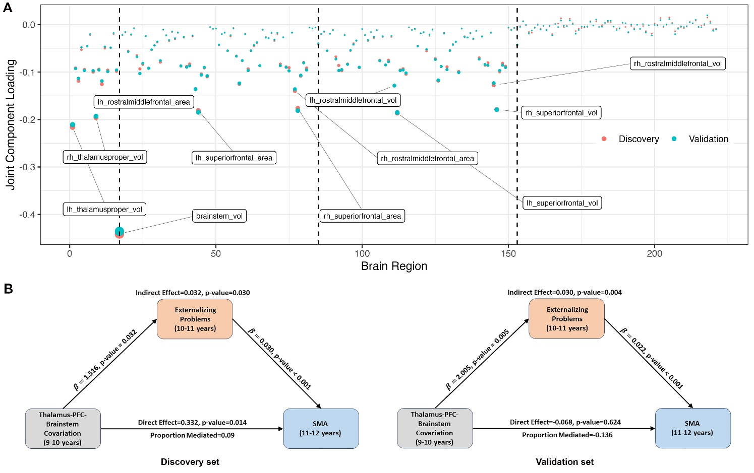
Figure S1 (A) Loadings of the structural covariation pattern from the discovery and validation sets. The pattern primarily reflected the covariation among regions implicated in the hypothesized Thalamus-PFC-Brainstem circuit. (B) Mediation analyses demonstrated that increased structural covariation values (indicating reduced brain volumes/surface area in regions outlined in (A)) correlated with increased externalizing problems at ages 10-11, subsequently leading to a higher frequency of SMA at ages 11-12. SMA: Screen Media Activity

