Ma, X., et al.: Wanting-liking dissociation and altered dopaminergic functioning: similarities between internet gaming disorder and tobacco use disorder. https://doi.org/10.1556/2006.2024.00011

Supplementary materials

Participant selection

IGD subjects
IGD needed to meet DSM-5 criteria for IGD and score more than fifty on Young’s internet addiction test (Y-IAT). The Y-IAT has been demonstrated to be a valid and reliable measure for assessing IGD (Dong et al., 2020; Zheng et al., 2019). Y-IAT scores ranging from fifty to eighty indicated frequent internet-use problems and scores higher than eighty mean noticeable problems related to overuse of the internet. Thus, the selection of IGD participants in the present study was in part based on Y-IAT scores of fifty or higher.

Tobacco use disorder (TUD) subjects
Criteria for TUD participants were as follows: (1) Smoked at least ten cigarettes per day with such smoking lasting one year or more; (2) Carbon monoxide CO levels in expired air of at least 5 ppm. Expiratory CO levels were measured using the Smokerlyzer System (Bedfont Scientific, Ltd, Rochester, UK).; (3) TUD severity was evaluated by the Fagerström Test for Nicotine Dependence (FTND) test and scores higher than four were required (Ghahremani, Faulkner, C, & London, 2018; Loughead et al., 2015). (4) The scores of the 10-item brief Questionnaire on Smoking Urges (QSU) more than fifteen were necessary (Sweitzer et al., 2014).

Healthy control (HC) participants
In the HC group, people with any addictive behaviours were excluded. Specifically, the criteria included: (1) Sustained game-play time should be less than four hours per day; (2) Not meet the requirements of gambling disorder in DSM-5; (3) Scores of IAT were no more than forty; (4) No more than twenty cigarettes smoked in their lifetime; (5) No other kinds of substance addiction (e.g., alcohol use disorder).
As few of the HC participants smoked, we did not further measure their Fagerström Test for Nicotine Dependence (FTND) score. However, many participants had experiences gaming. Thus, we further measured their addiction level to gaming used DSM-5 criteria for IGD and Young’s internet addiction test (Y-IAT).

Exclusion criteria
The exclusion criteria included: (1) Any kind of mental or neurological related diseases or related history; (2) The Mini-International Neuropsychiatric Interview (MINI) showed that participants exhibited no cognitive impairment (Lecrubier et al., 1997; Sheehan et al., 1998), or Beck depression Scale suggested that participants may get the depression (Aben, Verhey, Lousberg, Lodder, & Honig, 2002; Geisser, Roth, & Robinson, 1997), with cognitive impairment or depression being exclusionary; (3) Past-year surgery, head trauma or heart-related diseases; (4) Claustrophobia; (5) Metal implants and tattoos of neck or head.

Supplementary Table 1. Demographic information for participants in study 1
 |  | HC  (n=35) |  | IGD  (n=39) | t |  | p-value
Gender (male/female) |  | 8/27 |  | 14/25
Age, years (mean ± SD) |  | 20.090±6.926 |  | 20.360±7.478 | 0.718 |  | .732
Y-IAT scores |  | 30.170±5.618 |  | 59.510±6.824 | 15.668 |  | <.001
DSM-5 scores |  | 2.030±0.857 |  | 6.230±1.477 | 13.823 |  | <.001
All values are mean + SD. IGD: Internet gaming disorder; Y-IAT: Young’s internet addiction test; DSM-5: Diagnostic and Statistical Manual of Mental Disorders-5

Fishing fans
For fishing fans, as there is no such formal scale in evaluating the degree of their craving to gaming, we only selected those who fishing at least one time a week and this frequency lasted for at least one year. All of them are male and aged 42±11.352 years old. No separation were observed in wanting and liking among them (t=0.721, p=0.513). We did not perform the correlation analyses, as there is no scientific measure of their finshing severity.
As there is lack of scientific evaluation of the fishing behaviors, we only put these results into the supplementary materials.

Supplementary Table 2. Demographic information for participants in study 2
 |  | HC  (n=71) |  | IGD  (n=58) |  | TUD  (n=31) |  | F/t |  | p-value
Gender (male/female) |  | 40/31 |  | 31/27 |  | 30/1
Age, years (mean ± SD) |  | 21.183±2.199 |  | 20.879±2.112 |  | 23.452±5.501 |  | 7.718 |  | .001
Y-IAT scores |  | 38.029±9.767 |  | 64.328±9.124 |  |  |  | 15.668 |  | <.001
DSM-5 scores |  | 2.465±1.620 |  | 5.828±0.994 |  |  |  | 13.823 |  | <.001
FTND |  |  |  |  |  | 7.06±1.413
All values are mean + SD. IGD: Internet gaming disorder; Y-IAT: Young’s internet addiction test; DSM-5: Diagnostic and Statistical Manual of Mental Disorders-5; FTND, Fagerstrom Test for Nicotine Dependence; TUD, tobacco use disorder.

Supplementary Table 3. Demographic information for participants in study 3
 |  | HC  (n=38) |  | IGD  (n=17) |  | TUD  (n=14) |  | F/t |  | p-value
Gender (male/female) |  | 38/0 |  | 17/0 |  | 13/1
Age, years (mean ± SD) |  | 20.823±2.132 |  | 20.937±2.224 |  | 22.534±3.018 |  | 1.368 |  | .273
Y-IAT scores |  | 32.191±7.854 |  | 65.195±8.462 |  |  |  | 16.565 |  | <.001
DSM-5 scores |  | 2.337±1.541 |  | 5.939±0.566 |  |  |  | 16.933 |  | <.001
FTND |  |  |  |  |  | 7.11±1.523
All values are mean + SD. IGD: Internet gaming disorder; Y-IAT: Young’s internet addiction test; DSM-5: Diagnostic and Statistical Manual of Mental Disorders-5; FTND, Fagerstrom Test for Nicotine Dependence; TUD, tobacco use disorder.

References for above participant selection

Aben, I., Verhey, F., Lousberg, R., Lodder, J., & Honig, A. (2002). Validity of the beck depression inventory, hospital anxiety and depression scale, SCL-90, and hamilton depression rating scale as screening instruments for depression in stroke patients. Psychosomatics, 43(5), 386-393.
Dong, G., Wang, M., Liu, X., Liang, Q., Du, X., & Potenza, M. N. (2020). Cue‐elicited craving–related lentiform activation during gaming deprivation is associated with the emergence of Internet gaming disorder. Addiction Biology, 25(1), e12713.
Geisser, M. E., Roth, R. S., & Robinson, M. E. (1997). Assessing depression among persons with chronic pain using the Center for Epidemiological Studies-Depression Scale and the Beck Depression Inventory: a comparative analysis. The Clinical journal of pain, 13(2), 163-170.
Ghahremani, D. G., Faulkner, P., C, M. C., & London, E. D. (2018). Behavioral and neural markers of cigarette-craving regulation in young-adult smokers during abstinence and after smoking. Neuropsychopharmacology, 43(7), 1616-1622. doi:10.1038/s41386-018-0019-7
Lecrubier, Y., Sheehan, D. V., Weiller, E., Amorim, P., Bonora, I., Sheehan, K. H., . . . Dunbar, G. C. (1997). The Mini International Neuropsychiatric Interview (MINI). A short diagnostic structured interview: reliability and validity according to the CIDI. European Psychiatry, 12(5), 224-231.
Loughead, J., Wileyto, E. P., Ruparel, K., Falcone, M., Hopson, R., Gur, R., & Lerman, C. (2015). Working memory-related neural activity predicts future smoking relapse. Neuropsychopharmacology, 40(6), 1311-1320. doi:10.1038/npp.2014.318
Sheehan, D. V., Lecrubier, Y., Sheehan, K. H., Amorim, P., Janavs, J., Weiller, E., . . . Dunbar, G. C. (1998). The Mini-International Neuropsychiatric Interview (MINI): the development and validation of a structured diagnostic psychiatric interview for DSM-IV and ICD-10. Journal of Clinical Psychiatry, 59(20), 22-33.
Sweitzer, M. M., Geier, C. F., Joel, D. L., McGurrin, P., Denlinger, R. L., Forbes, E. E., & Donny, E. C. (2014). Dissociated effects of anticipating smoking versus monetary reward in the caudate as a function of smoking abstinence. Biological Psychiatry, 76(9), 681-688. doi:10.1016/j.biopsych.2013.11.013
Zheng, H., Hu, Y., Wang, Z., Wang, M., Du, X., & Dong, G. (2019). Meta-analyses of the functional neural alterations in subjects with Internet gaming disorder: Similarities and differences across different paradigms. Progress in Neuro-Psychopharmacology and Biological Psychiatry, 94(2019), 109656.

ROI selection process in study 2

First, for liking circuit.
As in the liking circuit, each hedonic hotspot is nestled within its larger limbic structure, they are tiny and need to be really carefully selected. The literautes showed that hedonic hotspots exist in limbic prefrontal cortex, in orbitofrontal and insula regions, where they may correspond to human sites that code sensory and higher pleasures (Kringelbach, 2010; Kringelbach, O'Doherty, Rolls, & Andrews, 2003; Small, Zatorre, Dagher, Evans, & Jones-Gotman, 2001).
In addition, especially crucial to the normal capacity for pleasure may be a particular hedonic hotspot located in the ventral pallidum, which lies at the base of the subcortical forebrain (K. S. Smith & Berridge, 2007). Thus, the ventral pallidum was selected as the hotspot for liking circuit.
The nucleus accumbens was also been listed as part of the liking circuit, but is really hard to detect, as literatures have pointed out that a nucleus accumbens hedonic hotspot is only one cubic millimeter in a rat brain, and probably about a cubic centimeter in humans. The hotspot constitutes only 10% of total nucleus accumbens volume: the remaining 90% of the nucleus accumbens lacks any ability to enhance ‘liking’, though still robustly causes intense ‘wanting’. As the nucleus accumbens is a mix of wanting and liking, we did not select it in any of the circuit.
As for the brainstem, it is really big, and there is no detailed description on the specific region involved in liking. Thus, we did not include it as a ROI in the current revision.
Literatures also suggested the limbic prefrontal cortex, as there is no preciously definitionin the manuscript and in the figure, we can not find a detailed brain regions responsible for this. Thus, we did not include it in the revision.

Based on these literatures and the following figure, we selected the following brain regions as ROI for our data analyses. They are: orbitofrontal cortex, the insula and the ventral pallidum.

Second, for wanting circuit.
As the ‘Wanting’ is mediated largely by brain mesocorticolimbic systems involving midbrain dopamine projections to forebrain targets, such as the nucleus accumbens and other parts of striatum (Berridge and Robinson, 2016). According to the literatures and the figure, we selected the following brain regions as ROI for wanting circuit:
The substantia nigra (SN), the amygdala, the dorsal striatum (the caudate and putamen, except the ventral pallidum), and the prefrontal cortex.

As the nucleus accumbens is a mixture of wanting and liking, we did not include it in any circuits.

Third, the selection of prefrontal cortex
As the reviewer pointed out, the prefrontal cortex is large and needs further constriction. In selecting the prefrontal cortex that represent for wanting circuit, and which for liking circuit. For this purpose, we read through the recently published meta-analyses on addiction and prefrontal cortex, which showed that there are several sub brain parts responsible for addiction. And the most important one for them is the DLPFC.

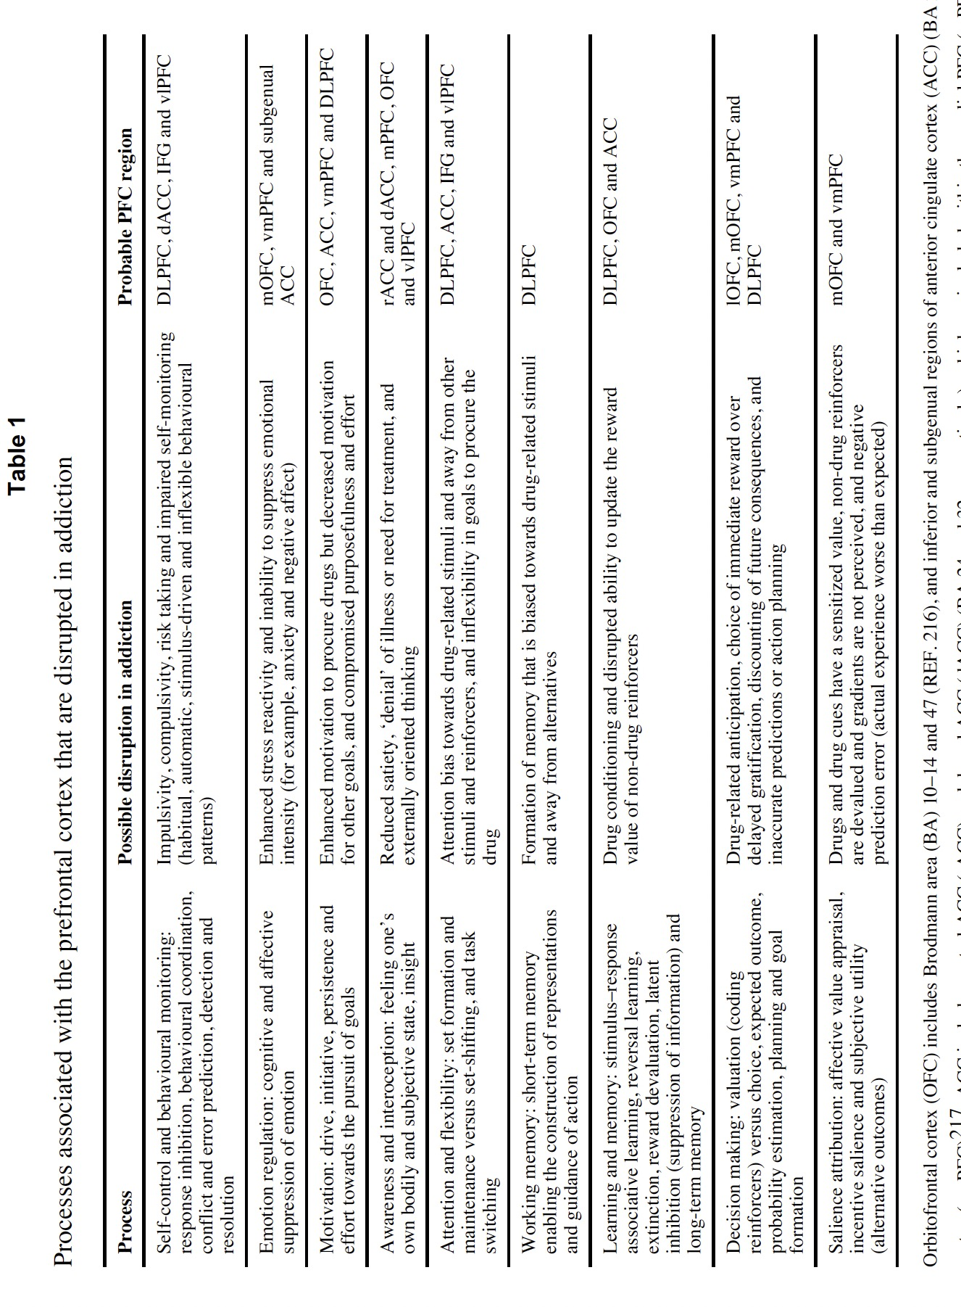
(Table from: Rita Goldstein, & Nora Volkow, Nat Rev Neurosi, 2012)

In the above paper, the authors focus on the functional neuroimaging studies conducted before that which that have expanded our understanding of the involvement of the PFC in addictions.

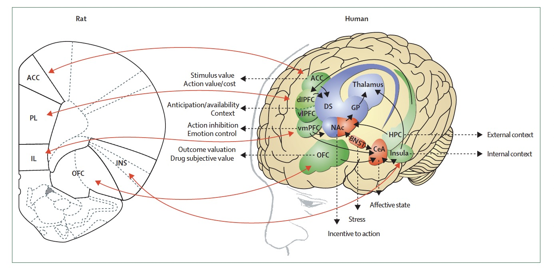
(Figures from: George Koop & Nora Volkow, Lancet Psychiatry, 2016)

In a paper published in 2016, the authors divided the prefrontal cortex into different part of sub-regions and correspondenced between rat and human brain regions relevant to the addiction process. In which the dlPFC was the mostly fit for wanting (anticipatin availability).
Thus, we decided select the DLPFC for wanting circuit and orbitofrontal cortex for liking circuit.

Then comes to the next issue: How to define these brain regions anatomically? In our study, we referenced a recent paper that described the functional division of the prefrontal cortex and the brodmann area. After careful consideration, we decided to select the BA 46 as ROI for DLPFC.
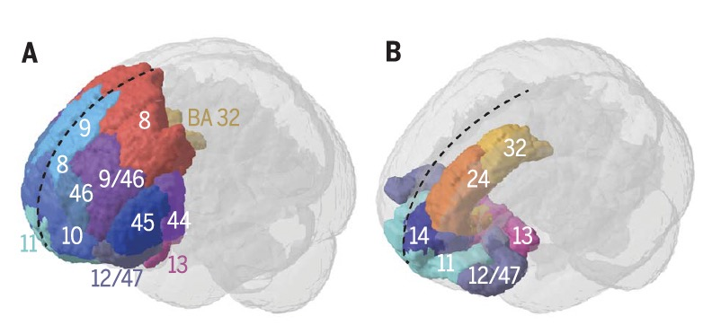
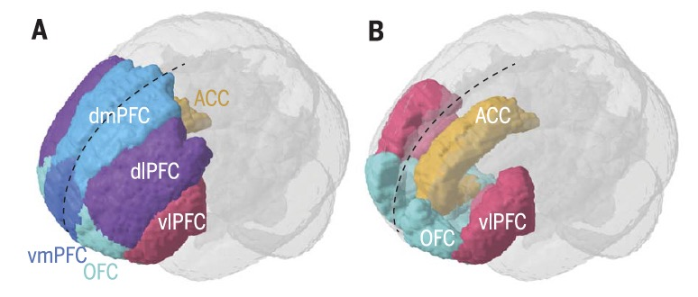
(Figures from: Carlen, what constitutes the prefrontal cortex, Science, 2017.)

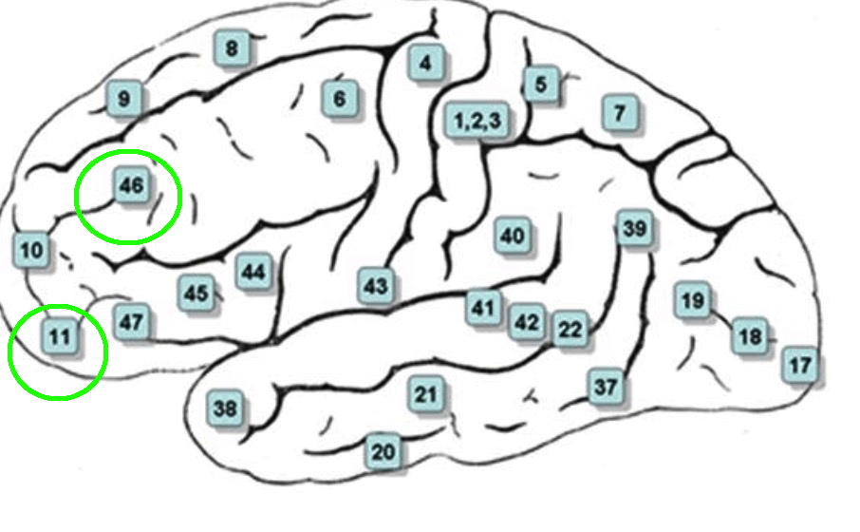

Fourth, the selection of orbito-frontal cortex
The orbitofrontal cortex refers to the ventral aspect of the frontal lobe that sits in the anterior cranial fossa, overlying the roof of the bony orbit. It forms part of the prefrontal cortex of the frontal lobe and includes Brodmann areas 10, 11, 12, 13 and 14.
The AAL could be divided into several sub-parts and to select which to represent the OFC? We read meta analyses, systematic review, or theoretical papers on OFC, although they all proposed the involvement of OFC in addictions, but all of them took the OFC as one and did not further separate OFC into sub-parts.
Then we tried to reading some experimental studies and to find the location of the OFC in these studies [e.g. Bracht, et, al. 2021], and also refrenced papers on OFC in depression [Drevets et a., 2007] and so on. Then, we referenced to the definition of Brodmann area, the in BA 11 is the best to represent OFC. We used broadman 11 as ROI for further ananlyses.

References for the ROI selection
Berridge KC. From prediction error to incentive salience: mesolimbic computation of reward motivation. European Journal of Neuroscience. 2012; 35(7):1124–1143.
Bracht T, Soravia L, Moggi F, Stein M, Grieder M, Federspiel A, Tschümperlin R, Batschelet HM, Wiest R, Denier N. The role of the orbitofrontal cortex and the nucleus accumbens for craving in alcohol use disorder. Transl Psychiatry. 2021 May 4;11(1):267.
Carlén M. What constitutes the prefrontal cortex? Science 358, 478–482 (2017)
Castro DC, Berridge KC. Opioid hedonic hotspot in nucleus accumbens shell: Mu, delta, and kappa maps for enhancement of sweetness “liking” and “wanting”. The Journal of Neuroscience. 2014; 34(12):4239–4250.
Drevets WC. Orbitofrontal cortex function and structure in depression. Ann N Y Acad Sci. 2007.
Koob G, Nora D Volkow. Neurobiology of addiction: a neurocircuitry analysis. Lancet Psychiatry 2016; 3: 760–73
Kringelbach, ML. The hedonic brain: A functional neuroanatomy of human pleasure. In: Kringelbach, ML.; Berridge, KC., editors. Pleasures of the brain. Oxford, U.K.: Oxford University Press; 2010. p. 202-221.
Kringelbach ML, O'Doherty J, Rolls ET, Andrews C. Activation of the human orbitofrontal cortex to a liquid food stimulus is correlated with its subjective pleasantness. Cereb Cortex. 2003; 13(10):1064–1071.
Mahler SV, Smith KS, Berridge KC. Endocannabinoid hedonic hotspot for sensory pleasure: anandamide in nucleus accumbens shell enhances 'liking' of a sweet reward. Neuropsychopharmacology. 2007; 32(11):2267–2278.
Morales I, Berridge KC.. ‘Liking’ and ‘wanting’ in eating and food reward: Brain mechanisms and clinical implications. Physiol Behav. 2020 Dec 1; 227: 113152.
Ostlund SB, LeBlanc KH, Kosheleff AR, Wassum KM, Maidment NT. Phasic Mesolimbic Dopamine Signaling Encodes the Facilitation of Incentive Motivation Produced by Repeated Cocaine Exposure. Neuropsychopharmacology. 2014; 39(10):2441–2449.
Peciña S, Berridge KC. Hedonic hot spot in nucleus accumbens shell: Where do mu-opioids cause increased hedonic impact of sweetness? J. Neurosci. 2005; 25(50):11777–11786.
Pecina S, Berridge KC. Dopamine or opioid stimulation of nucleus accumbens similarly amplify cue-triggered 'wanting' for reward: entire core and medial shell mapped as substrates for PIT enhancement. Eur J Neurosci. 2013; 37(9):1529–1540.
Rita Z. Goldstein and Nora D. Volkow.Dysfunction of the prefrontal cortex in addiction: neuroimaging findings and clinical implications. Nat Rev Neurosci. ; 12(11): 652–669. doi:10.1038/nrn3119.
Smith KS, Berridge KC, Aldridge JW. Disentangling pleasure from incentive salience and learning signals in brain reward circuitry. Proc Natl Acad Sci U S A. 2011; 108(27):E255–E264.
Small DM, Zatorre RJ, Dagher A, Evans AC, Jones-Gotman M. Changes in brain activity related to eating chocolate - From pleasure to aversion. Brain. 2001; 124:1720–1733.
Smith KS, Berridge KC. Opioid limbic circuit for reward: interaction between hedonic hotspots of nucleus accumbens and ventral pallidum. Journal Of Neuroscience. 2007; 27(7):1594–1605.
Zhou Y, Li X, Zhang M, Zhang F, Zhu C, Shen M. Behavioural approach tendencies to heroin-related stimuli in abstinent heroin abusers. Psychopharmacology. 2011; 221(1):171–176.

The ROI selection and the results in study 3
Two of our authors (XF Ma & HS Ni) performed the analysis following the two methods provided by S. Prasad et al.¹ and Ohtsuka C et al.² All extraction standards strictly follow their protocols.

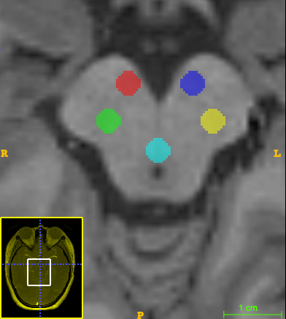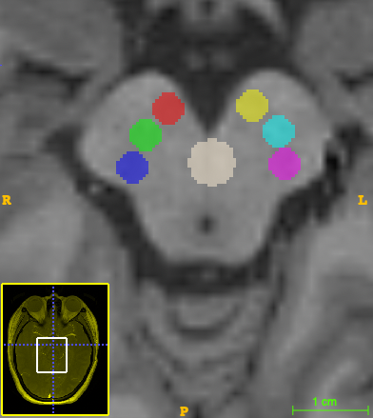
Central
Medial
Lateral
Supplementary Figure 3-1: Left: The ROI selection method by Prasad et al.; Right, the ROI selection method by Ohtsuka et al.

We took the results using Prasad’s method in the main manuscript, and put the Ohtsuka’s method here.

In this method, we only extracted data from level 1 and 2. As in the level 3, most of the values are out of the range of 5-25%, although we tried several times. Thus, in the end, we only extracted data from level 1 and 2 in this revision. All further analyses were based on the data from level 1 and 2.
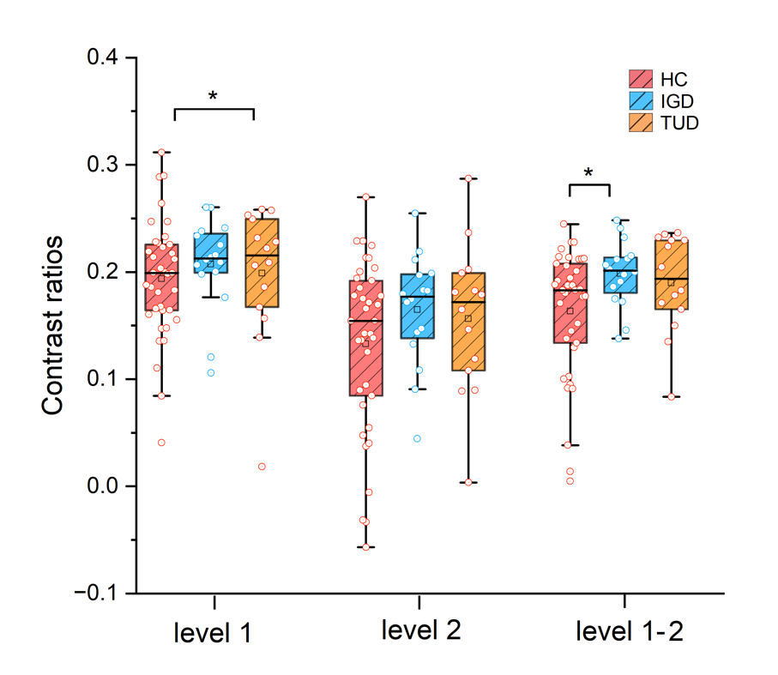

Supplementary figure 3-2, the The NM features in different groups at levels 1,2and 1-2 in central ROIs.
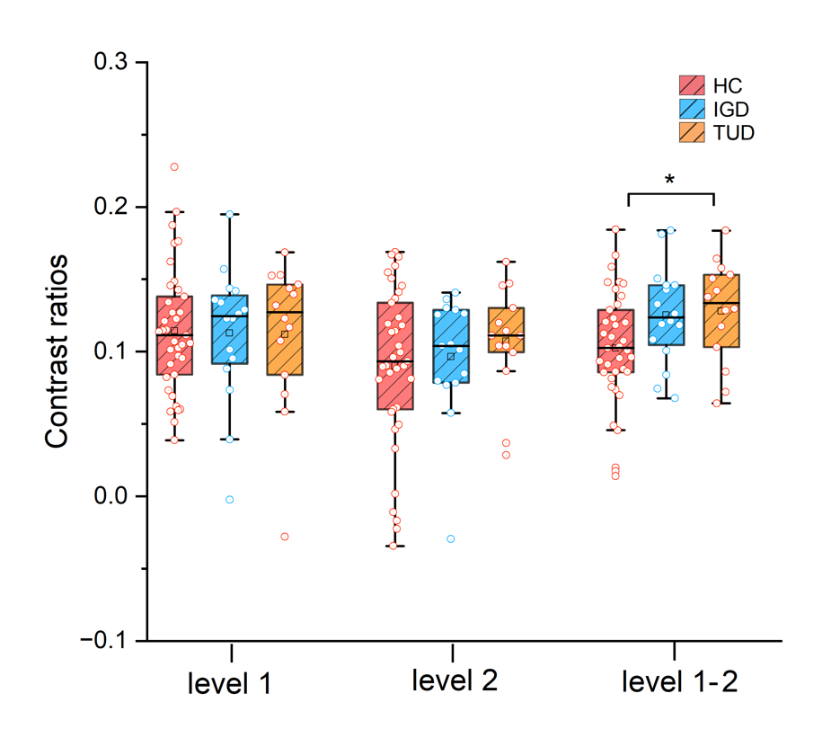

Supplementary figure 3-3, The NM features in different groups at levels 1,2 and 1-2 in lateral ROIs.

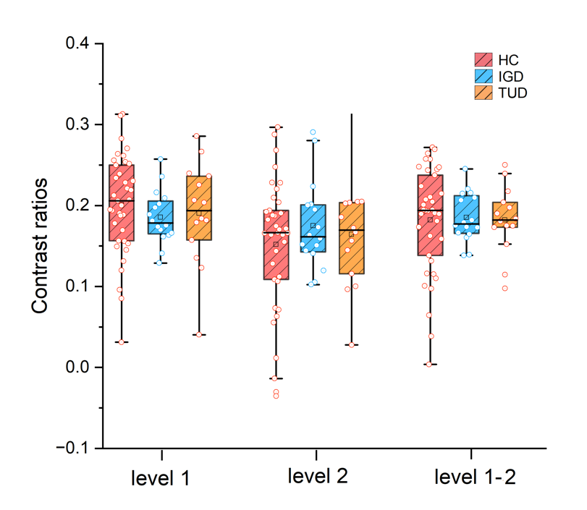
Supplementary figure 3-4, the The NM features in different groups at levels 1,2 and 1-2 in medial ROIs.

Supplementary figure 3-5, correlation between the NM features and the addiction level in TUD subjects in central ROIs.

Supplementary figure 3-6, correlation between the NM features and the addiction level in TUD subjects in lateral ROIs.

Supplementary figure 3-7, correlation between the NM features and the addiction level in TUD subjects in medial ROIs.

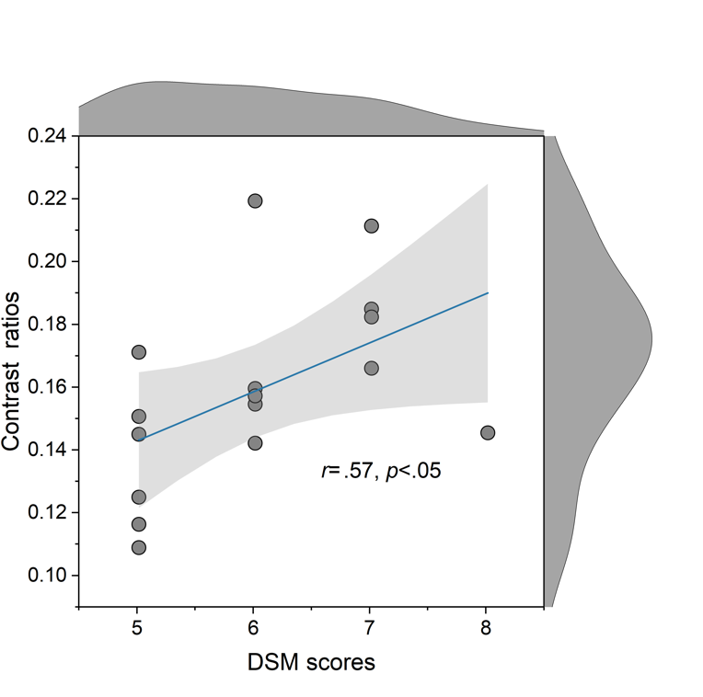
Supplementary figure 3-8, correlation between the NM features and the addiction level in IGD subjects in central ROIs.
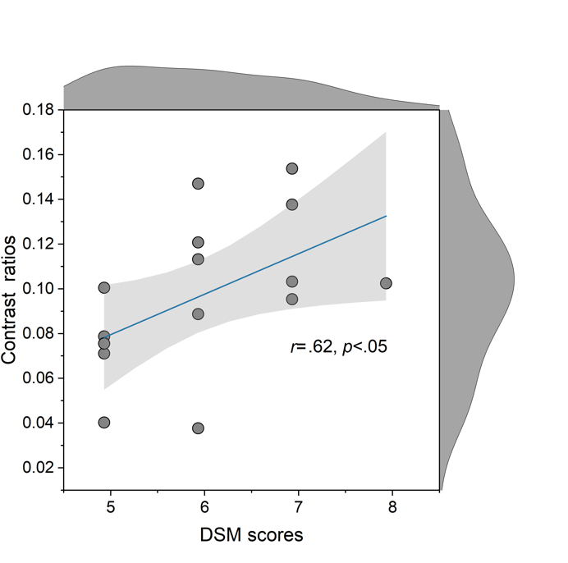
Supplementary figure 3-9, correlation between the NM features and the addiction level in IGD subjects in lateral ROIs.

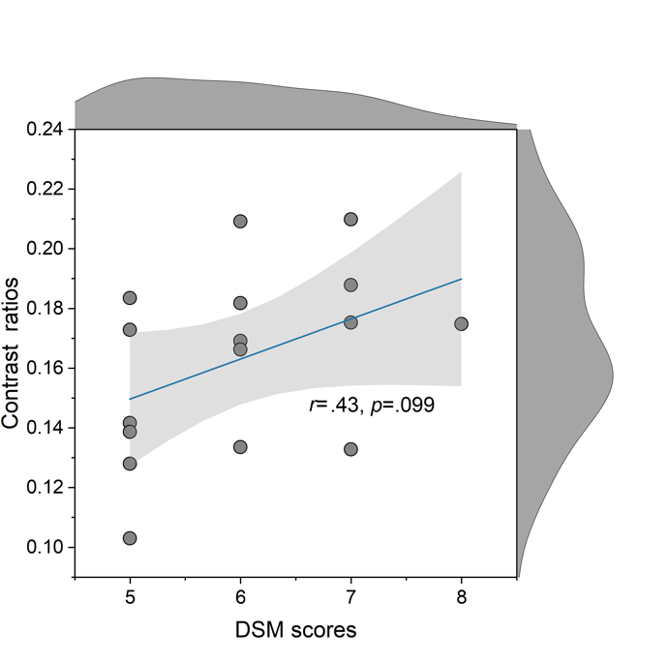
Supplementary figure 3-10, correlation between the NM features and the addiction level in IGD subjects in medial ROIs.

In summary, the conclusions we can draw from the updated results are the same as the previous version, but more robust.

References for the NM ROI selection in study 3

1 Prasad, S. et al. Three-dimensional neuromelanin-sensitive magnetic resonance imaging of the substantia nigra in Parkinson's disease. Eur. J. Neurol. 25, 680-686 (2018). https://doi.org:10.1111/ene.13573
2 Ohtsuka, C. et al. Changes in substantia nigra and locus coeruleus in patients with early-stage Parkinson's disease using neuromelanin-sensitive MR imaging. Neurosci. Lett. 541, 93-98 (2013). https://doi.org:10.1016/j.neulet.2013.02.012

